

**CSE302 (Section 02)**

**[Summer 2022]**

**Lab Assignment Submission Report**

**Assignment Title:Lab02**

**Submitted by:**

**Md.Abu Zafor**

**Your Student ID**

**2020-2-60-158**

1. **Screenshots**

**Lab Task #01: (Schema Definition)**

**1.Account Table**

**.**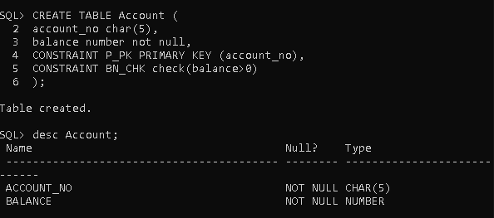

1. **Customer Table**

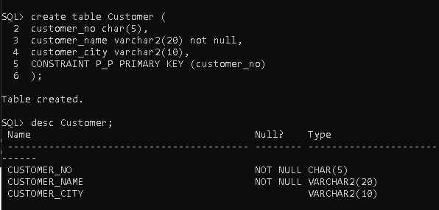

**3.Depositor Table:**

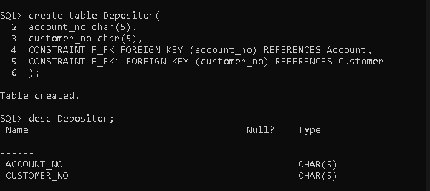

**Lab Task #02: (Schema Modification)**

1. **Write SQL statement to add a new attribute ‘date_of_birth’ (date type) in customer table.**

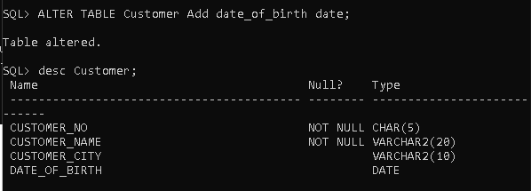

**ii. Write SQL statement to drop the attribute ‘date_of_birth’ from customer table.**

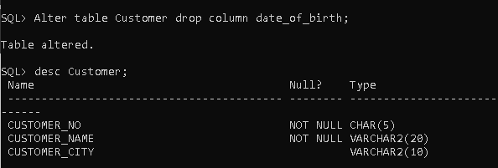

1. **Write SQL statement to rename the attribute account_no, customer_no from depositor table to a_no and c_no, respectively.**

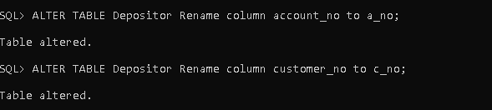

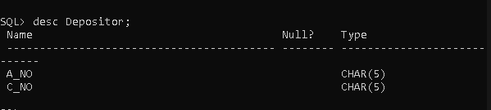

1. **Write SQL statements to add two foreign key constraints ‘depositor_fk1’**

**and ‘depositor_fk2’ which identifies a_no and c_no as a foreign key.**

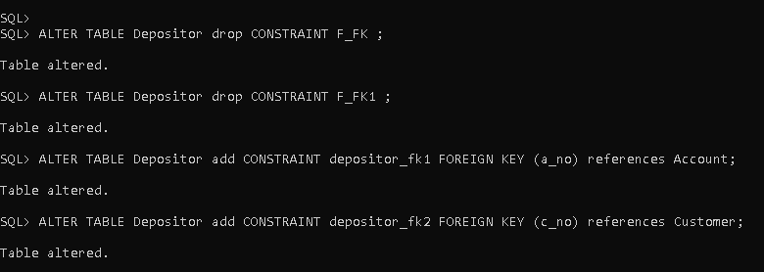

**Lab Task # 03 (Inserting Records into Tables):**

**Inserting value into Account table**

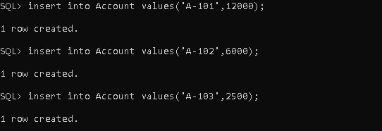

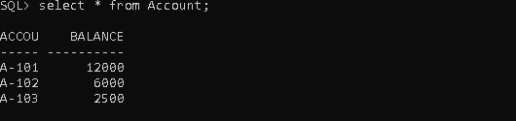

**Inserting value into Customer table**

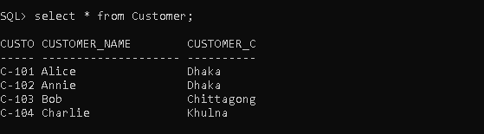

**Inserting value into Depositor table**

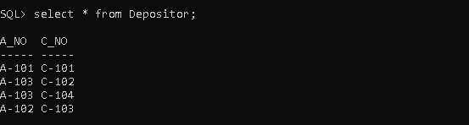

**Problem 1:**

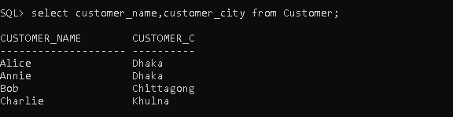

**Problem 2:**

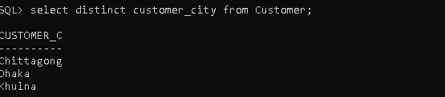

**Problem 3:**

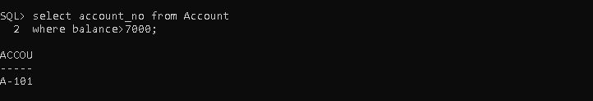

**Problem 4:**

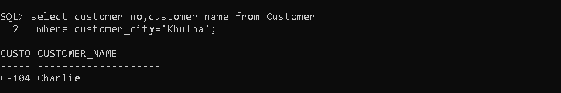

**Problem 5:**

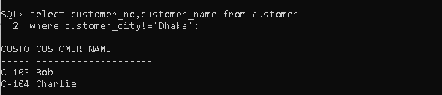

**Problem 6:**

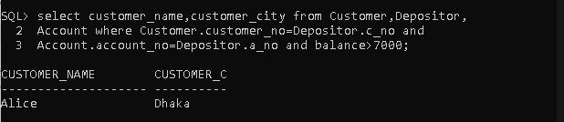

**Problem 7:**

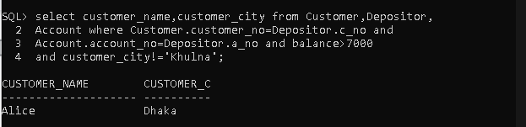

**Problem 8:**

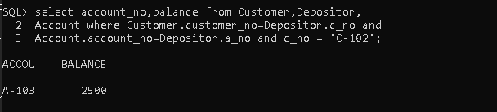

**Problem 9:**

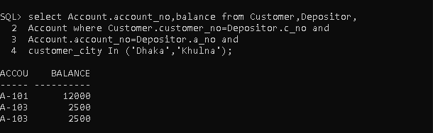

**Problem 10:**

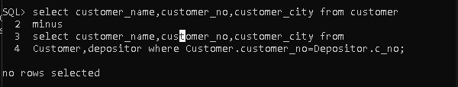

1. **Learning Outcomes**

**My learning outcomes are given below of lab 02:**

**Schema Modification:**

1. **How to add a new attribute;**
2. **How to drop an attribute;**
3. **How to modify data type of an attribute;**
4. **How to rename an attribute;**
5. **How to rename a table;**
6. **How to add a new constraint into a table;**
7. **How to delete a constraint from a table;**
8. **How to check all constraints;**
9. **Learned about Cartesian product and natural join;**
10. **How to use natural join conditions.**