Created Two branch java & JavaScript & pushed the code.
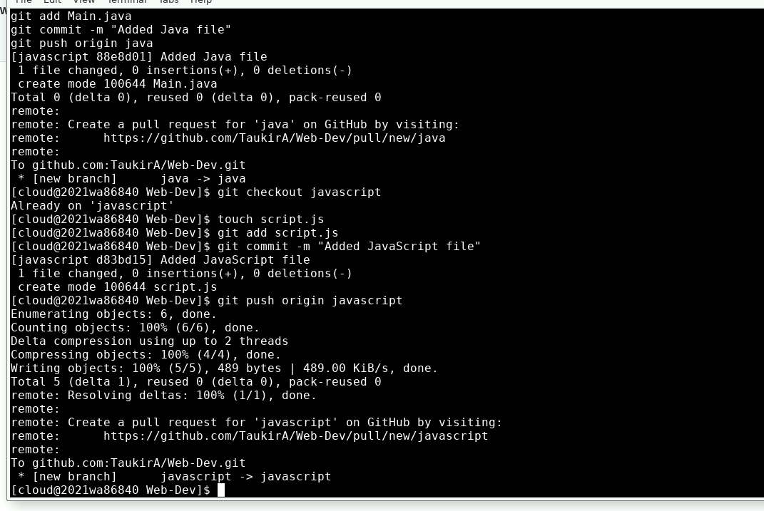
Created Main.java file & added some content to it.

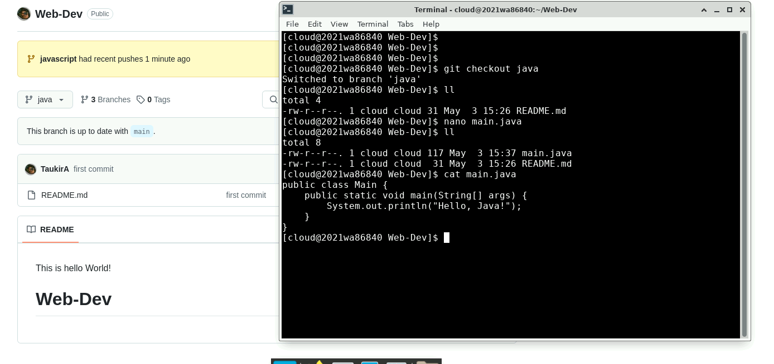
Perform the commit so that push can be added in GitHub repo.
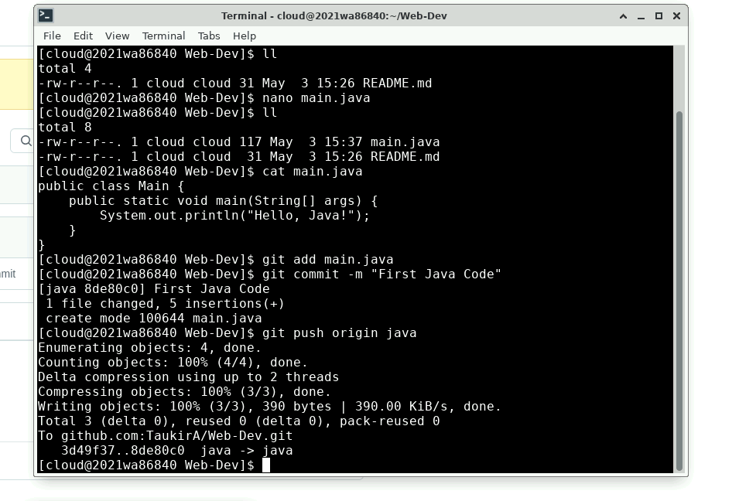
Java file visible in portal.
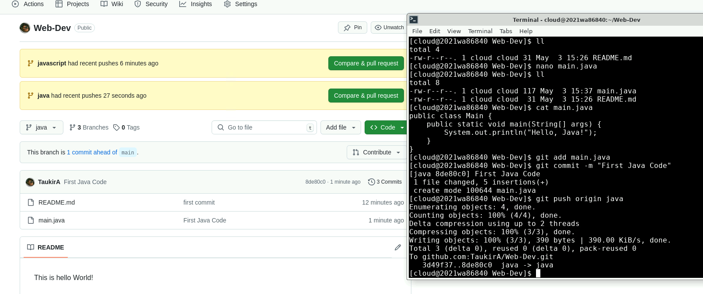
Again, made some changes to main.java file & again pushed the code to GitHub.

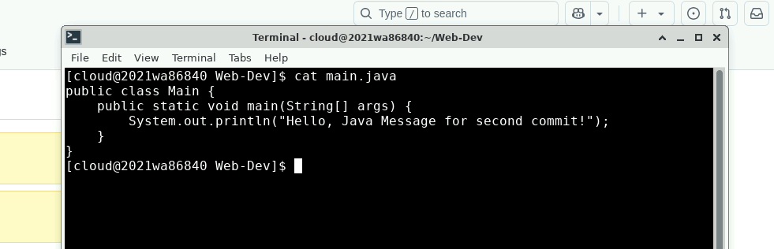
Changes are reflected in GitHub.
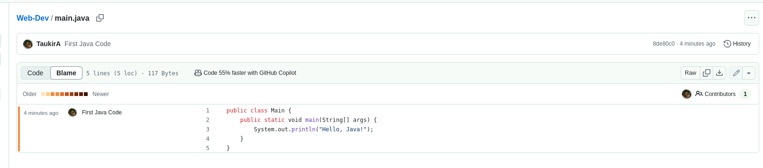
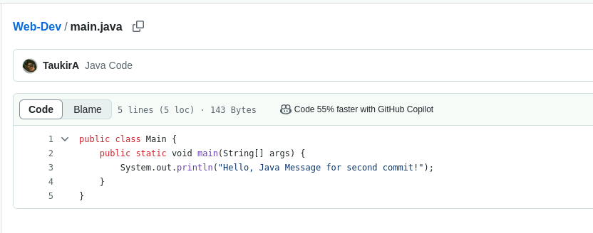
Changed the branch to main & merged all the branches & pushed the code again to main.
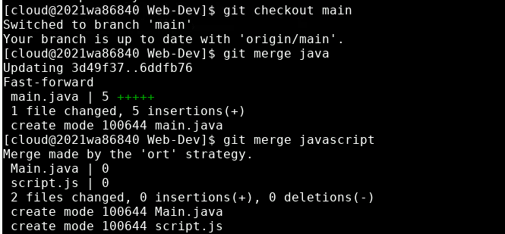
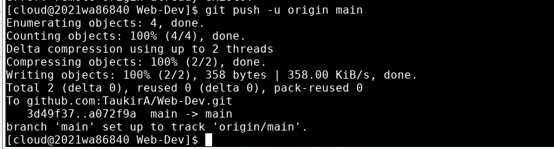

Task 2:
Created the two-csv file & manually uploaded the file to GitHub.
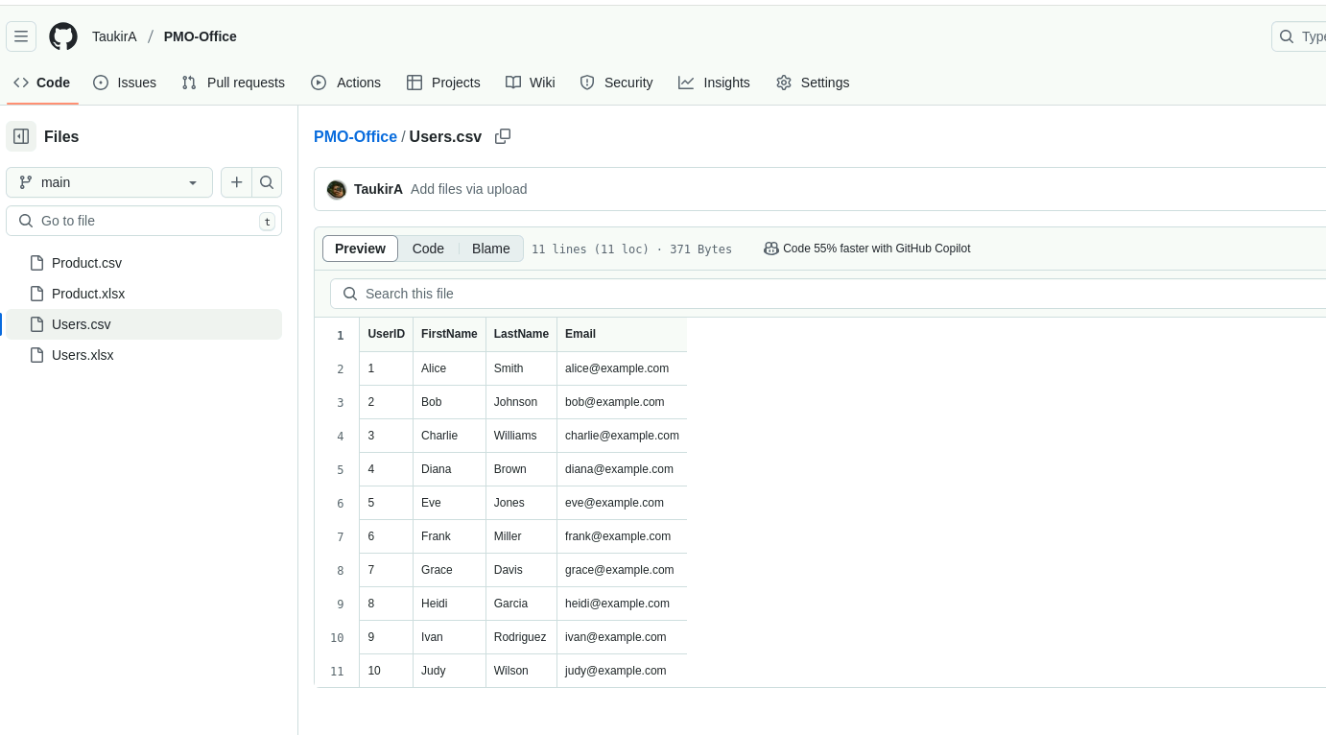Created two files CSV file & & clone in local machine.
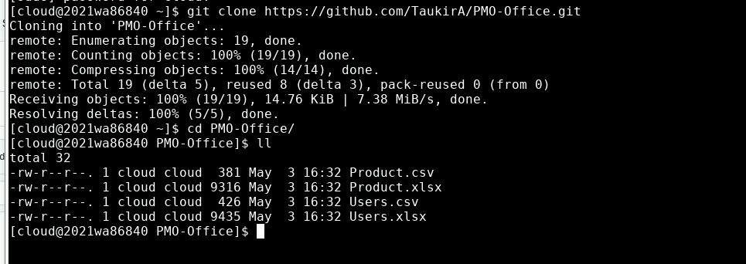
Made some modifications in local machine & pushed the data again to GitHub.
