- Explain the meaning of free space loss.
Free-space path loss (FSPL) quantifies the attenuation of signal power over a distance in free space.
The formula is: FSPL $= {\left.\left( \frac{4πd}{λ}\right.\right)}^{2}$
- d is the distance between the transmitter and receiver (meters)
- lambda is the wavelength of the signal (meters)

- What are the factors that contribute free space loss?
Ans: Loss increases with distance, frequency, and lower antenna gain. As signals propagate, the spreading of electromagnetic waves leads to diminished power, making efficient antenna design and proper frequency selection crucial for minimizing loss.
FSPL_{db}=(4πdf/c)²

- What do you mean by multipath signal?
Ans: Signal reaches the receiver via multiple paths due to reflection, diffraction, or scattering. These multiple signal paths can cause constructive or destructive interference, leading to signal fading, distortion, or phase shifts that impact reception quality.
- Explain how received power varies with respect to distance.
Ans: Received power decreases with distance following inverse square law, meaning that doubling the distance leads to a quarter of the received power. Signal attenuation occurs due to wave dispersion, making effective antenna positioning and power management essential
Pr=Pt⋅GtGrλ² / (4πd)²
- If transmitted power is increased, what happens to path loss?
Ans: Path loss remains unchanged, but received signal strength improves. Higher transmitted power compensates for attenuation effects, enhancing signal reliability, especially in long-distance communication systems. However, excessive power can cause interference in wireless networks.

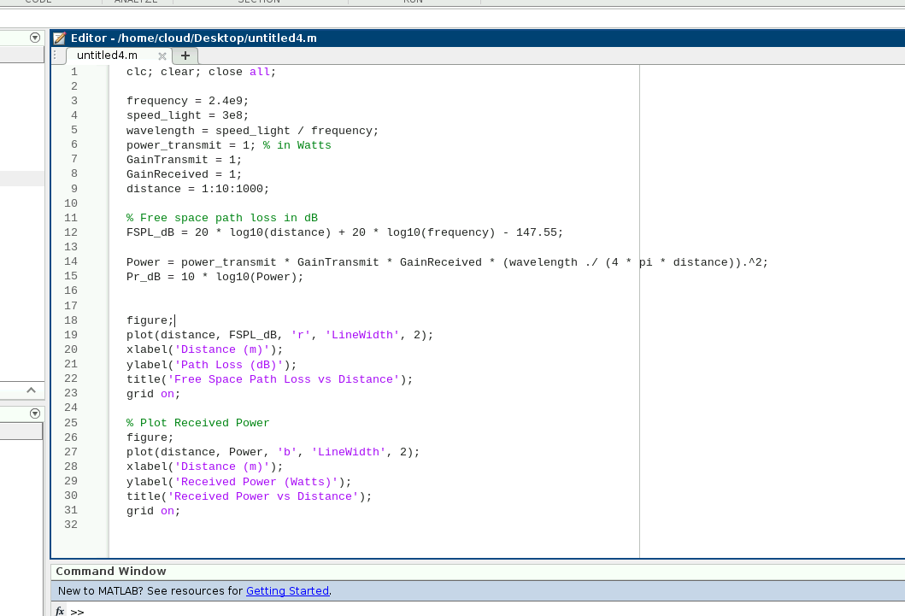
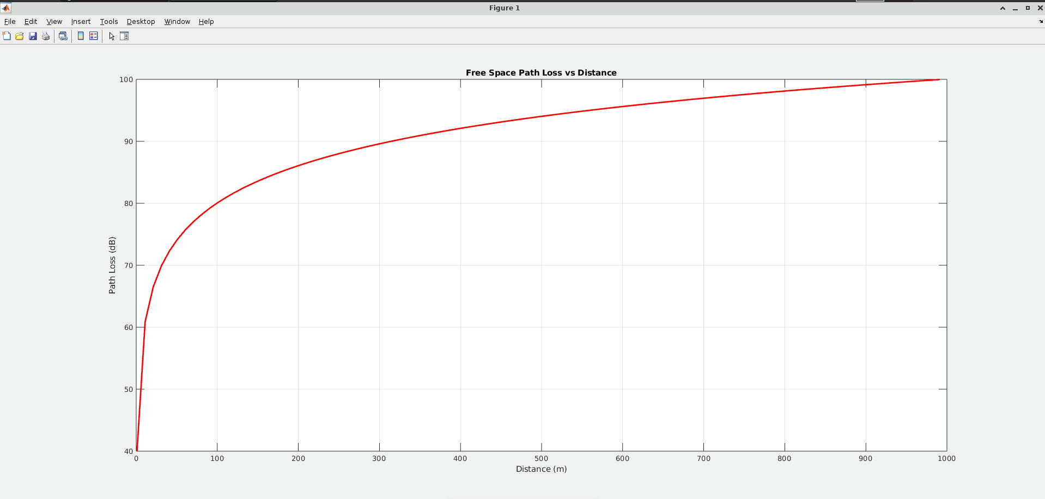

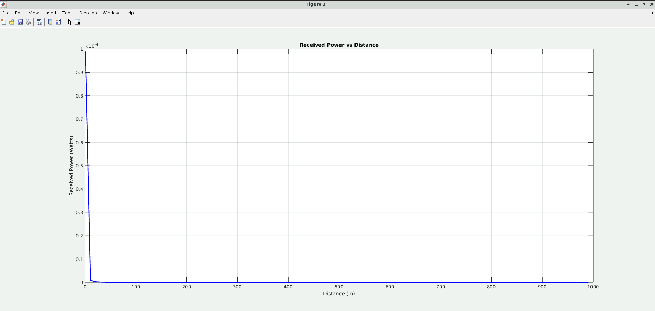

Received power decreases as path loss increases, following an inverse relationship. As the signal travels farther from the transmitter, its strength diminishes due to spreading and attenuation effects. This loss is more significant at higher frequencies, which experience greater free space attenuation.

