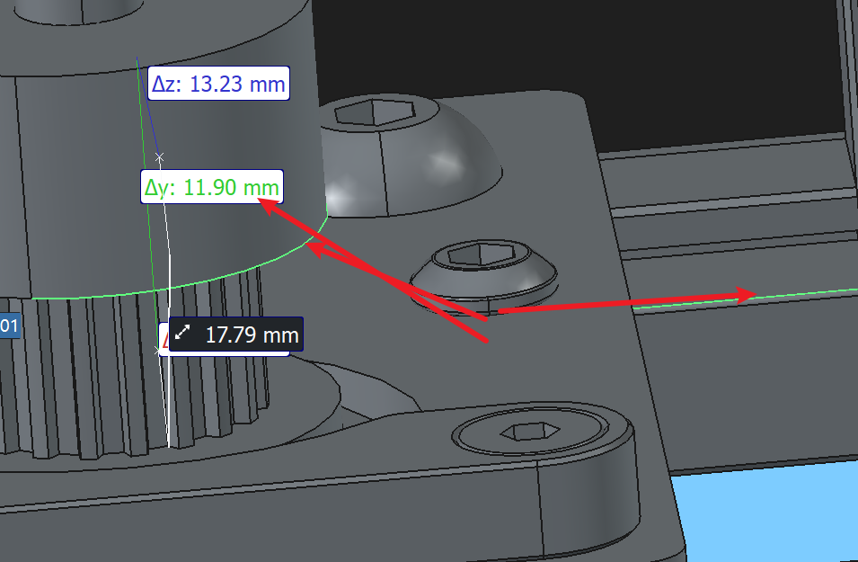

套装里的电机底座厚度是2.47 ≈2.5

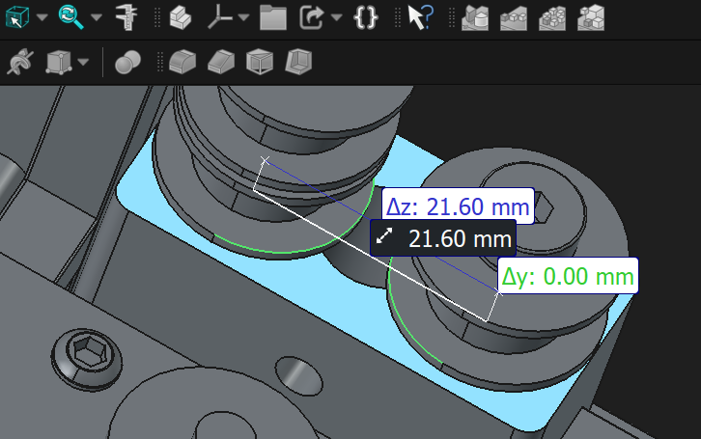

21.6-18 = 3.6

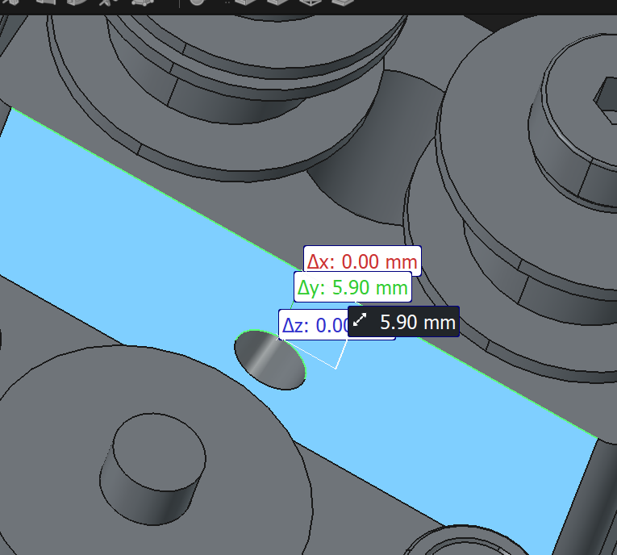

5.9+2.1 = 8
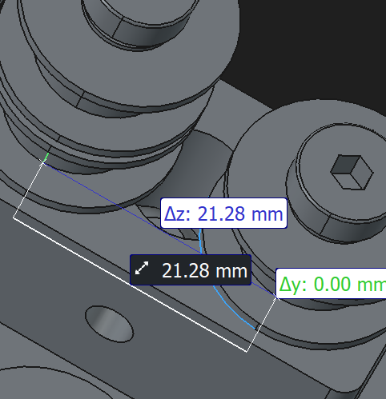
21.28

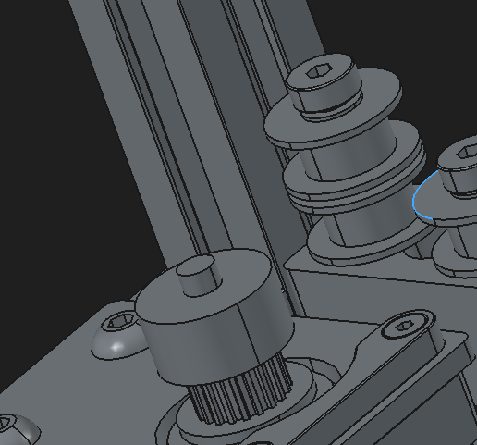

17.5-8.9 = 8.6
8.6+4 = 12.6

