In [1]:
import pandas as pd
import matplotlib.pyplot as plt
from sklearn.model_selection import train_test_split

In [4]:
df= pd.read_csv('dhaka homeprices.csv', sep = ';')

In [7]:

Out[7]:

In [9]:

In [10]:
df
# Split the 'area,price' column into two separate columns 'area' and 'price'
df[['area', 'price']] = df['area,price'].str.split(',', expand=True)

# Convert the 'area' and 'price' columns to numeric types
df['area'] = pd.to_numeric(df['area']) df['price'] = pd.to_numeric(df['price'])

plt.xlabel('Area in Square Fit') plt.ylabel('Price in Taka') plt.scatter(df['area'], df['price'])
plt.scatter(df['area'], df['price'],color='red', marker='+') plt.title('Homeprices in Dhaka city')
plt.plot()

[]
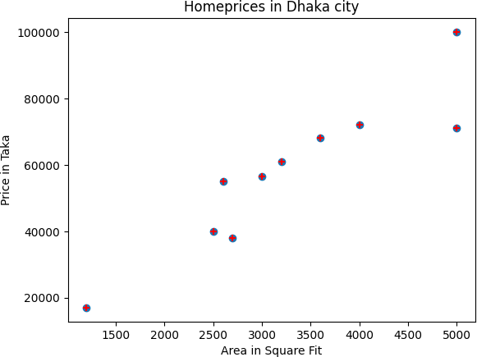
df= pd.read_csv('dhaka homeprices.csv')

Out[10]: |  | area | price
 | 0 | 2600 | 55000
 | 1 | 3000 | 56500
 | 2 | 3200 | 61000
 | 3 | 3600 | 68000
 | 4 | 4000 | 72000
 | 5 | 5000 | 71000
 | 6 | 2500 | 40000
 | 7 | 2700 | 38000
 | 8 | 1200 | 17000
 | 9 | 5000 | 100000

In [11]:
df.head()

Out[11]: |  | area | price
 | 0 | 2600 | 55000
 | 1 | 3000 | 56500
 | 2 | 3200 | 61000
 | 3 | 3600 | 68000
 | 4 | 4000 | 72000

In [12]:
df.head(3)

Out[12]: |  | area | price
 | 0 | 2600 | 55000
 | 1 | 3000 | 56500
 | 2 | 3200 | 61000

In | [13]: | x = df[['area']] y = df['price']
In | [15]: | xtrain, xtest, ytrain, ytest = train_test_split(x, y, test_size = 0.40,rando
In | [16]: | xtest

Out[16]: |  | area
 | 2 | 3200
 | 9 | 5000
 | 6 | 2500
 | 4 | 4000

In [17]:
xtrain

Out[17]: |  | area
 | 0 | 2600
 | 3 | 3600
 | 1 | 3000
 | 7 | 2700
 | 8 | 1200
 | 5 | 5000

In [18]:
ytest

Out[18]: |  | price
 | 2 | 61000
 | 9 | 100000
 | 6 | 40000
 | 4 | 72000

dtype: int64

In [19]:
from sklearn.linear_model import LinearRegression

In [20]:
reg= LinearRegression ()

In [21]:
reg.fit(xtrain,ytrain)

Out[21]:
▾ LinearRegression
LinearRegression()
i ?

In [22]:
LinearRegression ()

Out[22]:
▾ LinearRegression
LinearRegression()
i ?

In [23]:
reg.score(xtest,ytest)

Out[23]:

In [24]:
/usr/local/lib/python3.11/dist-packages/sklearn/utils/validation.py:2739: Us erWarning: X does not have valid feature names, but LinearRegression was fit ted with feature names
warnings.warn(

Out[24]:

In [25]:
/usr/local/lib/python3.11/dist-packages/sklearn/utils/validation.py:2739: Us erWarning: X does not have valid feature names, but LinearRegression was fit ted with feature names
warnings.warn(

Out[25]:

In [26]:
/usr/local/lib/python3.11/dist-packages/sklearn/utils/validation.py:2739: Us erWarning: X does not have valid feature names, but LinearRegression was fit ted with feature names
warnings.warn(

Out[26]:

In [ ]:
0.7182056168655753

reg.predict([[3300]])

array([55021.66064982])

reg.predict([[3200]])

array([53572.839244])

reg.predict([[2850]])

array([48501.96432364])

This notebook was converted with convert.ploomber.io

