In [1]:
import pandas as pd
import matplotlib.pyplot as plt
from sklearn.model_selection import train_test_split

In [2]:
df= pd.read_csv('insurance.csv')

In [3]:
df

Out[3]: | age | sex | bmi | children | smoker | region | charges
 | 0 19 | female | 27.900 | 0 | yes | southwest | 16884.92400
 | 1 18 | male | 33.770 | 1 | no | southeast | 1725.55230
 | 2 28 | male | 33.000 | 3 | no | southeast | 4449.46200
 | 3 33 | male | 22.705 | 0 | no | northwest | 21984.47061
 | 4 32 | male | 28.880 | 0 | no | northwest | 3866.85520
 | ... ... | ... | ... | ... | ... | ... | ...
 | 1333 50 | male | 30.970 | 3 | no | northwest | 10600.54830
 | 1334 18 | female | 31.920 | 0 | no | northeast | 2205.98080
 | 1335 18 | female | 36.850 | 0 | no | southeast | 1629.83350
 | 1336 21 | female | 25.800 | 0 | no | southwest | 2007.94500
 | 1337 61 | female | 29.070 | 0 | yes | northwest | 29141.36030

1338 rows × 7 columns

In [4]:
df['sex'] = df['sex'].astype('category')
df['sex'] = df['sex'].cat.codes

In [5]:
df

Out[5]: | age | sex | bmi | children | smoker | region | charges
 | 0 19 | 0 | 27.900 | 0 | yes | southwest | 16884.92400
 | 1 18 | 1 | 33.770 | 1 | no | southeast | 1725.55230
 | 2 28 | 1 | 33.000 | 3 | no | southeast | 4449.46200
 | 3 33 | 1 | 22.705 | 0 | no | northwest | 21984.47061
 | 4 32 | 1 | 28.880 | 0 | no | northwest | 3866.85520
 | ... ... | ... | ... | ... | ... | ... | ...
 | 1333 50 | 1 | 30.970 | 3 | no | northwest | 10600.54830
 | 1334 18 | 0 | 31.920 | 0 | no | northeast | 2205.98080
 | 1335 18 | 0 | 36.850 | 0 | no | southeast | 1629.83350
 | 1336 21 | 0 | 25.800 | 0 | no | southwest | 2007.94500
 | 1337 61 | 0 | 29.070 | 0 | yes | northwest | 29141.36030

1338 rows × 7 columns

In [6]:
df['smoker'] = df['smoker'].astype('category') df['smoker'] = df['smoker'].cat.codes df['region'] = df['region'].astype('category') df['region'] = df['region'].cat.codes

In [7]:
df

Out[7]: | age | sex | bmi | children | smoker | region | charges
 | 0 19 | 0 | 27.900 | 0 | 1 | 3 | 16884.92400
 | 1 18 | 1 | 33.770 | 1 | 0 | 2 | 1725.55230
 | 2 28 | 1 | 33.000 | 3 | 0 | 2 | 4449.46200
 | 3 33 | 1 | 22.705 | 0 | 0 | 1 | 21984.47061
 | 4 32 | 1 | 28.880 | 0 | 0 | 1 | 3866.85520
 | ... ... | ... | ... | ... | ... | ... | ...
 | 1333 50 | 1 | 30.970 | 3 | 0 | 1 | 10600.54830
 | 1334 18 | 0 | 31.920 | 0 | 0 | 0 | 2205.98080
 | 1335 18 | 0 | 36.850 | 0 | 0 | 2 | 1629.83350
 | 1336 21 | 0 | 25.800 | 0 | 0 | 3 | 2007.94500
 | 1337 61 | 0 | 29.070 | 0 | 1 | 1 | 29141.36030

1338 rows × 7 columns

In [8]:
df.isnull().sum()

Out[8]:
0
age 0

sex 0
bmi 0
children 0
smoker 0
region 0
charges 0

dtype: int64

In [9]:
x = df.drop(columns='charges')

In [10]:
x

Out[10]: | age | sex | bmi | children | smoker | region
 | 0 19 | 0 | 27.900 | 0 | 1 | 3
 | 1 18 | 1 | 33.770 | 1 | 0 | 2
 | 2 28 | 1 | 33.000 | 3 | 0 | 2
 | 3 33 | 1 | 22.705 | 0 | 0 | 1
 | 4 32 | 1 | 28.880 | 0 | 0 | 1
 | ... ... | ... | ... | ... | ... | ...
 | 1333 50 | 1 | 30.970 | 3 | 0 | 1
 | 1334 18 | 0 | 31.920 | 0 | 0 | 0
 | 1335 18 | 0 | 36.850 | 0 | 0 | 2
 | 1336 21 | 0 | 25.800 | 0 | 0 | 3
 | 1337 61 | 0 | 29.070 | 0 | 1 | 1

1338 rows × 6 columns

In [11]:
y = df['charges']

In [12]:
x

Out[12]: | age | sex | bmi | children | smoker | region
 | 0 19 | 0 | 27.900 | 0 | 1 | 3
 | 1 18 | 1 | 33.770 | 1 | 0 | 2
 | 2 28 | 1 | 33.000 | 3 | 0 | 2
 | 3 33 | 1 | 22.705 | 0 | 0 | 1
 | 4 32 | 1 | 28.880 | 0 | 0 | 1
 | ... ... | ... | ... | ... | ... | ...
 | 1333 50 | 1 | 30.970 | 3 | 0 | 1
 | 1334 18 | 0 | 31.920 | 0 | 0 | 0
 | 1335 18 | 0 | 36.850 | 0 | 0 | 2
 | 1336 21 | 0 | 25.800 | 0 | 0 | 3
 | 1337 61 | 0 | 29.070 | 0 | 1 | 1

1338 rows × 6 columns

In [13]:
y

Out[13]: |  | charges
 | 0 | 16884.92400
 | 1 | 1725.55230
 | 2 | 4449.46200
 | 3 | 21984.47061
 | 4 | 3866.85520
 | ... | ...
 | 1333 | 10600.54830
 | 1334 | 2205.98080
 | 1335 | 1629.83350
 | 1336 | 2007.94500
 | 1337 | 29141.36030

1338 rows × 1 columns

dtype: float64

In [15]: xtrain, xtest, ytrain, ytest = train_test_split(x, y, test_size = 0.3, rando In [16]:
from sklearn.linear_model import LinearRegression

In [17]:
lr= LinearRegression ()

In [18]:
lr.fit(xtrain,ytrain)

Out[18]:
▾ LinearRegression
LinearRegression()
i ?

In [19]:
c = lr.intercept_

In [20]:
c

Out[20]:

In [21]:

In [22]:

Out[22]:

In [23]:

In [24]:
y_pred_train
np.float64(-11827.733141795718)

m = lr.coef_

m
array([ 256.5772619 , -49.39232379, 329.02381564, 479.08499828,
23400.28378787, -276.31576201])

y_pred_train = lr.predict(xtrain)

Out[24]: | array([ 2074.0645306 , | 8141.81393908, | 18738.94132528, | 7874.86959064,
 | 6305.12726989, | 2023.19725425, | 26861.18663021, | 14932.93021746,
 | 10489.56733846, | 16254.02800921, | 11726.39324257, | 11284.0092172 ,
 | 39312.16870908, | 5825.91078917, | 12314.92042527, | 3164.68427134,
 | 15406.30681252, | 4648.58167988, | 5011.79585436, | 6012.4796038 ,
 | 15349.49652486, | 8970.97358853, | 8780.43012222, | 34229.60622887,
 | 6700.80932636, | 26943.25864121, | 27280.48004482, | 15477.83837581,
 | 8825.62578924, | 34394.38378457, | 10177.85528603, | 3901.18161227,
 | 15608.58732963, | 29584.76846515, | 29453.37088923, | 28132.67012427,
 | 10003.22154888, | 33049.08935397, | 3963.45204974, | 25461.54857001,
 | 5656.76892592, | 27993.86773531, | 7049.4472544 , | 15100.38851758,
 | 2552.92266861, | 35458.5756605 , | 15250.90732084, | 3190.28483443,
 | 1768.85441295, | 10155.17603664, | 9937.89476088, | 11225.91583863,
 | 16776.25691816, | 4332.14442527, | 1904.56473771, | 4169.01766783,
 | 5586.26152347, | 6181.88067913, | 26788.8656339 , | 14126.13855797,
 | 11861.37395532, | 7811.00983646, | 14043.16898219, | 2761.62716836,
 | 13245.886833 , | 11768.08899683, | 1979.53264953, | 1004.70130715,
 | 36800.01548491, | 7337.39948485, | 9016.87626313, | 2197.43885099,
 | 11522.76560606, | 7722.68648352, | 11766.49141567, | 25673.41065575,
 | 27094.55413975, | 8386.55039897, | 7851.02612612, | 340.5541035 ,
 | 4812.77154806, | 7653.38621355, | 3335.8737924 , | 8277.91415433,
 | 1727.07582017, | 4469.3512268 , | 33273.43493881, | 5960.10203273,
 | 11514.72887612, | 9076.67077562, | 31445.7194256 , | 11381.75279488,
 | 11464.45517614, | 4744.19913099, | 6959.16143068, | 5558.39697169,
 | 5082.89311652, | 9788.2815884 , | 31360.93228849, | 3182.21328435,
 | 37708.34391043, | 10814.52053521, | 8936.63917176, | 3082.15463971,
 | 11928.53837714, | 30612.08362018, | 2768.14633037, | 5859.36717165,
 | 11271.63384986, | 10014.30225729, | 6043.73686629, | 12975.42245732,
 | 12066.96034099, | 28052.15863473, | 11361.56357043, | 11060.29810116,
 | 14348.98304548, | 12312.23589186, | 28147.75655535, | 11823.51072484,
 | 12848.87384573, | 15178.13163272, | 4197.13873747, | 28308.19263972,
 | 8971.99085308, | 28732.62186124, | 11179.06619869, | 6579.03176313,
 | 13059.30213716, | 14726.65831226, | 9783.6398503 , | 2444.05494314,
 | 5724.67349993, | 2786.36526883, | 5696.67137344, | -1003.82184963,
 | 14605.31776434, | 3995.13441381, | 10503.83704955, | 13075.10394921,
 | 11394.53019512, | 9261.88891647, | 13608.73784577, | 1042.57486857,
 | 11340.66753684, | 9273.62568527, | 8281.21400296, | 14977.26865395,
 | 12554.43628217, | 29821.10868267, | 17471.58043595, | 10459.61280091,
 | 9389.23502709, | 12782.30564709, | 5788.18196996, | 15693.65157911,
 | 7291.38867849, | 5634.70792056, | 31414.11538842, | 13661.85253666,
 | 12990.82789567, | 12116.96433071, | 12483.56884527, | 5245.19260841,
 | 2720.97048488, | 3967.45298094, | 5831.18485508, | 336.78003257,
 | 8327.6083617 , | 7788.78193696, | 5978.53780791, | 14780.22108067,
 | 4154.59712226, | 7660.7596099 , | 4986.40913178, | 808.63142297,
 | 6347.28680981, | 6028.99252197, | 3002.31581222, | 30358.06082481,
 | 10242.8271406 , | 12160.459422 , | 36713.30683683, | 5484.52486596,
 | 13900.01813071, | 1032.83264035, | 7075.58814557, | 25622.72563058,
 | 10388.5347597 , | 5748.21820814, | 15638.72505346, | 8412.71678181,
 | 33607.43410022, | 12873.4767783 , | 9089.752017 , | 11495.39625664,
 | 29552.08877794, | 4833.05771099, | 8535.10872516, | 10379.54084243,
 | 2480.53742917, | 33644.40927286, | 26048.49780558, | 12539.77833076,
 | 7288.62030409, | 6523.97395347, | 33590.95177474, | 34304.29013204,
 | 10903.83077465, | 28227.37382203, | 33047.75080641, | 4484.39001642,
 | 33279.27378584, | 9131.498238 , | 33409.39957307, | 26078.36522976,
 | 13348.90616834, | 12332.40769064, | 5643.77644808, | 15413.40505405,
 | 10751.99223385, | 4512.13100449, | 14657.52748835, | 16829.95674466,

2761.72430528, | 7501.05082023, | 34047.62899298, |  | -2007.51465386,
4961.00911327, | 11317.6348311 , | 14807.90116752, |  | 9435.27403931,
-174.72351449, | 37372.501456 , | 3762.34340068, |  | 15752.87879474,
4533.80783189, | 2098.27922285, | 10611.76084205, |  | 11035.74435668,
15662.70306033, | 8452.46307921, | 38420.53380273, |  | 10153.96721241,
11949.02953257, | 4513.62352998, | 12416.5499223 , |  | 26496.89917632,
9790.09769801, | 6000.9083136 , | 10006.79989424, |  | 25365.92932362,
10336.38146363, | 10881.45558102, | 8959.58819878, |  | 15429.29849108,
3007.7593242 , | -1527.1369542 , | 595.0082712 , |  | 28619.70924858,
5735.13445102, | 13970.64440894, | 3305.77699221, |  | 34409.46642665,
3043.17108273, | 9053.67241541, | 8038.69942437, |  | 13921.55865666,
8610.49602819, | -1661.86948091, | 7849.37339028, |  | 12779.93729567,
11037.97419828, | 5255.92758077, | 27495.79302831, |  | 17224.77382277,
18593.63259562, | 2746.80146262, | 5275.27563221, |  | 11085.22524556,
6570.01359126, | 8302.25598465, | 5367.40939532, |  | 13799.54616716,
2045.94198386, | 7402.89767646, | 3764.4410032 , |  | 1760.64721451,
9363.07450189, | 6140.38557298, | 1314.37779181, |  | 11671.78227335,
8736.5725223 , | 39286.25467818, | 13249.36687172, |  | 30803.50766988,
24424.72359513, | 13298.04012908, | 7847.50609887, |  | 4020.34673658,
6470.53340058, | 8103.13157642, | 17572.38934907, |  | 5463.80240816,
1720.72220413, | 4483.63471429, | 11235.6798057 | , | 4871.80772605,
9599.55423169, | 10504.32504824, | 10086.4072409 | , | 11529.5329541 ,
35005.12140493, | 10147.62707077, | 10703.7386335 | , | 28556.89108092,
1869.72444194, | 875.61483071, | 10028.75005365, |  | 4457.93180971,
6874.73842656, | 3154.99749978, | 7407.75407908, |  | 23047.8677789 ,
11941.32287211, | 5679.85229684, | 3962.30629893, |  | 17379.22814439,
7399.8475945 , | 1220.25651548, | 1129.73035709, |  | 7875.37201881,
8723.40864086, | 6913.75960144, | 9128.65976282, |  | 8758.06405861,
11131.81608651, | 34937.02999535, | 5430.86984699, |  | 3487.3144824 ,
10685.02032677, | 6036.76635438, | 8038.75071512, |  | 9348.7407623 ,
9517.12218624, | 10281.87645397, | 6180.09405404, |  | 9625.27921867,
27611.14409316, | 22788.54080536, | 10608.81341111, |  | 8996.37360704,
-558.16181714, | 24628.92851588, | 5865.38954851, |  | 2007.1668902 ,
5697.77720309, | 28148.35347362, | 16246.80713907, |  | 38680.33998848,
16153.55207819, | 14308.20748622, | 3608.9664882 , |  | 25485.86708084,
10486.72886328, | 13810.33483707, | 13482.47816538, |  | 3816.33829804,
9835.63469515, | 38393.62988914, | 25686.53285693, |  | 4480.81828534,
14174.70048894, | 31679.26284821, | 6536.16893229, |  | 28213.86609471,
6511.88155615, | 11748.28032857, | 8378.82241274, |  | 12138.97948989,
3899.8430647 , | 12455.56775743, | 13407.92219028, |  | 4314.22620068,
12606.33253837, | 16817.53373587, | 25600.61877905, |  | 13254.55530136,
27856.96498955, | 26774.1696515 , | 8299.11875315, |  | 11924.78780417,
36037.02555559, | 11753.51147713, | 9612.83188791, |  | 11739.85825097,
10857.95138337, | 8260.13988411, | 5201.97267194, |  | 1414.13238067,
27489.15709534, | 11915.98981091, | 13498.35913048, |  | -1151.92131812,
7634.13406195, | 5086.2804916 , | 13266.85964902, |  | 10251.31617551,
8209.36805295, | 31277.78662118, | 9396.65937063, |  | 2914.69041458,
11579.02586027, | 11369.15838247, | 7002.34702162, |  | 14286.69121486,
9886.13408567, | 11560.46014711, | 12107.01166543, |  | 5594.18640499,
3102.26981212, | 40510.36178217, | 13233.33826677, |  | 14972.36619052,
9093.48440766, | 5307.31451251, | 10035.94877401, |  | 4833.05771099,
9163.14783934, | 13681.31852877, | 3408.34583782, |  | 3668.15202357,
9130.39240835, | 4614.12170568, | 5867.27324315, |  | 9141.0565233 ,
5619.25739267, | 26202.46161277, | 4336.10619194, |  | 5337.72298523,
5694.49405967, | 9241.05753909, | 4798.70417681, |  | 14813.45552543,
16596.10164952, | 26512.17612842, | 35981.64750157, |  | 1959.90820619,

36628.00590197, | 3298.04607716, | 15743.67103696, | 7010.02746994,
6347.73481996, | 30232.95082653, | 13712.03943065, | 11112.45139724,
8252.63752105, | 2513.08863012, | 16022.56454881, | 30459.9171821 ,
-427.99018373, | 8906.44312983, | 9669.66904945, | 8958.77368717,
14004.86476893, | 5395.14077291, | 4647.69485912, | 12769.68023106,
26256.35833457, | 17109.23881501, | 29301.61601095, | 16148.84338277,
8556.74931687, | 10884.76304641, | 15069.21096634, | 11742.80568191,
11463.29020438, | 24798.33579241, | 32935.05127763, | 9447.01284923,
11263.82198647, | 27058.19135351, | 3727.17273344, | 6235.37996105,
5634.34788611, | 11375.81271239, | 38459.90260383, | 33433.3327724 ,
27019.20779653, | 14322.90346862, | 35753.77813666, | 39828.81704797,
2699.20978031, | 26544.92005876, | 5801.67791461, | 36691.80475494,
5617.15382896, | 11295.79287081, | 2493.45312458, | 35065.32086295,
15536.91747116, | 7518.89601523, | 12487.81679279, | 5146.29149725,
10989.0257861 , | 29309.49211747, | 7929.03120369, | 25165.38545566,
11350.99073475, | -475.42203046, | 33144.5020946 , | 11932.14914167,
6894.95886927, | 10950.8802387 , | 28374.49301829, | 10807.39484445,
-1064.45853761, | 4115.66609311, | 8268.49123537, | 3784.09414906,
2774.7626293 , | 11855.25774512, | 8177.53860723, | 33326.87290643,
13311.213621 , | 3368.65061653, | 5990.26307605, | 31353.20430226,
10868.45997592, | 1608.81535536, | 36756.69056015, | 9579.68800196,
37118.83359406, | 6737.15570938, | 14266.57428335, | 7277.05276671,
28664.76681887, | 4180.8442388 , | 17098.94258587, | 11755.05067281,
9021.81454919, | 36337.66492945, | 13409.58694339, | 18326.21509106,
15804.69637834, | 38144.49443262, | 12048.36352931, | 31174.86242905,
9060.68719286, | 4092.43208616, | 9289.88436131, | 12449.75219373,
12073.6146709 , | 9113.53240811, | 15192.82761512, | 160.75522003,
6921.21946022, | 11490.29535344, | 4314.73552513, | 13438.47878328,
32539.6930199 , | 10717.0621359 , | 24929.94531866, | 26624.25073151,
14294.43414719, | 14288.99239433, | 14372.04877609, | 6770.64009929,
31205.7216261 , | 15083.41098975, | 30158.82528863, | 6200.01942589,
1774.43309283, | 29747.46460692, | 7953.685427 , | 32171.69491421,
33427.66435771, | 32748.21650557, | 3092.17933212, | 9141.18500956,
10111.37020792, | 9824.90047942, | 31549.84065928, | 29998.83207722,
7646.49792864, | 30873.89537255, | 11157.72549685, | 8186.36855919,
4408.84133334, | 30038.08221719, | 11471.82312792, | 15727.56734133,
16383.80261583, | 7216.76849643, | 3699.44217986, | 5559.23894873,
31566.87581596, | 5889.9466349 , | 6328.93270344, | 11287.53028309,
14483.10097743, | 7206.65053103, | 10462.63011798, | 15844.7261424 ,
11202.6972998 , | 3837.37438591, | 5123.40984062, | 28578.1646108 ,
35209.07741918, | 10410.29798001, | 9695.28848994, | 7600.61853736,
10526.82486419, | 7367.31527095, | 17310.0718288 , | 29770.30940228,
14635.81555879, | 12267.0564496 , | 1345.6350543 , | 15089.69033911,
2118.44399426, | 9053.17897216, | 13592.22826951, | 14556.23962882,
7350.61706384, | 13969.7838365 , | 6316.87165544, | 11433.95173869,
9861.8521541 , | 4868.79429288, | 9453.53569669, | 2213.96975302,
14310.15331917, | 3269.78209179, | 2457.26343368, | 7220.17468154,
15676.58535511, | 8709.45135892, | 11537.76347204, | 31453.50069629,
5892.44470966, | 1606.04893851, | 16092.29109007, | 7179.89432464,
12098.79668299, | 11546.25196496, | 11024.43385918, | 8782.46341424,
12067.34662375, | 16686.95993848, | 7561.89890035, | 11550.23408612,
36562.98492885, | 5247.03713852, | 7488.80882552, | 40162.43654089,
9980.72073046, | 4842.04570325, | 12197.3512341 , | 3883.85730975,
39129.25884243, | 33354.87792557, | 14737.47640514, | -1020.31179186,
13598.22925322, | 30824.51337969, | 29199.50654508, | 11164.40039591,
5418.27543458, | 2088.52527934, | 14678.31343263, | 3383.02748811,

7092.1833581 , | 2041.64891063, | 29497.33148371, | 32647.67654606,
34788.94202753, | 12711.11890093, | 19045.09044796, | 7757.19595318,
39023.90990712, | 9225.09100509, | 3518.36647621, | 12773.18166292,
8205.09754257, | 36856.66567118, | 11326.07162019, | 7960.73237778,
4249.3570333 , | 2898.02978921, | 6113.87972482, | 12992.03795697,
29178.74316365, | 11407.06997487, | 6155.49528738, | 27481.9362252 ,
30491.18323106, | 11411.20700908, | 2582.23116932, | 12710.90360869,
34520.23286023, | 33995.50704623, | 29536.27580879, | 2644.55296491,
12245.7057242 , | 7713.04262932, | 2193.9413866 , | 3721.18700322,
8522.64062682, | 9667.49831378, | 9419.15959966, | 6859.81640791,
3388.60733771, | 9754.63833418, | 14595.61949213, | 9533.86324333,
5516.87834761, | 16087.26641111, | 8140.34022361, | -1925.08853342,
12003.19114562, | 13325.59049258, | 33278.14832215, | 27052.11017809,
11616.66711686, | 8352.99980838, | 13631.64395543, | 29166.67739155,
17533.71828863, | 6263.11615765, | 12084.95441291, | 9311.23580717,
29422.74753735, | 8334.82923184, | 31869.23826103, | 13462.86153724,
4804.96512923, | 17522.07390146, | 28317.90490297, | -194.59342968,
331.41840404, | 3263.57535894, | 6299.94665545, | 27175.36269388,
4339.76180018, | 10203.29446907, | 7721.03550679, | 12060.83924441,
26650.28934856, | 15723.30058378, | 35379.92237391, | 31854.7942175 ,
6875.61570421, | 34026.63582246, | 14314.80614484, | 7246.99595506,
7518.97989239, | 10246.57947268, | 9296.37551589, | 12387.47999714,
9139.22821795, | 12185.24629748, | 7044.17098013, | 3819.29061535,
30588.65313102, | 3325.59644066, | 8583.84281638, | 6823.77115184,
3385.35292217, | 12687.32304169, | 643.29476534, | 555.58086997,
12302.54443237, | 16411.99819216, | 8345.62183304, | 10026.41869457,
35681.52730849, | 35438.7174606 , | 13315.48895038, | 6158.30755041,
1992.25658684, | 12474.86234593, | 33056.6821723 , | 13356.50098038,
35453.02299432, | 14015.61861869, | 10011.0958963 , | 12553.24878372,
4832.8766969 , | 5189.33241335, | 6975.05786391, | 16219.65859383,
12136.47597056, | 8955.88539834, | 34217.35169486, | 3016.29734875,
24683.13870549, | 38421.16354743, | 12600.0002481 , | 10644.80327789,
16749.16571975, | 34831.9650687 , | 34877.5449832 , | 8247.2283546 ,
9941.60165986, | 12266.29301409, | 34203.01181562, | 14889.57680482,
4023.79366686, | 6592.19564458, | 6762.4019646 , | 16260.15496343,
35577.74547275, | 6526.02006681, | 12163.89860445, | 36173.52090744,
9279.79952432, | 4260.14963451, | 9763.52467789, | 4639.60484472,
6922.95210575, | 12969.7550139 , | 4256.73969657, | 12430.70192733,
15777.35011379, | 30773.46708298, | 11336.40956576, | 33606.53946427,
14480.29750087, | 8522.19179267, | 32455.51011045, | 30338.68728169,
12031.10154357, | 31277.70274402, | 10589.56718453, | 3267.02739023,
10486.27634367, | 11817.9016669 , | 11018.86648151, | 30602.13536665,
10627.82575006, | 5543.75208159, | 9979.28094743, | 2024.40731556,
36680.24014639, | 7007.22815929, | 3594.5490699 , | 2707.91083509,
7220.70026195, | 29148.27337663, | 27048.06160544, | 13779.98868113,
1249.95253605, | 29607.93237133, | -1316.43322594, | 3836.21602843,
26051.33452165, | 11557.145869 , | 198.44776736, | 6129.24544046,
1080.53148314, | 14633.39591662, | 14243.30696952, | 10577.01100155,
3684.11562875, | 29818.68446151, | 32645.16083099, | 6814.62074089,
17990.69760509, | 9501.45430502, | 13096.05168663, | 10131.77648372,
10314.27461209, | 3059.58352207, | 10947.36144854, | 9175.55641866,
5794.96602322, | 26970.5619884 , | 10579.87748415, | 5935.06772785,
32505.66662638, | 13113.41966313, | 2006.18837709, | 15066.19364927,
10464.17148585, | 7117.77806354, | 2075.48695532, | 5444.3979288 ,
26309.98534611, | 498.36583523, | -53.00017083, | 31878.55790341,
843.33151719, | 13535.24091903, | 6425.419617 , | 9657.95890588,

 |  | 36864.03879134, | 937.11209112, | 40474.11036389, | 11641.54038524,
 |  | 14929.85130408, | 33731.88094337, | 10630.82488483, | 4602.14460222,
 |  | 3285.00775314, | 31519.53149568, | 14184.46131254, | 3881.66997242,
 |  | 2535.01446757, | 13891.6193726 , | 26794.30663013, | 31193.2623816 ,
 |  | 7345.51499093, | 6130.80303308, | 13096.25777931, | 12925.94625636,
 |  | 12765.64430125, | 11624.73866694, | 37091.3776533 , | 10040.56284824,
 |  | 12742.06373425, | 5025.10451419, | 10661.09402373, | 5348.7667013 ,
 |  | 7593.42274582, | 28002.53724231, | 5122.59866875, | 13176.62524711,
 |  | 14542.75739319, | 983.29805392, | 23236.94762067, | 3614.95052669,
In | [25]: | 11139.64465512, | 6085.25078246, | 4411.74291809, | 2376.39480234])
import matplotlib.pyplot as plt plt.scatter(ytrain,y_pred_train) #plt.xlabel('Actual Charges') #plt.ylabel('Predicted Charges') plt.xlabel('Actual Charges', color='red') plt.ylabel('Predicted Charges', color='black') plt.show()

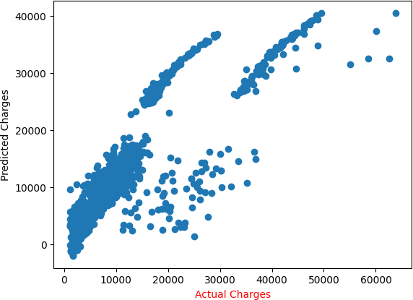

In [27]:
# Plot 'ytrain' using '*'
#plt.scatter(ytrain, ytrain, marker='*', label='Actual Charges', color='blue # Plot 'y_pred_train' using '+'
plt.scatter(ytrain, y_pred_train, marker='*', label='Predicted Charges', col plt.xlabel('Actual Charges')
plt.ylabel('Predicted Charges') plt.title('Actual vs Predicted Charges')
# Add legend to differentiate between actual and predicted charges
plt.legend() plt.show()

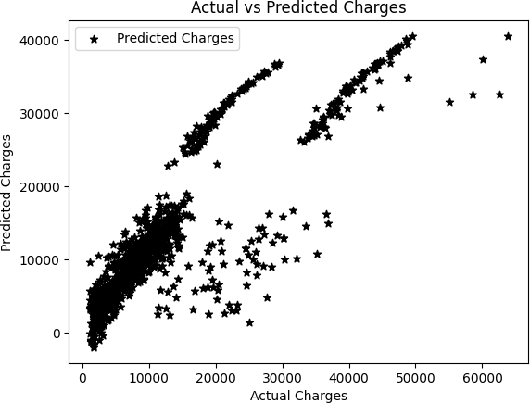

In [28]:
from sklearn.metrics import r2_score r2_score (ytrain, y_pred_train)

Out[28]: 0.7306840408360217

In [29]:
y_pred_test = lr.predict(xtest)

In [30]:
# Plot 'ytest' using '*'
#plt.scatter(ytest, ytest, marker='*', label='Actual Charges', color='blue') # Plot 'y_pred_train' using '+'
plt.scatter(ytest, y_pred_test, marker='*', label='Predicted Charges', color plt.xlabel('Actual Charges')
plt.ylabel('Predicted Charges') plt.title('Actual vs Predicted Charges')
# Add legend to differentiate between actual and predicted charges
plt.legend() plt.show()

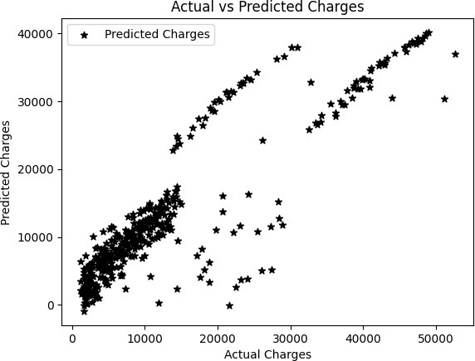

In [31]:
r2_score (ytest, y_pred_test)

Out[31]: 0.7911113876316933

In [32]:
# Create scatter plot

plt.scatter(ytrain, ytrain, marker='*', label='ytrain', color='blue') # ytra plt.scatter(ytrain, y_pred_train, marker='+', label='y_pred_train', color='r # Add labels and legend
plt.xlabel('Actaul Charges') plt.ylabel('Predicted Charges')
plt.title('Scatter plot of ytrain and y_pred_train') plt.legend()
# Show plot
plt.show()

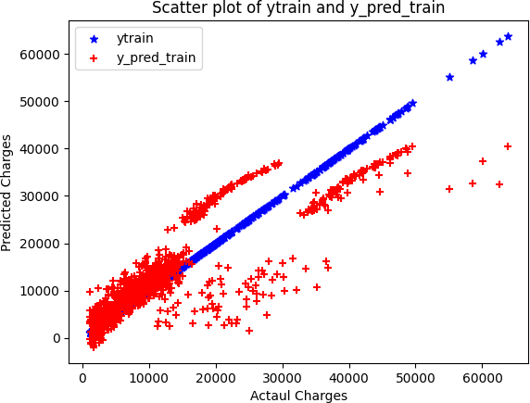

In [33]:
# Create scatter plot
plt.scatter(ytest, ytest, marker='*', label='ytest', color='blue') # ytrain plt.scatter(ytest, y_pred_test, marker='+', label='y_pred_test', color='red' # Add labels and legend
plt.xlabel('Actaul Charges') plt.ylabel('Predicted Charges')
plt.title('Scatter plot of ytest and y_pred_test') plt.legend()
# Show plot
plt.show()

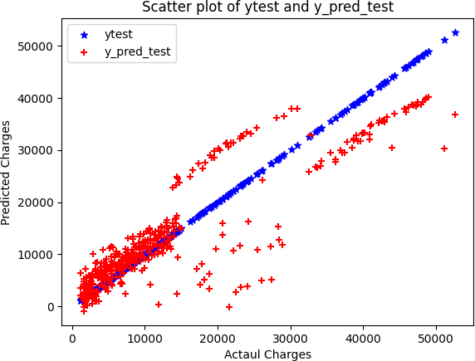

In [ ]:

This notebook was converted with convert.ploomber.io

