In [1]:
# Importing necessary libraries
import pandas as pd
from sklearn.model_selection import train_test_split
from sklearn.tree import DecisionTreeClassifier
from sklearn.preprocessing import LabelEncoder
from sklearn.metrics import accuracy_score, confusion_matrix,ConfusionMatrix

In [2]:
# Load the dataset
data = pd.read_csv('DT.csv')

In [3]:
data
 | Day | Outlook | Temp | Humidity | Wind | PlayTennis | Unnamed: 6
0 | D1 | sunny | hot | high | weak | No | NaN
1 | D2 | sunny | hot | high | strong | No | NaN
2 | D3 | overcast | hot | high | weak | Yes | NaN
3 | D4 | rain | mild | high | weak | Yes | NaN
4 | D5 | rain | cold | normal | weak | Yes | NaN
5 | D6 | rain | cold | normal | strong | No | NaN
6 | D7 | overcast | cold | normal | strong | Yes | NaN
7 | D8, | sunny | mild | high | weak | No | NaN
8 | D9 | sunny | cold | normal | weak | Yes | NaN
9 | D10 | rain | mild | normal | weak | Yes | NaN
10 | D11 | sunny | mild | normal | strong | Yes | NaN
11 | D12 | overcast | mild | high | strong | Yes | NaN
12 | D13 | overcast | hot | normal | weak | Yes | NaN
13 | D14 | rain | mild | high | strong | No | NaN
14 | D15 | sunny | hot | normal | weak | No | NaN

Out[3]:

In [5]:
# Encoding categorical variables
label_encoders = {}

# Remove the 'Unnamed: 6' column
data = data.drop('Unnamed: 6', axis=1)

for column in data.columns[1:]: # Ignore 'Day' as it’s an identifier
le = LabelEncoder()
data[column] = le.fit_transform(data[column]) label_encoders[column] = le

In [6]:
# Splitting data into features (X) and target (y)
X = data.drop(['Day', 'PlayTennis'], axis=1) # Features

y = data['PlayTennis'] # Target

# Splitting into training and testing sets
X_train, X_test, y_train, y_test = train_test_split(X, y, test_size=0.25, ra

In [7]:
# Separating features and target variable
X = data[['Outlook', 'Temp', 'Humidity', 'Wind']] # Feature columns
y = data['PlayTennis'] # Target column

In [8]:
# Split the data into training and testing sets
X_train, X_test, y_train, y_test = train_test_split(X, y, test_size=0.2,rand

In [9]:
# Train the Decision Tree classifier
model = DecisionTreeClassifier(random_state=42) model.fit(X_train, y_train)
# Make predictions on the test set
y_pred = model.predict(X_test)

In [10]:
y_pred

Out[10]:

In [11]:

Out[11]:
array([1, 1, 0])

y_test
PlayTennis

9 1

11 1
0 0

dtype: int64

In [12]:
# Calculate and print accuracy
accuracy = accuracy_score(y_test, y_pred) print("Model accuracy:", accuracy)

Model accuracy: 1.0

In [14]:
# Display confusion matrix
conf_matrix = confusion_matrix(y_test, y_pred) print("\nConfusion Matrix:") print(conf_matrix)
ConfusionMatrixDisplay.from_predictions(y_test, y_pred,display_labels=label_

Out[14]:
Confusion Matrix:
[[1 0]
[0 2]]
<sklearn.metrics._plot.confusion_matrix.ConfusionMatrixDisplay at 0x7f628e8 091c0>

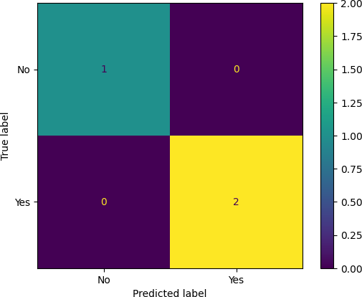

In [16]:
# Show actual vs predicted values for each test sample
print("\nActual vs Predicted:")
for actual, predicted in zip(y_test, y_pred):
print(f"Actual: {label_encoders['PlayTennis'].inverse_transform([actual] f"Predicted: {label_encoders['PlayTennis'].inverse_transform([pred

Actual vs Predicted: Actual: Yes, Predicted: Yes Actual: Yes, Predicted: Yes Actual: No, Predicted: No

In [17]:
# Example prediction for new input {rain, mild, high, strong}
input_data = pd.DataFrame({
'Outlook': [label_encoders['Outlook'].transform(['rain'])[0]],
'Temp': [label_encoders['Temp'].transform(['mild'])[0]],
'Humidity': [label_encoders['Humidity'].transform(['high'])[0]],
'Wind': [label_encoders['Wind'].transform(['strong'])[0]]
})

In [19]:
# Predict whether to play tennis
prediction = model.predict(input_data)
result = label_encoders['PlayTennis'].inverse_transform(prediction) print("\nPrediction for input {rain, mild, high, strong}: Play Tennis =",res

Prediction for input {rain, mild, high, strong}: Play Tennis = No

In [ ]:

This notebook was converted with convert.ploomber.io

