In [1]:

In [2]:

In [3]:

Out[3]:

In [5]:

In [6]:
df
import pandas as pd import numpy as np import seaborn
import matplotlib.pyplot as plt
df= pd.read_csv('Mall_Customers.csv')
df

 | CustomerID | Gender | Age | Annual Income  (k$) | Spending Score (1-  100)
0 | 1 | Male | 19 | 15 | 39
1 | 2 | Male | 21 | 15 | 81
2 | 3 | Female | 20 | 16 | 6
3 | 4 | Female | 23 | 16 | 77
4 | 5 | Female | 31 | 17 | 40
... | ... | ... | ... | ... | ...
195 | 196 | Female | 35 | 120 | 79
196 | 197 | Female | 45 | 126 | 28
197 | 198 | Male | 32 | 126 | 74
198 | 199 | Male | 32 | 137 | 18
199 | 200 | Male | 30 | 137 | 83

200 rows × 5 columns

df.rename (columns = {'Gender': 'gender', 'Age': 'age', 'Annual Income (k$)'

Out[6]: | CustomerID | gender | age | income | score
 | 0 1 | Male | 19 | 15 | 39
 | 1 2 | Male | 21 | 15 | 81
 | 2 3 | Female | 20 | 16 | 6
 | 3 4 | Female | 23 | 16 | 77
 | 4 5 | Female | 31 | 17 | 40
 | ... ... | ... | ... | ... | ...
 | 195 196 | Female | 35 | 120 | 79
 | 196 197 | Female | 45 | 126 | 28
 | 197 198 | Male | 32 | 126 | 74
 | 198 199 | Male | 32 | 137 | 18
 | 199 200 | Male | 30 | 137 | 83

200 rows × 5 columns

In [7]:
df.shape

Out[7]:

In [8]:

Out[8]:

In [9]:
df.describe()
(200, 5)
df.isnull().values.any()
np.False_

Out[9]: |  | CustomerID | age | income | score
 | count | 200.000000 | 200.000000 | 200.000000 | 200.000000
 | mean | 100.500000 | 38.850000 | 60.560000 | 50.200000
 | std | 57.879185 | 13.969007 | 26.264721 | 25.823522
 | min | 1.000000 | 18.000000 | 15.000000 | 1.000000
 | 25% | 50.750000 | 28.750000 | 41.500000 | 34.750000
 | 50% | 100.500000 | 36.000000 | 61.500000 | 50.000000
 | 75% | 150.250000 | 49.000000 | 78.000000 | 73.000000
 | max | 200.000000 | 70.000000 | 137.000000 | 99.000000

In [10]:
seaborn.pairplot (df[['age', 'income','score']])

Out[10]: <seaborn.axisgrid.PairGrid at 0x7eecaa808a40>

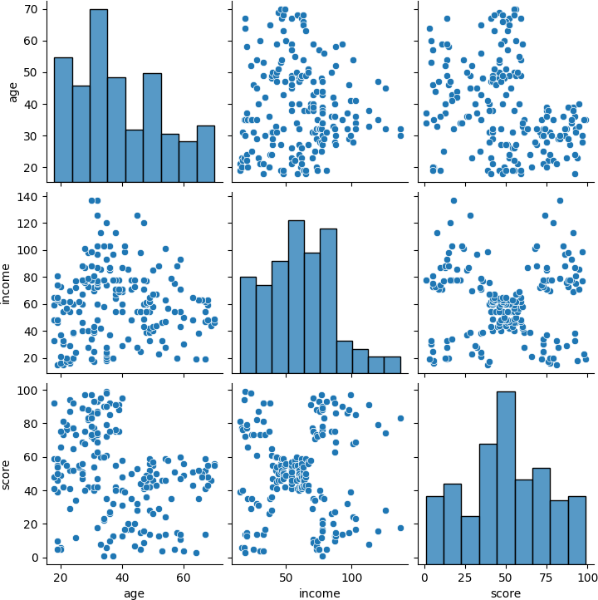

In [11]:
import sklearn.cluster as cluster

In [13]:

In [14]:
#Finding out the centroids
kmeans.cluster_centers_
kmeans = cluster.KMeans(n_clusters=5, init='k-means++', max_iter=300, n_init kmeans = kmeans.fit(df[['score','income']])

Out[14]: | array([[49.51851852, | 55.2962963 ],
 | [82.12820513, | 86.53846154],
 | [17.11428571, | 88.2 ],
 | [20.91304348, | 26.30434783],
 | [79.36363636, | 25.72727273]])

In [15]:
kmeans = kmeans.fit(df[['income','score']])

In [16]:
kmeans.cluster_centers_

Out[16]: | array([[55.2962963 , | 49.51851852],
 | [86.53846154, | 82.12820513],
 | [88.2 , | 17.11428571],
 | [26.30434783, | 20.91304348],
 | [25.72727273, | 79.36363636]])
In [17]: | df['income_clusters'] | = kmeans.labels_
In [18]: | df

Out[18]: | CustomerID | gender | age | income | score | income_clusters
 | 0 1 | Male | 19 | 15 | 39 | 3
 | 1 2 | Male | 21 | 15 | 81 | 4
 | 2 3 | Female | 20 | 16 | 6 | 3
 | 3 4 | Female | 23 | 16 | 77 | 4
 | 4 5 | Female | 31 | 17 | 40 | 3
 | ... ... | ... | ... | ... | ... | ...
 | 195 196 | Female | 35 | 120 | 79 | 1
 | 196 197 | Female | 45 | 126 | 28 | 2
 | 197 198 | Male | 32 | 126 | 74 | 1
 | 198 199 | Male | 32 | 137 | 18 | 2
 | 199 200 | Male | 30 | 137 | 83 | 1

200 rows × 6 columns

In [19]:
# counting in which cluster how many values
df['income_clusters'].value_counts()

Out[19]: | income_clusters | count
 | 0 | 81
 | 1 | 39
 | 2 | 35
 | 3 | 23
 | 4 | 22

dtype: int64

In [20]:
seaborn.scatterplot(x= 'score', y = 'income', hue= 'income_clusters', data=

Out[20]: <Axes: xlabel='score', ylabel='income'>

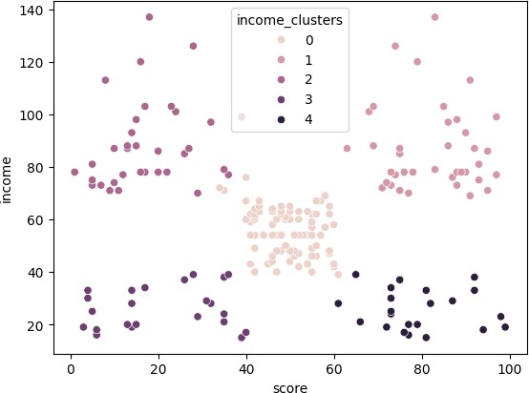

In [21]:
seaborn.scatterplot(x= 'income', y = 'score', hue= 'income_clusters', data=

Out[21]: <Axes: xlabel='income', ylabel='score'>
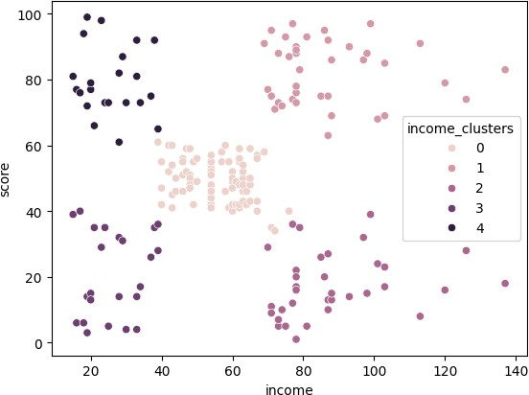

In | [22]: | #trying with 2 clusters  kmeans = cluster.KMeans(n_clusters = 2)
In | [23]: | kmeans = kmeans.fit(df[['age','score']])
In | [24]: | kmeans.cluster_centers_

Out[24]:

In [25]:

In [26]:
df
array([[28.95294118, 73.62352941],
[46.16521739, 32.88695652]])

df['age_clusters'] = kmeans.labels_

Out[26]: | CustomerID | gender | age | income | score | income_clusters | age_clusters
 | 0 1 | Male | 19 | 15 | 39 | 3 | 1
 | 1 2 | Male | 21 | 15 | 81 | 4 | 0
 | 2 3 | Female | 20 | 16 | 6 | 3 | 1
 | 3 4 | Female | 23 | 16 | 77 | 4 | 0
 | 4 5 | Female | 31 | 17 | 40 | 3 | 1
 | ... ... | ... | ... | ... | ... | ... | ...
 | 195 196 | Female | 35 | 120 | 79 | 1 | 0
 | 196 197 | Female | 45 | 126 | 28 | 2 | 1
 | 197 198 | Male | 32 | 126 | 74 | 1 | 0
 | 198 199 | Male | 32 | 137 | 18 | 2 | 1
 | 199 200 | Male | 30 | 137 | 83 | 1 | 0

200 rows × 7 columns

In [27]:
df['age_clusters'].value_counts()

Out[27]:

age_clusters
count

1 115
0 85

dtype: int64

In [28]:
df

Out[28]: | CustomerID | gender | age | income | score | income_clusters | age_clusters
 | 0 1 | Male | 19 | 15 | 39 | 3 | 1
 | 1 2 | Male | 21 | 15 | 81 | 4 | 0
 | 2 3 | Female | 20 | 16 | 6 | 3 | 1
 | 3 4 | Female | 23 | 16 | 77 | 4 | 0
 | 4 5 | Female | 31 | 17 | 40 | 3 | 1
 | ... ... | ... | ... | ... | ... | ... | ...
 | 195 196 | Female | 35 | 120 | 79 | 1 | 0
 | 196 197 | Female | 45 | 126 | 28 | 2 | 1
 | 197 198 | Male | 32 | 126 | 74 | 1 | 0
 | 198 199 | Male | 32 | 137 | 18 | 2 | 1
 | 199 200 | Male | 30 | 137 | 83 | 1 | 0

200 rows × 7 columns

In [29]:
seaborn.scatterplot(x= 'age', y = 'score', hue= 'age_clusters', data= df)

Out[29]: <Axes: xlabel='age', ylabel='score'>
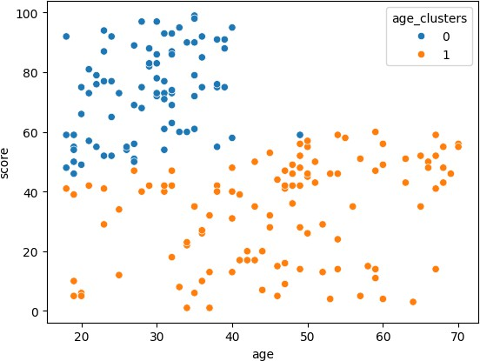

In [30]:
#from sklearn.cluster import kMeans
from sklearn.cluster import KMeans

In [31]:
# to calculate 12 clusters k_range = range(1,12) wcss = []

In [33]:

In [34]:

Out[34]:

In [35]:

Out[35]:
# implementing for loop for 12 clusters to find out wcss value for each clus # adding wcss values of clusters in wcss array
for k in k_range:
km= KMeans(n_clusters =k) km.fit(df[['income','score']]) wcss.append (km.inertia_)
wcss
[269981.28000000014,
183811.2827701642,
106348.37306211119,
73880.64496247198,
44448.45544793369,
38858.959975143895,
33350.695778415124,
30200.289692945924,
23248.1028893587,
21104.264059714787,
18548.354361671354]
plt.xlabel ('Number of Clusters(k)') plt.ylabel ('Sum of squared error') plt.plot (k_range , wcss)
[<matplotlib.lines.Line2D at 0x7eec9fd043e0>]

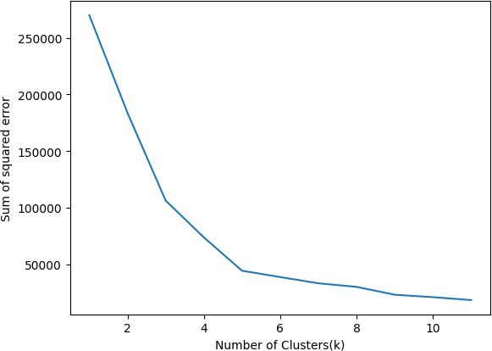

In [ ]:

This notebook was converted with convert.ploomber.io

