In [1]:
# Importing necessary libraries
import pandas as pd
from sklearn.model_selection import train_test_split
from sklearn.tree import DecisionTreeClassifier
from sklearn.preprocessing import LabelEncoder
from sklearn.metrics import accuracy_score, confusion_matrix,ConfusionMatrix

In [2]:
# Load the dataset
data = pd.read_csv('New_DT.csv')

In [3]:
data

Out[3]: |  | Day | Outlook | Temp | Humidity | Wind | PlayTennis
 | 0 | N1 | sunny | hot | normal | strong | Yes
 | 1 | N2 | sunny | hot | normal | strong | No
 | 2 | N3 | rain | cold | normal | strong | No
 | 3 | N4 | sunny | cold | high | strong | Yes
 | 4 | N5 | overcast | cold | high | weak | Yes
 | 5 | N6 | overcast | cold | normal | strong | No
 | 6 | N7 | rain | cold | normal | weak | Yes
 | 7 | N8 | rain | hot | high | weak | No
 | 8 | N9 | overcast | mild | high | weak | No
 | 9 | N10 | sunny | hot | high | weak | Yes
 | 10 | N11 | overcast | hot | high | strong | Yes
 | 11 | N12 | rain | hot | normal | strong | Yes
 | 12 | N13 | rain | cold | high | strong | No
 | 13 | N14 | overcast | mild | high | weak | No
 | 14 | N15 | sunny | cold | normal | strong | No

In [5]:
# Encoding categorical variables
label_encoders = {}

for column in data.columns[1:]: # Ignore 'Day' as it’s an identifier
le = LabelEncoder()
data[column] = le.fit_transform(data[column]) label_encoders[column] = le

In [ ]:

In [6]:
# Splitting data into features (X) and target (y)
X = data.drop(['Day', 'PlayTennis'], axis=1) # Features
y = data['PlayTennis'] # Target

# Splitting into training and testing sets
X_train, X_test, y_train, y_test = train_test_split(X, y, test_size=0.25, ra

In [7]:
# Separating features and target variable
X = data[['Outlook', 'Temp', 'Humidity', 'Wind']] # Feature columns
y = data['PlayTennis'] # Target column

In [8]:
# Split the data into training and testing sets
X_train, X_test, y_train, y_test = train_test_split(X, y, test_size=0.2,rand

In [9]:
# Train the Decision Tree classifier
model = DecisionTreeClassifier(random_state=42) model.fit(X_train, y_train)
# Make predictions on the test set
y_pred = model.predict(X_test)

In [10]:
y_pred

Out[10]:

In [11]:

Out[11]:
array([1, 0, 0])

y_test
PlayTennis

9 1

11 1
0 1

dtype: int64

In [12]:
# Calculate and print accuracy
accuracy = accuracy_score(y_test, y_pred) print("Model accuracy:", accuracy)

Model accuracy: 0.3333333333333333

In [13]:
# Display confusion matrix
conf_matrix = confusion_matrix(y_test, y_pred) print("\nConfusion Matrix:") print(conf_matrix)
ConfusionMatrixDisplay.from_predictions(y_test, y_pred,display_labels=label_

Out[13]:
Confusion Matrix:
[[0 0]
[2 1]]
<sklearn.metrics._plot.confusion_matrix.ConfusionMatrixDisplay at 0x7aeae49 94fb0>

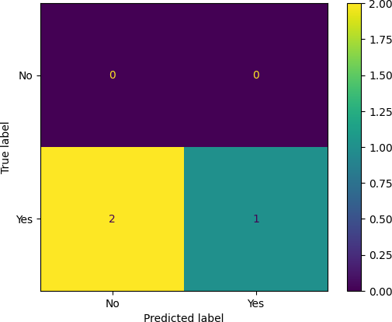

In [14]:
# Show actual vs predicted values for each test sample
print("\nActual vs Predicted:")
for actual, predicted in zip(y_test, y_pred):
print(f"Actual: {label_encoders['PlayTennis'].inverse_transform([actual] f"Predicted: {label_encoders['PlayTennis'].inverse_transform([pred

Actual vs Predicted: Actual: Yes, Predicted: Yes Actual: Yes, Predicted: No Actual: Yes, Predicted: No

In [15]:
# Example prediction for new input {rain, mild, high, strong}
input_data = pd.DataFrame({
'Outlook': [label_encoders['Outlook'].transform(['rain'])[0]],
'Temp': [label_encoders['Temp'].transform(['mild'])[0]],
'Humidity': [label_encoders['Humidity'].transform(['high'])[0]],
'Wind': [label_encoders['Wind'].transform(['strong'])[0]]
})

In [16]:
# Predict whether to play tennis
prediction = model.predict(input_data)
result = label_encoders['PlayTennis'].inverse_transform(prediction) print("\nPrediction for input {rain, mild, high, strong}: Play Tennis =",res

Prediction for input {rain, mild, high, strong}: Play Tennis = No

In [18]:
# Example prediction for new input {rain, mild, high, strong}
input_data = pd.DataFrame({
'Outlook': [label_encoders['Outlook'].transform(['sunny'])[0]],
'Temp': [label_encoders['Temp'].transform(['hot'])[0]],

'Humidity': [label_encoders['Humidity'].transform(['normal'])[0]], 'Wind': [label_encoders['Wind'].transform(['weak'])[0]]
})

In [19]:
# Predict whether to play tennis
prediction = model.predict(input_data)
result = label_encoders['PlayTennis'].inverse_transform(prediction) print("\nPrediction for input {rain, mild, high, strong}: Play Tennis =",res

Prediction for input {rain, mild, high, strong}: Play Tennis = Yes

In [ ]:

This notebook was converted with convert.ploomber.io

