lab7confusionmatrix

November 7, 2025

[1]:
import pandas as pd
import matplotlib.pyplot as plt import seaborn as sns
from sklearn.metrics import confusion_matrix , classification_report

[3]:
def plot_confusion_matrix(conf_matrix, class_names):
df_cm = pd.DataFrame(conf_matrix, index=class_names, columns=class_names) plt.figure(figsize=(8, 6))
sns.heatmap(df_cm, annot=True, fmt='d', cmap='Blues') plt.ylabel('Actual')
plt.xlabel('Predicted') plt.show()

[7]:
truth = ["Dog","Not a dog","Dog","Dog", "Dog", "Not a dog", "Not a dog", "Dog",␣
𝗌"Dog", "Not a dog"]
prediction = ["Dog","Dog", "Dog","Not a dog","Dog", "Not a dog", "Dog", "Not a␣
𝗌dog", "Dog", "Dog"]

[8]:
from sklearn.metrics import confusion_matrix
# Assuming 'truth' and 'prediction' are defined earlier in your code
cm = confusion_matrix(truth, prediction) plot_confusion_matrix(cm, ["Dog", "Not a dog"])

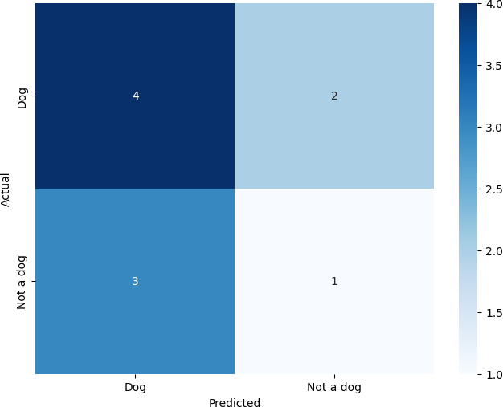

[9]:
print(classification_report(truth, prediction))

 | precision | recall | f1-score | support
Dog | 0.57 | 0.67 | 0.62 | 6
Not a dog | 0.33 | 0.25 | 0.29 | 4
accuracy |  |  | 0.50 | 10
macro avg | 0.45 | 0.46 | 0.45 | 10
weighted avg | 0.48 | 0.50 | 0.48 | 10

[10]:
2*(0.57*0.67/(0.57+0.67))
[10]: 0.6159677419354839
[11]:
2*(0.33*0.25/(0.33+0.25))
[11]: 0.2844827586206896

[ ]:

