Honorable Delegates,

The case before this year’s WASMUN International Court of Justice (ICJ) is:

Case: Whaling in the Southern Antarctic Ocean Sanctuary

It is my extreme pleasure to welcome you to this year’s session of the International Court of Justice at the 2016 Washington State Model United Nations Conference (WASMUN) held at the University of Washington. I urge all delegates to consider the cultural, historical, economic, and political factors that all play an important role in the case before the Court. In this Court, you are the advocates of your country, and some will be judges, and others agents. Enjoy researching the case!

My name is Pat Mehigan, and I will be the President/Director for the International Court of Justice. Before we have the opportunity to meet, I would like to tell you all a bit about myself. I am a senior at WSU-Vancouver, and I am a double major in Political Science and History. I have been involved with MUN for twelve years, and I have spent the last two years as the Coach/Co-advisor of the Clark College MUN program. I am excited to get to know all of you.

My name James Maltman and I am a freshman at UW planning on double majoring between History and Economics. I have been involved with Model UN for almost exactly a year, having attended five conferences with WASMUN 2015 being his first. Before that, I was heavily involved in high school debate, qualifying to state three times, and the Tournament of Champions once. I am excited to be a part of WASMUN 2016, and look forward to helping facilitate a lively, productive discussion.

The ICJ is charged with educating and developing awareness of the United Nations through local, national, and international conferences and communities. These two days affords us an occasion to work together in the ICJ and the United Nations as well as throughout the international system.

In closing, I would like to thank everyone involved and to all our delegates for making the trip to WASMUN. We will do our best to make your WASMUN experience, fun, productive, and memorable.

Best regards,

Pat Mehigan, President/Director-International Court of Justice

James Maltman, Vice President/ Assistant Director-International Court of Justice

**Case: Whaling in the Southern Antarctic Ocean Sanctuary**

Japan has been ignoring protests from activists groups such as The *Sea Sheppard*, that are against Japan’s annual whaling hunt for several years but Japan is intending to continue so again this year. Commercial whaling is banned under the International Whaling Convention (IWC), but Japan has since 1987 used a loophole to carry out "lethal research" on the creatures in the name of science. Japan has had such programmes in place since 1986, including an annual hunt in the Southern Ocean, which has been declared a whale sanctuary.[1]

While Japan maintains that annual whaling is sustainable, many anti-whaling governments and organizations are strongly against it and have called for Japan to end its practices. The organization, *Sea Sheppard* campaigns are guided by the United Nations *World Charter for Nature*. In section 1, General Principles, number 4, says; “ecosystems and organisms, as well as the land, marine and atmospheric resources that are utilized by man, shall be managed to achieve and maintain optimum sustainable productivity, but not in a way as to endanger the integrity of those species with which they coexist.”[2]

Organizations like *Sea Sheppard* and *Greenpeace* argue that whales are endangered and should be protected, though Japan continues to conduct its annual whaling practice to gather information about the status of the whale populations. Japan has said that its practices have little to no impact on the whale populations, and therefore, they should be able to continue with its research on whales. Japan has responded to the calls that the study of whales can be conducted in less brutal ways, by saying that lethal sampling is absolutely necessary.[3]

The International Whaling Commission (IWC) was established in 1946 following the creation of the *International Convention for the Regulation of Whaling (ICRW)*. The IWC purpose is to control whaling activities by setting catch limits, conducting scientific research, and regulating whaling vessels and equipment.[4]All large cetaceans are subject to the provisions of two international conventions. In 1981, the Convention on International Trade in Endangered Species (CITES) banned international trade in products of great whales by listing these species on CITES Appendix I.[5] In 1982, the International Whaling Commission (IWC) agreed to a ban on all commercial whaling. Commonly known as *the moratorium*, it was implemented in 1986. These are two of the most important conservation decisions of the 20th century, but they are continuously undermined by three commercial whaling nations: Norway, Iceland and Japan.

The adoption of *the Moratorium*, also known as *The International Convention for the Regulation of Whaling (ICRW)* came from an attempt at introducing a resolution at the annual IWC meeting held in London in 1972.[6] At this time, the resolution failed to achieve the necessary three-fourths majority vote to amend the Schedule. A resolution calling for a moratorium on commercial whaling was presented at annual meetings throughout the 1970's, but the whaling nations were sufficient in number to block the majority required to adopt the resolution. However, a significant worldwide shift occurred in the whaling industry in the 1970's and the perception of whales changed. Two main changes brought about this shift. First, the decline of the whaling industry brought significant economic changes.[7] Secondly, the political atmosphere changed drastically due to the rise of environmental and animal rights movements.

In 1994, the International Whaling Commission (IWC) declared the Southern Ocean to be a haven for whales.[8] This declaration was not an outright ban, however, as contained under Article XIII of the 1946 *International Convention for the Regulation of Whaling (ICRW)*. That “any Contracting Government may grant to any of its nationals a special permit authorizing that national to kill, take and treat whales for purposes of scientific research subject to such restrictions as to number and subject to such other conditions as the Contracting Government thinks fit, and the killing, taking, and treating of whales in accordance with the provisions of this Article shall be exempt from the operation of this Convention.”[9] It is under this exception of scientific research that Japan has claimed that its activities in the Antarctic are legitimate.[10]

[11]

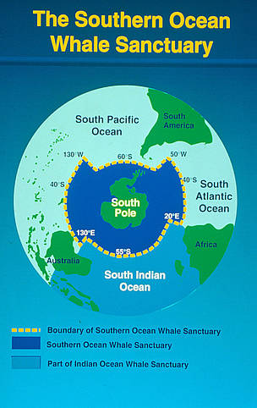[12]

The Antarctic Treaty, which was signed in Washington on December 1, 1959, was created to ensure "in the interest of all mankind that Antarctica shall continue forever to be used exclusively for peaceful purposes and shall not become the scene or object of international discord."[13] Antarctica has been designated as “a natural reserve, devoted to peace and science”. Activities are subject to regulations concerning environmental impact assessments, protection of fauna and flora, waste management, and others. Article VII of the Treaty requires each Party to freely exchange information about its activities; this requirement was later elaborated in various measures of the Antarctic Treaty Consultative Meeting and in the Environment Protocol.[14] Every year the Treaty Parties meet "for the purpose of exchanging information, consulting together on matters of common interest pertaining to Antarctica, and formulating and considering and recommending to their Governments measures in furtherance of the principles and objectives of the Treaty"[15]

The United States, Australia, New Zealand, and the Netherlands have said they were "disappointed" over Japan's annual whale hunt off Antarctica. "The Governments of Australia, the Netherlands, New Zealand, and the United States remain resolute in our opposition to commercial whaling, including so-called 'scientific' whaling, in particular in the Southern Ocean Whale Sanctuary."[16] Japan has claimed that there is a robust whale population in the world. It makes no secret of the fact that whale meat from this research ends up on dinner tables and in restaurants. Anti-whaling nations and environmentalist groups routinely condemn the activity as a cover for commercial whaling, and that its activities are a bid to revive its dwindling whaling industry. The four nations speak out at Japan's claim it is carrying out research, saying they wish to emphasize that lethal techniques are not required in modern whale conservation and management.

Australia, however, has refused to accept Japanese whaling activities as scientific, stating, “We are dealing here with the slaughter of whales, not scientific research”.[17] Australia has additionally declared a whale sanctuary around its own territory, some of which reaches into the Southern Ocean. Japan has refused to recognize this aforementioned sanctuary.[18] An IWC treaty banned commercial whaling in 1986. Nations that claim that their whaling is for scientific purposes, which includes but is not limited to Japan, are allowed to do what they wish with their catches, which includes the sale of whale meat in domestic markets. While this is not technically considered to be commercial whaling, it is opposed by a majority of nations.[19]

Japan itself sells whale meat in its own domestic markets. The Japanese government has defended this practice in two ways; first, it is not commercial because there is no profit involved in these activities. Rather, “A non-profit research institute, which carries out this research program, sells the by-product in order to cover a portion of its research costs.”[20] Secondly, the government has cited cultural reasons, such as the quote from then Prime Minster Yukio Hatoyama that “We have a tradition here in Japan of eating whale meat.” Japan has used this cultural argument to defend its activities in other ways. Claiming both that most Japanese citizens do not believe that the hunting of whales is cruel and are indifferent to the accusations of cruelty that emanate from other nations, and that cultural traditions and histories dictate that the entirety of captured whales, which includes not just the meat for consumption, is to be used for various purposes.[21]

Japan has issued statements in defense of the scientific legitimacy of their whaling. They first state that they do support the protection for whales that are endangered, such as the blue whale. However, as far as whaling in the arctic goes, they have a stated annual maximum sampling of 590 minke whales, 50 Bryde’s whales, 50 Sei whales, and 10 sperm whales.[22] Japan claims that these whales are not endangered and their activities do not pose a significant risk to any of the populations.

Prior to this case, the Japanese whale research program in the Antarctic (JARPA II) is the most recent research program permitted by the Japanese government for its Antarctic activities. The IWC has opposed the activities of JARPA II, and has issued resolutions where they stated that they believed “that the aims of JARPA II do not address critically important research needs,” and that Japan should “suspend indefinitely the lethal aspects of JARPA II conducted within the Southern Ocean Whale Sanctuary.”[23]

Australia claims that it tried to work with Japan to deal with the issue before using the International Court of Justice (ICJ), stating, “I would prefer to deal with it diplomatically.”[24] However, as no solution on the whaling issue was reached, Australia has lodged a formal diplomatic protest with the assistance of other nations, and has sent ships and aircraft to monitor Japanese ships and their activities. Australia claimed that this was done for “surveillance, not enforcement, interdiction, or intervention.”[25] From there, Japanese activities continued and the two nations reached no solution, eventually prompting Australia to bring the matter forward to the ICJ.

All Judges of the International Court of Justice shall carefully consider all aspects of this case before delivering a verdict to the Members of the Court. Decisions should be based on any evidence presented to the Court, the testimony of any witnesses, and the statements from each sides Advocates.

Bibliography

“2007 Resolutions” IWC 30 Oct 2007. Web. 29 November 2012. <http://www.iwcoffice.org/meetings/resolutions/resolution2007.htm#res1>

“A Guide to the History, Composition, Jurisdiction, Procedure, and Decisions of the Court.” <http://www.icj-cij.org/icjwww/igeneralinformation/ibbook/Bbookframepage>

“Australia considering whaling challenge.” TVNZ, 11 Dec 2009. Web. 29 November 2012. <http://tvnz.co.nz/world-news/australia-considering-whaling-challenge-3283925>

The Antarctic Treaty, 1959, *Article IX.* [www.ats,aq/](http://www.ats,aq/)

Charter of the United Nations, 1945. [www.un.org](http://www.un.org).

Farr, Malcolm and Lauren Williams. “Navy, RAAF to shadow whalers.” The Daily Telegraph, 14 Dec 2007. Web. 16 November 2012. <http://www.dailytelegraph.com.au/news/indepth/navy-raaf-to-shadow-whalers/story-e6frev90-1111115106808>.

[www.haguejusticeportal.net](http://www.haguejusticeportal.net)

International Convention for the Regulation of Whaling (ICRW), 1946.

International Court of Justice, [www.icj-cij.org](http://www.icj-cij.org).

International Whaling Commission, [www.iwc.org](http://www.iwc.org).

Japan Whaling Association, [www.whaling.jp](http://www.whaling.jp).

“The Japanese Government’s position on whaling.” n.p., n.d. Web. 16 November 2012. <http://www.melbourne.au.emb-japan.go.jp/pdf/whalinge.pdf>.

Kirby, Alex. “Whaling ban set to end.” BBC, 11 June 2000. Web. 16 November 2012. <http://news.bbc.co.uk/2/hi/science/nature/782697.stm>.

Legal information institute. <http://www.law.cornell.edu/topics/international.html>

“Nations Unite Against Japan’s Annual Whale Hunt,” *The Telegraph*, December 14, 2011.

<http://www.telegraph.co.uk/news/worldnews/asia/japan/8954985/Nations-unite-against-Japans-annual-whale-hunt.html>.

“The Position of the Japanese Government on Research Whaling.” Ministry of Foreign Affairs of Japan, 2011. Web. 16 November 2012. <http://www.mofa.go.jp/POLICY/q_a/faq6.html>.

Statute of the International Court of Justice, [www.icj-cij.org](http://www.icj-cij.org).

Rob Taylor. “Australia sends patrols to shadow Japan whalers.”The National Post, 18 Dec 2007. <http://web.archive.org/web/20071224184916/http://www.nationalpost.com/news/world/story.html?id=180665>.

Rothwell, Donald R. “Australia v. Japan: JARPA II Whaling Case before the International Court of Justice.” *The Hague Justice Portal*. The Hague Justice Portal, 2 July 2010. <http://www.haguejusticeportal.net/eCache/DEF/11/840.html>.

Taylor, Rob. “Australia sends patrols to shadow Japan whalers. “The National Post, 18 Dec 2007. Web. 16 November 2012. <http://web.archive.org/web/20071224184916/http://www.nationalpost.com/news/world/story.html?id=180665>.

United Nations, *Convention on International Trade in Endangered Species (CITES)*. <http://www.un.org>.

“Whale Sanctuaries.” IWC, 9 Jan 2009. Web. 16 November 2012. <http://www.iwcoffice.org/conservation/sanctuaries.htm>.

Willacy, Mark. “Japan vows to carry on whaling.” ABC News, 11 Dec 2009. Web. 29 November 2012. <http://www.abc.net.au/news/2009-12-11/japan-vows-to-carry-on-whaling/2586866?section=justin>.

William Aron, William Burke, and Milton M.R. Freeman, *The Whaling Issue*, 24 MARINE POL’Y 179 (2000).

World Charter for Nature, 1982. [www.un.org](http://www.un.org).

World Wildlife, 2013. <http://www.wwf.org.au/our_work/saving_the_natural_world/wildlife_and_habitats/australian_priority_species/whales/what_is_wwf_doing_to_protect_whales/whale_sanctuaries/>

**Backup Case: Alleged Violations of Sovereign Rights and Maritime Spaces in the Caribbean Sea (Nicaragua V. Colombia)**

**I: Introduction:**

On November 26, 2013, the Republic of Nicaragua filed suit against the Republic of Colombia in the International Court of Justice (ICJ). Both parties lay claim to parts of the potentially oil rich San Andres archipelago, as well as the sea around it in the Caribbean. A 2012 suit on the subject *Territorial and Maritime Dispute* (Nicaragua v. Colombia) determined that while Colombia would retain control of the archipelago, Nicaragua would gain jurisdiction over large swathes of the sea around it[26].

Colombia has since ignored this ruling, continuing to allow its fishermen to fish in the waters now deemed part of Nicaraguan territory. Nicaragua claims that its territorial waters,as determined by the 2012 suit, were violated by Colombia. Withdrawing from the Pact of Bogota, the treaty that grants the ICJ jurisdiction over disputes between American states, Colombia claims that the ICJ has no jurisdiction over the case[27].

**II: Historical context:**

Nicaragua and Colombia have long held competing claims over territorial waters. As early as the 1800’s, territorial disputes regarding the Carribean were present. In 1928, both nations signed an agreement-the Esguerra-Bárcenas treaty- settling border disputes, including determining possession of the islands of the Caribbean. However, in 1980, the Nicaraguan government retracted the treaty, claiming that it was signed under duress by the U.S and therefore not valid. A 2007 ICJ ruling overturned this retraction, granting Colombia sovereignty over the islands agreed to in the treaty[28].

A 2012 decision by the ICJ further codified the territorial possessions of each nation. According to the decision, Colombia retained control of the islands at: “Alburquerque, Bajo Nuevo, Southeast Cays, Quitasueño, Roncador, Serrana and Serranilla”. Whereas before, Colombia controlled large portions of the sea around the island chain, the court granted Nicaragua sovereignty over the sea extending 200 miles from its borders, except for a small area surrounding the island chain (Fig. 1) .This constitutes a transfer of about 30,000 square miles of territory. The transferred area contains highly valuable fishing rights, as well as possible oil reserves below the surface. Colombian fishermen claim that they have historically relied on the area for their catch, and that their livelihood is at stake[29].

In response to the ruling, Colombia in 2012 withdrew from the Pact of Bogota, claiming that all future territorial disputes should be settled by treaties, as they historically had been. In addition, they promised Colombian fishermen would have the right to access the waters they had historically fished. Seeing this as a violation of the territory they now possessed, Nicaragua again filed suit with the ICJ in 2013, this is the case that the Court will be deciding on. There has been no external intensification of aggression between the two parties, though Colombia still conducts naval patrols in what are now, according to the court, Nicaraguan waters.

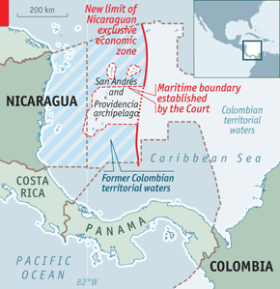

Fig. 1

**III: Nicaraguan claims**

Filed on November 26, 2013, Nicaragua’s case consists of two claims, that Colombia A: violated their territory, and B: used the threat of force to do so. The text of the Nicaraguan application states

The dispute concerns the violations of Nicaragua’s sovereign rights and maritime zones declared by the Court’s Judgment of 19 November 2012 and the threat of the use of force by Colombia in order to implement these violations.[30]

In support of their first claim, they reference official Colombian state documents, which display Nicaragua’s newly granted territory as part of Colombia’s “Integral Contiguous Zone” (Fig 2). This document shows that Colombia considers the waters between all islands of the archipelago to be part of its territory. In addition, they reference quotes by the Colombian President, including:

I repeat the decision I have made : The judgment of the International Court of Justice IS NOT APPLICABLE without a treaty.[B]ased on Colombia’s laws and taking into account clear principles of international law, by way of this decree and as recognized to us by international law, we are establishing jurisdictional and control rights over the mentioned zone.[31]

In supporting their second claim, the Nicaraguans reference other quotes by the President of Colombia, Juan Manuel Santos, as well as high ranking naval officials, ordering the Navy to protect the historic fishing rights of the inhabitants of the islands in question.

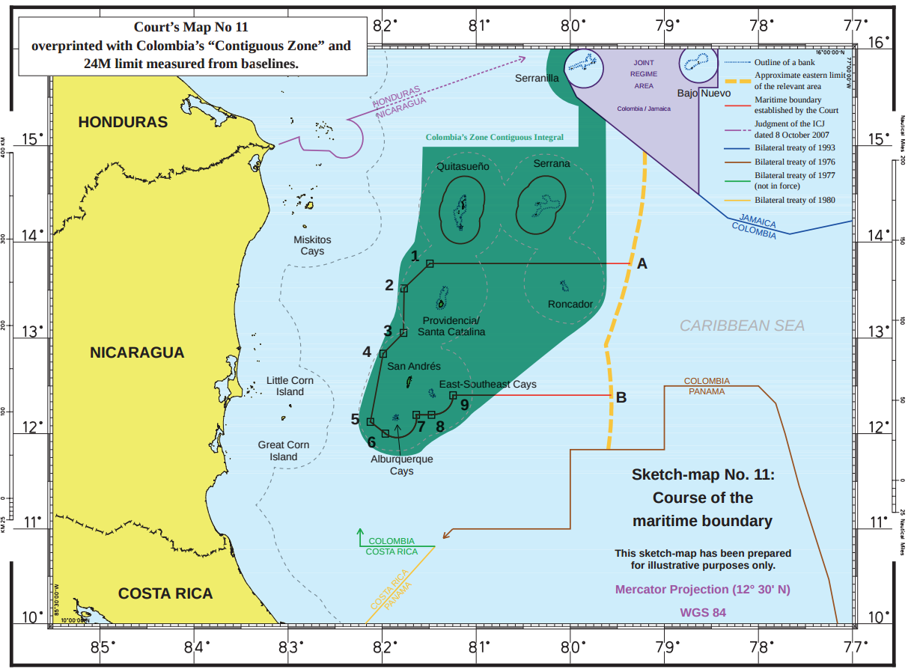

(Fig. 2)

In their appeal to the ICJ, Nicaragua argues that the ICJ has jurisdiction over the case for two reasons. First, since Nicaragua filed their case shortly before Colombia’s denunciation of the Pact of Bogota was to take effect, they argue that under article XXXI of the Pact, the court is able to adjudicate the case. The article states:

The High Contracting Parties declare that they recognize, in relation to any other American State, the jurisdiction of the [ICJ] as compulsory ipso facto, without the necessity of any special agreement so long as the present Treaty is in force, in all disputes of a juridical nature that arise among them concerning : (a) the interpretation of a treaty; (b) any question of international law; (c) the existence of any fact which, if established, would constitute the breach of an international obligation; (d) the nature or extent of the reparation to be made for the breach of an international obligation.[32]

Secondly, the Nicaraguans assert that the court’s jurisdiction lies in an inherent ability to pass judgment relating to cases that it has adjudicated in the past. Since this case is in relation to the previous court ruling, they argue that the court should be able to pass a decision.

**IV: Colombia’s Objections**

In its objections, Colombia argues both that it has not violated any ICJ ruling but also that the ICJ does not, in fact, have the jurisdiction to adjudicate the case. While Colombia states that it has not violated the ruling, and that it intends to find a method of complying, while still abiding by its own domestic policy, it provides no further comment or evidence. The crux of Colombia’s objections lie in its arguments about the jurisdiction of the court, which are five in number.

First, Colombia argues that the court lacks jurisdiction because Colombia filed its denunciation of the Pact of Bogota before the suit was filed. They interpret article LVI of the pact to mean that, while a denunciation cannot nullify any pending suits filed before the date of denunciation, no suits filed after the denunciation are valid[33].

Second, they argue that Nicaragua failed to approach Colombia with its grievances in any material manner. Therefore this would mean that there is in fact no dispute between the two nations, and that the court lacks jurisdiction, according to the claim[34].

Third, building off of the second objection, they claim that since Nicaragua failed to approach them with their grievances, article II of the Pact of Bogota was not fulfilled, which grants the court jurisdiction when “a controversy arises between two or more signatory states which, in the opinion of the parties, cannot be settled by direct negotiations through the usual diplomatic channels”. This, according to Colombia, would mean that the parties had not yet come to the conclusion that the issue could not be settled through normal channels[35].

Fourth, Colombia attempts to prove that the court has no “inherent jurisdiction” that it can utilize. They argue that the court is bound to its charter and nothing else when determining its jurisdiction over cases[36].

Fifth, building off of the fourth objection, Colombia cites multiple cases to try prove that even if the court could possibly possess some “inherent jurisdiction” it has no inherent jurisdiction over its previous rulings, or cases that relate to its previous rulings. It argues “The Court lacks jurisdiction over ‘disputes arising from non-compliance with its Judgments’”.[37]

**V: Works Cited**

"Application of Nicaragua to the ICJ." *International Court of Justice* (2013): n. pag. Web.

"Hot Waters." *The Economist*. The Economist Newspaper, 29 Nov. 2012. Web. 07 Feb. 2016.

"International Court of Justice Nicaragua V Colombia." *International Court of Justice*. N.p., n.d. Web. 07 Feb. 2016.

Organization of American States. *Pact Of Bogota*. N.p.: n.p., 1948. *Pact Of Bogota*. OAS. Web.

"Preliminary Objections of the Republic of Colombia." *International Court of Justice*. N.p., 2013. Web.

*Territorial and Maritime Dispute (Nicaragua v. Colombia): Judgment of 19 November 2012*. The Hague: International Court of Justice, 2012. Web.

1. Rothwell, Donald R. “Australia v. Japan: JARPA II Whaling Case before the International Court of Justice.” May 31, 2010. [www.haguejusticeportal.net](http://www.haguejusticeportal.net).
2. World Charter for Nature (1982).
3. Japan Whaling Association, 2012.
4. International Whaling Commission. [www.iwc.org](http://www.iwc.org).
5. United Nations, *Convention on International Trade in Endangered Species (CITES)*. <http://www.un.org>.
6. William Aron, William Burke, and Milton M.R. Freeman, *The Whaling Issue*, 24 MARINE POL’Y 179 (2000).
7. Aron, Burke, and Freeman, 2000. 187.
8. “Whale Sanctuaries.” IWC, 9 Jan 2009. Web. Nov. 16, 2012.
9. *International Convention for the Regulation of Whaling* (ICRW), 1946.
10. “The Position of the Japanese Government on Research Whaling.” Ministry of Foreign Affairs of Japan, 2011. Web. Nov 16, 2012. <http://www.mofa.go.jp/POLICY/q_a/faq6.html>.
11. <http://www.iwc.org>
12. <http://www.wwf.org.au/our_work/saving_the_natural_world/wildlife_and_habitats/australian_priority_species/whales/what_is_wwf_doing_to_protect_whales/whale_sanctuaries/>
13. The Antarctic Treaty, 1959. [www.ats.aq/](http://www.ats.aq/).
14. The Antarctic Treaty, 1959, *Article VII*. [www.ats,aq/](http://www.ats,aq/).
15. The Antarctic Treaty, 1959, *Article IX.* [www.ats,aq/](http://www.ats,aq/).
16. “Nations Unite Against Japan’s Annual Whale Hunt,” *The Telegraph*, December 14, 2011 .
17. Rob Taylor. “Australia sends patrols to shadow Japan whalers.”The National Post, 18 Dec 2007. Web. Nov. 16 2012. <http://web.archive.org/web/20071224184916/http://www.nationalpost.com/news/world/story.html?id=180665>
18. Farr, Malcolm and Lauren Williams. “Navy, RAAF to shadow whalers.” The Daily Telegraph, 14 Dec 2007. Web. Nov. 16, 2012. <http://www.dailytelegraph.com.au/news/indepth/navy-raaf-to-shadow-whalers/story-e6frev90-1111115106808>.
19. Kirby, Alex. “Whaling ban set to end.” BBC, 11 June 2000. Web. Nov. 16, 2012. <http://news.bbc.co.uk/2/hi/science/nature/782697.stm>. .
20. “The Position of the Japanese Government on Research Whaling.” Ministry of Foreign Affairs of Japan, 2011. Web. Nov. 16, 2012. <http://www.mofa.go.jp/POLICY/q_a/faq6.html>.
21. “The Japanese Government’s position on whaling.” n.p., n.d. Web. Nov. 16, 2012. <http://www.melbourne.au.emb-japan.go.jp/pdf/whalinge.pdf>.
22. “The Position of the Japanese Government on Research Whaling.”, 2012.
23. “2007 Resolutions” IWC 30 Oct 2007. Web. 29 November 2012. <http://www.iwcoffice.org/meetings/resolutions/resolution2007.htm#res1>
24. “Australia considering whaling challenge.” TVNZ, 11 Dec 2009. Web. 29 November 2012. <http://tvnz.co.nz/world-news/australia-considering-whaling-challenge-3283925>
25. Willacy, Mark. “Japan vows to carry on whaling.” ABC News, 11 Dec 2009. Web. 29 November 2012. <http://www.abc.net.au/news/2009-12-11/japan-vows-to-carry-on-whaling/2586866?section=justin>
26. *Territorial and Maritime Dispute (Nicaragua v. Colombia): Judgment of 19 November 2012*. The Hague: International Court of Justice, 2012. Web.
27. "Preliminary Objections of the Republic of Colombia." *International Court of Justice*. N.p., 2013. Web.
28. *Territorial and Maritime Dispute, 2012*
29. "Hot Waters." *The Economist*. The Economist Newspaper, 29 Nov. 2012. Web. 07 Feb. 2016.
30. "Application of Nicaragua to the ICJ." *International Court of Justice* (2013): n. pag. Web.
31. *Application of Nicaragua, 2013*
32. Organization of American States. *Pact Of Bogota*. N.p.: n.p., 1948. *Pact Of Bogota*. OAS. Web.
33. "Preliminary Objections of the Republic of Colombia." *International Court of Justice*. N.p., 2013. Web.
34. Ibid
35. Ibid
36. Ibid
37. "Preliminary Objections of the Republic of Colombia." *International Court of Justice*. N.p., 2013. Web.