Name: Ken Florencio

Student Number: 991547422

Course: SYST17796, class 1211_34537

Professor: Sivagama Srinivasan

Assignment: ICE1

Due Date: Feb 8, 2021 1:00 P.M. EST

Branch name: Ken_Florencio_ICE1

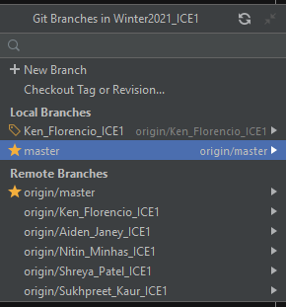

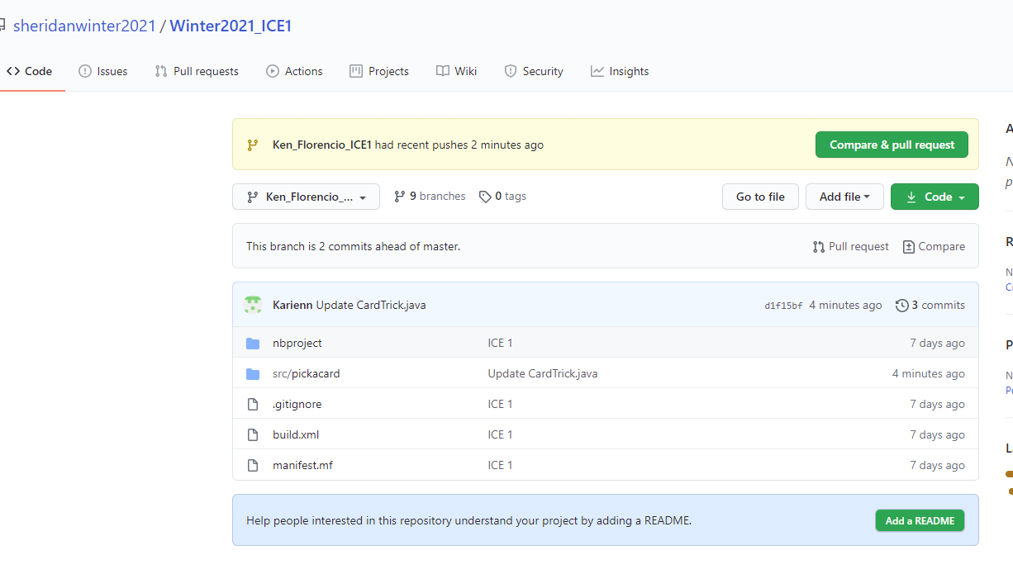

Testing wrong:

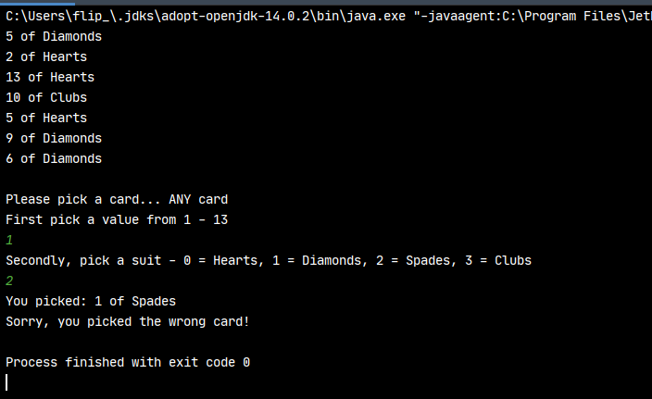

Testing right card: 