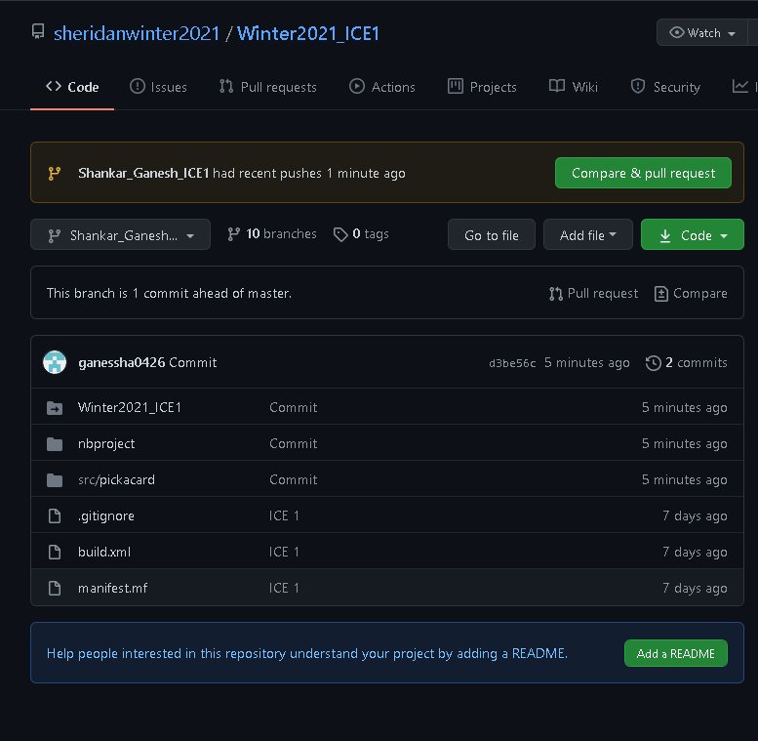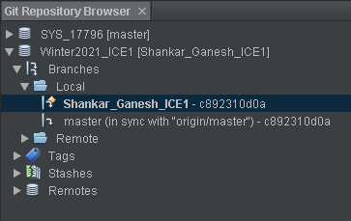Shankar Ganesh – ICE 1 – Screenshots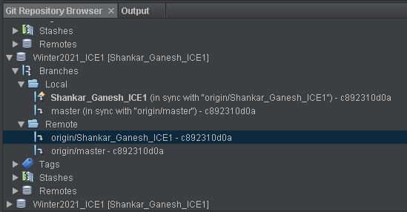

Branch Name: Shankar_Ganesh_ICE1 (<https://github.com/sheridanwinter2021/Winter2021_ICE1/tree/Shankar_Ganesh_ICE1>)