Case study

In a food delivery management system foods are delivered from a restaurant to customer’s location. A restaurant is identified by unique restaurant_id,Name, openingHour, closingHour and customer is identified by unique customer_id,name,email and contact number. Both restaurant and customer have a location which contains location_id, streetNo, house number, street name, state and city. Food is delivered by delivery staff. A delivery staff is recognized by staff_id, staff_name, mobile number and rating. A staff has only one location and a location might have many delivery staff. A restaurant belongs to many menu lists and a menu list is associated with only one restaurant. A menu list contains many orders which is identified by unique order id, total, status and a order might be associated with many menu lists. A custom can have ordered more than one. A delivery staff is assigned to more than one orders and a order is associated with only one delivery staff. A order has only one location and a location may many orders. A order is completed by only one payment. A payment is identified by payment_id,method, payable amount. A customer may write more than one review and a review is written by only one customer. A review is recognized by review_id, restaurant rating, delivery staff rating, delivery staff review, restaurant review. A review may write for a restaurant, a order and a delivery staff and all of them have many reviews.

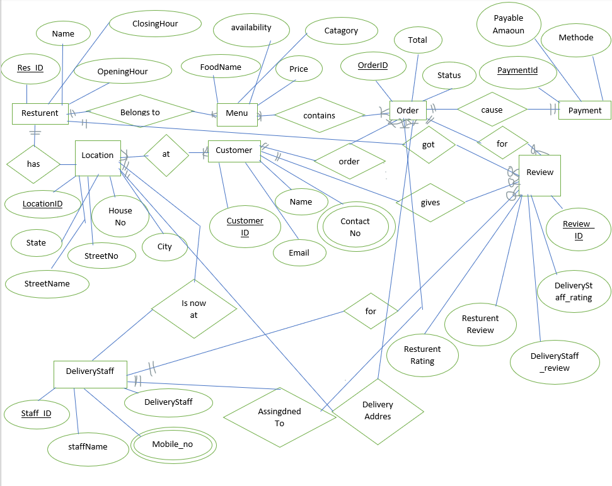

has(res.-id ,name,openinghour,closinghour,Branch-city,Branch-id,Branch-no)
1nf – no multivalued attribute
2nf – res.-id ,name,openinghour,closinghour,Branch-city,Branch-id,Branch-no
3nf – no transitive dependency
res.-id ,name,openinghour,closinghour,Branch-city,Branch-id,Branch-no
Table res.-id ,name,openinghour,closinghour,Branch-city,Branch-id,Branch-no

is at(location_id, streetNo, house number, street name, state, city, Rating, staff-id,staff-name,mobile-no)

1nf – mobile-no multivalued attribute
2nf – location_id, streetNo, house number, street name, state, city,Rating, staff-id,staff-name,mobile-no
3nf – location_id, streetNo, house number, street name, state, city,Rating, staff-id,staff-name,mobile-no
Table - location_id, streetNo, house number, street name, state, city,staff-id,staff-name,mobile-no
at(location_id, streetNo, house number, street name, state, city,customer-id,customer_name,email,contact_no)
1nf – contact_no multivalued attribute
2nf – location_id, streetNo, house number, street name, state, city,customer-id,customer_name,email,contact_no
3nf – location_id, streetNo, house number, street name, state, city,customer-id,customer_name,email,contact_no
Table location_id, streetNo, house number, street name, state, city,customer-id,customer_name,email,contact_no

gives (customer-id,customer_name,email,contact_no,restaurant_rating,review_resturant,review-id,deliverystaff_rating,review_deliverystaff)
1nf – contact_no multivalued attribute
2nf- customer-id,customer_name,email,contact_no,restaurant_rating,review_resturant,review-id,deliverystaff_rating,review_deliverystaff
3nf- no transitive dependency
customer-id,customer_name,email,contact_no,restaurant_rating,review_resturant,review-id,deliverystaff_rating,review_deliverystaff
Table- customer-id,customer_name,email,contact_no,restaurant_rating,review_resturant,review-id,deliverystaff_rating,review_deliverystaff

For(Rating, staff-id,staff-name,mobile-no, restaurant_rating,review_resturant,review-id,deliverystaff_rating,review_deliverystaff)
1nf- mobile-no multivalued attribute
2nf- Rating, staff-id,staff-name,mobile-no, restaurant_rating,review_resturant,review-id,deliverystaff_rating,review_deliverystaff
3nf- no transitive dependency
Rating, staff-id,staff-name,mobile-no, restaurant_rating,review_resturant,review-id,deliverystaff_rating,review_deliverystaff
Table- Rating, staff-id,staff-name,mobile-no, restaurant_rating,review_resturant,review-id,deliverystaff_rating,review_deliverystaff

orders(customer-id,customer_name,email,contact_no,order_id,total,status)
1nf- contract_no multivalued attribute.
2nf- customer-id,customer_name,email,contact_no,order_id,total,status
3nf- customer-id,customer_name,email,contact_no,order_id,total,status
Table- customer-id,customer_name,email,contact_no,order_id,total,status

got (res.-id ,name,openinghour,closinghour, restaurant_rating,review_resturant,review-id,deliverystaff_rating,review_deliverystaff)
1nf- no multivalued attribute
2nf- res.-id ,name,openinghour,closinghour, restaurant_rating,review_resturant,review-id,deliverystaff_rating,review_deliverystaff
3nf- no transitive dependency
res.-id ,name,openinghour,closinghour, restaurant_rating,review_resturant,review-id,deliverystaff_rating,review_deliverystaff
table- res.-id ,name,openinghour,closinghour, restaurant_rating,review_resturant,review-id,deliverystaff_rating,review_deliverystaff

belongs to (res.-id ,name,openinghour,closinghour,food_name,availability,price,category)
1nf- no multivalued attribute
2nf-res.id,name,openinghour,closinghour,food_name,availability,price,category3nf- res.-id,name,openinghour,closinghour,food_name,availability,price,category
table- res.-id ,name,openinghour,closinghour,food_name,availability,price,category

contains(food_name,availability,price,category, order_id,total,status)
1nf- no multivalued attribute
2nf- food_name,availability,price,category, order_id,total,status
3nf- no transitive dependency
food_name,availability,price,category, order_id,total,status
table- food_name,availability,price,category, order_id,total,status

causes (order_id,total,status,payment-id,method,payable_amount)
1nf- no multivalued attribute
2nf- order_id,total,status,payment-id,method,payable_amount
3nf-no transitive dependency
order_id,total,status,payment-id,method,payable_amount
table- order_id,total,status,payment-id,method,payable_amount

Total table

1. staff id, name , contactNo , rating
2. staff id,name , contactNo, rating , location id
3. Location id , houseNo, streetname ,city
4. location id, houseNo, street name, city
5. Customer id ,name, email, contactNo
6. address, location id , customer id
7. location id, houseNo, streetname, city,
8. Restaurant id, restaurantName, opening hour, closing hour , location id
9. location id , houseNo , streetname , city,
10. Order id, deliveredAt, total, status, location id
11. staff id,name, contactNo , rating
12.order id, total,status, staff id
13. staff id,name, contactNo , rating
14. review id , restaurantRating, deliverystaffRating , reviewRestaurant , reviewDeliverystaff, staff id
15. restaurant id , RestaurantName, opening hour, closing hour
16. menu id, menuName , availability , price, category, restaurant id
17. restaurant id , RestaurantName, opening hour, closing hour,
18. review id , restaurantRating, deliverystaffRating , reviewRestaurant , reviewDeliverystaff, restaurant id
19.menu id, foodName, availability, price, category,
20.order id, total, status
21.quantity, menu id, order id
23.payment id , method , payableAmount , order id
24. order id, total, status ,
25. review id , restaurantRating, deliverystaffRating , reviewRestaurant , reviewDeliverystaff, order id
26.order id, total, status ,customer id
27. Customer id , name, email, contactNo,
28. Customer id ,name, email, contactNo
29. review id , restaurantRating, deliverystaffRating , reviewRestaurant , reviewDeliverystaff, Customer id

Final table

1. staff id, name , contactNo, rating , location id
2. location id, houseNo, streetname, city
3. Customer id , name, email, contactNo
4. address, location id , customer id
5. Restaurant id, restaurantName, opening hour, closing hour , location id
6. Order id,total, status, location id
7. order id, total,status, staff id
8. order id, total, status , customer id
9. review id , restaurantRating, deliverystaffRating , reviewRestaurant , reviewDeliverystaff, staff id

10. review id , restaurantRating, deliverystaffRating , reviewRestaurant , reviewDeliverystaff, restaurant id

11. review id , restaurantRating, deliverystaffRating , reviewRestaurant , reviewDeliverystaff, order id

12. review id ,restaurantRating, deliveryStaffRating , reviewRestaurant , reviewDeliveryStaff, Customer id

13. menu id, foodName , availability , price, category, restaurant id

14. quantity, menu id, order id

15. payment id ,method , payableAmount , order

