# 

# Mini-Project Report on

# **“STUDENT ATTENDANCE MANAGEMENT SYSTEM”**

**Open Source Technology Laboratory (OSTL)/S.E./Sem IV**

**TAUSIF KHAN, PID No. EU2182013, (Roll no. 12) [Div.B] [Batch No: B1 ]**

**PARTH BHATT ,PID No. EU2182014, (Roll no. 06) [Div.B] [Batch No: B1]**

**NAVEED MERCHANT,PID No. EU2182018, (Roll no. 17) [Div.B] [Batch No: B1]**

Under the guidance of

**Ms. Nancy Nadar**

**(Assistant Professor)**



**Department of Computer Engineering**

**St. John College of Engineering and Management, Palghar**

**University of Mumbai**

2019–2020

**CERTIFICATE**

This is to certify that the S.E. Open Source Technology Laboratory (OSTL) mini-project entitled **“STUDENT ATTENDANCE MANAGEMENT SYSTEM”** is a bonafide work of

**TAUSIF KHAN, PID No. EU2182013, (Roll no. 12) [Div.B] [Batch No: B1 ]**

**PARTH BHATT ,PID No. EU2182014, (Roll no. 06) [Div.B] [Batch No: B1]**

**NAVEED MERCHANT,PID No. EU2182018 (Roll no. 17) [Div.B] [Batch No: B1]**

submitted to University of Mumbai in partial fulfilment of the requirement for the award of the degree of **“Computer Engineering”** during the academic year 2019–2020.

**Ms. Nancy Nadar**

Guide

# **S.E. OSTL Mini-Project Report Approval**

This mini-project synopsis entitled **STUDENT ATTENDANCE MANAGEMENT SYSTEM**by ***TAUSIF KHAN, PARTH BHATT, NAVEED MERCHANT*** is approved for the degree of ***Computer Engineering*** from ***University of Mumbai***.

###### **Examiners**

**Ms. Nancy Nadar**

1.---------------------------------------------

**Date :- 11/5/20**

# **Declaration**

###### We declare that this written submission represents our ideas in our own words and where others’ ideas or words have been included, we have adequately cited and referenced the original sources. We also declare that we have adhered to all principles of academic honesty and integrity and have not misrepresented or fabricated or falsified any idea/data/fact/source in our submission. We understand that any violation of the above will be cause for disciplinary action by the Institute and can also evoke penal action from the sources which have thus not been properly cited or from whom proper permission has not been taken when needed.

---------------------------------------

Signature

TAUSIF KHAN (PID No. EU2182013)

---------------------------------------

Signature

PARTH BHATT (PID No.EU2182014)

---------------------------------------

Signature

NAVEED MERCHANT (PID No.EU2182018)

**Date:- 11/5/20**

**Abstract**

Student attendance managementsystem deals with the maintenance of the student’s attendance details. It is generates the attendance of the student on basis of presence in class. It is maintained on the daily basis of their attendance. the staffs will be provided with the separate username & password to make the student’s status.

The staffs handling the particular subjects responsible to make the attendance for all students. Only if the student present on that particular period, the attendance will be calculated. The students attendance reports based on weekly and consolidate will be generated.

**Table of Contents**

|  |  |  |
| --- | --- | --- |
|  | **Abstract** | **7** |
|  | **List of Figures** | **9** |
|  | **List of Tables** | **10** |
|  | **List of Abbreviations** | **11** |
| **Chapter 1** | **Introduction** | **12** |
| **Chapter 2** | **Requirement Analysis** | **14** |
| **Chapter 3** | **Report on Present Investigation** | **15** |
| **Chapter 4** | **Implementation** | **20** |
| **Chapter 5** | **Conclusion** | **39** |

**List of Figures**

|  |  |  |
| --- | --- | --- |
| **Figure No.** | **Figure Name** | **Page No.** |
| 3.2 | System Flow Diagram | 15 |
| 3.3 | Data Flow Diagram | 16 |
| 3.4 | Entity Relationship Diagram | 18 |
| 3.5 | Use case Diagram | 19 |
|  |  |  |
|  |  |  |
|  |  |  |

**List of Tables**

|  |  |  |  |
| --- | --- | --- | --- |
| **Table No.** | **Table Name** | | **Page No.** |
| 4.2 | Login Table | | 1 |
| 4.3 | Staff details | | 2 |
| 4.4 | Student details Table | | 3 |
| 4.5 | Attendance Table | | 4 |
|  |  |
|  |  |
|  |  |
|  |  |
|  |  |
|  |  |
|  |  |
|  |  |
|  |  |
|  |  |
|  |  |
|  |  |
|  |  |
|  |  |
|  |  |
|  |  |
|  |  |
|  |  |
|  |  |
|  |  |
|  |  |
|  |  |
|  |  |
|  |  |
|  |  |
|  |  |
|  |  | |  |

**List of Abbreviations**

|  |  |
| --- | --- |
| **OSTL** | Open Source Technology Laboratory |
| **SJCEM** | St. John College of Engineering and Management |
|  |  |
|  |  |
|  |  |
|  |  |
|  |  |
|  |  |

**Chapter 1**

**Introduction**

Student attendance management system deals with the maintenance of the student’s attendance details. It is generates the attendance of the student on basis of presence in class. It is maintained on the daily basis of their attendance. The staffs will be provided with the separate username & password to make the students status.

The staffs handling the particular subjects responsible to make the attendance for all students. Only if the student present on that particular period, the attendance will be calculated. The students attendance reports based on weekly and consolidate will be generated.

College Attendance Management System is one of the important issues for most of the education institutes like school, College, classes, etc. As in our system I have used Tkinter module for Graphical User Interface or (GUI) and text files to store students data and every student data will be store in admin text files .

As in our system there will be two logins for student and admin users. As this system helps many students to give attendance in simply and fastest way and also it helps admin users to see every students attendance of a particular subject in easy and simply way.

**Chapter 2**

**Requirement Analysiss**

**Hardware specifications**

Hardware is a set of physical components, which performs the functions of applying appropriate, predefined instructions. In other words, one can say that electronic and mechanical parts of computer constitute hardware.

Hardware configuration to run the program

* Processor with 128 MB RAM

**Software Requirements:**

The software is a set of procedures of coded information or a program which when fed into the computer hardware, enables the computer to perform the various tasks. Software is like a current inside the wire, which cannot be seen but its effect can be felt.

* Operating System:- Windows XP/7/8/10
* Application Software:- Application software uses python installed and python idel.

**Chapter 3**

**Report on Present Investigation**

**(Proposed System)**

This system developed will reduce the manual work and avoid redundant data. By maintaining the attendance manually, then efficient reports cannot be generated. The system can generate efficient weekly,consolidate report based on the attendance. As the attendances are maintained in registers it has been a tough task for admin and staff to maintain for long time. Instead the software can keep long and retrieve the information when needed.

The Student Management System project is written in Python. The project file contains a python script (AMS.py). This is a simple GUI based application which is very easy to understand and use. It uses [Tkinter](https://wiki.python.org/moin/TkInter) module for the GUI. Talking about the application, the student can login with his enrollnment number and password and give attendance and they can also see his attendance records in past.

And also in this system the main role is on admin like they first login with his Username-id and password and after login the dashboard open and they able to view all students record of a particular date. So this system helps students and staff members and admin to manage and handle all data in a simple manner.

Authentication is an activity of linking an independent or an individual process on the basis of username and password which basically consists of characters, numbers, alphanumeric values, special characters etc. Most of the authentications are complex, though they seem to be boring to the users and are very hard to remember. Every one of us, use the simple textual passwords which can be easily guessed by the attacker.

**Features:**

1. Student Login
2. Admin Login
3. Admin View Record of all Students in a particular date.
4. Select the subject for attendance.
5. Student View his Record on Dashboard of every subject.

**DIAGRAMS :**

# **3.2)** **SYSTEM FLOW DIAGRAM:**

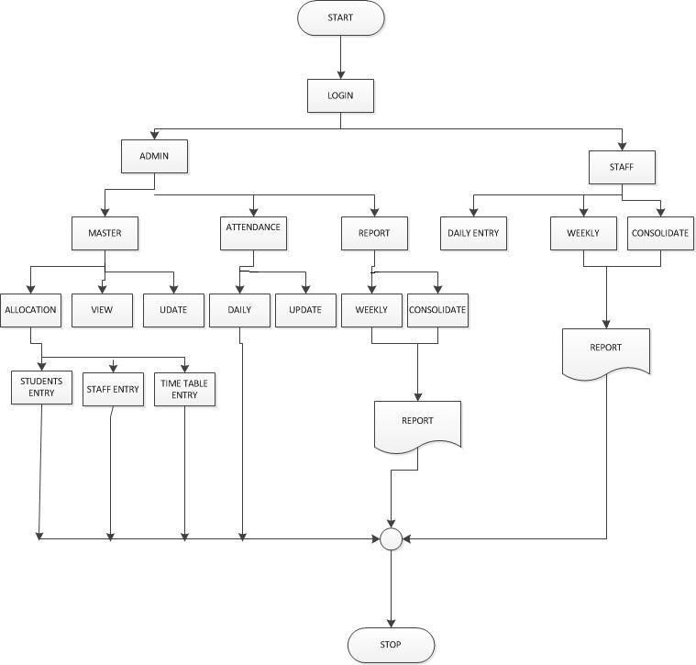

**3.3) Data Flow Diagram**

3.3.1) DFD level 0:

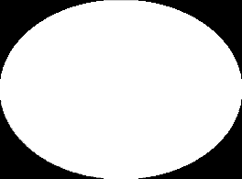

ATTANDANCE

MANAGEMENT SYSTEM

USER

REPORT

DATABASE

Figure 3.3.1-DataFlowDiagram Level0

3.3.2) DFD level 1:

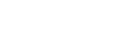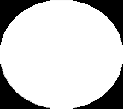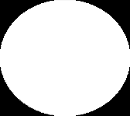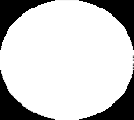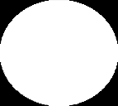

ENTRY

LOGIN

INVALID

UID / PWD

AUTHENDICAT

ION

CHECK

USER

DATABASE

ADMIN

ACCESS

STAFF

ACCESS

PERSON

Figure 3.3.2-DataFlowDiagram Level1

**3.3.3) DFD level 2:**

3.3.3.1) Admin:

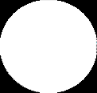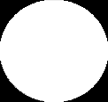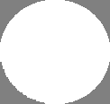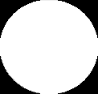

ALLOCATION

STUDENTS

Get details

contribution

VIEW

ACCESS

Stored data from

database

STAFFS

ATTANDANCE

Get details

TIME TABLE

UPDATE

REPORT

ADMIN

Stored data from

database

contribution

contribution

Stored data from

database

Get details

Figure 3.3.2.1-DataFlowDiagram Level2

**3.4) SYSTEM DESIGN:**

# 3.4.1) Entity Relationship Diagram:

*

*

*

*

*

*

Figure 3.4.1-Entity Relationship Diagram

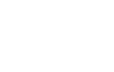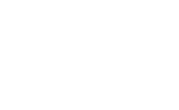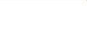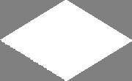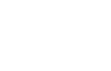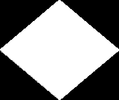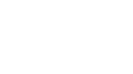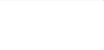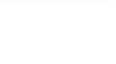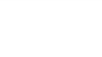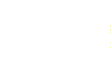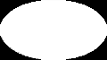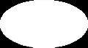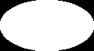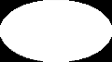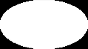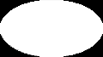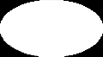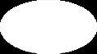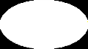

year

DoB

III IV

dept

Address

II

V

I

VI

VII

Name

mno

Rolllno

TTaabblleennaammee

day

Status

1

date

1

1

hour

Attandance *

*

subjject

Authendication

Rolll no

subjject

password

Subjject

code

Staff name

*

user

Staffs details

Attendance details

Time table

Student details

**3.5) Use case Diagram:**

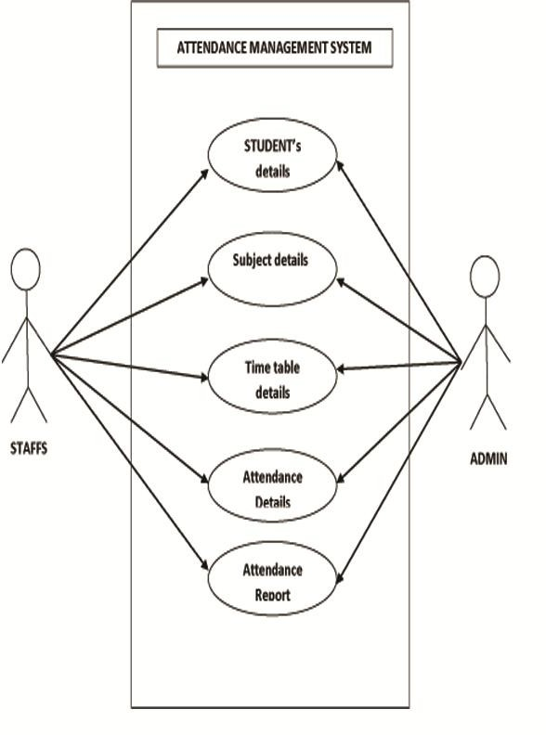

Figure:3.5 -Use case Diagram

**Chapter 4**

**Implementation**

In Student attendance management system there will be two logins for student and admin users. As this system helps many students to give attendance in simply and fastest way and also it helps admin users to see every students attendance of a particular subject in easy and simply way.

To make a simple python program for banking system

Create the following methods and perform the following operations

1. Create Bank class.
2. Create deposit,withdraw and show_balance methods.
3. Declare name and balance.
4. Create object for Bank class.
5. Calling the methods using objects.

**Source code:**

from tkinter import *

import tkinter.messagebox

import time

get=None

def record(event):

global get

a=student_username_entry.get()+'.txt'

fw=open(a,'a+')

fwt=open("admin.txt",'a+')

fw.write(" ")

fwt.write(" ")

fw.write(student_username_entry.get())

fwt.write(student_username_entry.get())

fw.write(" ")

fwt.write(" ")

fw.write('Present')

fwt.write('Present')

fw.write(" ")

fwt.write(" ")

fw.write(var2.get())

fwt.write(var2.get())

fw.write(" ")

fwt.write(" ")

fw.write(time.strftime("%H:%M:%S"))

fwt.write(time.strftime("%H:%M:%S"))

fw.write(" ")

fwt.write(" ")

fw.write(time.strftime("%Y-%m-%d"))

fwt.write(time.strftime("%Y-%m-%d"))

fw.write('\n')

fwt.write('\n')

get.destroy()

dashboard_button_1.destroy()

fw.close()

student_login_frame=None

student_password_entry=None

student_username_entry=None

def student_login():

global student_login_frame

student_login_frame = Frame(student_admin_frame, width=900, height=500, bg='black')

student_login_frame.place(x=0, y=0)

student_login_frame.tkraise()

student_icon = Label(student_login_frame, image=img15, bd=0, bg='#EBF2F8')

student_icon.place(x=370, y=10)

username_label = Label(student_login_frame, text='Username', font=('Berlin Sans FB', 16), bg='#EBF2F8')

username_label.place(x=405, y=200)

global student_username_entry

student_username_entry = Entry(student_login_frame, bg='white', relief='sunken', highlightcolor='#D2E0F1',highlightthickness=1, highlightbackground='#D8D6D7', font=('Tw Cen MT', 14))

student_username_entry.place(x=350, y=240)

password_label = Label(student_login_frame, text='Password', font=('Berlin Sans FB', 16), bg='#EBF2F8')

password_label.place(x=405, y=280)

global student_password_entry

student_password_entry = Entry(student_login_frame, bg='white', show='*', relief='sunken', highlightcolor='#D2E0F1',highlightthickness=1, highlightbackground='#D8D6D7', font=('Tw Cen MT', 14))

student_password_entry.place(x=350, y=320)

student_password_entry.bind('<Return>', authorize)

login_button = Button(student_login_frame, image=img24, bd=0, bg='#EBF2F8')

login_button.bind('<Button-1>',authorize)

login_button.place(x=357, y=380)

cancel_button = Button(student_login_frame, image=img14, bd=0, bg='#EBF2F8', command=student_exit)

cancel_button.place(x=357, y=430)

def authorize(event):

fr = open('database.txt', 'r')

flag = 0

for line in fr:

if student_username_entry.get() in line and student_password_entry.get()=='12345':

flag = 1

break

if flag == 1 and len(student_username_entry.get())==5:

student_portal()

fr.close()

def show_admin_record():

show_admin_record_frame = Frame(admin_display_frame, width=650, height=500, bd=0, bg='white')

show_admin_record_frame.place(x=0, y=0)

show_admin_record_frame.tkraise()

headings = Label(show_admin_record_frame, bg='white',text="ROLL NO STATUS SUBJECT TIME DATE")

headings.place(x=50, y=0)

heading_seperator = Label(show_admin_record_frame, image=img10, bg='white')

heading_seperator.place(x=-50, y=20)

p = Listbox(show_admin_record_frame, width=100, height=327, bd=0, bg='black', fg='white',font="Candara 12 bold")

p.place(x=0, y=50)

global L

for x in range(len(L)):

p.insert(END, L[x])

L=[]

back = Button(show_admin_record_frame, image=img20, command=admin_portal, highlightthickness=0)

back.place(x=560, y=-10)

L=[]

def authorize_admin_record():

global var3

global L

if enter_date_entry.get() != '':

fr=open("admin.txt",'r')

for line in fr:

flag=0

if enter_date_entry.get() in line and var3.get() in line:

flag=1

if flag==1:

L.append(line)

fr.close()

show_admin_record()

var3=None

enter_data_entry=None

def admin_record():

admin_record_frame=Frame(admin_display_frame, width=650, height=500,bg='#EBF2F8')

admin_record_frame.place(x=0,y=0)

enter_date_label=Label(admin_record_frame,text="Enter Today's date in yyyy-mm-dd ",font=('Berlin Sans FB',16),bg='#EBF2F8')

enter_date_label.place(x=150,y=50)

global var3

global enter_date_entry

var3 = StringVar() enter_date_entry=Entry(admin_record_frame,bg='#EBF2F8',relief='flat',highlightcolor='#D2E0F1',highlightthickness=1,highlightbackground='#D8D6D7',font=('Tw Cen MT',14))

enter_date_entry.place(x=210,y=110)

optionList = ('Python', 'AOA', 'OS','CG','M4','COA')

var3.set(optionList[0])

d_menu = OptionMenu(admin_record_frame, var3, *optionList)

d_menu.config(font=('calibri', (20)), width=320, fg='blue', image=img16, indicatoron=0, bd=0,bg='#EBF2F8')

d_menu.place(x=150, y=200) get_admin_record=Button(admin_record_frame,image=img21,command=authorize_admin_record,bd=0,bg='#EBF2F8')

get_admin_record.place(x=240,y=340)

def home():

global display_frame

display_frame = Frame(student_login_frame, width=650, height=500, bg='#EBF2F8')

display_frame.place(x=250, y=0)

display_frame.tkraise()

ned_logo = Label(display_frame, image=img3, bg='#EBF2F8')

ned_logo.place(x=-180, y=-200)

sp_logo = Label(display_frame, image=img4, bg='#EBF2F8')

sp_logo.place(x=150, y=175)

var2=None

attendance_frame=None

def takeattendance():

global attendance_frame

attendance_frame = Frame(display_frame, width=650, height=500, bg='#EBF2F8')

attendance_frame.tkraise()

attendance_frame.pack()

instruction_label=Label(attendance_frame,text="SELECT THE SUBJECT AND PRESS THE 'ATTENDANCE' LOGO",font=('Felix Titling',14,'bold'),bg='#EBF2F8')

instruction_label.place(x=20,y=100)

global var2

var2 = StringVar()

optionList = ('Python', 'AOA', 'OS','CG','M4','COA')

var2.set(optionList[0])

d_menu = OptionMenu(attendance_frame, var2, *optionList)

d_menu.config(font=('calibri', (20)), fg='blue', image=img16, indicatoron=0,bd=0)

d_menu.place(x=150,y=200)

global get

get=Button(attendance_frame,image=img17,bd=0,bg='#EBF2F8')

get.place(x=200,y=310)

get.bind("<Button-1>",record)

back = Button(attendance_frame, image=img18,command=home,bd=0,bg='#EBF2F8')

back.place(x=360, y=300)

display_frame=None

dashboard_button_1=None

def student_portal():

dashboard_frame=Frame(student_login_frame,width=250,height=500,bg='#1C2739')

dashboard_frame.place(x=0,y=0)

dashboard_frame.tkraise()

dashboard_label=Label(dashboard_frame,image=img5,bg='#1C2739')

dashboard_label.place(x=5,y=5)

divider_logo=Label(dashboard_frame,image=img9,bg='#1C2739')

divider_logo.place(x=0,y=60)

global dashboard_button_1

dashboard_button_1 = Button(dashboard_frame,image=img6,command=takeattendance,bg='#1C2739',bd=0)

dashboard_button_1.place(x=5, y=120)

dashboard_button_2 = Button(dashboard_frame, image=img7,bd=0,bg='#1C2739', command=show_student_record)

dashboard_button_2.place(x=-30, y=200)

dashboard_button_3 = Button(dashboard_frame, image=img8,bd=0,bg='#1C2739', command=student_login)

dashboard_button_3.place(x=10, y=270)

global display_frame

display_frame=Frame(student_login_frame,width=650,height=500,bg='#EBF2F8')

display_frame.place(x=250,y=0)

display_frame.tkraise()

ned_logo=Label(display_frame,image=img3,bg='#EBF2F8')

ned_logo.place(x=-180,y=-200)

instruction_label=Label(display_frame,text="Welcome To Student Portal",font=('Felix Titling',14,'bold'),bg='#EBF2F8')

instruction_label.place(x=165,y=100)

sp_logo=Label(display_frame,image=img4,bg='#EBF2F8')

sp_logo.place(x=150,y=175)

def show_student_record():

showrecord_frame=Frame(display_frame, width=650, height=500,bg='#FFFFFF')

showrecord_frame.place(x=0,y=0)

showrecord_frame.tkraise()

headings=Label(showrecord_frame,bg='white',text="ROLL NO STATUS SUBJECT TIME DATE")

headings.place(x=50,y=0)

heading_seperator=Label(showrecord_frame,image=img10,bg='white')

heading_seperator.place(x=-50,y=20)

t=student_username_entry.get()+'.txt'

try:

p = Listbox(showrecord_frame, width=100, height=327, bd=0, bg='black', fg='white', font="Candara 12 bold")

fr=open(t,'r')

line=fr.readline()

while line:

p.insert(END,line)

line=fr.readline()

p.place(x=0, y=50)

fr.close()

back = Button(showrecord_frame, image=img20, command=home,highlightthickness=0)

back.place(x=560, y=-10)

except:

tkinter.messagebox.showerror("ERROR","File is Empty")

admin_display_frame=None

def admin_portal():

admin_dashboard_frame = Frame(admin_login_frame, width=250, height=500, bg='#1C2739')

admin_dashboard_frame.place(x=0, y=0)

admin_dashboard_frame.tkraise()

dashboard_label = Label(admin_dashboard_frame, image=img5, bg='#1C2739')

dashboard_label.place(x=5, y=5)

divider_logo = Label(admin_dashboard_frame, image=img9, bg='#1C2739')

divider_logo.place(x=0, y=60)

dashboard_button_1 = Button(admin_dashboard_frame, image=img7, bd=0, bg='#1C2739', command=admin_record)

dashboard_button_1.place(x=-30, y=120)

dashboard_button_2 = Button(admin_dashboard_frame, image=img8, bd=0, bg='#1C2739', command=admin_login)

dashboard_button_2.place(x=10, y=200)

global admin_display_frame

admin_display_frame = Frame(admin_login_frame, width=650, height=500,bg='#EBF2F8')

admin_display_frame.place(x=250, y=0)

admin_display_frame.tkraise()

ned_logo = Label(admin_display_frame, image=img3,bg='#EBF2F8')

ned_logo.place(x=200, y=10)

admin_logo = Label(admin_display_frame, image=img19,bg='#EBF2F8')

admin_logo.place(x=200, y=200)

def admin_authorize(event):

if admin_username_entry.get()=='admin' and admin_password_entry.get()=='admin123':

admin_portal()

def student_exit():

main_window()

def admin_exit():

main_window()

admin_username_entry=None

admin_password_entry=None

admin_login_frame=None

def admin_login():

global admin_login_frame

admin_login_frame=Frame(student_admin_frame,width=900,height=500,bg='black')

admin_login_frame.place(x=0,y=0)

admin_login_frame.tkraise()

admin_icon=Label(admin_login_frame,image=img13,bd=0,bg='#EBF2F8')

admin_icon.place(x=370,y=10)

username_label=Label(admin_login_frame,text='Username',font=('Berlin Sans FB',16),bg='#EBF2F8')

username_label.place(x=405,y=200)

global admin_username_entry

admin_username_entry=Entry(admin_login_frame,bg='white',relief='sunken',highlightcolor='#D2E0F1',highlightthickness=1,highlightbackground='#D8D6D7',font=('Tw Cen MT',14))

admin_username_entry.place(x=350,y=240)

password_label = Label(admin_login_frame, text='Password', font=('Berlin Sans FB', 16), bg='#EBF2F8')

password_label.place(x=405, y=280)

global admin_password_entry

admin_password_entry = Entry(admin_login_frame, bg='white',show='*', relief='sunken', highlightcolor='#D2E0F1',highlightthickness=1,highlightbackground='#D8D6D7', font=('Tw Cen MT', 14))

admin_password_entry.place(x=350, y=320)

admin_password_entry.bind('<Return>',admin_authorize)

login_button=Button(admin_login_frame,image=img24,bd=0,bg='#EBF2F8')

login_button.bind('<Button-1>',admin_authorize)

login_button.place(x=357,y=380)

cancel_button=Button(admin_login_frame,image=img14,bd=0,bg='#EBF2F8',command=admin_exit)

cancel_button.place(x=357,y=430)

student_admin_frame=None

def main_window():

global student_admin_frame

student_admin_frame = Frame(root, width=900, height=500,bg="#EBF2F8")

student_admin_frame.place(x=0, y=0)

instruction_label=Label(student_admin_frame,text="Welcome To The Attendance System",font=('Felix Titling',25,'bold'),bg='Green')

instruction_label.place(x=230,y=200)

main_logo_image=Label(student_admin_frame,image=img23,bg='#EBF2F8')

main_logo_image.place(x=200,y=50)

black_button_student = Button(student_admin_frame,image=img11, bd=0, command=student_login,bg="#EBF2F8")

black_button_student.place(x=100, y=300)

black_button_teacher = Button(student_admin_frame,image=img12, bd=0, command=admin_login,bg="#EBF2F8")

black_button_teacher.place(x=500, y=300)

root=Tk()

root.geometry("900x500")

root.title("Attendance System")

img3=PhotoImage(file='ned-student-portal-logo.gif')

img4=PhotoImage(file='student_portal-logo.png')

img5=PhotoImage(file='dashboard-logo.png')

img6=PhotoImage(file='attendance-logo.png')

img7=PhotoImage(file='view-records-logo.png')

img8=PhotoImage(file='logout-logo.png')

img9=PhotoImage(file='divider-logo.png')

img10=PhotoImage(file='heading-seperator.png')

img11=PhotoImage(file='student-login1.gif')

img12=PhotoImage(file='admin-login1.gif')

img20=PhotoImage(file='back-button2.png')

img21=PhotoImage(file='show-record-button.png')

img23=PhotoImage(file='main.png')

img24=PhotoImage(file='login-button.png')

img13=PhotoImage(file='admin-icon.png')

img14=PhotoImage(file='cancel-button.png')

img15=PhotoImage(file='student-icon.png')

img16=PhotoImage(file='dropdown.png')

img17=PhotoImage(file='take-attendance.png')

img18=PhotoImage(file='back-button.png')

img19=PhotoImage(file='admin-portal-logo.png')

main_window()

root.mainloop()

**Output-**

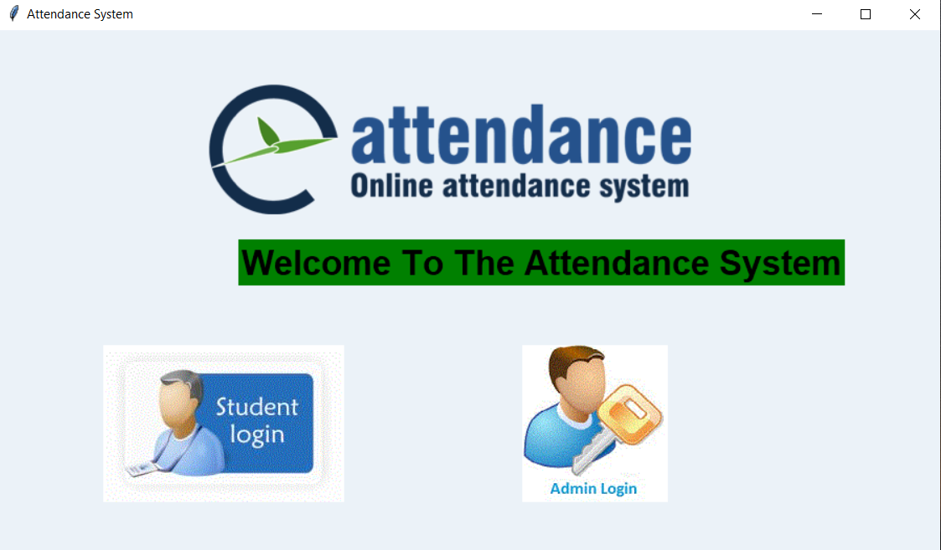

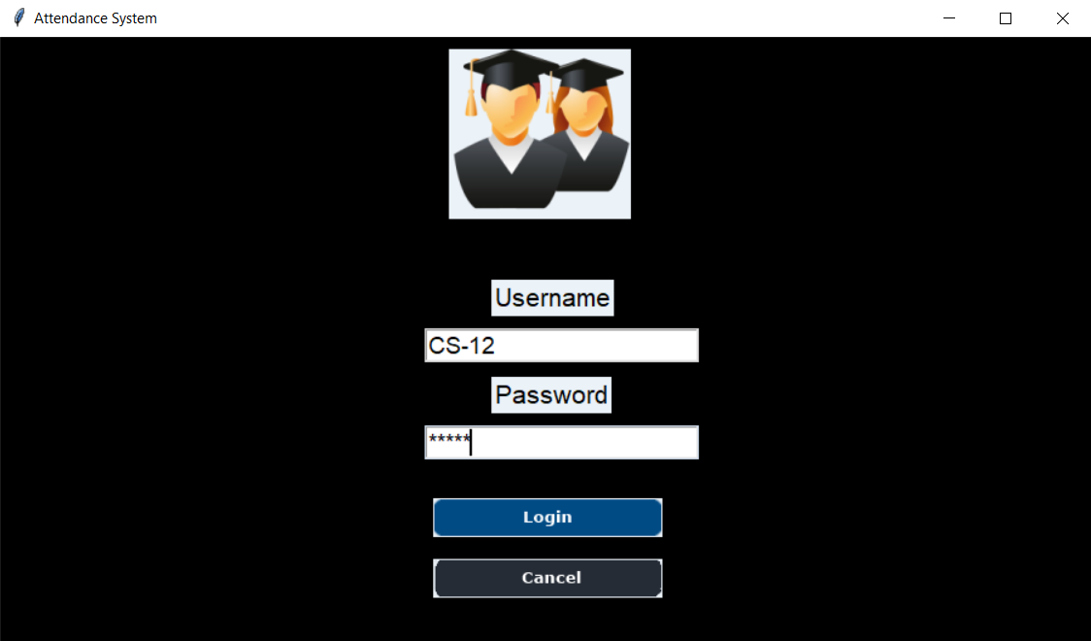

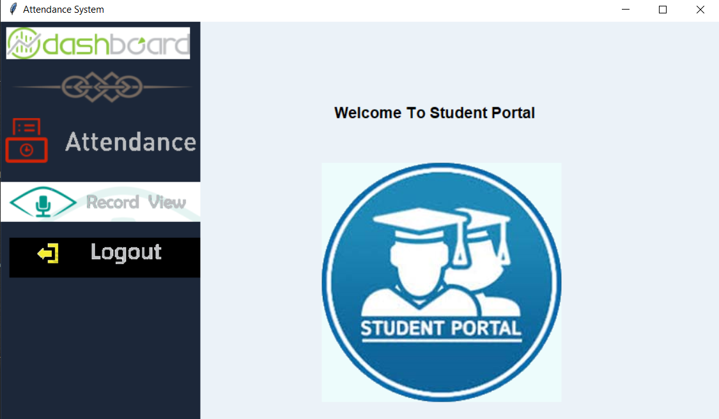

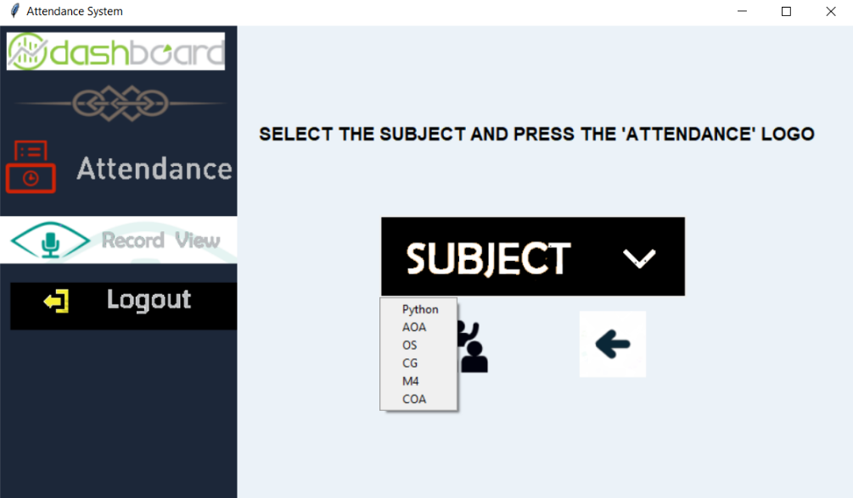

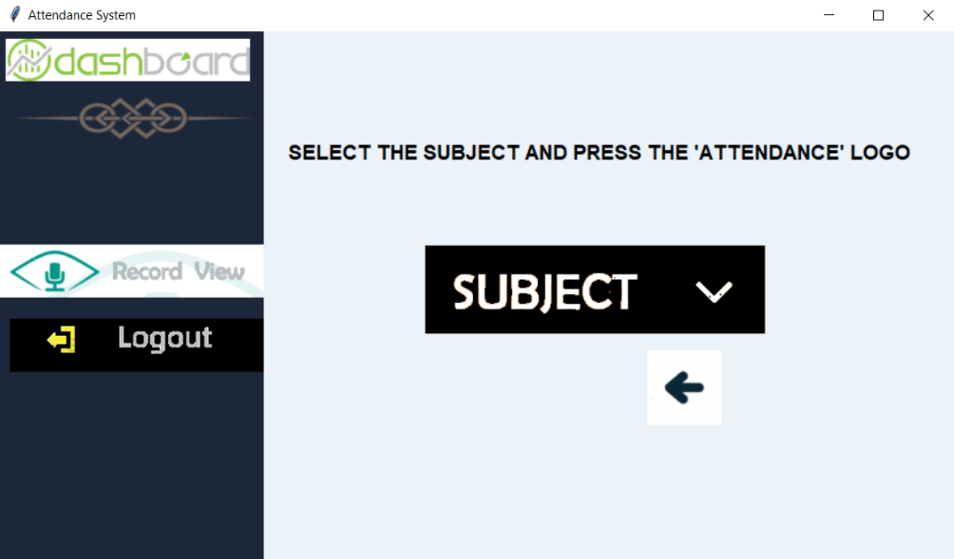

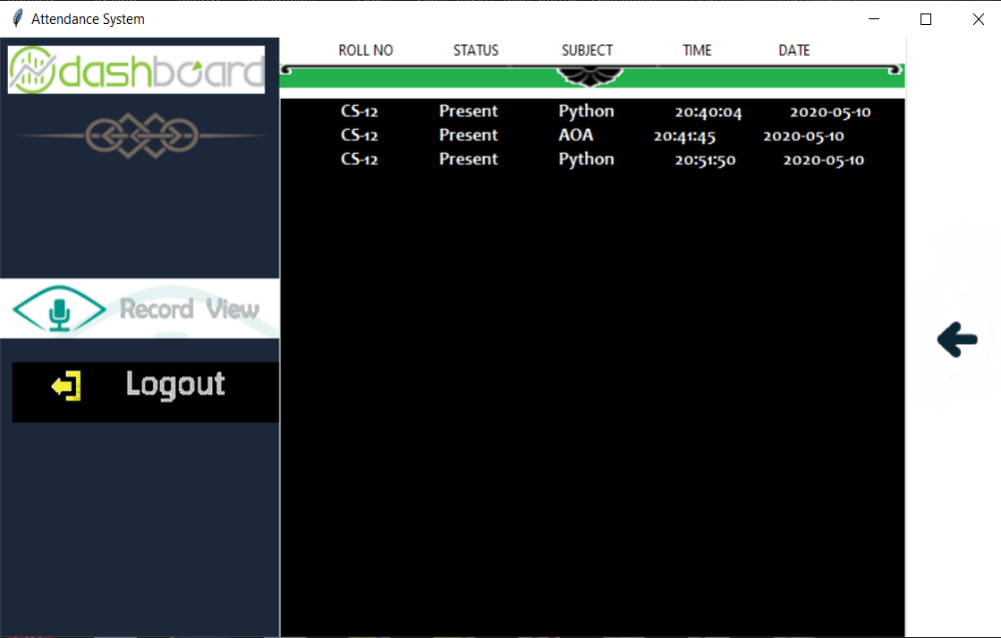

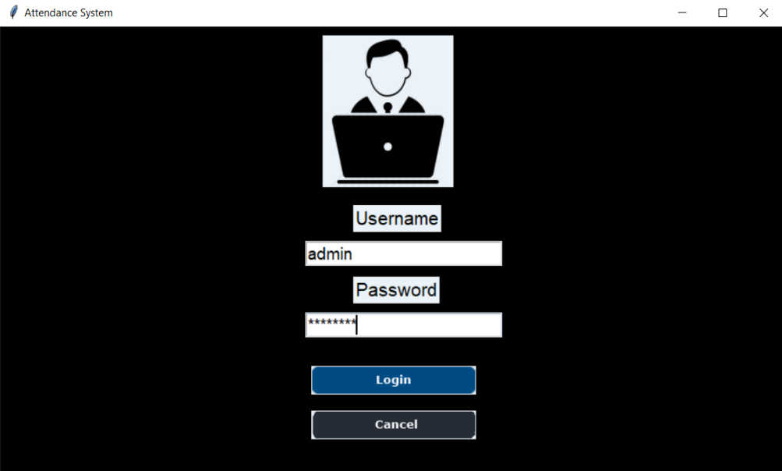

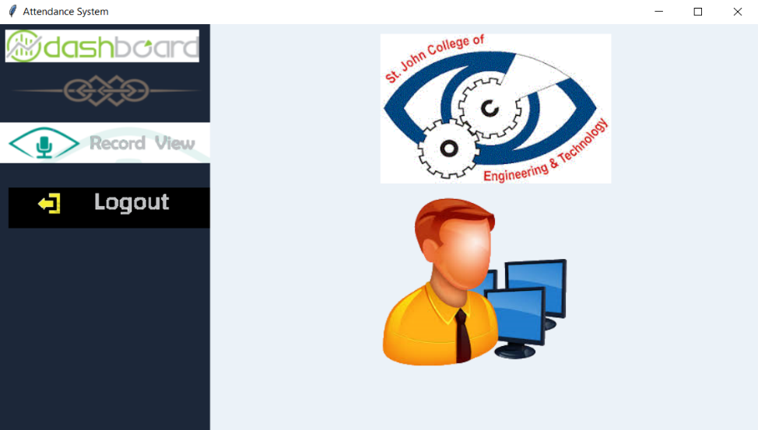

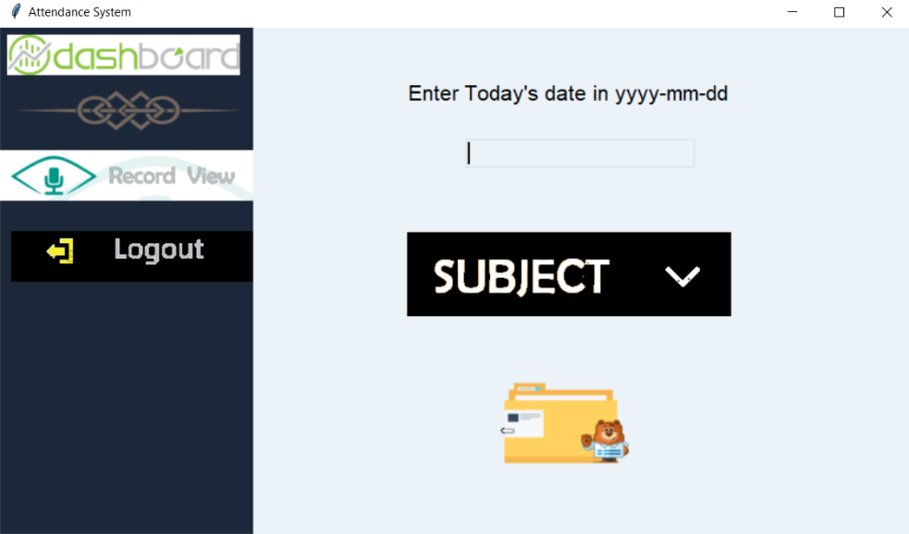

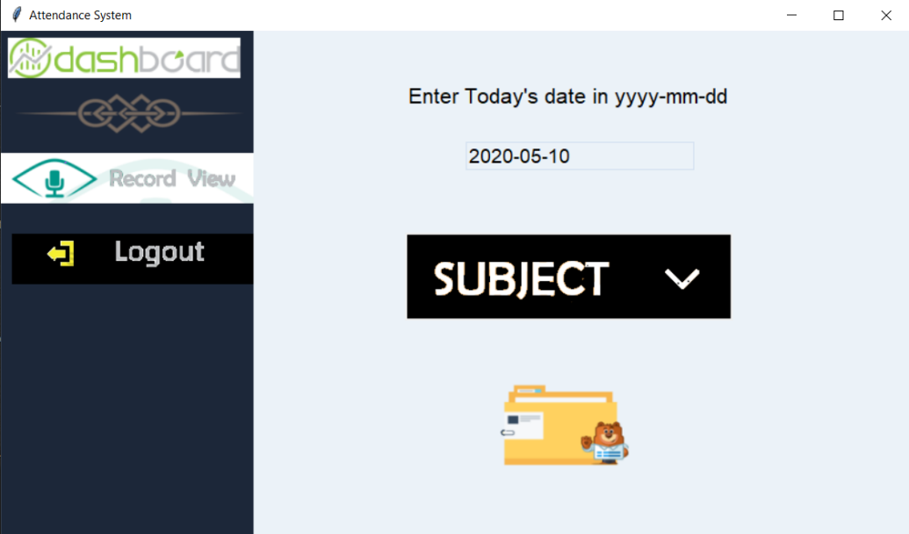

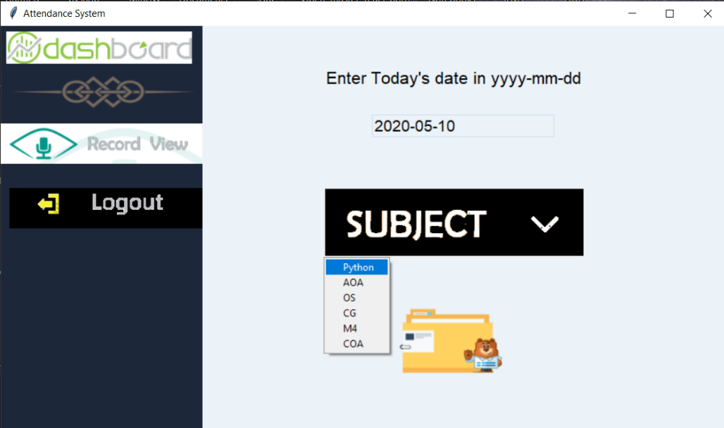

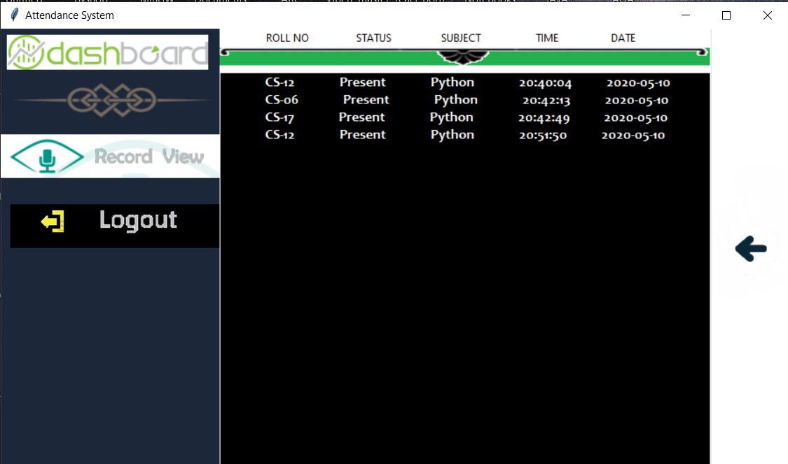

**Chapter 5**

**Conclusion**

The survey helps in building the system for automating the attendance system. It also focuses on generating monthly attendance of every student so that it is easy for teachers to analyze it and take action accordingly. With this study, we have proposed an efficient Student Attendance System to take and maintain attendance of students for all educational institutes. This proposed system along taking and viewing attendance will provide additional features i.e. making requests to teachers so that unmarked attendance can be marked. Also, there will be a provision for handovering lectures to other teachers. Thus this system will be beneficial for institute.