NAME :- TAUSIF KHAN
ROLL. NO :- 12
CLASS :- SE COMPS B

EXPERIMENT. NO : 04

AIM :- Write a program to demonstrate use of control statements in python:
- Write a program in python to implement FizzBuzz
- A python program to display even numbers between m and n (m and n are taken from user)
- Write a python program to swap two numbers and find whether the first number is positive or negative or equal to zero.
- A python program to search for an element in the list of elements (The List must be entered through keyboard.

Tools Used :- Python 3.4.3, Terminal

THEORY :- In Python we have two types of Control Statement
- Decision making
- Loops

- DECISION MAKING :-
Decision making is anticipation of conditions occurring while execution of the program and specifying actions taken according to the conditions.
Decision structures evaluate multiple expressions which produce TRUE or FALSE as outcome. You need to determine which action to take and which statements to execute if outcome is TRUE or FALSE otherwise.
Following is the general form of a typical decision making structure found in most of the programming languages –
Python programming language assumes any non-zero and non-null values as TRUE, and if it is either zero or null, then it is assumed as FALSE value.
Python programming language provides following types of decision making statements. Click the following links to check their detail.

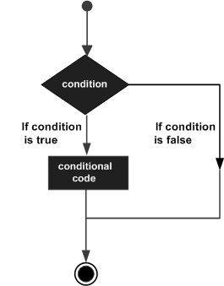

There three types of decision making statements
- If Statements :- An if statement consists of a boolean expression followed by one or more statements.
- If – else if Statements (if – elif) :- An if statement can be followed by an optional else statement, which executes when the boolean expression is FALSE.
- Nested If else :- You can use one if or else if statement inside another if or else if statement(s).

- LOOPS :-
In general, statements are executed sequentially: The first statement in a function is executed first, followed by the second, and so on. There may be a situation when you need to execute a block of code several number of times.
Programming languages provide various control structures that allow for more complicated execution paths.
A loop statement allows us to execute a statement or group of statements multiple times. The following diagram illustrates a loop statement –

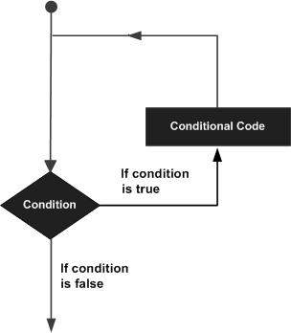

Python programming language provides following types of loops to handle looping requirements.
Python has three types of loop
- While Loop :- Repeats a statement or group of statements while a given condition is TRUE. It tests the condition before executing the loop body.
- For Loop :- Executes a sequence of statements multiple times and abbreviates the code that manages the loop variable.
- Nested Loop :- You can use one or more loop inside any another while, for or do..while loop.

CODES & OUTPUTS :-

Write a program in python to implement FizzBuzz.

CODES :-
x = int(input("Enter the starting value "))
y = int(input("Enter the ending value "))
for i in range(x,y):
if(i%3==0 and i%5==0):
print("Fizz Bizz")
elif(i%3==0):
print("Fizz")
elif(i%5==0):
print("Bizz")
else:
print(i)

'''OUTPUT:-
student@lab:~/Desktop/shreyash$ python3 numfor.py
Enter the starting value 1
Enter the ending value 50
1
2
Fizz
4
Bizz
Fizz
7
8
Fizz
Bizz
11
Fizz
13
14
Fizz Bizz
16
17
Fizz
19
Bizz
Fizz
22
23
Fizz
Bizz
26
Fizz
28
29
Fizz Bizz
31
32
Fizz
34
Bizz
Fizz
37
38
Fizz
Bizz
41
Fizz
43
44
Fizz Bizz
46
47
Fizz
49
student@lab:~/Desktop/shreyash$ '''

A python program to display even numbers between m and n (m and n are taken from user)

CODES :-
x = int(input("Enter the starting value "))
y = int(input("Enter the ending value "))
while(x<=y):
if(x%2==0):
print(x)
x=x+1

'''OUTPUT:-
student@lab:~/Desktop/shreyash$ python3 num-x-y.py
Enter the starting value 200
Enter the ending value 250
200
202
204
206
208
210
212
214
216
218
220
222
224
226
228
230
232
234
236
238
240
242
244
246
248
250
student@lab:~/Desktop/shreyash$ '''

Write a python program to swap two numbers and find whether the first number is positive or negative or equal to zero.

CODES :-
x = int(input("Enter the first number "))
y = int(input("Enter the second number "))
x,y = y,x
if(x == 0):
print("Number is neither positive nor negative")
elif(x > 0):
print("Number is a positive number")
else:
print("Number is a negative number")

'''OUTPUT :-
student@lab:~/Desktop/shreyash$ python3 swap.py
Enter the first number 3
Enter the second number -9
Number is a negative number
student@lab:~/Desktop/shreyash$ python3 swap.py
Enter the first number 4
Enter the second number 7
Number is a positive number
student@lab:~/Desktop/shreyash$'''

A python program to search for an element in the list of elements (The List must be entered through keyboard.

CODES :-
x = [int(x)for x in input(" Enter the elements of list ").split()]
y = int(input("Enter any one number "))
flag = 0
for i in x:
if(i == y):
flag =1;
if(flag ==1):
print("Entered number is present in the list ")
else:
print("Entered number is not present in the list ")

'''OUTPUT:-
student@lab:~/Desktop/shreyash$ python3 list.py
Enter the elements of list 45 78 98 34 23
Enter any one number 34
Entered number is present in the list
student@lab:~/Desktop/shreyash$ python3 list.py
Enter the elements of list 65 98 67 12 56 34 90
Enter any one number 21
Entered number is not present in the list
student@lab:~/Desktop/shreyash$ '''

CONCLUSION :-
Thus we have studied various control statements (i.e if ,if – elif, while, for) and implemented it in programs

