**128 byte Packet Size**

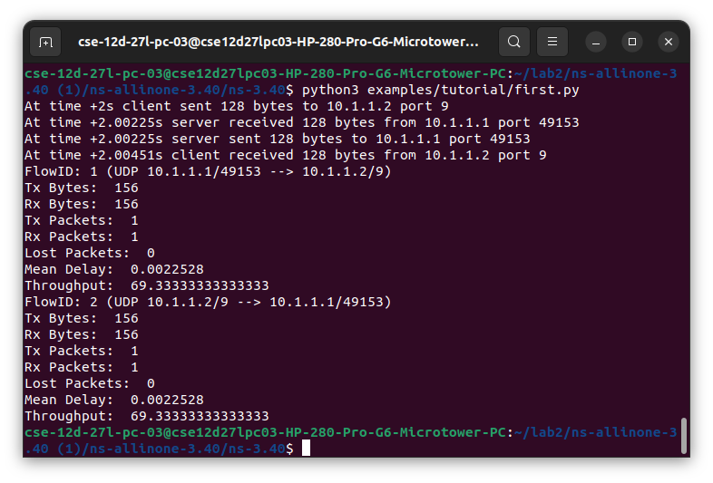

**256 byte Packet Size**

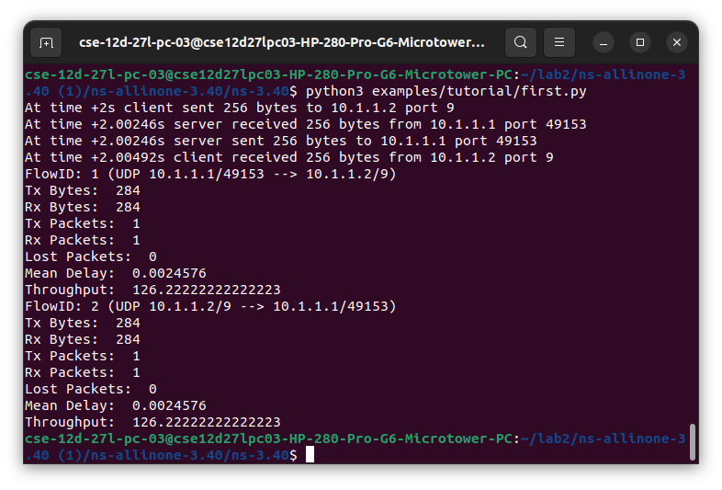

**512 byte Packet Size**

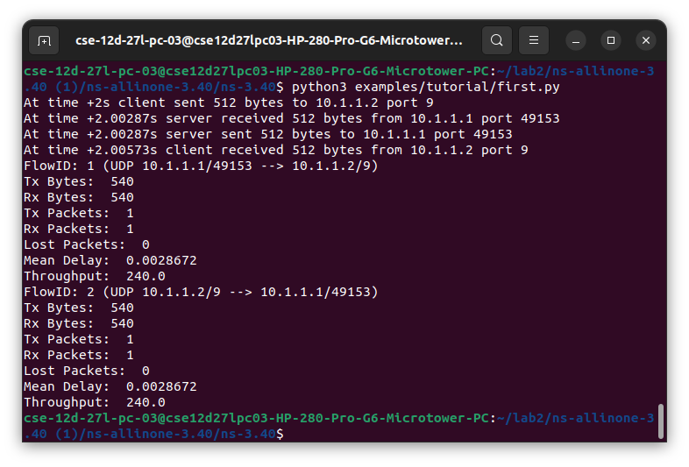

**1024 byte Packet Size**

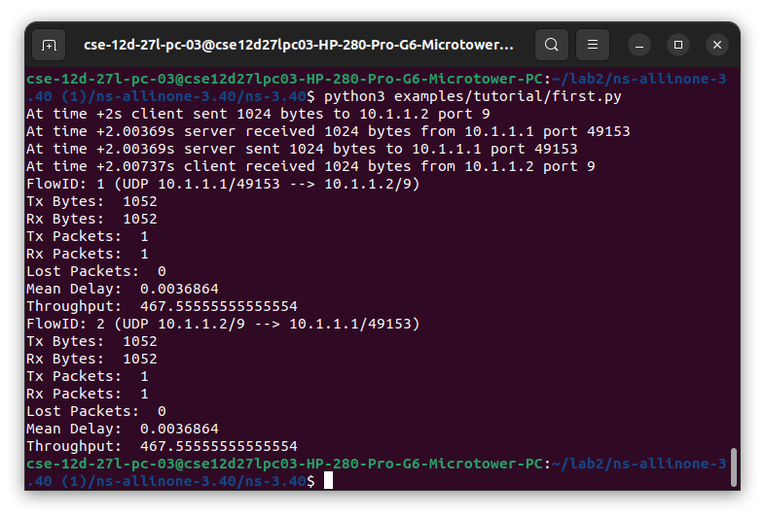

**2048 byte Packet Size**

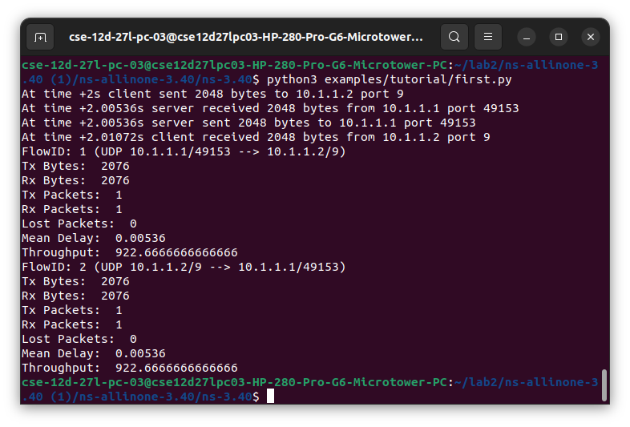

**Throughput vs Data Size graph:**

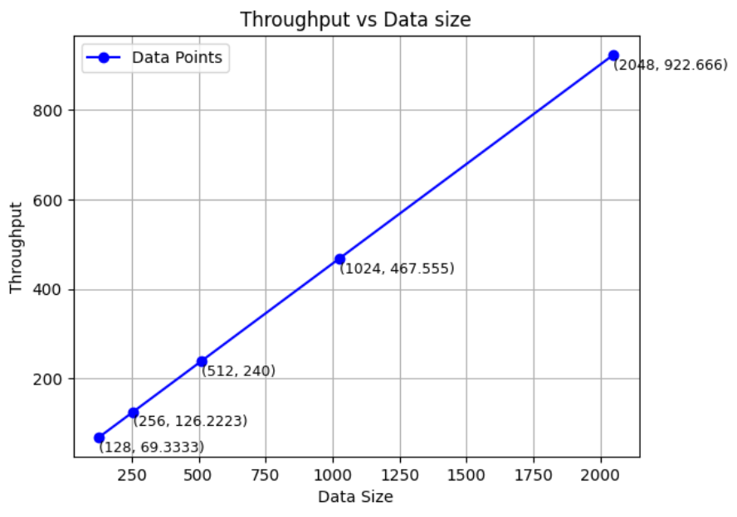

This graph illustrates the relationship between data size (x-axis) and throughput (y-axis), where throughput increases as the data size grows. The trend shows a steady rise.