**HTTP Request**

**Data Link Layer**

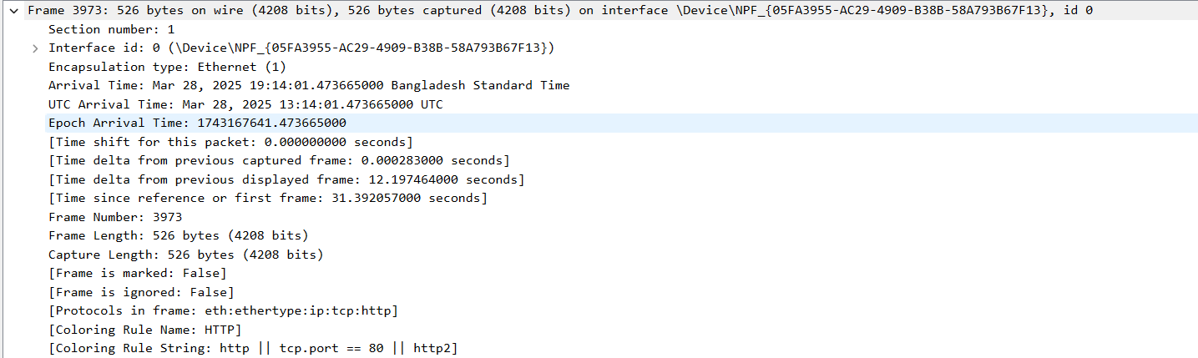

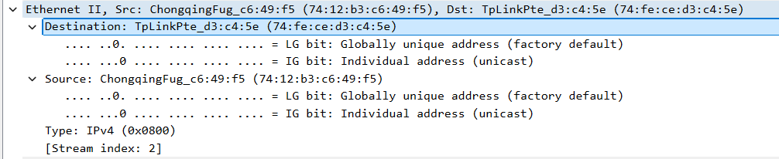

Destination MAC: (74:fe:ce:d3:c4:5e)

Source MAC: (74:12:b3:c6:49:f5)

**Network Layer**

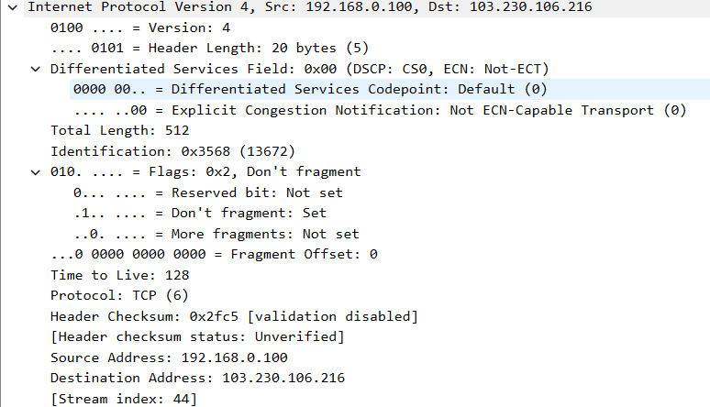

Source IP: 192.168.0.100

Destination IP: 103.230.106.216

**Transport Layer**

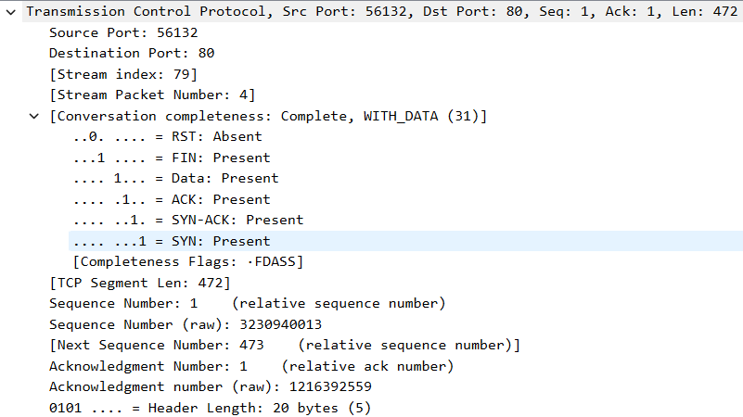

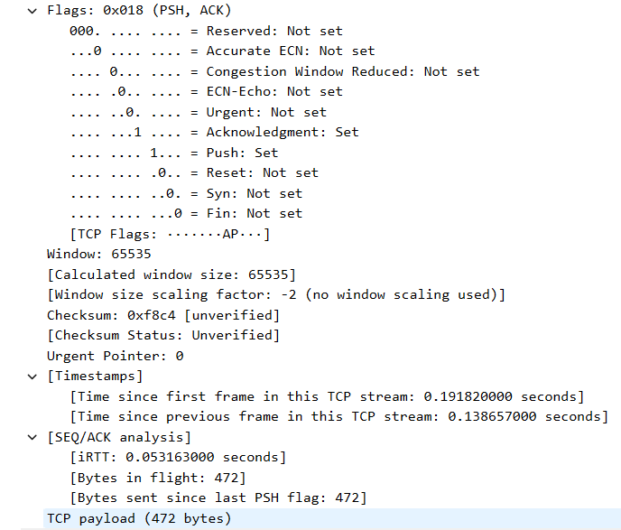

Source port: 56132

Destination port: 80

**Application Layer**

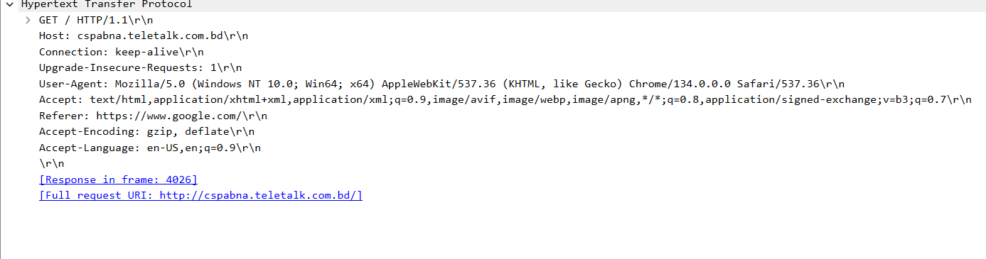

Requested URL: <http://cspabna.teletalk.com.bd/>

HTTP Version: HTTP/1.1

Language: English(US)

The connection is “keep-alive” which requests to keep the connection open for multiple requests.

User agent is using Mozilla/5.0 (Windows NT 10.0; Win64; x64) or AppleWebKit/537.36 (KHTML, like Gecko) or Chrome/134.0.0.0 or Safari/537.36

**HTTP response**

**Data Link Layer**

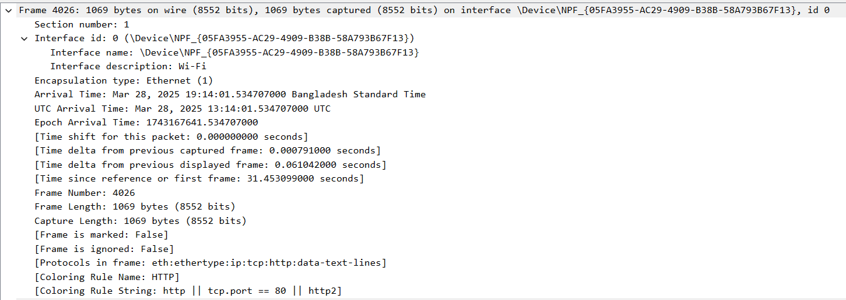

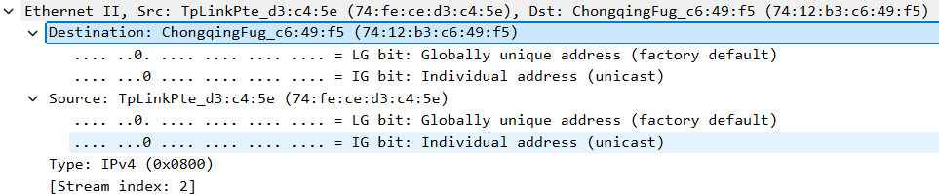

Destination MAC: (74:12:b3:c6:49:f5)

Source MAC: (74:fe:ce:d3:c4:5e)

**Network Layer**

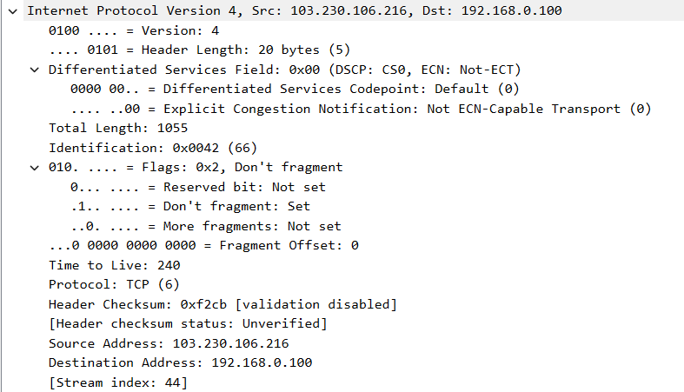

Source IP: 103.230.106.216

Destination IP: 192.168.0.100

**Transport Layer**

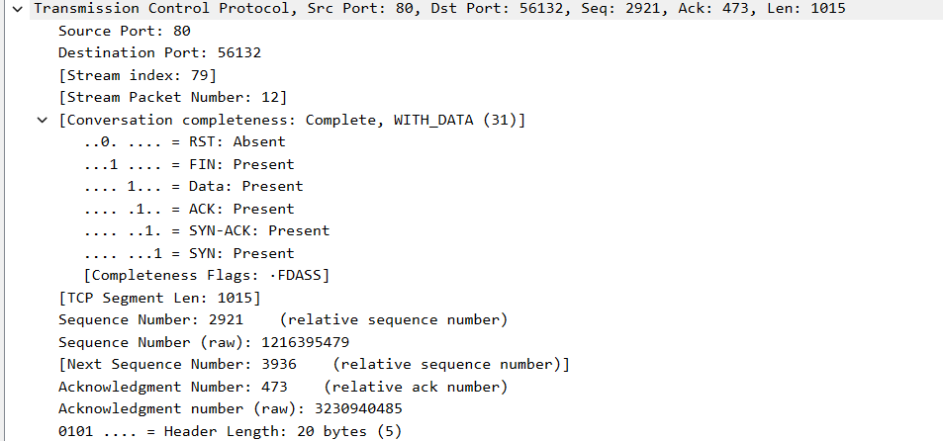

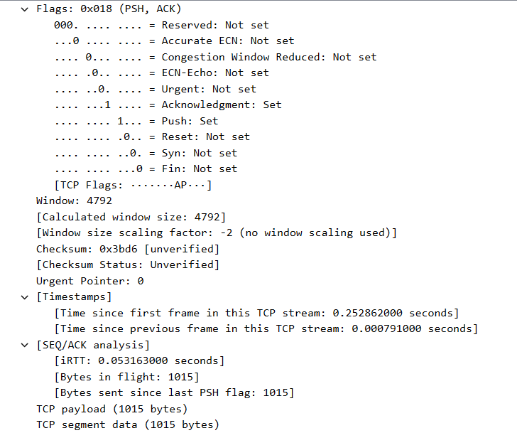

Source port: 80

Destination port: 56132

**Application Layer**

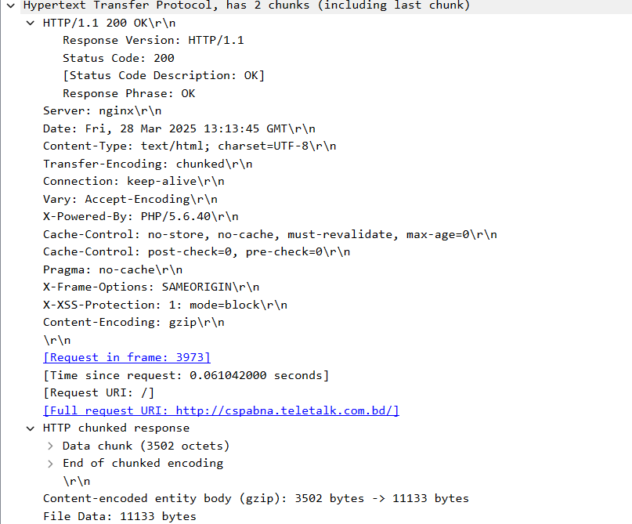

The HTTP response status 200 OK confirms a successful request. The server is nginx(web based). The response contains an HTML document in UTF-8 encoding.