Using selenium library write the Python script

<https://selenium-python.readthedocs.io/>

open the web page:

<http://www.degalukainos.lt/>

Be sure that the page is fully open. On the page from the list box

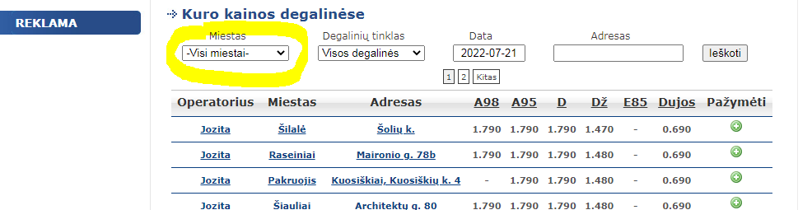

Get the Vilnius

And press the button

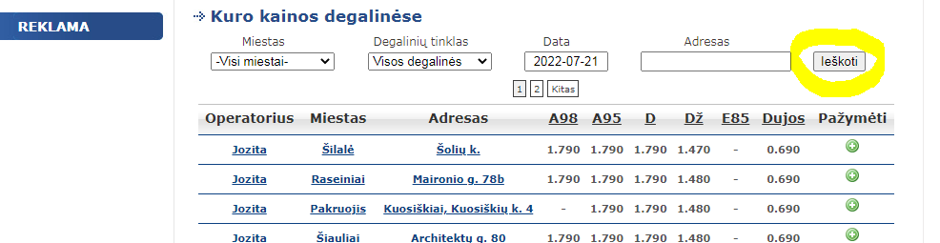

From the resulted sorted list get the address with lowest price for the A95 fuel

Open other tab in the browser.

Connect to the gmail account using filling the form from selenium

And send email to himself with the Address and the Price

Conditions:

* In the script use finding elements by XPath
* The mail credentials keep in the separate module
* Try to split the script for separate functions with returning parameters where it is possible

**Prideti PyTest**