**Pytest Tutorial**

<https://youtu.be/yA5jqNCCOLE>

<https://docs.pytest.org/en/7.1.x/getting-started.html>

<https://realpython.com/pytest-python-testing/>

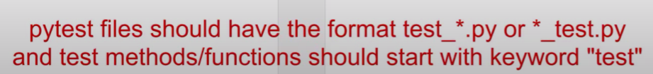

**Norint paleisti testus viename faile reikia:**

1. Run/Debug configurations -> + -> Python tests -> pytest.
2. Ir nustatyti Script path į testus. Pvz.: test_login.py

**Norint paleisti testus esancius folderyje reikia:**

1. Run/Debug configurations -> + -> Python tests -> pytest.
2. Ir nustatyti Script path į testu folderi. Pvz.: LearningPyTest. Tokiu budu per viena karta paleidziami visi TestCases esantys skirtinguose .py failuose „test_XXX.py“

Taip pat galima paleisti per komandine eilute, tai reikia buti tame folderyje ir suvesti “pytest”, tokiu budu bus paleidziami visi esantys testai.

Command Line:

…>pytest -v =output labiau detailed.

>--help =visa info

>pytest -h =visa detailed

“k” =specified the keyword, pagal kuri atrenkama kuriuos testus tik paleisti. Todel buvo paleisti testai tik su log

Markers -m

@pytest.mark.xfail

Tikimasi, jog testas nebus teisingas

@pytest.mark.skip

Skipina testa

@pytest.mark.skipif

@pytest.mark.skipif(sys.version_info < (3, 10), reason="Python version not supported")

Skipina, kai atitinka salyga.

**Fixtures**

<https://docs.pytest.org/en/7.1.x/explanation/fixtures.html>

@pytest.fixture()  
def setUp():  
 print("Launch browser")  
 print("Login")  
 print("Browse products")  
 yield #  
 print("Logoff")  
 print("Close Browser")  
def testAddItemtoCart(setUp):  
 print("Add item successful")  
def testRemoveItemtoCart(setUp):  
 print("Remove item successful")

**Confest.py**

Test configuration file

<https://docs.pytest.org/en/7.1.x/reference/fixtures.html?highlight=scope#conftest-py-sharing-fixtures-across-multiple-files>

Parametrizing Fixtures

<https://docs.pytest.org/en/7.1.x/how-to/parametrize.html#parametrize>

