
SCHOOL OF TECHNOLOGY MANAGEMENT & ENGINEERING
NMIMS, Navi Mumbai
(Academic Year 2026–2027)
VERITAS: Multi-Agent Deepfake Detection and Reasoning
Project Report submitted in the partial fulfilment
of
Bachelor of Technology (B.Tech.)
in
Artificial Intelligence & Data Science
By
Harshil Kamde (A024)
Siddhant Patil (A045)
Tavis Fernandes (A117)

Under the supervision of
Dr. Preeti Agarwal
(Faculty Mentor, STME, NMIMS)

SCHOOL OF TECHNOLOGY MANAGEMENT & ENGINEERING
NMIMS, Navi Mumbai
CERTIFICATE
This is to certify that the project entitled “VERITAS: Multi-Agent Deepfake Detection and Reasoning” has been done by Harshil Kamde (A024), Siddhant Patil (A045) and Tavis Fernandes (A117) under my guidance and supervision and has been submitted in partial fulfilment of the degree of Bachelor of Technology (B.Tech.) in Artificial Intelligence & Data Science of STME, SVKM’s NMIMS (Deemed-to-be University), Mumbai, India.

__________________________ | __________________________
Dr. Preeti Agarwal | Examiner
Project Mentor (Name and Signature) | (Name and Signature)

Date: ____________________ | __________________________
Place: Navi Mumbai | Dr. Preeti Gupta
 | Associate Dean
 | NMIMS, STME

ACKNOWLEDGEMENT
We express our sincere gratitude to our faculty mentor, Dr. Preeti Agarwal, Faculty Mentor, School of Technology Management & Engineering (STME), for the guidance, feedback and encouragement provided throughout this capstone project.
We thank the School of Technology Management & Engineering, SVKM’s NMIMS, Navi Mumbai, for the academic programme and facilities that made this work possible.
We also acknowledge the creators of the FakeAVCeleb dataset, on which the detectors in this project were trained and evaluated, and the developers of the open-source software on which VERITAS is built, including PyTorch, torchvision, FastAPI, OpenCV, FFmpeg, React and Vite.

Student Names
NAME | ROLL NO. | SAP ID | Signature
Harshil Kamde | A024
Siddhant Patil | A045
Tavis Fernandes | A117

ABSTRACT
Deepfakes are images, videos and audio recordings in which a person’s face or voice has been synthesised or altered by machine-learning models. They can be made with freely available tools, and a convincing forgery may manipulate the face, the voice or both. Most published detectors examine a single modality, produce a binary decision even when evidence is weak, and are evaluated on clean data although media shared online is almost always re-encoded. This project addresses these gaps with VERITAS, a multimodal deepfake detection and reasoning system.
VERITAS accepts an image, a video or an audio file through a browser-based console built with React and Vite. A FastAPI backend routes each file to the detectors that apply: a spatial detector (EfficientNet-B0 on a face crop), a temporal detector (R3D-18 on sixteen face-cropped frames) and an audio detector (EfficientNet-B0 on a 128-band log-mel spectrogram). A context component restates whether the visual and audio scores agree but does not vote. A transparent fusion rule, corrected_fixed, combines the visual scores, treats visual and audio manipulation as independent events, and reports a fused fake score, a verdict and probabilities for four manipulation types. Scores between 0.45 and 0.55 are reported as inconclusive, and files for which no detector could produce evidence, such as pure tones or videos without a detectable face, are reported as unverifiable rather than authentic. Results stream to the browser as each detector finishes, and the user can download a JSON report.
The detectors were trained on an identity-disjoint split of the FakeAVCeleb dataset after an audit that removed mislabelled and duplicated files and corrected an audio-cache error affecting 313 files. Augmented retraining made the spatial and audio detectors far more robust to compression, rescaling, blur, codecs and noise. On the fusion_val development split, the selected configuration reduced false deepfake verdicts on degraded genuine clips from 119 to 6 of 250 scenario-clips, at the cost of more missed visual-only fakes after heavy compression (from 53 to 64 of 825). The temporal detector remains vulnerable to compression and blur, and manipulation-type attribution weakens when visual evidence weakens. All 85 backend tests, the frontend test and the production build pass, and a browser-level quality-assurance pass confirmed correct handling of images, videos with and without audio, audio-only files and unverifiable inputs.
Because fusion_val was used for model selection and the final test split has been inspected repeatedly, these results are development evidence and not an estimate of real-world accuracy. VERITAS is therefore presented as a decision-support tool for human review, not as conclusive forensic proof.
Keywords: deepfake detection, multimodal fusion, EfficientNet, R3D-18, audio anti-spoofing, robustness, FakeAVCeleb

Table of Contents
List of Figures ix
List of Tables x
Abbreviations xi
Chapter 1: Introduction 1
1.1 Background of the Project Topic 1
1.2 Motivation and Scope 2
1.3 Problem Statement 2
1.4 Objectives 3
1.5 Salient Contributions 3
1.6 Functional and Technical Requirements 4
1.7 Organisation of the Report 5
Chapter 2: Literature Survey 6
2.1 Background: Deepfake Generation and Datasets 6
2.2 Spatial (Frame-Level) Detection 7
2.3 Temporal (Video-Level) Detection 7
2.4 Audio Deepfake Detection 8
2.5 Multimodal Fusion and Audio-Visual Consistency 8
2.6 Robustness, Calibration and Explainability 9
2.7 Comparison of Approaches and Research Gap 9
Chapter 3: Methodology and Implementation 11
3.1 System Architecture 11
3.2 Dataset and Leakage-Controlled Partitioning 12
3.3 Input Handling and Modality Routing 14
3.4 Face Detection and Cropping 14
3.5 The Three Detectors 15
3.6 Context Explanation Component 16
3.7 Fusion: the corrected_fixed Method 17
3.8 Backend API and Streaming Response Flow 18
3.9 Frontend: Analysis Console and Report Generation 19
3.10 Model Loading, Configuration and Rollback 21
3.11 Development Environment and Hardware 22
Chapter 4: Results and Analysis 23
4.1 Evaluation Protocol and Integrity of the Evidence 23
4.2 Detector Selection on Clean Data 24
4.3 Robustness of the Individual Detectors 24
4.4 System-Level Results with corrected_fixed Fusion 27
4.5 Error Analysis 29
4.6 Software Testing and Browser-Based Quality Assurance 29
4.7 Summary of Findings 31
Chapter 5: Advantages, Limitations and Applications 32
5.1 Advantages 32
5.2 Limitations 32
5.3 Applications 33
Chapter 6: Conclusion and Future Scope 35
6.1 Conclusion 35
6.2 Future Scope 36
References 37
Appendix A: Soft Code Flowcharts 41
A.1 corrected_fixed fusion (backend/fusion_policy.py, abridged) 41
A.2 No-speech guard (backend/audio_agent.py, abridged) 42
A.3 Context explanation (backend/mock_agents.py, abridged) 42
A.4 Reproducing the evaluation 42
Appendix B: List of Papers Presented and Published 43
Appendix C: Log Book 44

List of Figures
Figure 3.1: Block diagram of the VERITAS system 12
Figure 3.2: Identity-disjoint partitions of FakeAVCeleb (manifest v3) 13
Figure 3.3: Verdict decision flow of the corrected_fixed method 18
Figure 3.4: Analysis console after analysing a FakeAVCeleb fake-video, fake-audio sample 20
Figure 3.5: Console result for an unverifiable input (grey frame with a pure tone): no fused score is shown 21
Figure 4.1: Spatial detector ROC-AUC under degradation on fusion_val 25
Figure 4.2: Temporal detector errors under degradation on fusion_val 26
Figure 4.3: Real audio called fake by the previous and selected audio detectors on fusion_val 27
Figure 4.4: System-level errors summed over five degradation scenarios on fusion_val 28
Figure A.1: Processing flowchart of the POST /analyse/stream endpoint 41

List of Tables
Table 1.1: Functional requirements of VERITAS 4
Table 1.2: Technical requirements of VERITAS 4
Table 2.1: Comparison of representative detection approaches 9
Table 3.1: Clip counts per partition and category (manifest v3) 13
Table 3.2: Detectors applied to each input type 14
Table 3.3: Production model configuration 21
Table 3.4: Development environment 22
Table 4.1: Spatial detector robustness on fusion_val: real called DEEPFAKE (/100), fake called AUTHENTIC (/115), AUC 24
Table 4.2: Temporal detector (temporal_agent_lc, threshold 0.35) robustness on fusion_val 25
Table 4.3: Audio detector robustness on fusion_val: real audio called fake (/129), fake audio called real (/86), ECE 26
Table 4.4: System-level errors of corrected_fixed on fusion_val: real called DEEPFAKE (/50), fake called AUTHENTIC (/165), inconclusive (real/fake) 28
Table 4.5: Browser QA outcomes in the analysis console (selected final_test examples and synthetic inputs) 30
Table B.1: Papers presented or published (to be completed by the students) 43
Table C.1: Project log book (to be completed by the students and countersigned by the mentor) 44
Table C.2: Commits recorded in the project repository 44

Abbreviations
Abbreviation | Meaning
AAC | Advanced Audio Coding
AI | Artificial Intelligence
API | Application Programming Interface
AUC | Area Under the (ROC) Curve
CNN | Convolutional Neural Network
CPU | Central Processing Unit
CRF | Constant Rate Factor (H.264 quality setting)
CUDA | Compute Unified Device Architecture
dBFS | Decibels relative to Full Scale
DDPM | Denoising Diffusion Probabilistic Model
ECE | Expected Calibration Error
F1 | Harmonic mean of precision and recall
FFT | Fast Fourier Transform
FSGAN | Face Swapping Generative Adversarial Network
GAN | Generative Adversarial Network
GPU | Graphics Processing Unit
Grad-CAM | Gradient-weighted Class Activation Mapping
H.264 | Advanced Video Coding standard (ITU-T H.264 / MPEG-4 AVC)
HTTP | Hypertext Transfer Protocol
IEEE | Institute of Electrical and Electronics Engineers
JPEG | Joint Photographic Experts Group (image compression)
JSON | JavaScript Object Notation
MP3 | MPEG-1 Audio Layer III
NDJSON | Newline-Delimited JSON
PNG | Portable Network Graphics
PPO | Proximal Policy Optimisation
QA | Quality Assurance
R3D-18 | 18-layer 3D Residual Network
ReLU | Rectified Linear Unit
ROC | Receiver Operating Characteristic
RTVC | Real-Time Voice Cloning
SNR | Signal-to-Noise Ratio
UI | User Interface
WAV | Waveform Audio File Format

Chapter 1: Introduction
This chapter introduces the problem of synthetic media manipulation and explains why VERITAS treats deepfake detection as a multimodal task. It sets out the background, the motivation and scope of the work, the problem statement, the objectives, the salient contributions, the functional and technical requirements, and the organisation of the remaining chapters.

1.1 Background of the Project Topic
A deepfake is an image, video or audio recording in which a person's face, voice or actions have been synthesised or altered by a machine-learning model so that the result appears genuine. Two families of generative models made such content widely accessible. Generative adversarial networks (GANs) train a generator against a discriminator until the generated samples become hard to tell apart from real ones [1], and denoising diffusion probabilistic models generate images by learning to reverse a gradual noising process [2]. Face-swapping tools built on these ideas replace the identity of a face in a video, while lip-synchronisation models re-animate the mouth region to match new speech.
Surveys of the field describe four broad kinds of facial manipulation: entire-face synthesis, identity swap, attribute manipulation and expression swap [3], and note that the same generative techniques apply to voice cloning and to combined audio-visual forgeries [4]. Public benchmarks have followed this progression. FaceForensics++ provided manipulated face videos produced by several methods together with compressed versions of each video [5]; Celeb-DF raised the visual quality of the fakes [6]; the DeepFake Detection Challenge dataset added scale and diversity of capture conditions [7]; and FakeAVCeleb paired manipulated video with manipulated, cloned audio so that detectors could be trained and evaluated on both modalities together [8].
Detection research has moved in parallel. Early detectors looked for local visual artefacts in individual frames [9], later work targeted the blending boundary that most face-swap pipelines leave behind [10], and video-level methods examine how faces move from frame to frame [11], [12]. Audio anti-spoofing research has developed its own datasets and models for synthetic and converted speech [13], [14], [15]. These lines of work are usually developed and evaluated separately, even though a convincing forgery shared online frequently contains both a manipulated face and a manipulated voice.

1.2 Motivation and Scope
The motivation for VERITAS is practical. A person who receives a suspicious clip does not know in advance whether the face, the voice, or both have been altered, and does not know which specialist tool to use. A single application that accepts an image, a video or an audio file, runs every analysis that applies to that file, and reports one combined verdict with an explanation of the evidence is easier to use and harder to misuse than a set of separate single-modality tools.
Three kinds of evidence are relevant. Spatial evidence is visible in individual frames, for example blending seams, texture inconsistencies or unnatural skin around a swapped face. Temporal evidence appears only across frames, for example flicker or inconsistent motion of facial landmarks. Audio evidence lies in the spectral structure of the voice, where speech synthesis and voice conversion leave characteristic artefacts. A system that examines only one of these can be bypassed by a forgery that manipulates another.
The scope of this project is the design, implementation and evaluation of a working multimodal detection system. It covers training and selecting three detectors on the FakeAVCeleb dataset [8], combining their outputs with a fixed, interpretable fusion rule, presenting the result in a web interface with streamed progress, and documenting the evidence for and against the system's reliability. The project does not attempt to build new generative models, to provide legally admissible forensic proof, or to certify performance on media from generators outside the training data.

1.3 Problem Statement
To design and implement a multimodal deepfake detection and reasoning system that accepts images, videos and audio files; analyses spatial, temporal and audio evidence with dedicated neural detectors; combines the available evidence into a single verdict with a manipulation-type estimate; abstains rather than guessing when the evidence is insufficient or absent; explains each detector's contribution to the user; and is evaluated with a leakage-controlled, identity-disjoint protocol that reports its limitations, in particular its behaviour on compressed and degraded media, transparently.

1.4 Objectives
- Build a spatial detector that estimates the probability that a face in a still image or video frame has been manipulated.
- Build a temporal detector that estimates the probability that a face video has been manipulated, using motion across a short window of frames.
- Build an audio detector that estimates the probability that a speech recording has been synthesised or converted.
- Combine the detector outputs with a fusion rule that handles any subset of available modalities and produces a verdict (authentic, deepfake, inconclusive or unverifiable) together with probabilities for four manipulation types.
- Provide a browser-based console that uploads a file, streams each detector's result as it finishes, displays the verdict and manipulation type, and exports a JSON report.
- Train and select models on identity-disjoint data splits, measure robustness to common compression and degradation, and record which data was used for which decision.

1.5 Salient Contributions
- An end-to-end application, VERITAS, that routes each upload by type and runs every detector that applies: the spatial and temporal detectors for faces in video, the spatial detector alone for images, and the audio detector for audio tracks and audio-only files.
- A leakage-controlled data protocol on FakeAVCeleb: 500 identities divided into five partitions with no shared identity, source or donor, followed by an audit that removed 26 mislabelled duplicate files and 11 duplicated rows, and the discovery and correction of a WAV-cache collision that had given 313 files the wrong audio.
- Robustness-oriented retraining of the spatial and audio detectors with compression, rescaling, blur, codec, gain and noise augmentation, with the trade-offs of the selected models measured and recorded.
- An interpretable fusion rule (corrected_fixed) that treats visual and audio manipulation as separate events, produces manipulation-type probabilities, and reports an inconclusive result inside an uncertainty band and an unverifiable result when no detector produced usable evidence.
- Safeguards that keep the system from presenting unassessed media as authentic: face-detection checks, a no-speech guard for silent and pure-tone audio, demotion of an AUTHENTIC result when the picture of a video was never checked, and an interface that shows no fused score for unverifiable media.
- An evaluation that reports the system's weaknesses, notably the temporal detector's sensitivity to compression and blur, alongside its strengths, and that states the evidential status of every number.

1.6 Functional and Technical Requirements
The requirements below were written following the structure recommended for software requirements in ISO/IEC/IEEE 29148 [16]: each requirement states a single verifiable capability. The project did not undergo a formal conformance assessment against the standard.
Table 1.1: Functional requirements of VERITAS
ID | Requirement | Verified by
FR-1 | Accept JPG, PNG, WEBP, BMP and TIFF images, MP4, MOV, AVI, MKV, WEBM and FLV videos, and WAV, MP3, M4A, AAC, OGG and FLAC audio up to 50 MB; reject other types with a clear message. | Unit tests, browser QA
FR-2 | Run the spatial detector on images and on a frame of each video, the temporal detector on videos, and the audio detector on audio files and on video soundtracks. | Routing tests
FR-3 | Report a detector as skipped, with its reason, when its modality is absent, no face is found, or the audio contains no speech. | Unit tests, browser QA
FR-4 | Fuse the available detector scores into one fused fake score, a verdict and probabilities for four manipulation types. | Fusion tests
FR-5 | Return INCONCLUSIVE for fused scores between 0.45 and 0.55 and UNVERIFIED when no detector produced a score. | Fusion tests, browser QA
FR-6 | Stream each detector result to the browser as soon as it is ready, followed by the final verdict. | Streaming tests, browser QA
FR-7 | Let the user download a JSON report containing the verdict, fused score and each detector's result. | Browser QA

Table 1.2: Technical requirements of VERITAS
ID | Requirement | Status
TR-1 | Backend in Python 3.10 with FastAPI and PyTorch; frontend in React with Vite. | Met
TR-2 | Inference on CPU without a GPU; training on a CUDA GPU. | Met
TR-3 | Reject requests larger than the upload limit before the body is read. | Met
TR-4 | Bind the API to localhost by default, because it has no authentication. | Met
TR-5 | Load each detector checkpoint by name from configuration, so that a previous model can be restored without code changes. | Met
TR-6 | Never invent a score: a detector whose checkpoint is missing reports itself unavailable and is excluded from fusion. | Met

1.7 Organisation of the Report
Chapter 2 reviews published work on deepfake generation and on spatial, temporal, audio and multimodal detection, and identifies the gap VERITAS addresses. Chapter 3 describes the implemented system: its architecture, the three detectors, the context explanation component, the fusion rule, the backend and the frontend. Chapter 4 presents the evaluation, including robustness to degradation, system-level fusion results, software tests and browser-based checks, and states the evidential limits of each result. Chapter 5 discusses advantages, limitations and applications. Chapter 6 gives the conclusion and future scope, followed by the references and appendices.
In summary, VERITAS addresses the need for a single tool that examines visual, temporal and audio evidence together, and the remainder of this report describes how that tool was built and how far its results can be trusted.

Chapter 2: Literature Survey
This chapter reviews the research that informs VERITAS. It first describes how deepfakes are generated and which datasets are used to study them, then surveys detection methods for each modality, multimodal fusion, robustness to compression, calibration and explainability. It closes with a comparison of representative approaches and the research gap that motivates this project.

2.1 Background: Deepfake Generation and Datasets
Modern face and voice manipulation rests on deep generative models. GANs [1] learn a generator through an adversarial game with a discriminator, while diffusion models [2] learn to denoise and can synthesise highly realistic images. Face-swapping systems such as FSGAN [17] transfer one person's face onto another person's head pose and expression without subject-specific training. Lip-synchronisation models such as Wav2Lip [18] use a pre-trained lip-sync expert discriminator to make the mouth of a target video match arbitrary speech. On the audio side, multispeaker text-to-speech systems conditioned on a speaker-verification embedding can clone a voice from a few seconds of reference audio [19].
The surveys by Tolosana et al. [3] and by Mirsky and Lee [4] organise this landscape. Tolosana et al. classify facial manipulations into entire-face synthesis, identity swap, attribute manipulation and expression swap, and review the detection methods and benchmarks for each. Mirsky and Lee cover both creation and detection, including audio and audio-visual reenactment, and argue that content-based detection alone is unlikely to remain sufficient as generators improve.
Datasets have shaped the field. FaceForensics++ [5] contains videos manipulated by several methods and released at multiple compression levels, which made the effect of compression on detectors measurable. Celeb-DF [6] provided higher-quality face swaps that defeated many detectors trained on earlier data. The DFDC dataset [7] collected consented videos from a large number of actors under varied conditions. FakeAVCeleb [8] is the dataset used in this project: it contains real videos of celebrities from VoxCeleb2 together with fake videos generated with FaceSwap, FSGAN [17] and Wav2Lip [18] and fake audio generated with a real-time voice-cloning system [19]. Its four categories (real video with real audio, real video with fake audio, fake video with real audio, and fake video with fake audio) make it suitable for training detectors that must say which modality was manipulated. Its authors reported that existing unimodal, ensemble and multimodal detectors found it challenging [8].

2.2 Spatial (Frame-Level) Detection
MesoNet [9] is a compact convolutional network designed to capture mesoscopic properties of images, between pixel noise and semantic content, and achieved high detection rates on the face-swap and Face2Face data it was evaluated on. Rössler et al. [5] benchmarked several detectors on FaceForensics++ and found that a deep CNN classifier (XceptionNet) trained on face crops performed best, but that accuracy fell substantially on strongly compressed video. Face X-ray [10] reframed detection as locating the blending boundary that most face-swap methods create; because it does not depend on the artefacts of one generator, it generalised better to unseen manipulation methods, although it relies on a blending step being present.
General-purpose image classifiers are the usual backbone for frame-level detectors. EfficientNet [20] scales network depth, width and input resolution together with a compound coefficient and, at the B0 size, offers ImageNet-level accuracy [21] with few parameters, which makes it practical for CPU inference. VERITAS uses an ImageNet-pre-trained EfficientNet-B0 for its spatial detector. Frame-level detectors share a weakness noted repeatedly in the literature [3], [5]: they learn compression- and resolution-specific cues, so their decisions shift when the same face is re-encoded, rescaled or blurred.

2.3 Temporal (Video-Level) Detection
Temporal detectors exploit the fact that many manipulation pipelines process frames independently, which can cause flicker and inconsistent motion. Güera and Delp [11] extracted per-frame CNN features and passed them to a recurrent network that classified the sequence. Haliassos et al. [12] pre-trained a spatio-temporal network on lip reading and then trained it to detect forgeries from mouth movements; this LipForensics approach generalised better to unseen manipulations and was more robust to perturbations than frame-based detectors. Three-dimensional convolutional networks such as R3D-18, studied by Tran et al. [22], learn spatio-temporal features directly from stacks of frames; their Kinetics-pre-trained weights [23] are widely available. VERITAS uses an R3D-18 temporal detector over a 16-frame face crop.

2.4 Audio Deepfake Detection
The ASVspoof 2019 challenge [13] established a large public database of synthesised, converted and replayed speech and a common evaluation protocol for spoofing countermeasures. RawNet2 [14] applies learned filters directly to the raw waveform, avoiding hand-designed features. AASIST [15] models spoofing artefacts across both the spectral and temporal domains with graph attention and reported a relative improvement of about 20% over the previous state of the art on ASVspoof 2019 logical access. A simpler and widely used alternative is to convert audio into a log-mel spectrogram and classify it with an image CNN; Hershey et al. [24] showed that image-classification architectures perform well on such spectrograms for large-scale audio classification. VERITAS follows this simpler route, classifying a 128-band log-mel spectrogram with EfficientNet-B0, because it reuses the same backbone as the spatial detector and runs quickly on a CPU.

2.5 Multimodal Fusion and Audio-Visual Consistency
Several works combine audio and video. Mittal et al. [25] compared affective cues extracted from the face and the voice with a Siamese-style network and triplet loss, on the premise that manipulation disturbs the agreement between the emotions they express. Chugh et al. [26] defined a modality dissonance score that measures disagreement between audio and visual streams and used it both to detect and to localise manipulated segments. FakeAVCeleb [8] was released specifically to support such audio-visual work and includes baselines for unimodal, ensemble and multimodal detection. These methods learn a joint model of both streams; VERITAS instead uses separate detectors per modality and a transparent rule to combine them, which makes it possible to report which modality drove the decision and to keep working when one modality is missing. A learned fusion policy trained with proximal policy optimisation [27] was explored during the project but remains experimental (Section 3.7).

2.6 Robustness, Calibration and Explainability
Robustness to compression is a recurring theme. FaceForensics++ [5] showed that detectors trained on high-quality video lose accuracy on heavily compressed video, and later surveys [3], [4] list compression, resizing and blur as standard perturbations against which detectors should be tested. Media shared online is almost always re-encoded, so robustness to these operations is a practical requirement rather than an academic one.
Calibration concerns whether a predicted probability matches the observed frequency of the predicted event. Guo et al. [28] showed that modern deep networks are often over-confident and proposed simple post-hoc corrections such as temperature scaling, together with the expected calibration error (ECE) as a summary measure. VERITAS reports ECE for its audio detector and states explicitly that its fused category probabilities are not calibrated.
Explainability methods such as Grad-CAM [29] highlight the image regions that most influenced a CNN's decision. Such heatmaps are commonly shown in deepfake detection demonstrations. The current VERITAS release does not compute Grad-CAM heatmaps at inference time; its explanations consist of each detector's written finding and score, the manipulation-type probabilities and a context statement that compares the visual and audio scores (Section 3.6).

2.7 Comparison of Approaches and Research Gap
Table 2.1 compares representative approaches with VERITAS. The comparison is qualitative because the cited works were evaluated on different datasets and protocols, and their reported numbers are not directly comparable with each other or with the results in Chapter 4.
Table 2.1: Comparison of representative detection approaches
Work | Modality | Key idea | Limitation relevant to VERITAS
MesoNet [9] | Image/frame | Compact CNN on mesoscopic features | Evaluated on two manipulation types (Deepfake, Face2Face)
FaceForensics++ baselines [5] | Image/frame | XceptionNet on face crops, several compression levels | Accuracy drops on strongly compressed video
Face X-ray [10] | Image/frame | Detects blending boundary | Assumes a blending step exists
Güera and Delp [11] | Video | CNN features + recurrent network | Visual only; no audio evidence
LipForensics [12] | Video | Lip-reading pre-training for mouth motion | Visual only; needs a visible mouth
RawNet2 [14], AASIST [15] | Audio | Raw-waveform and graph-attention anti-spoofing | Audio only
Emotions don't lie [25], MDS [26] | Audio + video | Joint audio-visual consistency | Learned joint model; less transparent about which modality was manipulated
VERITAS (this work) | Image, video, audio | Per-modality detectors + transparent fusion with abstention | Fixed fusion rule; temporal detector not robust to compression (Chapter 4)

The review identifies three gaps that VERITAS addresses at the level of a working system. First, most detectors cover a single modality, while real forgeries may manipulate the face, the voice or both. Second, many published systems produce a binary decision even when the evidence is weak or a modality is missing; few distinguish between "authentic", "uncertain" and "could not be assessed". Third, robustness to everyday re-encoding is frequently reported as a limitation but less often measured and traded off explicitly when a model is chosen for deployment. VERITAS combines per-modality detectors with an abstaining fusion rule and a documented robustness evaluation in a single application. It does not claim to advance the state of the art for any individual detector.
In summary, the literature provides strong single-modality detectors and several audio-visual methods, but leaves room for an integrated, transparent system that handles any combination of modalities, abstains when evidence is insufficient, and reports its robustness honestly. The next chapter describes how VERITAS was built to fill that role.

Chapter 3: Methodology and Implementation
This chapter describes the implemented VERITAS system as it exists in the current repository (branch data-integrity-manifest-v2, commit fbe4281). It covers the overall architecture, the dataset and partitioning protocol, the three detectors, the context explanation component, the fusion and verdict logic, the backend API, the frontend, the development environment and the configuration and rollback mechanisms. Every model name, threshold and data figure given here was checked against the source code and the training records in the repository.

3.1 System Architecture
VERITAS is a two-tier web application. A React single-page application served by Vite provides the analysis console. A FastAPI service in Python loads the three PyTorch detectors at start-up, receives uploads, runs the applicable detectors, fuses their results and streams the outcome back as newline-delimited JSON (NDJSON). During development the Vite server forwards requests under /api to the backend on port 8000. Figure 3.1 shows the block diagram.
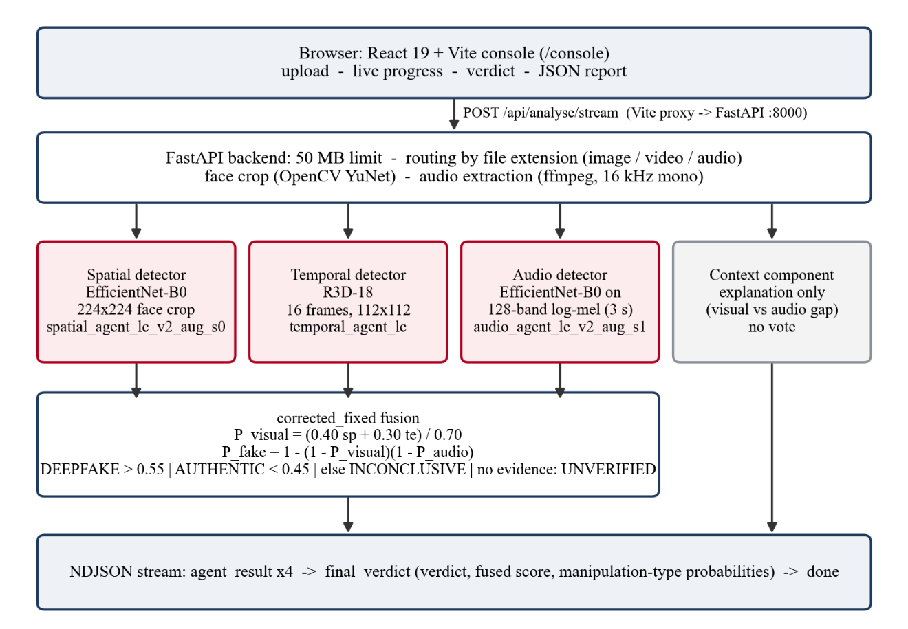
Figure 3.1: Block diagram of the VERITAS system
The pipeline for one upload has five stages: input validation and routing; face detection or audio extraction; detector inference; context explanation; and fusion and verdict. The detectors run one after another in a fixed order (spatial, temporal, audio, context) and each result is sent to the browser as soon as it is available, so the user sees progress rather than waiting for the whole analysis.

3.2 Dataset and Leakage-Controlled Partitioning
All detectors were trained on FakeAVCeleb v1.2 [8]. The dataset contains 21,566 videos across its four categories. Because the same celebrity appears in many real and fake videos, a random split would place the same identity in training and evaluation data and overstate accuracy. VERITAS therefore uses an identity-disjoint split of 500 primary identities into five partitions, balanced across ten demographic strata (five ethnic groups, men and women), with no identity, source video or face donor shared between partitions. Clips whose source or donor would cross a partition boundary were excluded (15,163 videos), leaving 6,403 clips in the original manifest and 6,366 in the current manifest (version 3) after the corrections described below. Figure 3.2 and Table 3.1 summarise the split.
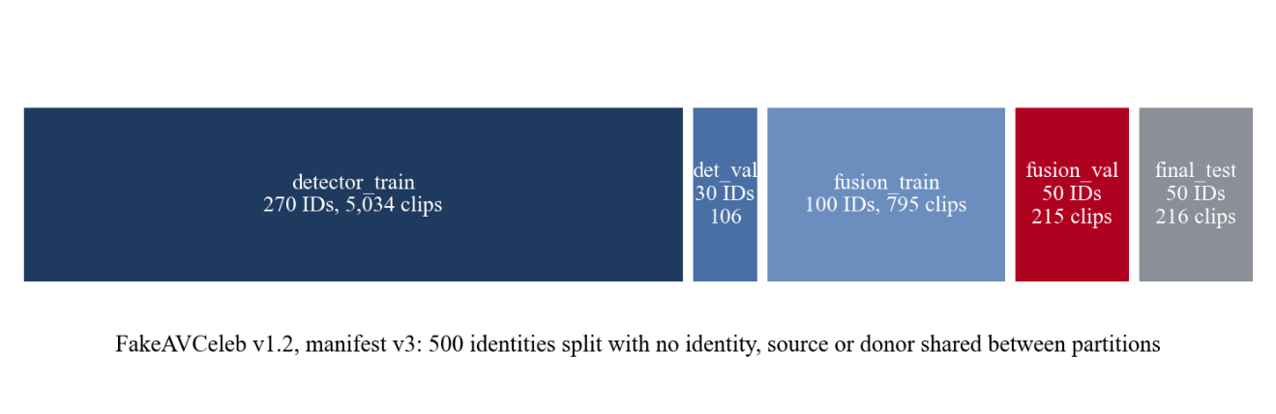
Figure 3.2: Identity-disjoint partitions of FakeAVCeleb (manifest v3)
Table 3.1: Clip counts per partition and category (manifest v3)
Partition | IDs | Real video, real audio | Real video, fake audio | Fake video, real audio | Fake video, fake audio | Total
detector_train | 270 | 270 | 269 | 2,679 | 1,816 | 5,034
detector_val | 30 | 30 | 30 | 31 | 15 | 106
fusion_train | 100 | 100 | 100 | 364 | 231 | 795
fusion_val | 50 | 50 | 50 | 79 | 36 | 215
final_test | 50 | 50 | 50 | 71 | 45 | 216

The partitions have distinct roles. detector_train trains the detectors and detector_val selects their checkpoints and thresholds. fusion_train and fusion_val were created for training and selecting a learned fusion policy, and fusion_val was later used to compare and select the robust detector candidates (Section 4.1). final_test was intended as a frozen hold-out set.
Two data-integrity problems were found and corrected during the project. An audit found 26 files labelled as manipulated that were byte-identical copies of authentic videos; manifest version 2 excludes them. Eleven fake-video, fake-audio files appeared twice because the dataset metadata lists one row per generation method; manifest version 3 keeps the first row. Separately, the original WAV cache named files by identity and file stem and dropped the category folder, so 313 files (269 of them in detector_train) were given another file's audio. The previous audio checkpoint was trained with that label noise. A new cache keyed by the dataset-relative path, with hash-checked sidecar files, replaced it, and the selected audio model was trained on the corrected audio. Every exclusion is recorded in the repository's dataset_audit directory, and the manifests are checked by automated tests.

3.3 Input Handling and Modality Routing
The backend classifies each upload by its file extension into image, video or audio and rejects any other type with HTTP 415. Requests whose declared size exceeds the 50 MB limit (plus 1 MB for form overhead) are rejected before the body is read. Table 3.2 lists which detectors run for each input type. A detector that does not apply is reported as skipped with its reason; it never contributes an invented score.
Table 3.2: Detectors applied to each input type
Input | Spatial | Temporal | Audio | Context
Image | Yes (whole image, face crop) | Skipped (not video) | Skipped (no audio) | Skipped (one modality)
Video with audio | Yes (middle frame) | Yes (16 frames) | Yes (soundtrack) | Explanation
Video without audio | Yes (middle frame) | Yes (16 frames) | Skipped (no audio stream) | Skipped (one modality)
Audio only | Skipped (no visual) | Skipped (not video) | Yes | Skipped (one modality)

For video, the spatial detector receives the middle frame, decoded with OpenCV and saved losslessly as PNG so that it is not compressed again. The temporal detector decodes its own frames. Audio is always passed through ffmpeg (using the binary bundled with the imageio-ffmpeg package) and converted to 16 kHz, 16-bit mono WAV, so the audio detector sees the same format for every container and codec.

3.4 Face Detection and Cropping
FakeAVCeleb clips are tightly framed face tracks, whereas an uploaded video may show a small face in a wide frame. Both visual detectors therefore crop the face before resizing. Face detection uses the YuNet detector [30] through OpenCV. The crop reproduces the framing of the training clips, measured on 240 detector_train frames: the face box side is 0.708 of the crop side and the face centre sits at 0.367 of the crop height. If several faces are present, the largest is used. If no face reaches the minimum detection score and size, or the face is cut off at the frame edge, the detector reports no_face and the visual modality is treated as unavailable.

3.5 The Three Detectors

3.5.1 Spatial detector: EfficientNet-B0
The spatial detector is an EfficientNet-B0 [20] initialised from ImageNet [21] weights, with a classifier head of dropout (0.3), a 1280-to-256 linear layer, ReLU, dropout (0.2) and a 256-to-2 linear layer. The face crop is resized to 224 × 224 pixels and normalised with the ImageNet mean and standard deviation. The softmax probability of the fake class is the detector's score, and the decision threshold is 0.50. Training used AdamW (learning rate 3 × 10⁻⁴, weight decay 10⁻⁴) with cosine annealing for five epochs, inverse-frequency class weights, mixed precision and batch size 32.
The production checkpoint, spatial_agent_lc_v2_aug_s0.pth, was trained with degradation augmentation: three frames per clip; one H.264 re-encode per clip with a constant rate factor (CRF) between 24 and 38 (probability 0.4); then JPEG compression at quality 25-95 (p 0.4), rescaling by a factor of 0.3-0.9 (p 0.3), Gaussian blur with σ 0.3-1.8 (p 0.25), crop-margin jitter (p 0.4), colour jitter (p 0.3) and horizontal flip. The checkpoint was chosen by the mean detector_val AUC over clean, JPEG q40, half-scale and H.264 CRF 32 copies, so the selection itself rewards robustness. Each checkpoint stores its training provenance: the manifest hash, augmentation configuration, selection rule and random seed.

3.5.2 Temporal detector: R3D-18
The temporal detector is an R3D-18 network [22] initialised from Kinetics-400 [23] weights, with its final layer replaced by a single-output linear layer. Sixteen frames are sampled at about 8 frames per second from a two-second window at the centre of the video. The face is located in the middle frame and the same crop is applied to all sixteen frames, which are resized to 112 × 112 pixels and normalised with the Kinetics statistics, giving an input tensor of shape 3 × 16 × 112 × 112. The sigmoid output is the fake probability. The decision threshold, 0.35, was selected on detector_val and is stored in the checkpoint. The production checkpoint is temporal_agent_lc.pth, trained for four epochs with AdamW (learning rate 2 × 10⁻⁴) and batch size 8; epoch 3 was kept. It was not trained with degradation augmentation, which matters for the results in Chapter 4. Videos with fewer than 16 frames are reported as unanalysable rather than padded.

3.5.3 Audio detector: mel-spectrogram CNN
The audio detector treats a spectrogram as an image. The centre three seconds of the 16 kHz waveform (wrap-padded if shorter) are converted to a mel spectrogram with 128 mel bands, an FFT size of 1024 and a hop length of 512, converted to decibels, resized to 224 × 224, normalised and repeated over three channels. An ImageNet-initialised EfficientNet-B0 with a single-output head produces the fake probability, and the threshold is 0.50.
The production checkpoint, audio_agent_lc_v2_aug_s1.pth, was trained on the corrected WAV cache with augmentation: an MP3 64 kbit/s, AAC 64 kbit/s or 44.1 kHz stereo variant (p 0.5), a random three-second window, gain of up to ±6 dB (p 0.5) and white noise at a signal-to-noise ratio of 15-40 dB (p 0.3). Model selection used detector_val F1 with ties broken by validation loss.
Because the model was trained only on speech, it has no meaningful output for non-speech audio. Before inference the detector checks whether the three-second crop looks like speech. A level below -60 dBFS is treated as silence, and a signal with more than 99.5% of its spectral energy in its six strongest frequency bins is treated as a pure tone. In either case the detector returns unavailable rather than a score. These thresholds flag none of the 22,215 dataset WAV files; before the guard was added, a 1 kHz test tone was scored as 0.99 fake. Other non-speech sounds, such as music or noise, are still scored.

3.6 Context Explanation Component
The context component is not a model and does not vote. When both a visual score and an audio score exist, it computes a visual estimate (spatial and temporal combined with weights 0.40 and 0.30), compares it with the audio score, and states whether the two point the same way and how large the gap is, for example "The visual score (100%) and audio score (100%) point the same way, a gap of 0%. This restates the other models' outputs; it is not separate evidence and does not change the verdict." When only one modality is available it says that cross-modal consistency cannot be assessed. Its output is excluded from fusion by design, because it contains no information that the detectors have not already provided. It is not a lip-synchronisation detector, and it cannot detect a forgery in which audio and video were manipulated consistently.

3.7 Fusion: the corrected_fixed Method
The production fusion method, corrected_fixed, is a fixed rule with no trained parameters. It first combines the visual detectors, then treats visual and audio manipulation as independent events. Let p_sp, p_te and p_au be the spatial, temporal and audio fake probabilities of the detectors that produced a valid score.
P_visual = (0.40 p_sp + 0.30 p_te) / 0.70 (or the single available visual score)
P_fake = 1 - (1 - P_visual)(1 - P_audio) (or the single available modality)
The second equation is the probability that at least one modality is manipulated if the two events were independent. Unlike a weighted average, it lets a confident audio detection raise the fused score even when the video looks genuine, which matches the structure of FakeAVCeleb's real-video, fake-audio category. The same two probabilities define four manipulation-type probabilities: authentic (1 - P_visual)(1 - P_audio), audio manipulated (1 - P_visual)P_audio, video manipulated P_visual(1 - P_audio), and audio-and-video manipulated P_visual P_audio. These are model-implied quantities, not calibrated probabilities, and the report and interface describe them as such.

3.7.1 Verdict thresholds and abstention
The fused score is compared with a central threshold of 0.50 and a dead band of 0.05, as shown in Figure 3.3. A score above 0.55 gives DEEPFAKE, with the most probable manipulated category as the manipulation type. A score below 0.45 gives AUTHENTIC. A score from 0.45 to 0.55 gives UNCERTAIN / INSUFFICIENT EVIDENCE, shown as "Inconclusive", and the leading category is reported only as a hypothesis. If no detector produced a valid score, for example a pure-tone audio file or a video with no detectable face and no speech, the result is UNVERIFIED MODALITY, shown as "Can't verify". Finally, an AUTHENTIC result is changed to inconclusive if any detector reported no_face or if the picture of a video was never checked, so that an unexamined face is never reported as genuine.
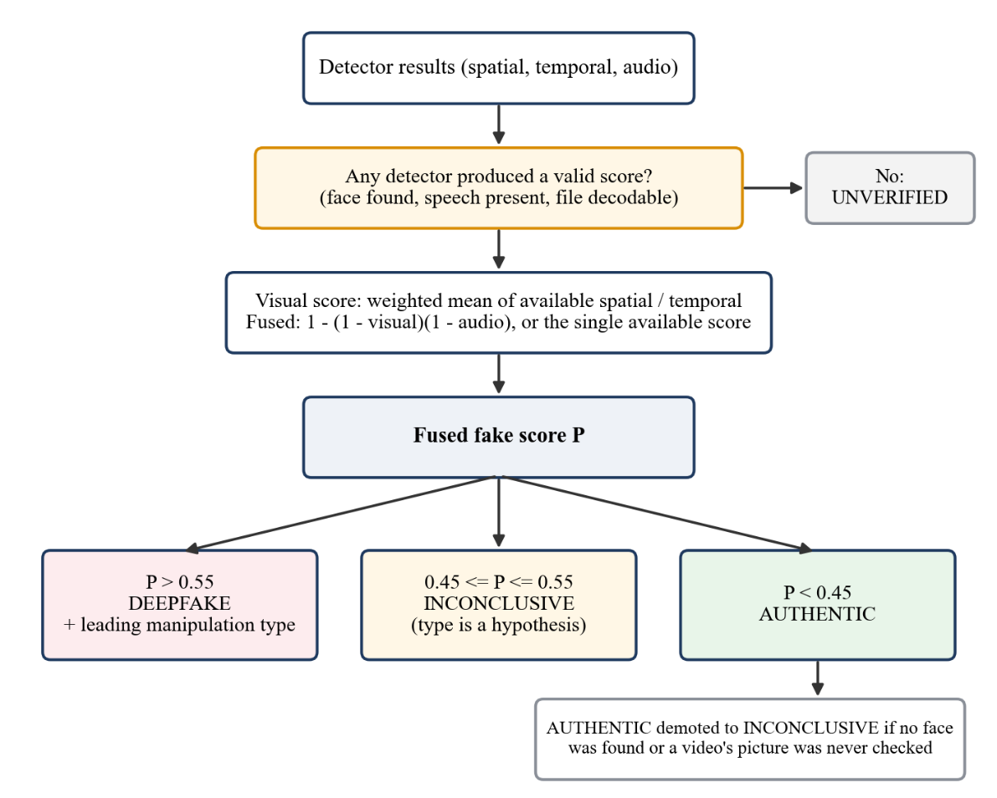
Figure 3.3: Verdict decision flow of the corrected_fixed method

3.7.2 Alternative fusion modes
Two other modes can be selected with the VERITAS_FUSION_MODE environment variable. The legacy mode is the original weighted average (weights 0.40, 0.30, 0.20 and 0.10), kept as a reference. The ppo mode loads a fusion policy trained with proximal policy optimisation [27] (ppo_fusion_policy_v4.pth), which maps a 14-dimensional summary of the detector outputs to fusion weights, a mismatch sensitivity and a threshold offset. PPO v4 was trained on the scores of the previous detectors, so when the currently loaded detectors differ from those recorded in its checkpoint, the backend falls back to corrected_fixed and reports the reason in the response. PPO fusion is therefore experimental and is not the production default.

3.8 Backend API and Streaming Response Flow
The backend exposes three endpoints. GET /healthz reports which checkpoint each detector loaded. POST /analyse returns the complete result as one JSON object. POST /analyse/stream, used by the console, returns NDJSON: one agent_result line per detector in the order spatial, temporal, audio, context; one final_verdict line containing the verdict, fused score, contributing and unavailable detectors, fusion method, manipulation-type probabilities and decision fields; and a closing done line. Model inference runs in a worker thread so that the event loop stays responsive. A short pause of 0.4 s between agent results gives the interface time to animate each update. The service binds to 127.0.0.1 by default because the API has no authentication.
Algorithm 3.1 summarises the streaming analysis in pseudocode.
Algorithm 3.1 Streaming analysis of one upload
input : file f
kind <- media type of f from its extension; reject if unknown or larger than 50 MB
if kind = image : S <- spatial(face_crop(f))
if kind = video : S <- spatial(face_crop(middle_frame(f)))
otherwise : S <- skipped
emit S
T <- temporal(16 face-cropped frames of f) if kind = video, else skipped; emit T
A <- skipped if kind = image or no audio stream or no speech, else audio(log_mel(f)); emit A
C <- context_explanation(S, T, A); emit C // never used in fusion
(P, verdict, categories) <- corrected_fixed(S, T, A)
if verdict = AUTHENTIC and (a detector reported no_face or the video picture was never checked)
verdict <- UNCERTAIN
emit final_verdict(verdict, P, categories, contributing, unavailable); emit done

3.9 Frontend: Analysis Console and Report Generation
The console at /console is written in React 19 with TypeScript, styled with Tailwind CSS and animated with Framer Motion. The user drops or selects a file; the console checks the extension and the 50 MB limit before uploading, shows a preview and states which detectors will be skipped for that file type. During analysis the header shows "Analysing, n of 4 reported", a progress bar advances as each NDJSON line arrives, and each detector card changes from Analysing to Reported or Skipped with the detector's written finding and score. Figure 3.4 shows the console after analysing a fake audio-visual sample.
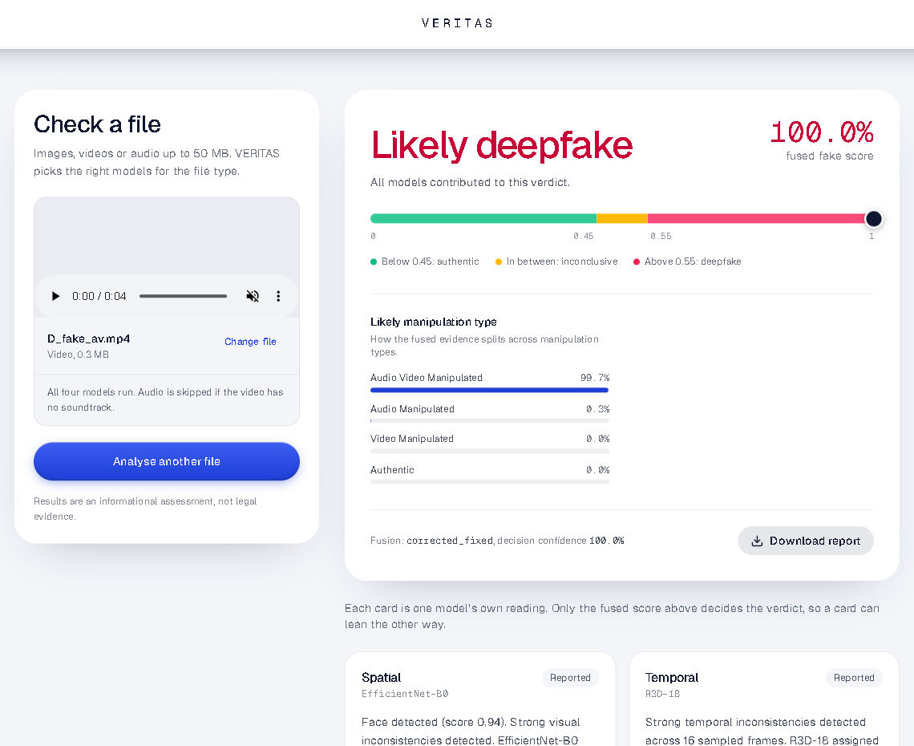
Figure 3.4: Analysis console after analysing a FakeAVCeleb fake-video, fake-audio sample
The verdict panel shows the headline (Likely deepfake, Likely authentic, Inconclusive or Can't verify), the fused fake score on a scale marked with the 0.45 and 0.55 boundaries, the manipulation-type probabilities, the fusion method and the decision confidence. (The panel can also show per-detector fusion weights, but only for fusion modes that report them; corrected_fixed does not.) For inconclusive results the manipulation type is labelled as a hypothesis. For unverifiable results the panel shows no fused score, no scale marker, no decision confidence and no manipulation-type bars, because the backend's numeric fields in that case are placeholders rather than evidence (Figure 3.5). Individual detector cards are deliberately coloured neutrally, because a single detector's score is a signal and not the decision. The Download report button saves a JSON file with the file name, size and type, the analysis time, the full verdict object and each detector's result.
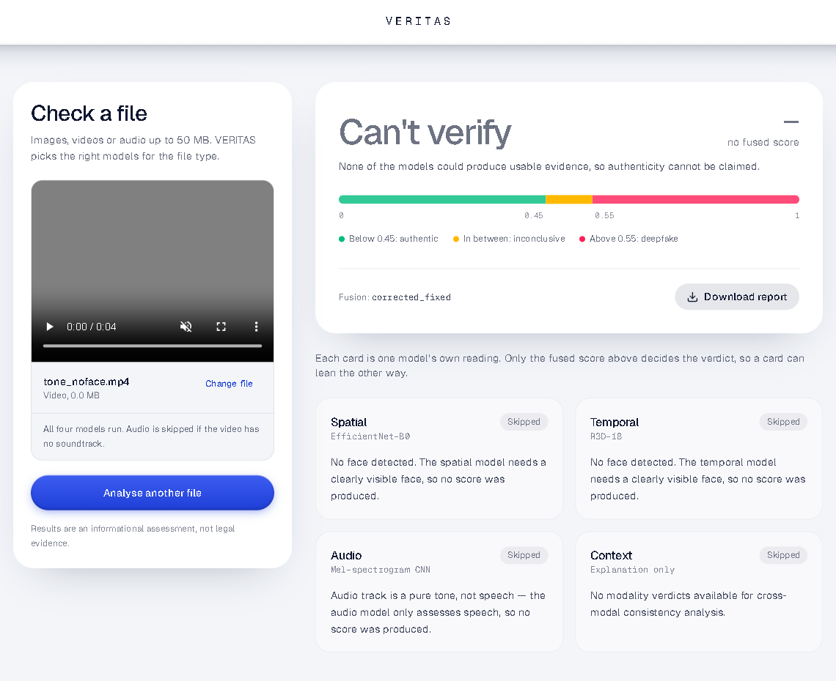
Figure 3.5: Console result for an unverifiable input (grey frame with a pure tone): no fused score is shown

3.10 Model Loading, Configuration and Rollback
At start-up the backend loads each detector from backend/models. The checkpoint file names can be overridden with VERITAS_SPATIAL_CHECKPOINT and VERITAS_AUDIO_CHECKPOINT, so the previous production detectors (spatial_agent_lc.pth and audio_agent_lc.pth), which are kept in the repository, can be restored without code changes. If a checkpoint is missing, that detector reports itself unavailable and is excluded from fusion. The temporal detector reads its decision threshold, frame count and window length from its checkpoint. Table 3.3 lists the production configuration, confirmed through the /healthz endpoint of the running service.
Table 3.3: Production model configuration
Component | File / setting | Notes
Spatial detector | spatial_agent_lc_v2_aug_s0.pth | EfficientNet-B0, augmented, threshold 0.50
Temporal detector | temporal_agent_lc.pth | R3D-18, threshold 0.35, not augmented
Audio detector | audio_agent_lc_v2_aug_s1.pth | EfficientNet-B0 on log-mel, corrected audio, augmented, threshold 0.50
Face detector | face_detection_yunet_2023mar.onnx | OpenCV YuNet
Fusion | corrected_fixed (VERITAS_FUSION_MODE) | Fixed rule; ppo mode is experimental
Rollback | spatial_agent_lc.pth, audio_agent_lc.pth | Previous detectors, selectable by environment variable

3.11 Development Environment and Hardware
Table 3.4 lists the environment recorded in the project's training reports and verified on the development machine. Detector training used a CUDA build of PyTorch on the laptop GPU; the backend runs inference on the CPU.
Table 3.4: Development environment
Item | Details
Hardware | NVIDIA GeForce RTX 4050 Laptop GPU (6 GB), Intel Core i7 (16 logical processors), 24 GB RAM
Operating system | Windows 11
Training environment | Python 3.10, PyTorch 2.6.0 with CUDA 12.4, mixed-precision training
Inference environment | Python 3.10, PyTorch 2.6.0 (CPU), torchvision 0.21, FastAPI 0.115, OpenCV 4.10, imageio-ffmpeg
Frontend | Node.js, React 19.1, Vite 7, TypeScript 5, Tailwind CSS 4, Framer Motion 12
Testing | pytest (backend), Node test runner (frontend), Playwright-driven Google Chrome (browser QA)

In summary, VERITAS combines three independently trained detectors, a face-aware preprocessing stage, a transparent fusion rule with explicit abstention, and a streaming web interface. The next chapter evaluates how well this system performs and where it fails.

Chapter 4: Results and Analysis
This chapter reports the evaluation of the implemented system. It first states the evidential status of each result, then presents detector robustness under degradation, system-level fusion results, error analysis, software test results and browser-based quality assurance. All figures are taken from evaluation outputs and reports stored in the repository (backend/training), and each table names the split it was computed on.

4.1 Evaluation Protocol and Integrity of the Evidence
The reader should weigh every number in this chapter against how it was obtained. The robustness and system-level results in Sections 4.2 to 4.4 were computed on fusion_val (215 clips from 50 held-out identities). fusion_val was also used to compare candidate detectors and to choose the production spatial and audio checkpoints. These results are therefore development evidence: they are optimistic for the selected models and are not an estimate of real-world accuracy.
The final_test split was intended as a frozen hold-out set, but it has been scored repeatedly during earlier stages of the project, its historical results were computed on a manifest version that contained one mislabelled file, and individual final_test clips were used as examples in the browser QA described in Section 4.6. It is therefore not an untouched test set, and this report does not present a final_test accuracy figure. A genuinely independent evaluation collection, gathered after model selection and never used for any decision, is still required before any real-world performance claim can be made; a protocol for such a collection is recorded in the repository (backend/training/independent_evaluation_v1).
The degradations used below are synthetic and are applied to FakeAVCeleb clips, whose fakes come from a small number of generators (FaceSwap, FSGAN, Wav2Lip and one voice-cloning system). Results on other generators, recording conditions or real social-media pipelines may differ substantially. The evaluation design (separating development and test evidence, documenting each test condition and recording results with the scripts that produced them) follows the principles of ISO/IEC/IEEE 29119-3 test documentation [31], without a formal conformance claim.

4.2 Detector Selection on Clean Data
On detector_val, the selection split for detector training, the first leakage-controlled detectors reached the following best-epoch results: spatial F1 0.979 and ROC-AUC 0.995; audio F1 0.943 and ROC-AUC 0.983; temporal F1 0.968 and ROC-AUC 0.994 at its threshold of 0.35. On the unmodified fusion_val clips the previous spatial model reached an AUC of 1.000 and the temporal model 0.998, and the corrected-audio models reached an audio AUC of at least 0.998. These near-perfect clean-data figures were the motivation for the robustness study that follows: they show that the detectors separate the native FakeAVCeleb clips well, but not whether they still work after the kind of re-encoding that uploaded media normally undergoes.

4.3 Robustness of the Individual Detectors

4.3.1 Spatial detector
Table 4.1 compares the previous spatial model with the selected augmented model on fusion_val under eight conditions, using the production face-crop path and a threshold of 0.50. Each cell gives the number of real clips called deepfake (of 100), the number of fake clips called authentic (of 115) and the ROC-AUC. Figure 4.1 plots the AUC.
Table 4.1: Spatial detector robustness on fusion_val: real called DEEPFAKE (/100), fake called AUTHENTIC (/115), AUC
Condition | Previous (spatial_agent_lc) | Selected (lc_v2_aug_s0)
Original | 0 / 0 / 1.000 | 1 / 5 / 0.996
JPEG quality 30 | 97 / 2 / 0.658 | 5 / 26 / 0.962
JPEG quality 60 | 75 / 0 / 0.834 | 1 / 14 / 0.981
Downscale ×0.5 | 98 / 0 / 0.457 | 5 / 11 / 0.979
Gaussian blur σ 1.5 | 100 / 0 / 0.459 | 9 / 31 / 0.907
H.264 CRF 32 | 16 / 78 / 0.701 | 8 / 32 / 0.911
720p frame, face 25% of width | 98 / 0 / 0.561 | 8 / 5 / 0.983
720p, face 25%, H.264 CRF 28 | 79 / 6 / 0.647 | 8 / 42 / 0.866

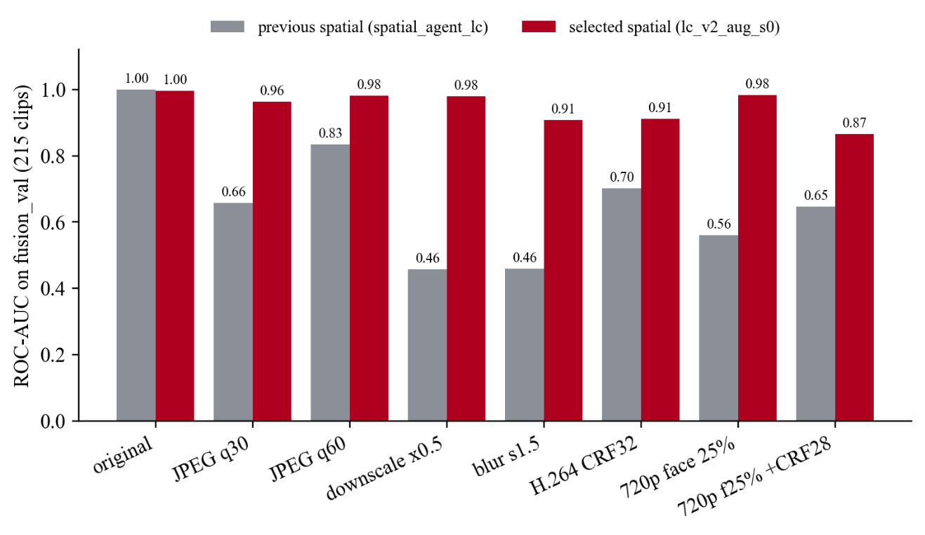
Figure 4.1: Spatial detector ROC-AUC under degradation on fusion_val
The previous model is near-perfect on native clips but collapses under re-encoding: it calls almost every degraded real face fake (97-100 of 100 under JPEG q30, downscaling and blur) and misses most fakes after H.264 compression. A retrain without augmentation behaved the same way, which shows that the improvement comes from the augmentation rather than from retraining alone. The augmented model keeps the AUC between 0.87 and 0.98 in every condition. The price is visible in the second number of each cell: it misses 5 of 115 native fakes, and between 11 and 42 fakes under degradation.

4.3.2 Temporal detector
The temporal detector was not retrained. Table 4.2 and Figure 4.2 show that it has the same failure pattern as the previous spatial model.
Table 4.2: Temporal detector (temporal_agent_lc, threshold 0.35) robustness on fusion_val
Condition | Real called DEEPFAKE (/100) | Fake called AUTHENTIC (/115) | AUC
Original | 2 | 1 | 0.998
JPEG quality 30 | 93 | 0 | 0.784
JPEG quality 60 | 22 | 4 | 0.969
Downscale ×0.5 | 69 | 0 | 0.971
Gaussian blur σ 1.5 | 99 | 0 | 0.778
H.264 CRF 32 | 7 | 85 | 0.717
720p frame, face 25% of width | 19 | 13 | 0.944
720p, face 25%, H.264 CRF 28 | 13 | 60 | 0.768

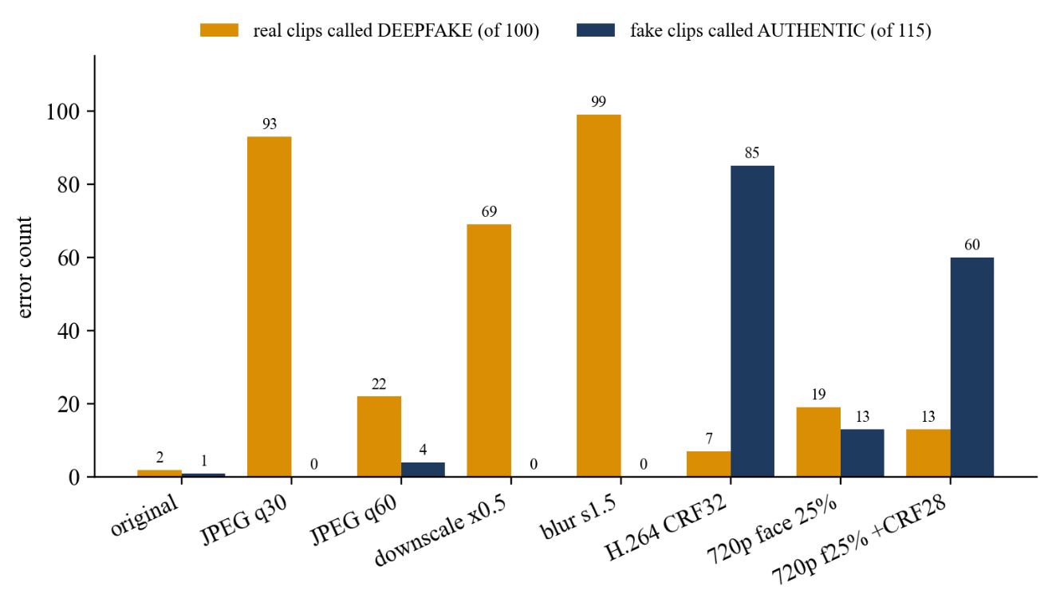
Figure 4.2: Temporal detector errors under degradation on fusion_val
JPEG compression and blur make real clips look fake (93 and 99 of 100), while H.264 re-encoding makes fake clips look real (85 of 115 missed at CRF 32). The temporal detector is therefore the least robust component of the current system, and its score should not be trusted on its own for uploaded media.

4.3.3 Audio detector
Table 4.3 compares the previous audio model, trained before the WAV-cache correction and without augmentation, with the selected model on fusion_val (129 real-audio clips and 86 fake-audio clips), and Figure 4.3 plots the false positives.
Table 4.3: Audio detector robustness on fusion_val: real audio called fake (/129), fake audio called real (/86), ECE
Format | Previous (audio_agent_lc) | Selected (lc_v2_aug_s1)
Original | 16 / 0 / 0.175 | 0 / 0 / 0.004
MP3 64 kbit/s | 20 / 0 / 0.211 | 0 / 0 / 0.005
AAC 64 kbit/s | 14 / 0 / 0.159 | 0 / 0 / 0.004
44.1 kHz stereo | 29 / 0 / 0.239 | 0 / 0 / 0.005
Gain -6 dB | 17 / 0 / 0.186 | 0 / 0 / 0.005
Gain +6 dB | 11 / 0 / 0.142 | 0 / 0 / 0.003
White noise, 20 dB SNR | 6 / 11 / 0.094 | 1 / 0 / 0.009

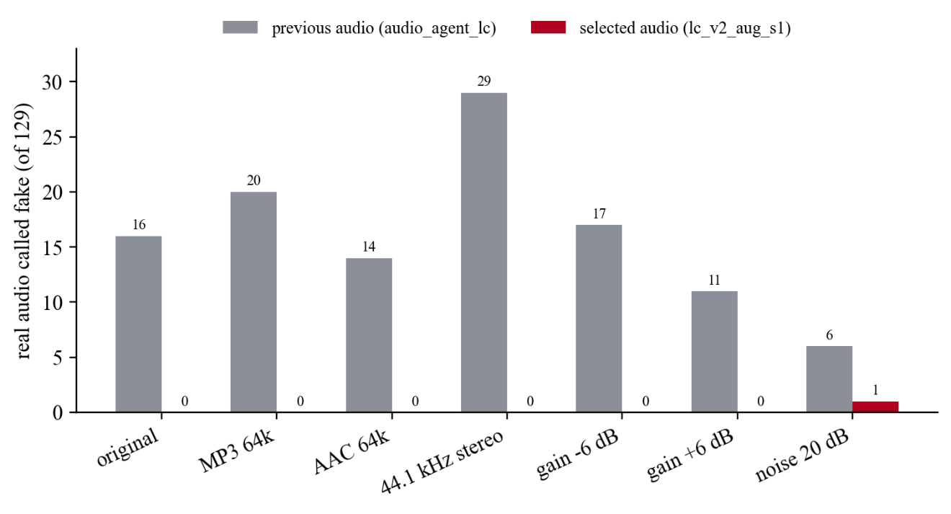
Figure 4.3: Real audio called fake by the previous and selected audio detectors on fusion_val
Most of the previous model's false positives disappear when the corrected audio is used, even without augmentation, which indicates that the 269 wrong-audio training examples acted as label noise. Without augmentation, however, the model was sensitive to added noise and to the random seed (12 and 43 of 86 fakes missed at 20 dB SNR for two seeds). With augmentation, both seeds missed no fake audio in any format and produced at most two false positives, with ECE no greater than 0.018. The ROC-AUC of every corrected model was at least 0.998 in every format except noise without augmentation. These results are in-distribution for the augmentation recipe and do not cover other codecs, real microphones or other voice generators.

4.4 System-Level Results with corrected_fixed Fusion
To measure the effect of the detector choice on the whole system, per-clip scores for every fusion_val clip were passed through the production fusion function under five scenarios in which video and audio are degraded together. A clip counts as fake unless it is real video with real audio (50 real and 165 fake clips per scenario). Table 4.4 shows the errors and Figure 4.4 the totals.
Table 4.4: System-level errors of corrected_fixed on fusion_val: real called DEEPFAKE (/50), fake called AUTHENTIC (/165), inconclusive (real/fake)
Scenario | Previous spatial + previous audio | Previous spatial + selected audio | Selected spatial + selected audio
Native | 4 / 0 / (2/0) | 0 / 0 / (0/0) | 0 / 3 / (0/1)
JPEG q60 + MP3 64k | 41 / 0 / (3/0) | 35 / 0 / (4/0) | 1 / 4 / (1/3)
Downscale ×0.5 + AAC 64k | 49 / 0 / (0/0) | 49 / 0 / (0/0) | 4 / 2 / (5/5)
H.264 CRF 32 + AAC 64k | 9 / 32 / (2/8) | 2 / 49 / (2/4) | 1 / 33 / (1/13)
720p face 25% H.264 CRF 28 + AAC 64k | 35 / 3 / (2/2) | 33 / 4 / (2/3) | 0 / 22 / (3/12)
Total over 5 scenarios | 138 / 35 | 119 / 53 | 6 / 64

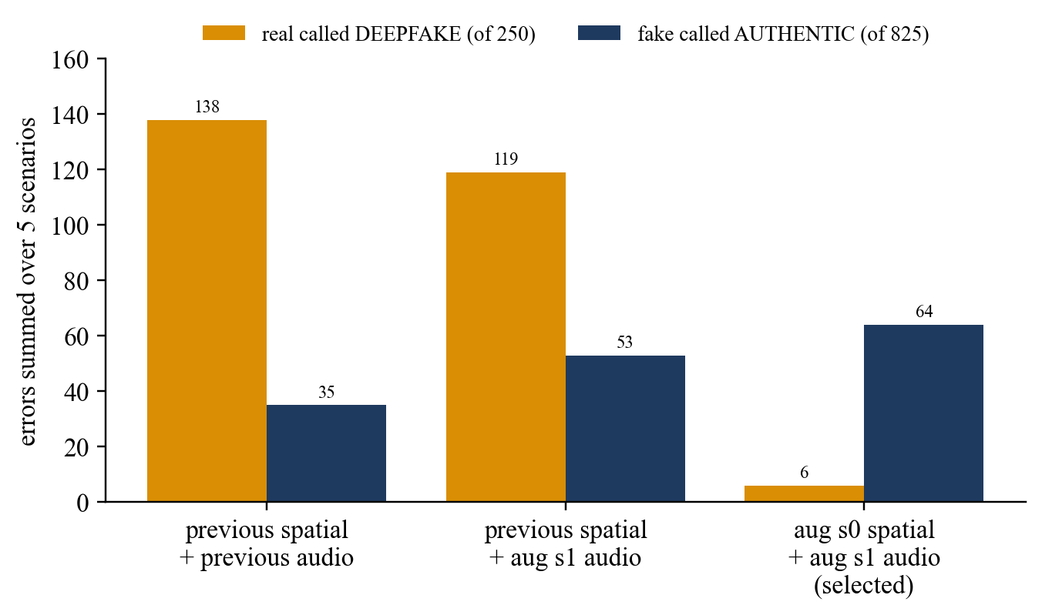
Figure 4.4: System-level errors summed over five degradation scenarios on fusion_val
With the selected detectors, real clips wrongly called deepfake fall from 119 to 6 of 250 scenario-clips compared with the previous spatial model, while fake clips wrongly called authentic rise from 53 to 64 of 825. On native clips, three visual-only fakes are now missed where none were before. This is a deliberate trade-off. Uploaded media is almost always re-encoded, and the previous spatial model called most re-encoded real faces fake, which would make the system unusable for genuine users; the robust model was therefore chosen as the safer default, accepting more missed visual-only fakes after heavy compression. No fusion threshold or weight was changed in response to these counts, because any rule tuned on them would be a further selection on fusion_val.

4.5 Error Analysis
Every fake clip that the selected configuration called authentic in Table 4.4 belongs to the fake-video, real-audio category: 3 on native clips, 33 under H.264 CRF 32 and 22 in the 720p re-encoded scenario. The audio detector caught every fake-audio clip in every scenario. The remaining misses are therefore visual-only fakes after heavy compression, where the spatial score has weakened and the temporal detector, which is not robust to H.264, reports them as real. Because corrected_fixed treats the modalities as independent, a weakened visual score cannot be compensated by the audio score when the audio is genuine.
A related effect concerns the manipulation type. For a fake-video, fake-audio clip, the category audio-and-video manipulated requires both P_visual and P_audio to be high. When compression weakens the visual evidence, the audio score still dominates the fused score, the verdict remains DEEPFAKE, and the leading category becomes audio manipulated. The verdict is correct but the attribution is incomplete. The manipulation type should therefore be read as an indication of which evidence was strongest, not as a reliable classification of how the media was made.
False positives on genuine media fall to a small number with the selected detectors, but the inconclusive band absorbs part of the remaining uncertainty: in the degraded scenarios between 1 and 13 clips per scenario were reported as inconclusive. The system's abstention is therefore doing useful work, and an inconclusive result should be treated as a request for human review rather than as a verdict of either kind.

4.6 Software Testing and Browser-Based Quality Assurance
The backend test suite (85 tests run with pytest) covers media routing, upload limits, face cropping, each detector's loading and readiness checks, the no-speech guard, the context component, the fusion methods and decision contract, PPO checkpoint loading and fallback, manifest integrity and reproducibility. All 85 tests passed on the final commit. The frontend unit test for the NDJSON stream reader passed, and the production build (TypeScript compilation and Vite bundling) completed successfully.
A browser-level QA pass was carried out by driving a real Google Chrome window against the running application (frontend on port 5173, backend on port 8000). Labelled samples were taken from the final_test split, and synthetic inputs were generated for unsupported cases. Table 4.5 lists the outcomes.
Table 4.5: Browser QA outcomes in the analysis console (selected final_test examples and synthetic inputs)
Input | Ground truth | Verdict shown | Manipulation type
Image (frame of real video) | Real | Likely authentic (34.8%) | Authentic
Image (frame of FaceSwap video) | Fake | Likely deepfake (98.4%) | Video manipulated
Video with audio | Real | Likely authentic (2.0%) | Authentic
Video with audio (FaceSwap + Wav2Lip, cloned audio) | Fake video, fake audio | Likely deepfake (100%) | Audio and video manipulated
Video without audio (FaceSwap) | Fake video | Likely deepfake (57.1%) | Video manipulated
Video without audio | Real | Likely authentic (2.0%) | Authentic
Audio only, WAV (voice clone) | Fake audio | Likely deepfake (100%) | Audio manipulated
Audio only, MP3 | Real | Likely authentic (0.0%) | Authentic
Pure 440 Hz tone, WAV | No speech | Can't verify | None shown
Grey frame with tone, MP4 | No face, no speech | Can't verify | None shown

For every input the console showed progress from 0 of 4 to 4 of 4 detectors reported, the correct detectors were marked as skipped with their reasons, the report download produced a valid JSON file matching the screen, and no console errors or failed requests were recorded apart from a benign cancellation of the stream after the final message. Unsupported file types were rejected with a message, and the Change file, Analyse another file and Home controls worked. The pass found one interface defect: unverifiable results displayed the backend's placeholder values as a 0.0% fused score, a marker in the authentic zone of the scale and 100% decision confidence. The interface was corrected to show no fused score in that case (commit fbe4281). The browser checks were run on the same code before it was committed; they were not repeated after the commit, but the frontend unit test and production build were.
These checks show that representative examples pass through the interface correctly. They are not evidence of detection accuracy: ten hand-picked examples cannot estimate an error rate, and the labelled examples came from a split that had been inspected before. They should be read as test execution results, separate from the model evaluation in Sections 4.2 to 4.5.

4.7 Summary of Findings
- The selected spatial and audio detectors are far more robust to compression and resampling than their predecessors; on fusion_val the spatial AUC stays between 0.87 and 0.98 across eight degradations, and the audio detector makes at most one error per format.
- The temporal detector remains vulnerable: JPEG compression and blur make real clips look fake, and H.264 re-encoding makes fake clips look real.
- At system level the selected configuration nearly eliminates false deepfake verdicts on degraded genuine clips (6 of 250) at the cost of more missed visual-only fakes after heavy compression (64 of 825).
- Manipulation-type attribution is incomplete when visual evidence weakens; fake-video, fake-audio clips can be attributed to audio only.
- All results are development evidence on FakeAVCeleb. No independent real-world accuracy estimate exists yet.
In summary, the evaluation shows a working system whose strengths and weaknesses are measured and documented. The selected configuration favours not accusing genuine media at the cost of missing some heavily compressed visual-only fakes, and the temporal detector is the clearest target for further work.

Chapter 5: Advantages, Limitations and Applications
This chapter draws on the implementation and the evaluation to summarise what VERITAS does well, where it falls short, and where it can responsibly be used.

5.1 Advantages
- Single application for three modalities. One upload is analysed for spatial, temporal and audio evidence as applicable, without the user choosing a tool.
- Modality-aware handling. Images, videos with and without audio, and audio-only files are routed automatically; inapplicable detectors are reported as skipped with a reason rather than given an invented score.
- Abstention instead of guessing. The inconclusive band and the unverifiable outcome, together with the no-face and no-speech safeguards, keep the system from presenting unassessed or ambiguous media as authentic.
- Transparent fusion. The fused score is a short, inspectable formula; the interface shows each detector's finding and score, the fused score and the manipulation-type probabilities.
- Streamed progress. Each detector's result appears as soon as it is ready, which keeps the interface responsive during longer video analyses.
- Modular, reversible configuration. Detectors are loaded by file name, previous models are kept for rollback, and a missing checkpoint disables only its own detector.
- Documented data integrity. Identity-disjoint splits, recorded exclusions, hashed checkpoints with training provenance and automated manifest tests make the training reproducible and auditable.

5.2 Limitations
- Temporal robustness. The R3D-18 detector was not trained with degradation augmentation. JPEG compression and blur cause false positives and H.264 re-encoding causes missed fakes (Section 4.3.2).
- Missed visual-only fakes after heavy compression. With the selected detectors, fake-video, real-audio clips re-encoded at high compression are often reported as authentic (Section 4.5).
- Incomplete manipulation-type attribution. When visual evidence weakens, audio-and-video fakes may be attributed to audio manipulation only, and the category probabilities are not calibrated.
- Limited non-speech handling. Silence and pure tones are reported as unverifiable, but other non-speech audio such as music or noise is still scored by a model trained only on speech.
- No independent accuracy estimate. All quantitative results are development evidence on fusion_val, a split also used for model selection; final_test has been inspected repeatedly. Performance on other generators and real-world media is unknown.
- Explanations depend on the detectors. The context statement and the per-detector findings restate the detector scores; they cannot reveal evidence the detectors missed, and the current release does not produce visual heatmaps.
- Single-frame spatial analysis for video. The spatial detector examines only the middle frame of a video, so a manipulation confined to other parts of the clip may be missed by that detector.
- Deployment scope. The API has no authentication and is intended for local use; the Vite proxy is a development convenience, not a production server configuration.

5.3 Applications
VERITAS is designed to support, not replace, human judgement. Suitable uses include triage of user-reported media by content-moderation teams, where a deepfake or inconclusive result routes the item to a human reviewer; preliminary checks by journalists and fact-checkers before deeper verification; forensic triage, where the per-detector findings help an analyst decide which modality to examine more closely; teaching and demonstration of how deepfake detectors work and fail; and research, where the modular design allows new detectors or fusion rules to be compared under the same protocol. In all of these settings the output is an informational assessment. It should not be treated as conclusive forensic proof or as legal evidence, and a likely authentic result does not certify that media is genuine.
In summary, VERITAS offers broad modality coverage, careful abstention and transparency, while its temporal robustness, attribution and independent validation remain open. These points shape the conclusion and future work in the next chapter.

Chapter 6: Conclusion and Future Scope
This chapter states the conclusion of the project and the work that remains.

6.1 Conclusion
This project designed, implemented and evaluated VERITAS, a multimodal deepfake detection and reasoning system. The delivered system accepts images, videos and audio files through a browser console, routes each file to the detectors that apply, and analyses it with an EfficientNet-B0 spatial detector, an R3D-18 temporal detector and an EfficientNet-B0 mel-spectrogram audio detector. A transparent corrected_fixed fusion rule combines the available evidence into a fused fake score, a verdict and manipulation-type probabilities, and abstains with an inconclusive or unverifiable result when the evidence is ambiguous or absent. Results stream to the interface as each detector finishes, and the user can download a JSON report.
The detectors were trained on an identity-disjoint partition of FakeAVCeleb after an audit that removed mislabelled and duplicated files and corrected an audio-cache error. Augmented retraining made the spatial and audio detectors substantially more robust to compression, rescaling, blur, codecs and noise, and at system level reduced false deepfake verdicts on degraded genuine clips from 119 to 6 of 250 on the development split, at the cost of more missed visual-only fakes after heavy compression (from 53 to 64 of 825). The temporal detector remains vulnerable to compression and blur, and manipulation-type attribution weakens when visual evidence weakens. The software passes its 85 backend tests, its frontend test and production build, and a browser-level QA pass on representative inputs, during which one interface defect was found and fixed.
These results are development evidence. They show that the system works end to end and document its trade-offs, but they do not establish real-world accuracy, which requires evaluation on a truly independent collection. VERITAS is therefore best understood as a working, honest decision-support tool for human review rather than as an automatic arbiter of authenticity.

6.2 Future Scope
The following work is proposed and has not been carried out.
- Temporal robustness. Retrain the R3D-18 detector with the same degradation recipe used for the spatial detector (frame-level JPEG, rescaling and blur, plus whole-clip H.264 re-encoding) and select it on robust validation AUC.
- Independent evaluation. Collect a new evaluation set after model selection, including media from other generators and real distribution channels, and use it once to estimate real-world performance.
- Broader and more diverse data. Add other datasets and generators, including recent diffusion-based face and voice synthesis, to reduce dependence on FakeAVCeleb's four generation methods.
- Audio-visual consistency and attribution. Add a learned audio-visual synchronisation or consistency model, and improve manipulation-type attribution when one modality's evidence is weak.
- Calibration and out-of-distribution detection. Calibrate the fused and category probabilities on independent data, and detect inputs (such as music or non-face content) that lie outside the training distribution.
- Visual explanations. Re-enable and validate Grad-CAM [29] or similar saliency maps for the spatial detector, and evaluate whether they help reviewers.
- Learned fusion. Retrain the experimental PPO fusion policy on the scores of the current detectors and compare it with corrected_fixed on independent data.
- Runtime and deployment. Optimise models for faster CPU inference, analyse more than one video frame spatially, and add authentication and a production web-server configuration.

References
[1] I. J. Goodfellow, J. Pouget-Abadie, M. Mirza, B. Xu, D. Warde-Farley, S. Ozair, A. Courville, and Y. Bengio, "Generative adversarial nets," in Advances in Neural Information Processing Systems 27 (NeurIPS), 2014, pp. 2672–2680.
[2] J. Ho, A. Jain, and P. Abbeel, "Denoising diffusion probabilistic models," in Advances in Neural Information Processing Systems 33 (NeurIPS), 2020, pp. 6840–6851.
[3] R. Tolosana, R. Vera-Rodriguez, J. Fierrez, A. Morales, and J. Ortega-Garcia, "DeepFakes and beyond: A survey of face manipulation and fake detection," Information Fusion, vol. 64, pp. 131–148, 2020, doi: 10.1016/j.inffus.2020.06.014.
[4] Y. Mirsky and W. Lee, "The creation and detection of deepfakes: A survey," ACM Computing Surveys, vol. 54, no. 1, Art. no. 7, 2021, doi: 10.1145/3425780.
[5] A. Rössler, D. Cozzolino, L. Verdoliva, C. Riess, J. Thies, and M. Nießner, "FaceForensics++: Learning to detect manipulated facial images," in Proc. IEEE/CVF Int. Conf. Computer Vision (ICCV), 2019, doi: 10.1109/ICCV.2019.00009.
[6] Y. Li, X. Yang, P. Sun, H. Qi, and S. Lyu, "Celeb-DF: A large-scale challenging dataset for DeepFake forensics," in Proc. IEEE/CVF Conf. Computer Vision and Pattern Recognition (CVPR), 2020, pp. 3207–3216.
[7] B. Dolhansky, J. Bitton, B. Pflaum, J. Lu, R. Howes, M. Wang, and C. Canton Ferrer, "The DeepFake Detection Challenge (DFDC) dataset," arXiv preprint arXiv:2006.07397, 2020.
[8] H. Khalid, S. Tariq, M. Kim, and S. S. Woo, "FakeAVCeleb: A novel audio-video multimodal deepfake dataset," in Proc. Neural Information Processing Systems Track on Datasets and Benchmarks, 2021 (arXiv:2108.05080).
[9] D. Afchar, V. Nozick, J. Yamagishi, and I. Echizen, "MesoNet: A compact facial video forgery detection network," in Proc. IEEE Int. Workshop on Information Forensics and Security (WIFS), 2018 (arXiv:1809.00888).
[10] L. Li, J. Bao, T. Zhang, H. Yang, D. Chen, F. Wen, and B. Guo, "Face X-ray for more general face forgery detection," in Proc. IEEE/CVF Conf. Computer Vision and Pattern Recognition (CVPR), 2020, pp. 5001–5010.
[11] D. Güera and E. J. Delp, "Deepfake video detection using recurrent neural networks," in Proc. 15th IEEE Int. Conf. Advanced Video and Signal Based Surveillance (AVSS), Nov. 2018, pp. 1–6.
[12] A. Haliassos, K. Vougioukas, S. Petridis, and M. Pantic, "Lips don't lie: A generalisable and robust approach to face forgery detection," in Proc. IEEE/CVF Conf. Computer Vision and Pattern Recognition (CVPR), 2021, pp. 5039–5049.
[13] X. Wang, J. Yamagishi, et al., "ASVspoof 2019: A large-scale public database of synthesized, converted and replayed speech," Computer Speech & Language, vol. 64, Art. no. 101114, Nov. 2020, doi: 10.1016/j.csl.2020.101114.
[14] H. Tak, J. Patino, M. Todisco, A. Nautsch, N. Evans, and A. Larcher, "End-to-end anti-spoofing with RawNet2," in Proc. IEEE Int. Conf. Acoustics, Speech and Signal Processing (ICASSP), 2021 (arXiv:2011.01108).
[15] J.-w. Jung, H.-S. Heo, H. Tak, H.-j. Shim, J. S. Chung, B.-J. Lee, H.-J. Yu, and N. Evans, "AASIST: Audio anti-spoofing using integrated spectro-temporal graph attention networks," in Proc. IEEE Int. Conf. Acoustics, Speech and Signal Processing (ICASSP), 2022, pp. 2405–2409, doi: 10.1109/ICASSP43922.2022.9747766.
[16] ISO/IEC/IEEE 29148:2018, Systems and software engineering — Life cycle processes — Requirements engineering. Geneva, Switzerland: ISO, 2018.
[17] Y. Nirkin, Y. Keller, and T. Hassner, "FSGAN: Subject agnostic face swapping and reenactment," in Proc. IEEE/CVF Int. Conf. Computer Vision (ICCV), 2019, pp. 7184–7193.
[18] K. R. Prajwal, R. Mukhopadhyay, V. P. Namboodiri, and C. V. Jawahar, "A lip sync expert is all you need for speech to lip generation in the wild," in Proc. 28th ACM Int. Conf. Multimedia (MM), 2020, pp. 484–492, doi: 10.1145/3394171.3413532.
[19] Y. Jia, Y. Zhang, R. J. Weiss, Q. Wang, J. Shen, F. Ren, Z. Chen, P. Nguyen, R. Pang, I. Lopez Moreno, and Y. Wu, "Transfer learning from speaker verification to multispeaker text-to-speech synthesis," in Advances in Neural Information Processing Systems 31 (NeurIPS), 2018.
[20] M. Tan and Q. V. Le, "EfficientNet: Rethinking model scaling for convolutional neural networks," in Proc. 36th Int. Conf. Machine Learning (ICML), PMLR vol. 97, 2019, pp. 6105–6114.
[21] J. Deng, W. Dong, R. Socher, L.-J. Li, K. Li, and L. Fei-Fei, "ImageNet: A large-scale hierarchical image database," in Proc. IEEE Conf. Computer Vision and Pattern Recognition (CVPR), 2009, pp. 248–255.
[22] D. Tran, H. Wang, L. Torresani, J. Ray, Y. LeCun, and M. Paluri, "A closer look at spatiotemporal convolutions for action recognition," in Proc. IEEE/CVF Conf. Computer Vision and Pattern Recognition (CVPR), 2018, pp. 6450–6459.
[23] W. Kay et al., "The Kinetics human action video dataset," arXiv preprint arXiv:1705.06950, 2017.
[24] S. Hershey et al., "CNN architectures for large-scale audio classification," in Proc. IEEE Int. Conf. Acoustics, Speech and Signal Processing (ICASSP), 2017 (arXiv:1609.09430).
[25] T. Mittal, U. Bhattacharya, R. Chandra, A. Bera, and D. Manocha, "Emotions don't lie: An audio-visual deepfake detection method using affective cues," in Proc. 28th ACM Int. Conf. Multimedia (MM), 2020, doi: 10.1145/3394171.3413570.
[26] K. Chugh, P. Gupta, A. Dhall, and R. Subramanian, "Not made for each other: Audio-visual dissonance-based deepfake detection and localization," in Proc. 28th ACM Int. Conf. Multimedia (MM), 2020, pp. 439–447, doi: 10.1145/3394171.3413700.
[27] J. Schulman, F. Wolski, P. Dhariwal, A. Radford, and O. Klimov, "Proximal policy optimization algorithms," arXiv preprint arXiv:1707.06347, 2017.
[28] C. Guo, G. Pleiss, Y. Sun, and K. Q. Weinberger, "On calibration of modern neural networks," in Proc. 34th Int. Conf. Machine Learning (ICML), PMLR vol. 70, 2017, pp. 1321–1330.
[29] R. R. Selvaraju, M. Cogswell, A. Das, R. Vedantam, D. Parikh, and D. Batra, "Grad-CAM: Visual explanations from deep networks via gradient-based localization," in Proc. IEEE Int. Conf. Computer Vision (ICCV), 2017, pp. 618–626.
[30] W. Wu, H. Peng, and S. Yu, "YuNet: A tiny millisecond-level face detector," Machine Intelligence Research, vol. 20, no. 5, pp. 656–665, 2023, doi: 10.1007/s11633-023-1423-y.
[31] ISO/IEC/IEEE 29119-3:2021, Software and systems engineering — Software testing — Part 3: Test documentation. Geneva, Switzerland: ISO, 2021.

Appendix A: Soft Code Flowcharts
This appendix gives the processing flowchart of the streaming endpoint, abridged extracts of the source code that implements the decisions described in Chapter 3, and the commands that reproduce the evaluation in Chapter 4. Paths are relative to the veritas directory of the repository.
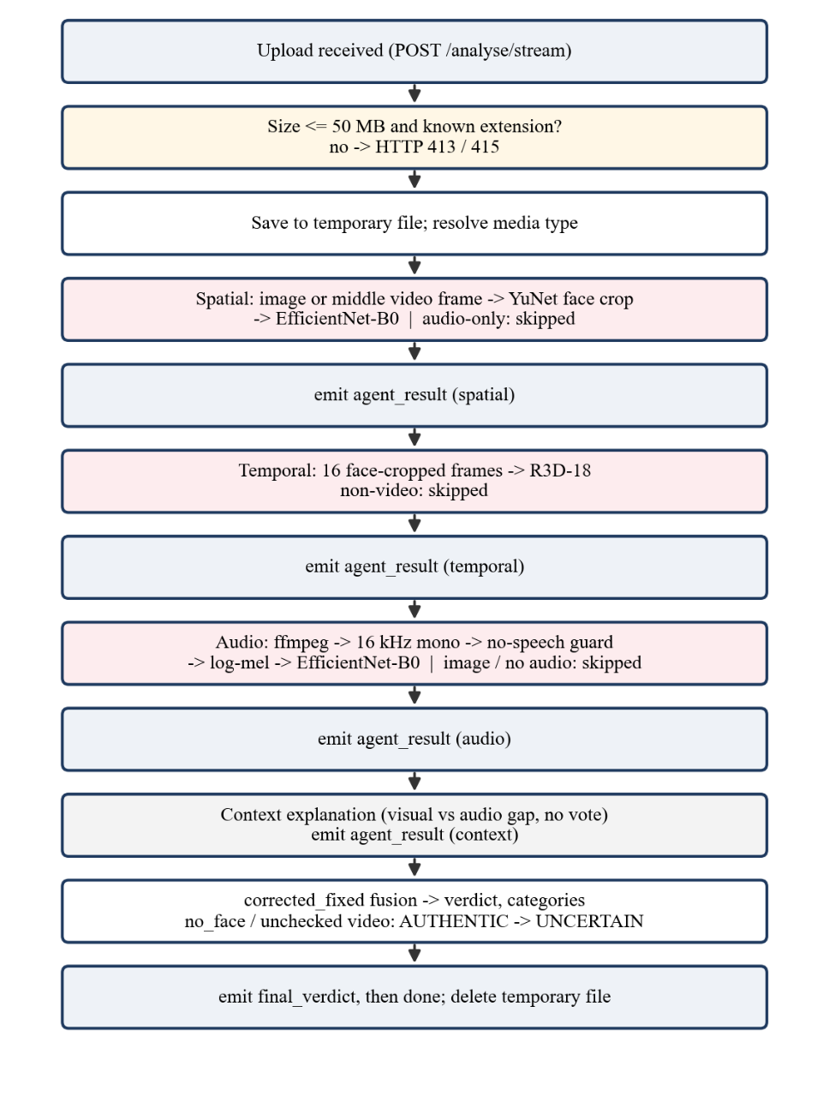
Figure A.1: Processing flowchart of the POST /analyse/stream endpoint

A.1 corrected_fixed fusion (backend/fusion_policy.py, abridged)
def compute_verdict_corrected_fixed(agents, media_type=""):
state_vec, metadata = extract_state_from_agents(agents, media_type)
p_sp = state_vec[0] if metadata["spatial_valid"] else None
p_te = state_vec[3] if metadata["temporal_valid"] else None
p_au = state_vec[6] if metadata["audio_valid"] else None
if p_sp is not None and p_te is not None:
p_vis = (0.40 * p_sp + 0.30 * p_te) / 0.70
else:
p_vis = p_sp if p_sp is not None else p_te
if p_vis is not None and p_au is not None:
p_fake = 1.0 - (1.0 - p_vis) * (1.0 - p_au)
elif p_vis is not None or p_au is not None:
p_fake = p_vis if p_vis is not None else p_au
else:
return 0.0, "UNVERIFIED MODALITY", ... # no detector produced a score
overall = round(p_fake, 4)
if overall > 0.55: verdict = "DEEPFAKE"
elif overall < 0.45: verdict = "AUTHENTIC"
else: verdict = "UNCERTAIN / INSUFFICIENT EVIDENCE"
# category probabilities: (1-pv)(1-pa), (1-pv)pa, pv(1-pa), pv*pa

A.2 No-speech guard (backend/audio_agent.py, abridged)
_SILENCE_DBFS = -60.0
_TONE_FRACTION = 0.995
def _no_speech_reason(wav_path):
x = centre 3 s crop of the 16 kHz mono waveform, scaled to [-1, 1]
if 20 * log10(rms(x)) < _SILENCE_DBFS:
return "Audio track is silent"
power = |rfft(x * hanning)|^2
if sum(6 largest bins of power) / sum(power) > _TONE_FRACTION:
return "Audio track is a pure tone, not speech"
return None # treated as speech and scored by the model

A.3 Context explanation (backend/mock_agents.py, abridged)
visual_p = (0.40 * spatial + 0.30 * temporal) / (sum of the weights present)
if visual_p is None or audio_p is None:
return not_applicable("Cross-modal consistency cannot be assessed.")
divergence = abs(visual_p - audio_p)
direction = "point the same way" if (visual_p >= 0.5) == (audio_p >= 0.5) else "point in different directions"
return {"status": "explanation", "confidence": divergence, "is_fake": None, ...} # never used in fusion

A.4 Reproducing the evaluation
The robustness results in Chapter 4 are produced by the scripts below, run from backend/training. Their raw outputs (per-clip scores and training logs) are stored in backend/training/robustness_eval_2026-10-24, and the written results in spatial_v2_results.md and audio_v2_results.md in the same directory.
python eval_spatial_robustness.py OUT.json <spatial checkpoints...>
python eval_temporal_robustness.py OUT.json
python eval_audio_robustness.py OUT.json <audio checkpoints...>
python eval_system_fusion_val.py OUT.json spatial.json temporal.json audio.json
cd backend && python -m pytest # 85 backend tests
cd frontend && node src/lib/ndjson.test.ts && npm run build

Appendix B: List of Papers Presented and Published
No paper based on this project had been submitted, presented or published at the time this report was prepared. If a paper is submitted or accepted before the final submission, the students should record its details in Table B.1 and attach a copy of the paper after this page.
Table B.1: Papers presented or published (to be completed by the students)
No. | Title and authors | Conference or journal | Status
1
2

Appendix C: Log Book
The project log book is kept by the students and countersigned by the faculty mentor. Its weekly entries could not be reconstructed from the project artefacts and are not invented here; Table C.1 is provided for the students to complete from their signed records.
Table C.1: Project log book (to be completed by the students and countersigned by the mentor)
Week | Date | Work carried out | Mentor remarks | Signature
1
2
3
4
5
6
7
8
9
10
11
12

For reference, Table C.2 lists the commits recorded in the project's Git repository. They document only the final implementation, data-integrity and evaluation stage of the project (22 to 24 October 2026) and do not replace the log book.
Table C.2: Commits recorded in the project repository
Date | Commit | Description
2026-10-22 | 09fddd9 | Add VERITAS multi-agent deepfake detection platform
2026-10-23 | d465f9b | Remove Express proxy; Vite forwards /api straight to FastAPI
2026-10-23 | d27d7c6 | Baseline snapshot before Phase 1 correctness fixes
2026-10-23 | d17dcee | Phase 1: correctness and reproducibility fixes
2026-10-23 | cc5739b | Phase 2: face detection and cropping before the visual models
2026-10-23 | 90dd041 | Phase 1 follow-up: no silent PPO fallback, safer media handling, accurate docs
2026-10-23 | b0bc442 | Archive audio calibration experiment (not deployed) and reconcile its results
2026-10-23 | f6ee889 | Manifest v2: exclude 26 byte-identical copies of authentic videos
2026-10-23 | 2b09cb1 | Pin line endings of hash-recorded files so recorded SHA-256 hashes hold on any checkout
2026-10-23 | 4a7753b | Manifest v3: list each file once per split (drop 11 repeated rows)
2026-10-23 | 4d97641 | Fix WAV cache filename collisions; add feature provenance
2026-10-23 | 07c2c16 | Re-evaluate audio calibration on collision-free features (not deployed)
2026-10-23 | 7f8847a | Fix temporal frame cache filename collisions
2026-10-23 | 5430c9e | Audio v2: augmentation, robustness evaluation and corrected-audio comparison
2026-10-23 | f8383bc | Version audio v2 candidate checkpoints with full hashes
2026-10-24 | 19b895a | Spatial v2: disk frame cache, degradation augmentation, robustness evaluations
2026-10-24 | 098a9bd | Load spatial v2 aug s0 and audio v2 aug s1 by default, with environment rollback
2026-10-24 | 74e52fe | Production hardening: no-speech audio guard, PPO detector gate, localhost binding
2026-10-24 | fbe4281 | Avoid misleading scores for unverifiable media

