**SYNOPSIS**

**On**

“Notepad”

**IN PARTIAL FULFILLMENT OF**

**MASTER OF COMPUTER APPLICATION**

**BY**

**Vaibhav Sanjay Mankar Roll no-33**

**MCA – I Semester - I**

**2021-2022**

**SUBMITTED TO**

**SAVITRIBAI PHULE PUNE UIVERSITY**

**Siddhant Institute of Computer Application**

**PUNE-411 041**

**Under the guidance of**

**Prof. (Name of College Project Guide)**

**Student Name: Vaibhav Sanjay Mankar**

**Date:23/01/22 Signature: Place: Pune**

# Report on Text Editor in Java

# Abstract

This is a simple text editor application developed in java or Notepad Application in Java Project with Source Code. It is created in java for front-end interface. It is used to simply write anything for our day to day use. Its main objective is to reduce the manual work and mistakes that occur in it. This application completely provides a user-friendly interface. Its main objective is to easily provide any support where users can write their notes and save it for further use. It has the variety of features.

# 1. Introduction

A useful text editor is an essential component of any personal computer. Every day we need to make notes, compose documents, and record vital pieces of information. We depend on our text editor.

In a broad sense, the application provides us with the ability to create, edit, and save files containing text. Text is a general category of keystrokes including, but not limited.

This application is a text editor in JAVA. This text editor developed in a JAVA platform is a replication of the word editors we all are familiar with and which we use quite often on a daily basis. The only difference being that, this editor has been created using JAVA for the front-end interface. The text edited in the editor is stored in the desired location.

# 2. Objective

Notepad is a common text-only ([plain text)](http://en.wikipedia.org/wiki/Plain_text) editor. The resulting files—typically saved with the [.txt](http://en.wikipedia.org/wiki/Text_file) extension—have no format tags or styles, making the program suitable for editing system files that are to be used in a [DOS](http://en.wikipedia.org/wiki/DOS) environment.

Notepad supports both left-to-right and right-to-left based languages, and one can alternate between these viewing formats by using the right or left Ctrl+Shift keys to go to right-to-left format or left-to-right format, respectively.

Unlike [WordPad,](http://en.wikipedia.org/wiki/WordPad) Notepad does not treat [newlines](http://en.wikipedia.org/wiki/Newline) in [Unix-](http://en.wikipedia.org/wiki/Unix) or [Mac-](http://en.wikipedia.org/wiki/Mac_OS)style text files correctly.

Early versions of Notepad offered only the most basic functions, such as finding text. Newer versions of Windows include an updated version of Notepad with a search and replace function ([Ctrl](http://en.wikipedia.org/wiki/Control_key) + H), as well as [Ctrl](http://en.wikipedia.org/wiki/Control_key) + F for search and similar [keyboard shortcuts.](http://en.wikipedia.org/wiki/Keyboard_shortcuts)

Notepad makes use of a built-in [window class](http://en.wikipedia.org/wiki/Window_class) named "EDIT". In older versions such as those included with Windows 9[5,](http://en.wikipedia.org/wiki/Windows_95) Windows 9[8,](http://en.wikipedia.org/wiki/Windows_98) Windows M[e](http://en.wikipedia.org/wiki/Windows_Me) and [Windows 3.1,](http://en.wikipedia.org/wiki/Windows_3.1) there is a 64k limit on the size of the file being edited, an operating system limit of the EDIT class.

Up to [Windows 95,](http://en.wikipedia.org/wiki/Windows_95) [Fixedsys](http://en.wikipedia.org/wiki/Fixedsys) was the only available [font](http://en.wikipedia.org/wiki/Font) for Notepad. [Windows NT 4.0](http://en.wikipedia.org/wiki/Windows_NT_4.0) and [98](http://en.wikipedia.org/wiki/Windows_98) introduced the ability to change this font. As of [Windows 2000,](http://en.wikipedia.org/wiki/Windows_2000) the default font was changed to Lucida Consol[e.](http://en.wikipedia.org/wiki/Lucida_Console) The font setting, however, only affects how the text is shown to the user and how it is printed, not how the file is saved to disk.

# 3. Functions of Notepad

1. **File Menu**

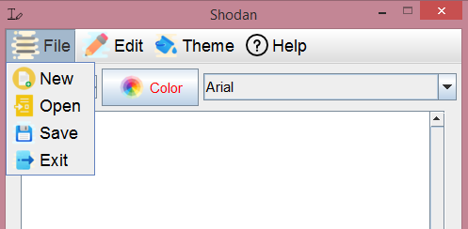

This is the File menu. Notice a couple of things about this menu. Notice the "..." at the end of several selections. This indicates that selecting these items will take you to a dialog box that will allow you to carry out that operation. Notice the code down the right side of the menu - Ctrl+N, Ctrl+O, etc. These are hotkeys you can use from within the document without having to go into the menu. For example, holding the <Ctrl> key down and pressing N is the same as going into the File menu and selecting New. These hotkeys can save you some time in getting to these functions. I wouldn't try to memorize these hotkeys right now, but just make a mental note of them - you'll learn them over time as you find them appropriate to your situation.

1. **New**

This will start a new document. If you are currently working on a document that you haven't saved, the system will prompt you to save the old document before starting a new one.

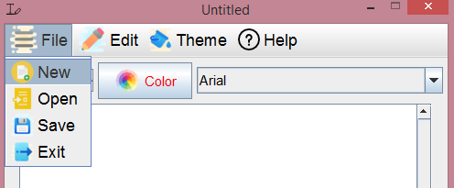

1. **Open**

- This allows you to bring an existing document into Notepad to view and/or edit it. You'll see the following dialog box when you make this selection:

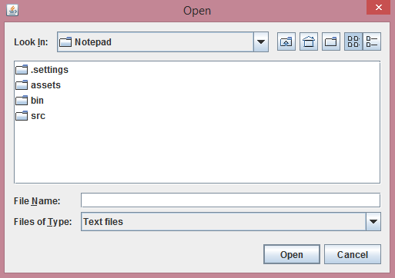

This is the standard Open dialog box used by most Windows programs. It consists of a toolbar across the top that shows you which folder you are currently in along with a couple of control buttons for getting to where you want to go. The main part of the Open dialog box shows you the files/folders that match the criteria for this application. Next is where the system will tell you the name of the file it thinks you want. Right now, it doesn't know so it assumes you want to look at all TXT files. Next is where you can tell the system what type of files you are interested in looking at. By default, Notepad looks at Text Documents (*.TXT), but you can change this to look at anything else. Finally, you can either Open the selection or Cancel this operation.

1. **Save**

If you are making modifications to an existing file, Save will put the changes back into the file after confirming that you really want to make the changes.

The program will automatically save the content at regular intervals. If the file has never been saved, it'll generate a save prompt asking you to specify a file name and save.

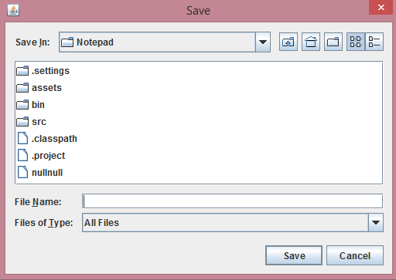

1. **Exit**

- This shuts down Notepad. If the file you've been working on has not been saved, you will be prompted to save the file before Notepad exits.

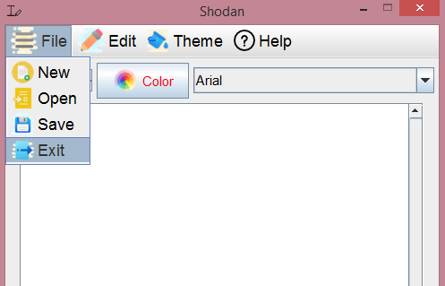

1. **Edit Menu**

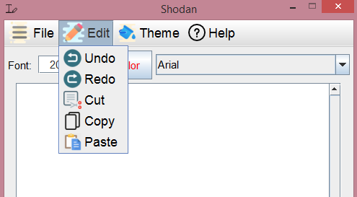

The Edit menu contains those functions that allow you to manipulate the information you have on the screen. In this case, there are four items that appear dim in the menu. The reason for this is that these items are not available at the present time. In most cases, you have to have something selected for these items to work. Windows does a pretty good job of communicating with you to tell you what you can and cannot do. Also notice that most of the items in the Edit menu have a key combination on the right (Ctrl+Z, etc.). These are hot keys that can be used from within the document without having to go to the Edit menu. For example, you can do a Copy from within a document by holding down the <Ctrl> key and pressing the "C" key. I don't recommend that you try and memorize these hot keys just now. Instead, I would recommend that you just make note of them as you use the menu items and over time pick up on those you use most frequently.

1. **Undo**

Notepad does have a rather neat feature called the Undo. In essence, this is your Oops button. If you make a mistake and suddenly say "Oops", you can select the Undo and reverse whatever it was you just did. Unless I'm mistaken, the Undo item will only work on the most recent change you've made to your document.

1. **Cut**

Again, this item is only available if you have something selected in your document. Otherwise you have nothing to Cut. You can select some piece of your document by holding down the left mouse button and dragging across the letters/words/sentences that you want to select. Your selection will have white letters and a blue background. Now you will be able to cut this selection. Cut removes the selected text from your document and puts it on the [Clipboard.](http://www.glantzberg.us/Windows/Windows031.htm) The information is not totally deleted, but is being held in case you want to put it somewhere else.

1. **Copy**

Copy is very similar to Cut. The only difference is that with Copy, your selected text is not removed from the document. Instead, a copy of your selected text is placed on the [Clipboard](http://www.glantzberg.us/Windows/Windows031.htm) for you to use later.

1. **Paste**

Once you have some text on the [Clipboard](http://www.glantzberg.us/Windows/Windows031.htm) (using either Cut or Copy above), you can move to wherever you would like to put this text and Paste it back into your document. In other words, the combination of Cut and Paste allows you to move text around within your document while the combination of Copy and Paste allows you to duplicate information.

1. **Font**

This allows you to change the font used to display the file you have open. It doesn't change the font of the file itself. It simply allows you to view/edit files using whatever font you wish.

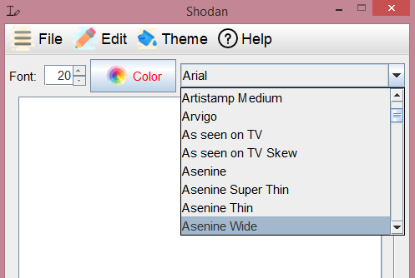

1. **Help Menu**

Most programs in Windows have a Help menu that provides information about using that particular program. The Help menu may not answer all your questions about a program, but I would encourage you to explore what is there before you look elsewhere. Most companies marketing software today are providing more Help and less hardcopy documentation.

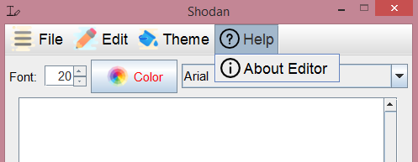

# 4. About Notepad

It is a simple text editor for Microsoft Windows and a basic text-editing program which enables computer users to create documents.

The function of the about for any program is simply to let you know what version of the program you are running. From time to time, the programmer might include some additional information about your system, but don't expect this. Here's what my version of About Notepad looks like:

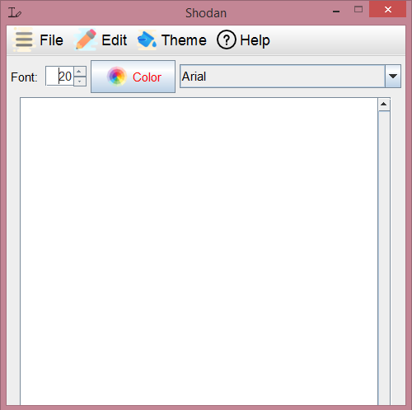

# 5. Advantages

* Notepad has a very simple and easy to use interface that doesn't take much memory and resources of the computer.
* Notepad offers users the option of editing and formatting texts especially when removing formatting from texts copied from a source e.g. the Internet.
* Notepad is a very useful tool for starters learning Website design and development in the sense that you get the opportunity to type in the html codes and see what each function does. You can also create a simple website with it, view it on the internet and host it online.

**6.Software Requirements Specifications**:-

∙ Front-end: Core and Advance Java

∙ Software required: Jdk

∙ Operating System required : Windows

**7.Hardware Requirement specifications:-**

∙ Processor: Pentium (4) or More for Optimum Performance.

∙ RAM : Minimum 256MB.

∙ Hard Disk : Minimum 1GB.

∙ It requires a 5MB of disk space to be completely installed

# 8. Disadvantages

* Easy to make a mistake.
* Slow, as all the code, has to be written by hand.

# 9. Areas for Improvement

Although a text editor should be a lightweight tool (and an inexpensive one), it should still pack a decent punch. If you need or want more from a text editor than you get from Notepad--but you don't want to waste money or system resources--we have six free options for you.

If you don't care about syntax highlighting or other coding features, and you just want "Notepad, but better," look at Notepad, which delivers improved just-plain-text editing for simple notes, memos, to-do lists, and other text-oriented tasks. It looks a lot like classic Notepad, but has quite a few more options, such as improved searching, sorting, and conversion functions (for dealing with text files.

# 10. Future scope

* Report on different basis can be easily created on demand.
* This project can be extended so that it will provide home delivery in those cities where this facility is available in present time.

# 10. Conclusion

A useful text editor is an essential component of any personal computer. Every day we need to make notes, compose documents, and record vital pieces of information. We depend on our text editor. We provided, a superbly useful software tool, for precisely these purposes.

This report provides an introduction to the functionality of the developed Notepad. No computer user should be without a thorough understands of the capabilities of this vital software application.

In a broad sense, the application provides us with the ability to create, edit, and save files containing text. Text is a general category of keystrokes including, but not limited to:

* Alphabetic characters (both upper and lower case),
* Numeric characters (0 through 9),
* Punctuation characters, and
* Formatting characters such as Enter, Tab, and Space.