Prompt:
“For some reason, when I run the code, I get this error:
Kernel Restarting: The kernel for project2/Project2/hurricane_harvey.ipynb appears to have died. It will restart automatically.”
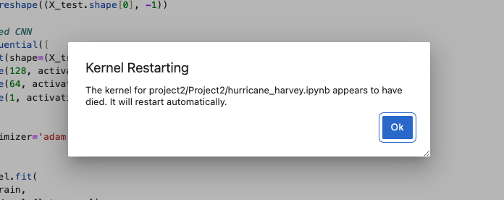

Output:
“That “Kernel Restarting” popup means your Python process inside Jupyter crashed at the OS level — usually because it ran out of RAM or GPU memory, not because of a syntax error.
Let’s break down why that happens in your specific block:
If your input images are, say, 256×256×3 and you have thousands of them, flattening makes each row 196,608 values wide.
So for even 10,000 images: 10,000 × 196,608 × 4 bytes ≈ 7.8 GB just for X_train_flat

Then you create X_val_flat, X_test_flat, and load them into TensorFlow, which makes internal copies. That can easily exceed your container or VM’s memory allocation and kill the kernel.

A fully connected (dense) ANN on flattened images has huge weight matrices — e.g.,
The first layer has 196,608 × 128, ≈ 25 million weights.
That’s hundreds of MB of parameters plus training batches in memory.
If your Docker container or VM only has 4–8 GB of RAM, the process gets killed by the OS (you’ll see Killed in logs if you check dmesg).

✅ How to fix or avoid it

Reduce image size before flattening
Resize your images before training: This shrinks each image to 64×64×3 → only 12,288 inputs instead of 196,608.

