**Name: Octavian Dragu**

**Student Number: 4555007**

**Course: Data processing**

**Date: 25.03.2022**

**Countries overview API**

**Usage documentation**

# Overview

With this API, data from different countries around the world about obesity, happiness and population is retrieved and sent to the users of the API. The data sets were provided from Kaggle, so the accuracy of the data is assumed to be correct.

# Requirements

The indications are written for Windows users.

The API was build using python flask. Flask is a web application framework written in Python and represent a web framework or a python module that lets you develop web applications easily.

Being a python module, to run it, the developer would need to install pip to install and manage additional packages that are not part of the Python standard library, such as Flask for example.

To check if you have python installed on your machine following the next step:

Open CMD and type **pip -V**, if you have it installed, the version of python should be displayed in CMD.

If Python is not installed, the following steps should be followed:

1. Download Python Executable Installer: Go to the official Python website ( <https://www.python.org> ) and download the latest version of Python.
2. Graphical user interface, text, application

   Description automatically generatedRun Executable Installer: Once the Python installer is downloaded run it. Make sure to check the boxes for install launcher for all users and Add Python to PATH.

In the next dialogue box, press Disable path length limit, which will allow Python to use long path names.

1. Check if Python and pip were installed by repeating the above step with CMD.

To install all of the modules required for this API, open a shell in the API folder and run:

“ pip install -r requirements.txt ”.

# Database

Due to the good efficiency in reading big amounts of data, sqlite was chosen to be used for this project. To view the db file, the developer will need to install sqlite on his machine, and open the file.

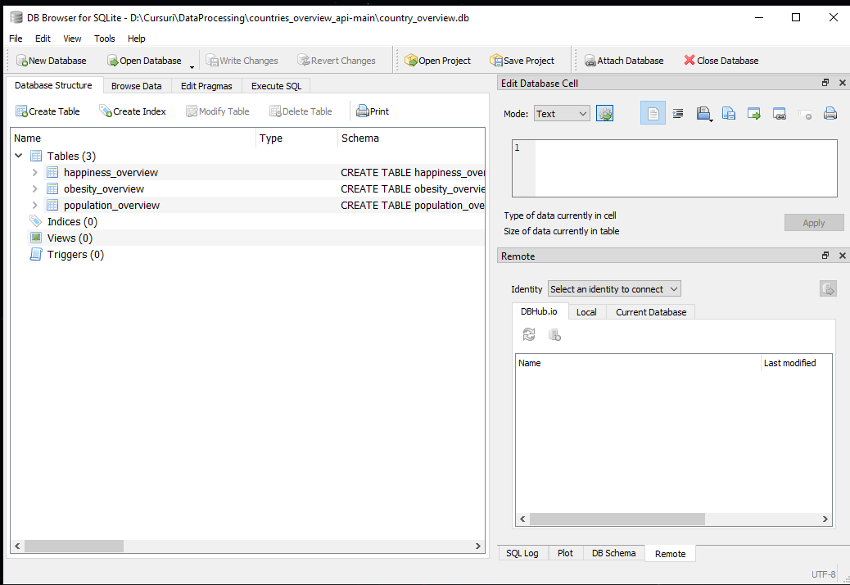

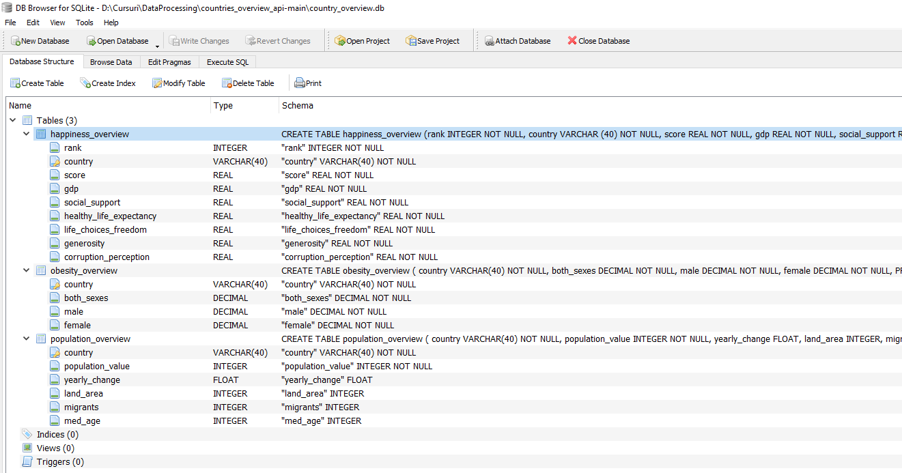

# Start the API

Open Shell in the API folder and type the following:

python api.py

# Routes

127.0.0.1:5000/happiness – World Happiness

127.0.0.1:5000/obesity – World Obesity

127.0.0.1:5000/population – World Population

The data comes in different types depending on headers: application/json, text/xml

# Consumer

The consumer was build using PHP and JS. The reason behind this was to expand the knowledge and skills with scripting programming languages in reading and work with data which is available in JSON /XML format.

To run the consumer, Xampp will need to be installed on your machine. After the installation just move the apiConsumer folder into it and start running it.