Pre-reactive gating in enzyme–substrate recognition
A kinetic hypothesis connecting screened electrostatics, conformational ensembles and quantum-assisted hydrogen transfer
Article type Perspective / falsifiable hypothesis | Draft 2.0 | 8 October 2026
Authorship To be confirmed before circulation; no institutional affiliation asserted

Abstract
Quantum-assisted hydrogen transfer is experimentally supported in selected enzyme systems, and electrostatic steering, conformational selection and protein dynamics influence substrate recognition. A stronger hypothesis requires more than placing these established phenomena in one sequence. We propose a narrowly defined, potentially measurable coupling: the electrostatic environment of a diffusing substrate may bias conformational-state probabilities before the formation of a persistent bound complex, and a residual kinetic memory of that bias may alter access to a short-range tunneling-competent geometry. Crucially, this effect is not guaranteed. Physiological ionic screening restricts the interaction range, and encounter durations may be too brief for slower protein motions to respond. We formulate an equilibrium limiting model and its time-dependent diffusion–conformation counterpart, derive illustrative energy and timescale bounds, and identify soybean lipoxygenase-1 as a mechanistically informative test bed. We distinguish the proposed pre-contact population response from electrostatic steering, conventional conformational selection, induced fit and post-binding gating. We specify discriminating experimental controls and rejection criteria, while treating possible transcriptional feedback as a separate downstream biological question. The contribution is a testable kinetic linkage, not a new quantum force, nonlocal substrate sensing, or evidence that enzymes anticipate future encounters.
Keywords | enzyme–substrate association; hydrogen tunneling; PCET; electrostatic screening; conformational selection; diffusion; kinetic isotope effects; soybean lipoxygenase-1

1 Central hypothesis and its null alternative
Enzymes can catalyze quantum-assisted hydrogen-transfer reactions, occupy dynamic conformational ensembles, and interact electrostatically with substrates prior to stable complex formation [1–7]. Yet the existence of these ingredients does not establish their mechanistic coupling. The present proposal asks whether an approaching substrate can, in some enzymes, bias the enzyme’s conformational probabilities at physically non-contact separations and whether that bias persists sufficiently through association to influence the distribution of subsequent tunneling-competent bound states.
Operational hypothesis (H₁): after controlling for ordinary diffusion, orientational steering, stable binding occupancy, and post-binding relaxation, a state-dependent pre-contact electrostatic interaction measurably alters the probability of entering a catalytic substate. Null hypothesis (H₀): the same kinetic observations are explained by standard electrostatic steering, ligand selection of pre-existing enzyme conformers, transient encounter binding, and/or induced fit; no separately resolvable pre-contact redistribution is required.
“Pre-contact” must have an operational definition (minimum atom–atom distance, hydration-shell boundary and absence of persistent site occupancy). A fleeting encounter complex must not be renamed “anticipation” to preserve the claim. Both models conserve causality and employ ordinary molecular interactions.

2 Established physical background

2.1 Quantum chemistry is local, not advance communication
Hydrogenic nuclear transfer and coupled proton–electron transfer (PCET) can display quantum contributions. Evidence includes intrinsic kinetic isotope effects and their temperature dependence, mutation-dependent donor–acceptor sampling, and microscopic modeling [1–3,8]. For a one-dimensional forbidden barrier, the WKB transmission scales approximately as:
T(E) ∝ exp{−2∫[x₁,x₂] [2m(V(x)−E)]¹ᐟ² dx / ℏ}, V(x) > E. (1)
The forbidden-region wavefunction is evanescent; this does not mean that atoms radiate signals, go “off shell,” or detect an approaching substrate without interaction. Electron transfer may involve longer tunneling distances in redox proteins [9], but transfer of an entire heavy substrate across solvent is not implied. For hydrogen-transfer chemistry the donor and acceptor must ultimately achieve appropriate short-range configurations.

2.2 Recognition involves competing kinetic pathways
Conformational selection and induced fit are not mutually exclusive labels for a protein; their relative flux depends on binding, dissociation, and conformational exchange rates [4,5]. An equilibrium population change inferred from ligand titration is not, by itself, evidence that the population changed before physical association. Kinetic traces may support several mechanisms unless exchange rates and binding occupancy are independently constrained [5,10].

2.3 Electrostatics are real but screened
Charge distributions influence substrate trajectories, protein dynamics and active-site electric fields. Electrostatic steering and ionic tethering have long been discussed in protein–ligand recognition [6]; local fields can contribute strongly to bound-state chemistry [7,11]. In bulk water at 0.15 M monovalent ionic strength, a simple Debye–Hückel estimate gives a screening length of approximately 0.79 nm. This is an idealized aqueous value, not a universal value within pockets, hydration shells, membranes or locally heterogeneous dielectric environments.
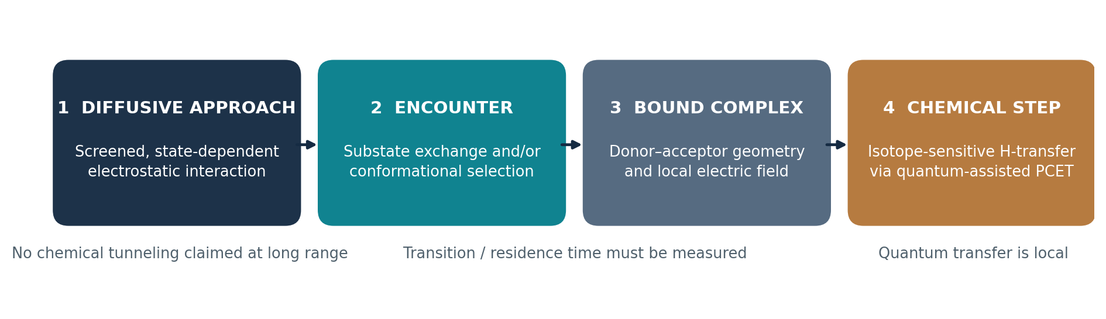
Figure 1. Four mechanistic stages. Only the first stage is the proposed additional pre-contact coupling; hydrogen transfer is assigned to the bound, short-range chemical step. This is a conceptual illustration, not experimental evidence.

3 Minimal thermodynamic and kinetic formulation

3.1 Conditional ensemble: the rapid-relaxation limiting case
Let an enzyme fluctuate among conformational states i with free energies Gᵢ⁰. A substrate at relative position r and orientation Ω modifies state-dependent interaction energies Uᵢ(r,Ω). If conformational equilibration is faster than changes in the encounter geometry, the conditional occupancy is:
πᵢ(r,Ω) = exp[−β(Gᵢ⁰ + Uᵢ(r,Ω))] / Σⱼ exp[−β(Gⱼ⁰ + Uⱼ(r,Ω))]. (2)
For a two-state inactive/competent representation, ΔG₀ = Gᴬ⁰ − Gᴵ⁰ and ΔU = Uᴬ − Uᴵ give:
πᴬ(r,Ω) = {1 + exp[β(ΔG₀ + ΔU(r,Ω))]}⁻¹. (3)
The central parameter is the differential interaction ΔU between substates; a uniform attraction that affects both states equally can steer approach without changing their relative populations. Equation (2) cannot be applied automatically to short, far-from-equilibrium encounters.

3.2 Non-equilibrium model: diffusion and exchange compete
If the encounter is fast relative to conformational exchange, one must evolve a joint probability density pᵢ(r,Ω,t), rather than assume instantaneous Boltzmann redistribution. A schematic translational form (orientational diffusion omitted for clarity) is:
∂ₜpᵢ = D∇·[∇pᵢ + βpᵢ∇Uᵢ] + Σⱼ(kⱼᵢpⱼ − kᵢⱼpᵢ) − kcap,ᵢ(r,Ω)pᵢ. (4)
Here D is relative diffusion, kᵢⱼ are conformation-exchange rates, and kcap describes entry into an operationally defined encounter/bound region. Reactant depletion and reaction chemistry must be represented by separate bound-state terms. The measurable prediction is that fitting both binding-resolved trajectories and intrinsic chemical rates requires nonzero state-dependent pre-contact coupling, not just a different association rate.

3.3 Quantum transfer belongs to the bound-state chemistry
For a chemically competent bound ensemble q (including donor–acceptor distance and electrostatic coordinates), the effective chemical rate can be approximated, only under appropriate averaging assumptions, by:
kchem,eff ≈ ∫dq ρbound(q) kchem(q), where kchem(q) may include tunneling. (5)
A changed second-order rate constant kcat/KM does not establish a changed intrinsic tunneling rate: association, dissociation, commitment factors and chemistry can all contribute. A test must separately estimate binding-state kinetics and hydrogen-transfer isotope effects [3].

4 Reality check: electrostatic strength and encounter duration
A convenient physical scale is the Bjerrum length lB = e²/(4πε₀εrkBT) ≈ 0.71 nm in water at 298 K. In a highly simplified homogeneous electrolyte, the interaction magnitude between two unit charges is |U|/kBT ≈ (lB/r) exp(−r/λD). For λD ≈ 0.79 nm, this evaluates to approximately 0.20 at 1 nm and 0.03 at 2 nm. These are pair-interaction scales—not predictions of conformational free-energy shifts. Charges, orientation, hydration and the protein dielectric can enhance, suppress, or even reverse the effective state dependence.
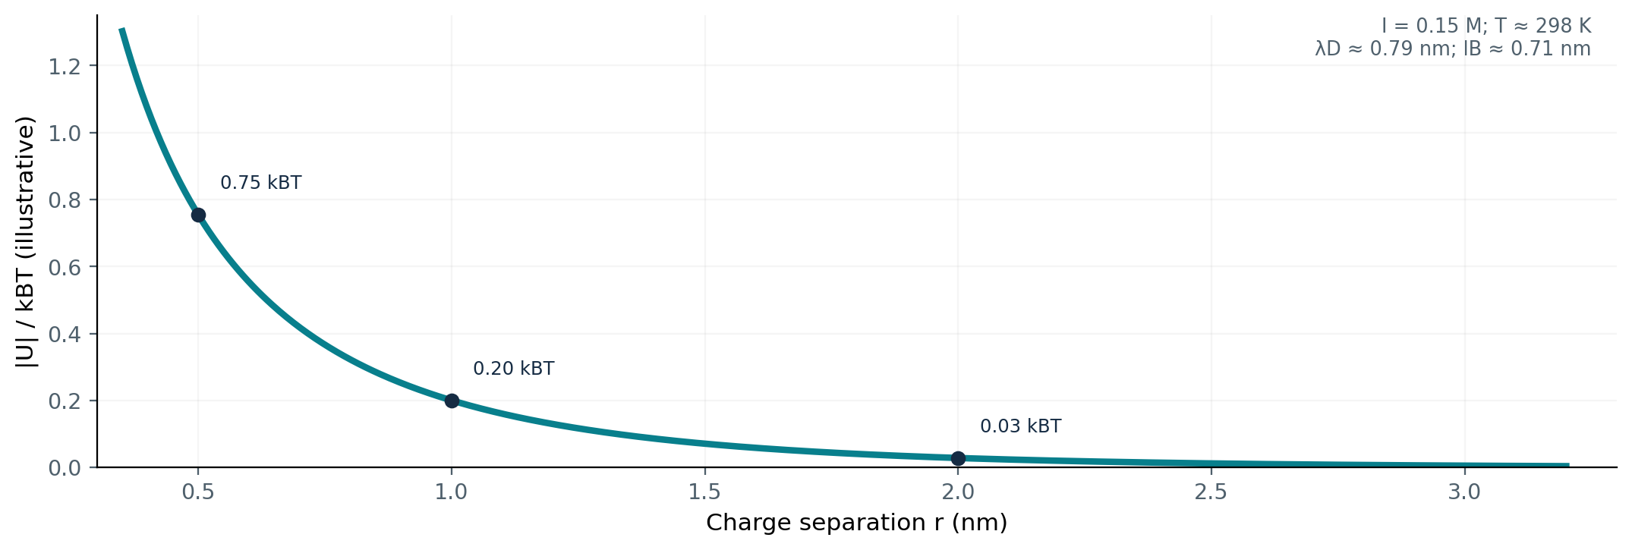
Figure 2. Illustrative screened unit-charge pair energy, using homogeneous Debye–Hückel theory. This is not an enzyme-specific field calculation; the sub-nanometre regime in particular requires explicit-solvent treatment.
A separate kinetic challenge is time. The elementary diffusion timescale τD ≈ r²/(6D) for r = 1 nm is about 0.17–1.7 ns when D = 10⁻⁹–10⁻¹⁰ m²/s. This is not a measured enzyme–substrate residence time: attractive interactions, repeated collisions and steric portals can extend residence. But it makes clear that microsecond–millisecond protein exchange cannot be assumed to equilibrate during an unimpeded nanosecond flyby. Ultrafast local polarization or side-chain response is a more plausible pre-contact target than concerted domain rearrangement.
Illustrative two-state calculation: if the competent state begins 2 kBT above the inactive state, its equilibrium occupancy is 0.119. A state-differential perturbation of −0.2 kBT would change that occupancy to 0.142 (an absolute increase of about 0.023) only if the ensemble has time to equilibrate. A −0.2 kBT differential is a hypothetical parameter, not a value inferred for SLO-1. If the relevant response is too slow, the actual change can be much smaller.

5 Proposed experimental platform: soybean lipoxygenase-1
Soybean lipoxygenase-1 oxidizes polyunsaturated fatty acids and has been extensively studied as an example of PCET with substantial hydrogen-isotope sensitivity. Mutational studies connect substrate-channel structure and donor–acceptor tuning to catalytic behavior [2,3,8,12]. Particularly useful work distinguishes first-order turnover isotope effects from second-order substrate capture and commitment effects, identifying a substrate-portal network [3]. This makes SLO-1 informative, not confirmatory, for testing pre-reactive gating.
Our proposed observable is the conditional probability of an enzyme configuration during solvent-exposed approach, ideally evaluated jointly with substrate distance and bound-state occupancy. The most realistic first phase is computational: use explicit-solvent trajectories, validated portal structures, multiple substrate protonation states, and physically matched charged/neutral analogues. The central output is ΔU(r,Ω), conformation-exchange times, and the lagged probability of reaching a catalytic donor–acceptor geometry after binding. The analogues must be checked for changed binding chemistry, solubility and nonspecific aggregation.
A second phase would target a subset of predicted interactions with mutagenesis and pre-steady-state isotope-resolved kinetics. Time-resolved structural or spectral probes should be selected only after the modeled lifetime and signal amplitude are known; ordinary stopped-flow fluorescence alone cannot resolve a nanosecond pre-contact event. Ultrafast optical approaches or photorelease methods have their own perturbation and synchrony problems [13].

6 Experiments designed to separate models
Test | Minimum controls | Decision-relevant observation
State-resolved explicit-solvent MD | Known portal mutants; charge states; matched-geometry analogue; force-field cross-check | An approach-dependent differential interaction and a conformational response before operational binding.
Diffusion/conformation master-equation fit | Joint fit of association, dissociation, exchange; held-out conditions | H₁ improves prediction of independent trajectories, not merely one fitted kcat/KM.
Charge and ionic-strength perturbations | Maintain pH, activity, viscosity, substrate solubility, binding affinity | Screening-dependent pre-contact coupling follows modeled state-specific field, not just capture rate.
H/D substrate isotope series | Independent binding/commitment measurements, isotope-position verification | After conditioning on binding kinetics, isotope-sensitive chemistry covaries with predicted access to short-range geometry.
Portal-directed mutations | Protein folding, activity, substrate portal and local-field checks | Changes in measured exchange/capture and chemical rates match a common quantitative model.
Independent structural/spectral probe | Reporter controls; timing relative to occupancy; no reporter-induced stabilization | A population change is resolved ahead of stable site occupancy at the resolution claimed.

Pre-register null comparisons. A model that explains only a concentration-dependent change in kcat or kcat/KM is not discriminating; those observables already respond to conventional kinetic mechanisms. Strong evidence would require independent, temporally resolved state and occupancy constraints and predictive transfer to new salt conditions, mutations or analogues.

7 Falsification criteria and competing explanations
The hypothesis should be regarded as unsupported for the studied enzyme if any of the following holds: (i) the state-dependent pre-contact energy is below reliable computational or experimental resolution; (ii) approach trajectories are shorter than required exchange times, with no fast mode large enough to matter; (iii) all changes can be reproduced by state-independent electrostatic steering plus ordinary bound-state conformational selection and induced fit; or (iv) putative pre-contact changes occur only in a transient complex that already satisfies the operational binding criterion.
Even a positive result would not demonstrate a new force or prove that evolution selected tunneling as a distinct objective. A positive result would support coupled encounter electrostatics → substate kinetics → bound-state chemical access. Alternative explanations include hydration changes, hydrophobic partitioning of fatty-acid substrates, ionic-strength effects on conformational stability, direct effects on PCET thermodynamics, probe artifacts, and altered microscopic commitment factors.

8 The transcriptional hypothesis is a separate, downstream question
The motivating thought that substrate arrival could stimulate mRNA synthesis of the same enzyme is biologically interesting but cannot be derived from tunneling alone. No established mechanism allows evanescent amplitude or “virtual atoms” to transmit a pre-encounter instruction to transcriptional machinery. Changes in metabolite production, redox state, allosteric signaling or sensor occupancy could alter transcription by ordinary cellular pathways. Adaptive prediction by microbial regulatory systems is documented [14], but is a population-level network property, not quantum foresight.
substrate availability → binding / catalysis → metabolite or sensor state → regulator → mRNA (6)
To test an mRNA extension, one must identify an organism, enzyme gene, signaling sensor, reporter and relevant response time. Until such a pathway is specified, this topic is excluded from the central pre-reactive-gating test.

9 Implications, originality and conclusion
This perspective does not claim originality for tunneling, protein conformational selection, electrostatic steering or their generic coexistence. Its narrower proposed contribution is an operational kinetic test for a state-differential, pre-contact electrostatic effect that survives binding sufficiently to modify access to a tunneling-sensitive chemical coordinate. This can fail either because the field is too weak or because the encounter is too brief—both outcomes are scientifically meaningful.
The immediate priority is therefore a quantitative feasibility analysis: compute screened approach-state interactions and conformational response times in a well-characterized enzyme, then determine whether a separable kinetic prediction survives alternative models. Only if that condition is met should complex experiments or broader biological claims be advanced. The model is deliberately local and causal: electrostatics conditions encounter statistics, molecular dynamics governs accessible geometry, and quantum-assisted transfer occurs during the chemical step.

References
[1] Robinson C, Yuen M, Brough H, Johannissen LO, Hay S. New Insight into Quantum Mechanical Hydrogen Tunneling in Enzymes. Biochemistry. 2026;65:237–248. https://doi.org/10.1021/acs.biochem.5c00769
[2] Klinman JP, Kohen A. Hydrogen Tunneling Links Protein Dynamics to Enzyme Catalysis. Annu Rev Biochem. 2013;82:471–496. https://doi.org/10.1146/annurev-biochem-051710-133623
[3] Hu S, Offenbacher AR, Lu ED, Klinman JP. Comparative kinetic isotope effects on first- and second-order rate constants of soybean lipoxygenase variants uncover a substrate-binding network. J Biol Chem. 2019;294:18069–18076. https://doi.org/10.1074/jbc.RA119.010826
[4] Weikl TR, Paul F. Conformational selection in protein binding and function. Protein Sci. 2014;23:1508–1518. https://doi.org/10.1002/pro.2539
[5] Hammes GG, Chang Y-C, Oas TG. Conformational selection or induced fit: a flux description of reaction mechanism. Proc Natl Acad Sci USA. 2009;106:13737–13741. https://doi.org/10.1073/pnas.0907195106
[6] Wade RC, Gabdoulline RR, Lüdemann SK, Lounnas V. Electrostatic steering and ionic tethering in enzyme–ligand binding: insights from simulations. Proc Natl Acad Sci USA. 1998;95:5942–5949. https://doi.org/10.1073/pnas.95.11.5942
[7] Eberhart ME, Alexandrova AN, Ajmera P, et al. Methods for Theoretical Treatment of Local Fields in Proteins and Enzymes. Chem Rev. 2025;125:3772–3813. https://doi.org/10.1021/acs.chemrev.4c00471
[8] Klinman JP. Importance of protein dynamics during enzymatic C–H bond cleavage catalysis. Biochemistry. 2013;52:2068–2077. https://doi.org/10.1021/bi301504m
[9] Page CC, Moser CC, Chen X, Dutton PL. Natural engineering principles of electron tunnelling in biological oxidation–reduction. Nature. 1999;402:47–52. https://doi.org/10.1038/46972
[10] Vogt AD, Di Cera E. Conformational selection or induced fit? A critical appraisal of the kinetic mechanism. Biochemistry. 2012;51:5894–5902. https://doi.org/10.1021/bi3006913
[11] Fried SD, Boxer SG. Electric Fields and Enzyme Catalysis. Annu Rev Biochem. 2017;86:387–415. https://doi.org/10.1146/annurev-biochem-061516-044432
[12] Li P, Soudackov AV, Hammes-Schiffer S. Impact of Mutations on the Binding Pocket of Soybean Lipoxygenase: Implications for Proton-Coupled Electron Transfer. J Phys Chem Lett. 2018;9:6444–6449. https://doi.org/10.1021/acs.jpclett.8b02945
[13] Uzorka A, Shanmugan S. Time-resolved spectroscopy in protein dynamics and enzyme mechanisms. Prog Biophys Mol Biol. 2026;201:212–238. https://doi.org/10.1016/j.pbiomolbio.2026.07.003
[14] Mitchell A, Romano GH, Groisman B, et al. Adaptive prediction of environmental changes by microorganisms. Nature. 2009;460:220–224. https://doi.org/10.1038/nature08112

Editorial and reproducibility note
This is a theory/perspective manuscript: no original wet-lab measurements, molecular trajectories, parameter fits or statistical significance tests are reported. Figures are original explanatory drawings. All numbers in Section 4 are idealized order-of-magnitude calculations, explicitly distinguished from enzyme-specific results. The final submission would require authorship confirmation, independently reviewed calculations, a target journal’s format and a specialist review of mechanistic assumptions.

