Pre-Reactive Quantum Gating in Enzyme-Substrate Recognition
A testable hypothesis linking electrostatic steering, conformational selection, and quantum tunneling
Article type: Hypothesis / Perspective
Status: Working manuscript for refinement and expert review
Abstract
Quantum mechanical tunneling contributes measurably to selected enzyme-catalyzed hydrogen- and electron-transfer reactions, while electrostatic steering, electrostatic preorganization, protein dynamics, and conformational selection independently shape molecular recognition and catalytic competence. This article proposes a unified but deliberately conservative extension of these observations: an approaching substrate may, within the ordinary range of electrostatic and solvent-mediated interaction, perturb the population of a pre-existing enzyme conformational ensemble before a long-lived Michaelis complex is formed. If particular substates shorten donor-acceptor distances or reshape the local electrostatic environment, such an encounter-stage population bias could increase the probability of reaching a tunneling-ready configuration. Tunneling itself remains a short-range quantum event and does not transmit information ahead of the substrate or require non-causal physics. A minimal statistical-mechanical model is formulated in which the substrate-dependent electric field shifts conformational free energies and the observed reaction rate is an ensemble average of configuration-dependent tunneling rates. The hypothesis generates falsifiable predictions involving ionic strength, charge-isosteric substrate analogues, distal electrostatic mutations, time-resolved conformational probes, vibrational Stark spectroscopy, kinetic isotope effects, and multiscale Brownian-dynamics/MD/QM-MM simulations. A more speculative extension considers whether repeated microscopic catalytic-state changes could couple indirectly to transcriptional regulation through established metabolite-sensing or signaling pathways. The proposal therefore separates three levels of claim: established quantum-assisted catalysis, testable pre-reactive ensemble gating, and speculative regulatory coupling.
Keywords: enzyme catalysis; quantum tunneling; hydrogen transfer; electrostatic steering; conformational selection; protein dynamics; kinetic isotope effect; pre-reactive gating
Significance statement
The proposal does not require enzymes to “sense the future.” It asks a narrower question: can ordinary pre-binding electrostatic interactions measurably bias a pre-existing conformational ensemble toward geometries in which a later quantum transfer step becomes more probable? If yes, molecular recognition and quantum-assisted chemistry would be linked continuously rather than treated as entirely separate stages.

1. Scope and central claim
Enzyme catalysis is often described as a sequence of substrate encounter, binding, formation of a catalytically competent complex, barrier crossing, and product release. This decomposition is experimentally useful, but it can obscure the fact that molecular interactions are continuous. Charged and polar substrates begin interacting with an enzyme before stable binding; enzymes occupy conformational ensembles rather than a single structure; and, for some chemical steps, light-particle transfer can contain a substantial tunneling component [1,2].
The central hypothesis developed here is that these facts may be coupled. During the encounter phase, the electric field and polarization associated with an approaching substrate could weakly shift the relative free energies of pre-existing conformational substates. When one subset of those substates possesses shorter donor-acceptor distances, more favorable active-site electrostatics, or both, the population shift would alter the probability of reaching a tunneling-ready state. The quantum event remains local: the proposed novelty lies in how the probability of entering the required geometry might already be changing during the approach to binding.
The proposal explicitly rejects a literal interpretation in which an enzyme detects an incoming molecule through virtual particles, “off-shell atoms,” or information transfer from a future collision. Off-shell/on-shell terminology is useful in relativistic quantum-field calculations but is not the appropriate language for ordinary nuclear motion in an enzyme. The molecularly relevant concepts are wavefunction delocalization, barrier penetration, electronic coupling, nuclear tunneling, solvent screening, and conformational population shifts.

Evidence levels used in this manuscript
Level | Claim | Status
Established | Hydrogen/electron tunneling can contribute to selected enzymatic reactions; electrostatics and conformational dynamics influence catalysis and recognition. | Supported by experimental and theoretical literature [1-13].
Proposed | Encounter-stage substrate electrostatics can shift the enzyme ensemble before a long-lived bound complex, increasing occupancy of tunneling-ready substates. | Plausible but not established; core hypothesis of this paper.
Speculative extension | Microscopic gating states could indirectly alter enzyme abundance through conventional regulatory networks. | Requires a separate signaling mechanism; no direct tunneling-to-mRNA pathway is claimed.

2. Empirical foundations

2.1 Quantum tunneling in enzymatic transfer reactions
Quantum mechanical tunneling is now accepted as a significant contributor in a subset of enzyme-catalyzed hydrogen-transfer reactions [1]. The strongest mechanistic evidence has come from kinetic isotope effects (KIEs), their temperature dependence, mutation studies, and theoretical models that treat hydrogen transfer in a Marcus-like or vibronically nonadiabatic framework [2,3]. Because tunneling probability is exponentially sensitive to barrier width and transferred mass, small changes in donor-acceptor geometry can have large kinetic consequences.
For a one-dimensional barrier, a semiclassical transmission factor can be represented schematically as:
P_tun ∝ exp[-2 ∫(x₁→x₂) κ(x) dx], κ(x) = √(2m[V(x)-E]) / ħ (1)
Within a classically forbidden region where V(x) > E, the WKB wavevector is imaginary and the amplitude decays evanescently. This is the mathematically defensible counterpart of describing the wavefunction as extending into a forbidden region; it is not radiation and does not constitute advance signaling.
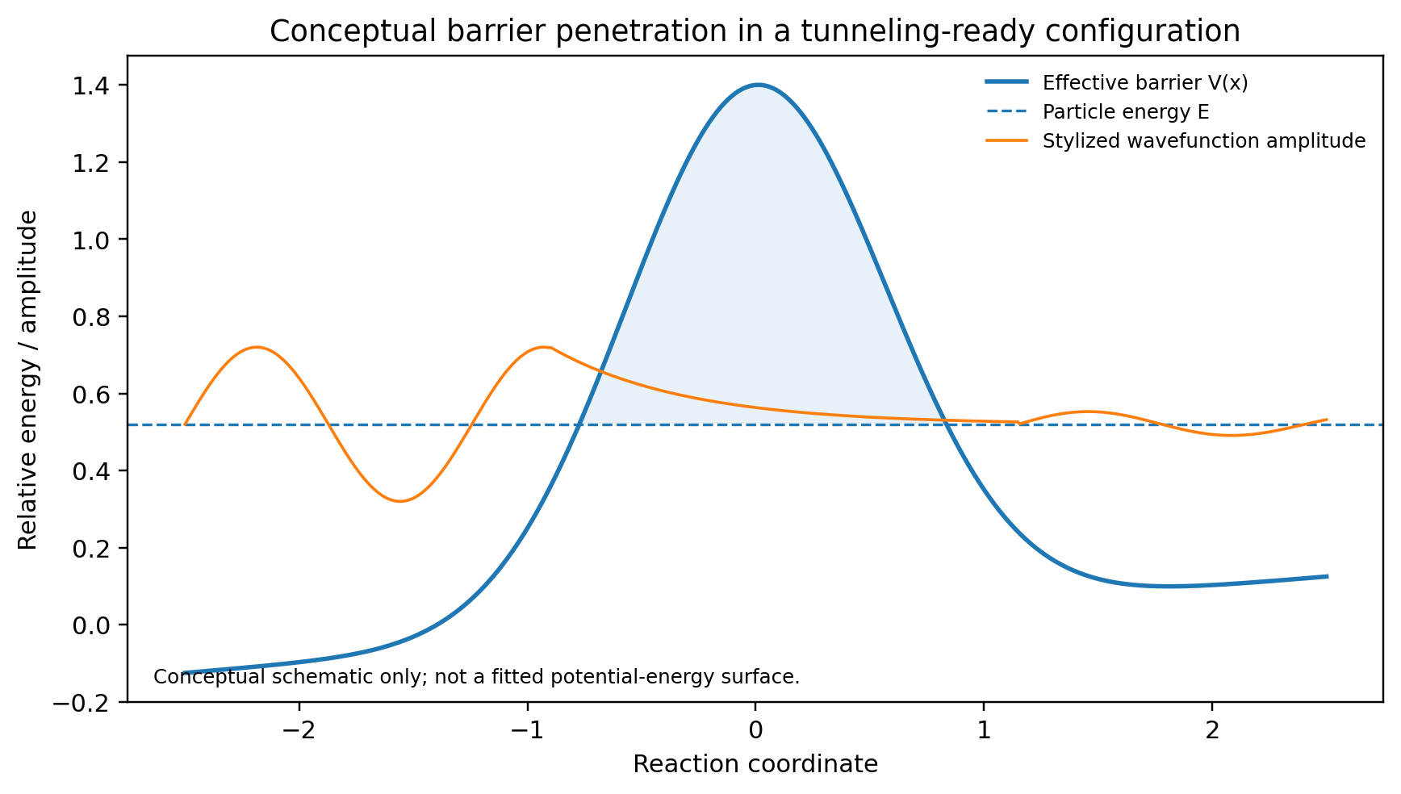
Figure 1. Conceptual barrier penetration. The plotted wavefunction is illustrative and is not intended to represent a particular enzyme potential-energy surface.
Protein motions can influence the probability of reaching short donor-acceptor distances. Experimental analyses of hydrogen transfer have therefore emphasized “donor-acceptor distance sampling” and tunneling-ready states [2,3]. Recent work continues to test how system rigidity, free-energy changes, and vibrational dynamics correlate with the temperature dependence of isotope effects [3].

2.2 Conformational selection and dynamic ensembles
Enzymes and other proteins occupy distributions of interconverting conformations. Conformational-selection models hold that ligand-compatible and catalytically useful substates can exist before ligand binding, with the ligand preferentially stabilizing or selecting members of the ensemble [4,5]. This does not exclude induced fit; both mechanisms can contribute on different timescales. The key premise required here is only that the unbound enzyme samples substates whose catalytic geometries and electrostatic environments are not identical.

2.3 Electrostatic steering and preorganization
Electrostatic interactions can influence the diffusional approach and orientation of substrates. Brownian-dynamics simulations and comparative studies have long shown that enzyme electrostatic fields can enhance association and orient charged substrates toward active sites [6,7]. Separately, electrostatic preorganization is a major framework for explaining catalytic stabilization of charge distributions along reaction coordinates [8-10]. Modern treatments emphasize that protein-generated fields fluctuate with protein dynamics and can be quantified with computational electrostatics and, in favorable systems, vibrational Stark spectroscopy [8,9].
These observations motivate a specific gap in the conventional narrative: if a substrate can experience and respond to an enzyme field before binding, the enzyme is subject to the reciprocal field of the substrate as well. The question is not whether the interaction exists, but whether it is large and structured enough, after solvent dielectric attenuation and ionic screening, to measurably bias the conformational ensemble on encounter timescales.

2.4 Electron tunneling as a boundary case
Long-range biological electron transfer demonstrates that electron tunneling through protein media can occur over distances of roughly 10-20 Å in appropriate redox architectures [11-13]. This should not be generalized to whole substrates or heavy nuclei: the much larger masses of nuclei make their tunneling amplitudes far more distance-sensitive. The present hypothesis therefore assigns encounter-stage action to classical electrostatics and conformational statistics, reserving nuclear tunneling for short donor-acceptor separations and electron tunneling for systems where established electronic coupling permits it.

3. Pre-reactive quantum-gating hypothesis
The proposed mechanism has four stages. None requires a stable enzyme-substrate complex at the first two stages, but all require ordinary physical interaction.
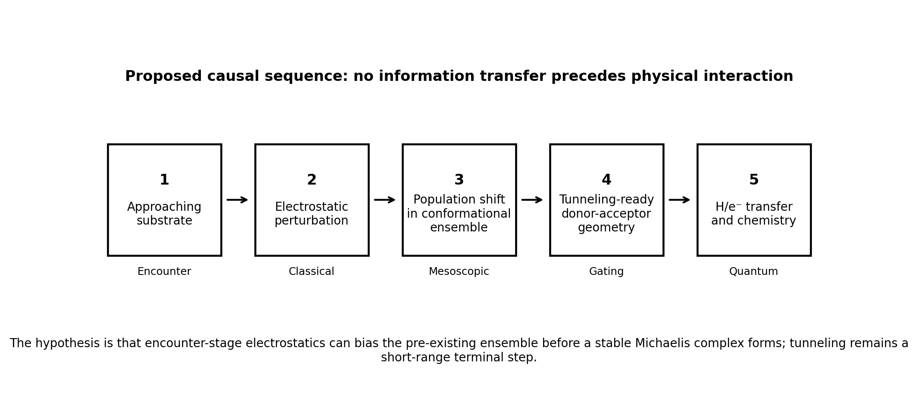
Figure 2. Proposed causal sequence linking encounter-stage electrostatics to short-range quantum transfer.

3.1 Encounter-stage field perturbation
At separation r, the substrate produces an electrostatic potential and field that are strongly modified by water, counterions, protein surface charge, and geometry. Within an encounter complex or near-surface diffusional trajectory, this field may interact with permanent dipoles, induced dipoles, charged residues, and collective polarization of the enzyme. The effect is expected to become negligible outside the screened interaction range; no macroscopic or unscreened “quantum sensing” is assumed.

3.2 Population bias of pre-existing substates
Suppose an unliganded enzyme samples conformational states i with baseline free energies Gᵢ⁰. An approaching substrate creates a local field E_s that perturbs each state differently because its charge distribution, dipole moment, polarizability, hydration pattern, and residue geometry differ. A minimal expression is:
Pᵢ(E_s) = exp{-β[Gᵢ⁰ + ΔGᵢ(E_s)]} / Z(E_s) (2)
ΔGᵢ(E_s) ≈ - μᵢ · E_s - ½ E_s · αᵢ · E_s + ΔGᵢ,solv (3)
Here β = 1/(kBT), μᵢ and αᵢ represent effective state-dependent dipolar and polarizability responses, and ΔGᵢ,solv summarizes solvent and ionic contributions. Equation (3) is deliberately coarse-grained: for realistic proteins, explicit-solvent electrostatics, many-body polarization, and conformational coupling would be required.

3.3 Formation of a tunneling-ready state
For a state described by donor-acceptor distance R and additional coordinates q, define a conditional tunneling-associated chemical rate k_tun(R,q). The observed chemical rate can then be written conceptually as an ensemble average:
k_obs(E_s) = ∫ dR dq P(R,q | E_s) k_tun(R,q) (4)
Because k_tun may depend exponentially on barrier width, a small field-induced shift in P(R,q | E_s) need not be large in population terms to create a measurable kinetic effect. This is the central quantitative claim: the substrate need not “trigger” tunneling at a distance; it need only alter the probability that subsequent thermal and structural fluctuations reach the narrow region of configuration space in which tunneling is efficient.

3.4 Relation to conformational selection and induced fit
The hypothesis is compatible with a continuum between conformational selection and induced fit. A weak encounter-stage perturbation could enrich a substate before stable binding; binding could then produce additional structural rearrangement; finally, local donor-acceptor sampling could generate the tunneling-ready state. The novelty is therefore not a new fundamental force but an experimentally separable ordering of already recognized physical processes.

4. Predictions and falsification criteria
A useful hypothesis must outperform a narrative by making observations that would be unlikely under a simpler model in which only diffusion and post-binding induced fit matter. The following predictions are designed with that criterion in mind.
P1 - Electrostatic screening should attenuate any pre-binding population bias. Increasing ionic strength should reduce encounter-stage electrostatic steering and any substrate-dependent conformational bias, after separately correcting for effects on binding affinity, protein stability, and the chemical step. A purely post-binding mechanism could show salt effects too, so the discriminating observation is a pre-binding conformational signal correlated with screening.
P2 - Charge-isosteric substrate analogues should separate shape from field effects. Analogues with similar steric shape and binding geometry but altered charge distribution or dipole should produce different pre-reactive ensemble shifts if electrostatics is causal. Nonreactive analogues are especially useful because they decouple conformational effects from turnover.
P3 - Distal electrostatic mutations can alter gating without gross active-site rearrangement. Mutations that change long-range field organization but preserve the mean active-site structure should change the occupancy or lifetime of tunneling-ready substates and may alter intrinsic KIE behavior. The strongest test would correlate computed field changes, time-resolved structural measurements, and isotope-sensitive kinetics.
P4 - The pre-reactive conformational response should precede stable complex formation. Rapid-mixing spectroscopy, NMR relaxation dispersion, single-molecule FRET, fluorescence lifetime probes, or other time-resolved methods should detect a substrate-concentration-dependent population change on an encounter timescale before the fully bound state dominates.
P5 - Isotopic substitution should affect the terminal transfer step more strongly than encounter steering. Replacing H with D or T should strongly alter the quantum-transfer component while leaving classical electrostatic approach approximately unchanged. A kinetic model that resolves association, conformational gating, and chemistry should therefore localize the isotope sensitivity to the later step rather than the initial field response.
P6 - Multiscale simulation should recover a distance-dependent ensemble bias. Brownian dynamics can sample approach trajectories; explicit-solvent MD can quantify state populations as a function of substrate separation and orientation; QM/MM or path-integral approaches can estimate the chemical/tunneling step. The hypothesis predicts a reproducible coupling between substrate position, enzyme-field response, conformer occupancy, and tunneling-relevant geometry.

Falsification criteria
The core hypothesis would be weakened substantially if (i) no substrate-dependent conformational population shift is detectable before stable binding in systems where simulations predict an appreciable field perturbation; (ii) observed kinetic effects are fully reproduced by diffusion, binding thermodynamics, and post-binding induced fit without a pre-reactive state; (iii) charge redistribution at fixed steric geometry does not alter the proposed gating observables; or (iv) tunneling-sensitive KIE changes fail to correlate with the population of candidate short-distance substates. Negative results in one enzyme would not disprove the mechanism universally, but repeated failure across appropriately chosen high-electrostatic, tunneling-sensitive systems would.

5. Experimental program
Experiment | Perturbation | Primary readout | Discriminating outcome
Rapid-mixing conformational probe | Substrate/analogue concentration; ionic strength | Pre-steady-state FRET/fluorescence/NMR population kinetics | A reversible conformational shift appears during encounter before the final bound-state signature.
Kinetic isotope series | H/D/T substrate isotopologues | Intrinsic KIE and temperature dependence | Isotope sensitivity maps to chemical transfer while pre-binding conformational response is largely isotope-insensitive.
Charge-isosteric analogue panel | Change charge/dipole with minimal steric change | Association rate, conformer population, KIE | Field-sensitive changes remain after controlling for affinity and shape.
Distal field mutations | Neutralize/invert selected remote charges | Stark shift, conformer occupancy, rate | Field perturbation predicts gating changes without requiring a large mean structural change.
Multiscale computation | Substrate separation/orientation coordinate | Electrostatic field, free-energy landscape, DAD distribution | Approach-dependent shifts in the probability of tunneling-ready geometries are reproduced quantitatively.
A practical starting system should satisfy three conditions: (1) a well-characterized hydrogen-transfer KIE or electron-transfer tunneling signature, (2) tractable pre-steady-state or structural spectroscopy, and (3) a substrate whose electrostatic properties can be modified without catastrophically changing sterics or chemistry. Flavoenzymes, selected dehydrogenases, lipoxygenase-family systems, or engineered model enzymes may offer candidates, but system selection should be driven by experimental accessibility rather than by the desire to force the hypothesis onto every enzyme class.

6. Why “off-shell sensing” is not required
The intuitive origin of this hypothesis can be expressed without importing quantum-field terminology that would create unnecessary conceptual problems. In nonrelativistic molecular quantum mechanics, nuclei and electrons are represented by quantum states whose amplitudes can extend into classically forbidden regions. In a tunneling calculation, the wavefunction decays across a barrier rather than vanishing at its classical boundary. That mathematical fact does not imply that an atom continuously emits a detectable precursor or that an enzyme can obtain information from a molecule before an interaction propagates to it.
Similarly, Heisenberg uncertainty describes constraints on the joint localization of conjugate variables; it does not imply that an atom randomly explores arbitrary macroscopic positions. The relevant molecular uncertainty is already encoded in the spatial distribution and vibrational state of the nuclei/electrons. For the proposed model, the physically sufficient “advance” interaction is ordinary electrostatics acting during the diffusional encounter, followed by state-dependent conformational statistics and then short-range tunneling.

7. Regulatory extension: from catalytic microstates to gene expression
The original motivating idea also asks whether pre-reactive or catalytic quantum effects might cause increased expression of the same enzyme through mRNA. No evidence currently supports a direct mechanism in which a tunneling wavefunction itself signals the transcriptional machinery. Transcription occurs through biochemical sensors, transcription factors, RNA regulators, signaling metabolites, and other established network components.
A weaker, biologically conventional extension is nevertheless testable. If an enzyme or pathway repeatedly samples a distinctive catalytic/redox/conformational state as substrate availability rises, that state could change metabolite concentrations, redox balance, second messengers, protein-protein interactions, or sensor occupancy. Those ordinary signals could then alter transcription. Microorganisms are also known to evolve regulatory programs that anticipate statistically predictable environmental changes [14]. Such anticipation is network-level adaptation, not quantum foresight.
Accordingly, a future regulatory model should be written as two coupled layers rather than a single quantum-to-mRNA step:
substrate encounter → ensemble bias → catalytic state / product flux → sensor or regulator → transcription (5)
The first arrow sequence is the molecular hypothesis advanced here; the final regulatory arrows would require organism- and pathway-specific evidence.

8. Limitations and alternative explanations
Several effects could mimic the proposed mechanism. Ionic strength alters protein stability, ligand activity coefficients, association kinetics, and active-site electrostatics after binding. Mutations may change hydration or dynamics rather than a simple scalar electric field. Fluorescent probes can perturb the conformational landscape they are intended to measure. Apparent pre-binding states can represent transient encounter complexes that already meet an operational definition of binding. Moreover, the contribution of protein dynamics to the chemical barrier remains system-dependent and debated; a correlation between motion and rate does not by itself prove dynamical “promotion” of barrier crossing.
The model should therefore be treated as an ensemble-kinetic hypothesis, not as a claim that tunneling explains enzyme catalysis generally. In many enzymes, classical transition-state stabilization, acid-base chemistry, covalent catalysis, metal coordination, entropy, desolvation, and geometric preorganization may dominate. Even in enzymes with measurable tunneling, the evolutionary importance of tunneling can differ from the mere existence of the effect.

9. Conclusion
The proposed pre-reactive quantum-gating framework links three independently established features of enzymology: electrostatic interactions during molecular encounter, pre-existing conformational ensembles, and quantum-assisted transfer in selected chemical steps. It predicts that an approaching substrate can sometimes alter the statistical weight of enzyme substates before stable binding, thereby changing the probability that subsequent fluctuations reach a tunneling-ready geometry. The proposal is causal and local: classical interactions bias the ensemble; quantum tunneling acts only when appropriate short-range geometry and energetics have been achieved.
The scientific value of the hypothesis is therefore not that it invokes quantum mechanics, but that it defines an experimentally separable intermediate layer between diffusion and chemistry. If pre-binding ensemble shifts correlate with field perturbations and with later tunneling-sensitive kinetics, the traditional boundary between “recognition” and “reaction” would become less discrete. If those correlations fail under controlled tests, the model can be rejected without disturbing the established evidence for tunneling or conformational dynamics themselves.

References
[1] Robinson C, Yuen M, Brough H, Johannissen LO, Hay S. New Insight into Quantum Mechanical Hydrogen Tunneling in Enzymes. Biochemistry. 2026;65(3):237-248. doi:10.1021/acs.biochem.5c00769.
[2] Klinman JP, Kohen A. Hydrogen Tunneling Links Protein Dynamics to Enzyme Catalysis. Annu Rev Biochem. 2013;82:471-496. doi:10.1146/annurev-biochem-051710-133623.
[3] Austin-Kloppe A, DeGroot N, Dhakal B, Sager J, Phan L, Poormoghim S, Lu Y. Free energy relationship analysis for temperature dependence of hydride kinetic isotope effects of NADH/NAD+ model reactions: implication for barrier compression by enzyme dynamics. Chem Sci. 2026;17:12440-12450. doi:10.1039/D6SC01847E.
[4] Ma B, Nussinov R. Enzyme dynamics point to stepwise conformational selection in catalysis. Curr Opin Chem Biol. 2010;14(5):652-659. doi:10.1016/j.cbpa.2010.08.012.
[5] Weikl TR, Paul F. Conformational selection in protein binding and function. Protein Sci. 2014;23(11):1508-1518. doi:10.1002/pro.2539.
[6] Wade RC, Gabdoulline RR, Lüdemann SK, Lounnas V. Electrostatic steering and ionic tethering in enzyme-ligand binding: insights from simulations. Proc Natl Acad Sci USA. 1998;95(11):5942-5949. doi:10.1073/pnas.95.11.5942.
[7] Sharp K, Fine R, Honig B. Computer simulations of the diffusion of a substrate to an active site of an enzyme. Science. 1987;236(4807):1460-1463. doi:10.1126/science.3589666.
[8] Eberhart ME, Alexandrova AN, Ajmera P, et al. Methods for Theoretical Treatment of Local Fields in Proteins and Enzymes. Chem Rev. 2025;125(7):3772-3813. doi:10.1021/acs.chemrev.4c00471.
[9] Dubey KD, Stuyver T, Shaik S. Local Electric Fields: From Enzyme Catalysis to Synthetic Catalyst Design. J Phys Chem B. 2022;126(49):10285-10294. doi:10.1021/acs.jpcb.2c06422.
[10] Warshel A, Sharma PK, Kato M, Xiang Y, Liu H, Olsson MHM. Electrostatic Basis for Enzyme Catalysis. Chem Rev. 2006;106(8):3210-3235. doi:10.1021/cr0503106.
[11] Page CC, Moser CC, Chen X, Dutton PL. Natural engineering principles of electron tunnelling in biological oxidation-reduction. Nature. 1999;402(6757):47-52. doi:10.1038/46972.
[12] Mostajabi Sarhangi S, Matyushov DV. Electron Tunneling in Biology: When Does it Matter? ACS Omega. 2023;8(30):27355-27365. doi:10.1021/acsomega.3c02719.
[13] Stuchebrukhov AA. Long-Distance Electron Tunneling in Proteins: A New Challenge for Time-Resolved Spectroscopy. Laser Phys. 2010;20(1):125-138. doi:10.1134/S1054660X09170186.
[14] Mitchell A, Romano GH, Groisman B, et al. Adaptive prediction of environmental changes by microorganisms. Nature. 2009;460:220-224. doi:10.1038/nature08112.

Notes for further development
This is a hypothesis/perspective draft rather than a report of new experimental data. Before submission, the manuscript would benefit from (i) selection of one enzyme system as a concrete case study, (ii) quantitative order-of-magnitude estimates for screened substrate fields and expected conformational free-energy shifts, (iii) a preregistered-like set of discriminating experiments, and (iv) review by researchers specializing in enzyme kinetics, nonadiabatic hydrogen transfer, and protein electrostatics.

