
Arab Academy for Science, Technology and Maritime Transport

College of Engineering and Technology
Mechatronics Department
B. Sc. Final Year Project

DESIGN AND IMPLEMENTATION OF AN ACTIVE ANKLE PROSTHESIS
Presented By:
Mohamed Ahmed Mohamed Tawakol

Supervised By:
Dr. Ahmed El Sawaf
Dr. Moustafa A. Fouz

DECLARATION
I hereby certify that this material, which I now submit for assessment on the programme of study leading to the award of Bachelor of Science in Mechatronics Engineering is entirely my own work, that I have exercised reasonable care to ensure that the work is original, and does not to the best of my knowledge breach any law of copyright, and has not been taken from the work of others save and to the extent that such work has been cited and acknowledged within the text of my work.

Signed: Mohamed Ahmed Mohamed Tawakol
Registration No.: 16104657

Date: 9, July 2021.

ACKNOWLEDGMENT
We would like to thank our tutors and mentors through our years of education since it was a journey and we could not have successfully completed our years of education if we hadn’t receive the mentorship we received at our college and the support from our families.

ABSTRACT
Below knee amputations are one of the most frequent limb removals. Because of armed disputes, medical conditions or other reasons. Amputees in the middle-east are in need of an active ankle that rehabilitates them into their society, since most amputees use passive ankles that could cause further medical problems. The goal of this project is to design a mechatronic smart ankle which mimics the function of the ankle joint in order to help amputees lead a normal life.
This report covers the mechanical design, control and electrical design and other important information that contributed to the design and implementation of the active ankle prosthesis.

TABLE OF CONTENTS
DECLARATION 2
ACKNOWLEDGMENT 3
ABSTRACT 4
TABLE OF CONTENTS I
LIST OF FIGURES III
LIST OF TABLES IV
LIST OF ACRONYMS/ABBREVIATIONS V
LIST OF UTILIZED STANDARDS VI
LIST OF REALISTIC CONSTRAINTS VII
1 INTRODUCTION 1
1.1 WHY DO AMPUTEES NEED ACTIVE PROSTHETIC ANKLES? 1
1.2 GOAL OF THE ACTIVE ANKLE PROTHESIS 2
1.3 GAIT CYCLE 2
1.4 INFORMATION ABOUT THE ANKLE JOINT 3
1.5 METHODOLOGY 3
2 LITERATURE REVIEW AND BACKGROUND 4
2.1 PREFACE 4
2.2 CLASSIFICATION OF PROSTHETIC ANKLES 4
2.3 HISTORY OF PROTHETIC ANKLES 4
2.4 DIFFERENT ACTIVE ANKLE PROSTHESIS 7
2.4.1 Ankle mimicking prosthetic foot (AMP) 2.0 7
Mechanical Design 7
Control of the AMP foot 2.0 9
Conclusions 10
2.4.2 SPARKy3 11
Intentions and Goals 11
Pre-design and Sketching: 12
Variable impedance control for an ankle orthosis: 12
2.4.3 Active Ankle Prosthesis by Electro-Hydrostatic Actuation 13
Goals of Electro-hydrostatic actuation 13
Components used 14
Hydraulic system Design 15
Controlling speed and angle of active ankle 15
Controlling torque/force of active ankle 16
Conclusions 16
2.4.4 PKU-RoboTPro-II Prosthesis 16
Control Strategy 17
Angle Adjustment Necessity 19
Angle Adjustment Theory 20
2.4.5 BIONIC RUNNING FOR UNILATERAL TRANSTIBIAL MILITARY AMPUTEES 20
Mechanical design: 22
Motors Selected: 23
Control system: 23
Conclusion 24
2.5 CHAPTER CONCLUSIONS 24
3 CONCLUSIONS AND FUTURE WORK 26
REFERENCES 27

LIST OF FIGURES
Figure ‎1-1: Gait cycle demonstration[1]. 2
Figure ‎1-2 : Terminology & range of each ankle angle.[1] 3
Figure ‎2-1 : The Seattle foot.[2] 5
Figure ‎2-2 : Old Keels design.[3] 5
Figure ‎2-3 : The proprio foot.[4] 6
Figure ‎2-4 : Sparky3.[5] 7
Figure ‎2-5 : Amp foot 2-D design.[6] 7
Figure ‎2-6 : Four bar linkage (a): locked state, (b): unlocked.[6] 9
Figure ‎2-7 :PI control of the motor's torque.[7] 10
Figure ‎2-8 : 3-D view of SPARKy3.[5] 12
Figure ‎2-9 : Control Scheme for SPARKy3.[5] 13
Figure ‎2-10 : Components used.[8] 14
Figure ‎2-11 : Hydraulics system schematics diagram.[8] 15
Figure ‎2-12 : Simulink model.[8] 15
Figure ‎2-13 : Simulink model for torque control.[8] 16
Figure ‎2-14 : PKU-RoboTPro-II prosthesis.[9] 17
Figure ‎2-15 : Control logic.[9] 18
Figure ‎2-16 : The ankle angle using different measurements for different conditions.[9] 19
Figure ‎2-17: Angle adjustment flow diagram.[9] 20
Figure ‎2-18 : 3-D View of the prosthesis.[10] 22
Figure ‎2-19 : Control schematics.[10] 24

LIST OF TABLES
Table 1: Full scale triggers.[7] 9
Table 2: Sensors used in the amp 2.0 [7] 11

LIST OF ACRONYMS/ABBREVIATIONS
HS  FF  HO  TO  PO  CD  CP  PP  MENA  Amp | Heel strike  Flat foot  Heel off  Toe off  Push off  Controlled dorsiflexion  Controlled plantarflexion  Power plantarflexion  Middle east and north African region  Ankle mimicking prosthetic
BLDC  PI  Li-Po  EHA | Brushless Direct Current  Proportional Integral controller  Lithium Polymer  Electro-hydrostatic actuation

LIST OF UTILIZED STANDARDS
- For the mechanical design the metric standards were utilized
- DIN ISO 355/ DIN 720 in the bearings
- DIN 69051Ballscrew and Ballscrew nut
- ISO 9001:2000 microship standards for microcontrollers manufacturing
- IEEE JTAG 1149.1 standards for microcontrollers,Esp32
- NSK 30302 bearing 15x42x14.25mm ISO 10285 Taper roller bearing 30302.
- M8 Bolt-ISO 4017 - 2011 Hexagon head screws with full thread-Product grade A and B.
- M10 Bolt-ISO 4017 - 2011 Hexagon head screws with full thread-Product grade A and B.
- Nut M10-ISO 4017 - 2011 Hexagon head screws with full thread-Product grade A and B.
- Nut M8-ISO 4017 - 2011 Hexagon head screws with full thread-Product grade A and B.
- Round wire coil springs which are manufactured using Music Wire ASTM A228.
- BS EN 24035:1992, ISO 4035:1986 Hexagon thin nuts (chamfered).
- Aluminium 6061 UNS-A96061 ISO 209.
- Steel A36 ISO9001:2008.
- ISO 9443:1991, Heat-treatable and alloy steels — Surface quality classes for hot-rolled round bars and wire rods.
- Ball Screw M12 pitch 4mm-ISO 3408-4 was prepared by Technical Committee ISO/TC 39, Machine tools.

LIST OF REALISTIC CONSTRAINTS
- Ankle joint angle range: Restricted by the natural movement of an ankle the angle range is from 10 to -20 (The angles are measured from the horizontal position of the ankle and the positive angle is when the ankle contracts upwards and the negative angle for downwards contraction).

- The weight of the active ankle must be light but strong enough to support the amputee and strong enough to withstand the dynamic and static loads.

- The active ankle should be comfortable for the user, known from the user’s feedback.

- The energy consumed by the active ankle should be little considering that the amputee will need to use the active ankle for a day of walking and there will be batteries that need to be recharged at the end of the day. So batteries should be able to energize the active ankle for about 16 hours considering the user spends 16 hours outside and sleeps for 8 hours which is the largest possible time he could use the active ankle.

- The weight of the amputee must also be accounted for, since different weight classes require different torque at the ankle joint, so the system could be designed for a specific weight class or be adaptive.

- The height of the amputee using the active ankle should be accounted for. To make sure the ankle is compatible with the amputee’s body without causing him imbalance or extra loading on his limbs due to imbalance.

- The speed of walking or the speed of the gait cycle must be considered. It could be set to a certain fixed speed or the system could be adaptable. To support the amputee through different speeds of walking.
Chapter One

INTRODUCTION

WHY DO AMPUTEES NEED ACTIVE PROSTHETIC ANKLES?
There are many people who lost their legs or parts of their legs in accidents or during armed disputes or other medical conditions like diabetic patients or chronic limb ischemia in atherosclerosis or infectious diseases. Below the knee amputations is an alarming health problem, causing high rates of physical, mental and considerable social impact on the amputee. Amputees in the MENA region struggle to afford prosthetic limbs in general since most manufacturers are outside of the region the prices of prosthetic limbs cost more because of customs and other taxes. Therefore, amputees in the middle east struggle to lead a normal life and do regular activities like walking running, etc... by using passive ankle. Which could negatively affect the limb health and cause more damage to the limb and in general using the passive prosthesis is a painful process even in walking or participating in normal activities.
Furthermore, based on information from the national limb resource centre and world medical organization, two million amputees are living with below the knee amputations in the United States, and that number is expected increase by double by 2050, around the world there are nearly 185,000 people have amputation every year which means that are from 300 to 500 amputation surgeries each day, in countries like Afghanistan and Iraq there are nearly 1,558 military people lost their limbs, and the number of amputations caused by diabetes increased by 24% from 1988 to 2009. Overall below the knee amputees around the world and specifically in the MENA region struggle to lead a normal life and do regular activities like walking, running, etc... Which could cause them even more mental pain. So, we need to design a mechatronic active ankle prosthesis, to help people with disabilities lead a normal life and be productive in their society.

GOAL OF THE ACTIVE ANKLE PROTHESIS
The goal of the active ankle is to mimic the function of a real ankle, to make the amputee able to participate in day-to-day activities since using a passive ankle could make the simplest activities such as walking a tedious one and as mentioned before it could worsen the medical condition that the amputee already suffers from. So, to mimic the ankle joint there needs to be a smart system and this smart mechatronic system starts with detecting the phase in which the ankle joint is in the gait cycle and this is achieved by certain sensors that will be discussed in details in the control chapter. For now, it is crucial to explain what is the gait cycle and its different states as it will be used later in the report.

GAIT CYCLE
The definition of the gait cycle as a term it is the cycle which starts from when the heel strikes the ground till it strikes again only by one limb specifically one leg. The gait cycle starts from heel strike (HS), then foot flat (FF), then heel off (HO). In the first three states, which are ultimately the stance phase the spring is storing energy and the motor is even energizing the spring. From the heel off (HO) till the toe off (TO) states the leg is transitioning into the swing phase where the ankle is completely off the ground during which the energy from the motor returns the angle of the ankle to zero ready for taking the next step. The swing phase which starts from toe off (TO) to another heel strike (HS) is approximately 0.38 to 0.42 s. While the stance phase which starts from heel strike (HS) to heel off (HO) is approximately 0.59 to 0.67 s. The average duration of one gait cycle ranges from 0.98 to 1.07 s.
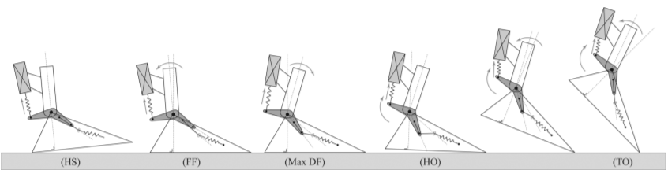
Figure ‎1-1: Gait cycle demonstration[1].
As shown in Figure 1-1 the gait cycle is clearly labeled by each state from HS to TO.

INFORMATION ABOUT THE ANKLE JOINT
For the ankle joint, positive angles represent dorsiflexion and negative angles represent plantar flexion as shown in Figure 1-2, the red point represents the fixed centre point of the joint. Also as shown in Figure 1-2: The angle of the joint is from 10 degrees in dorsiflexion and -20 degrees in plantarflexion.
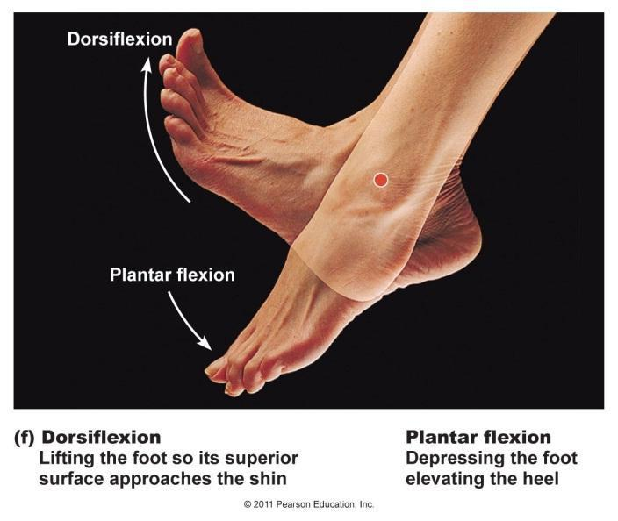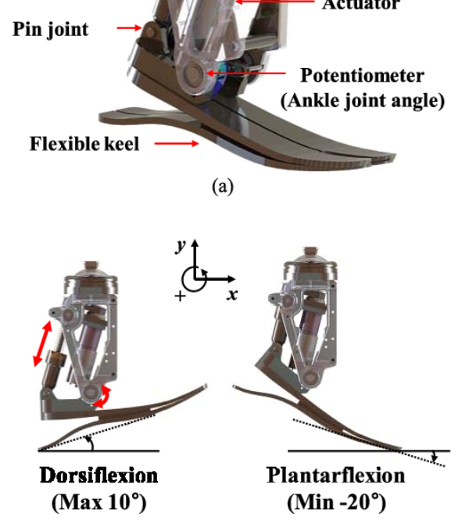
Figure ‎1-2 : Terminology & range of each ankle angle.[1]

METHODOLOGY
As mentioned, the ankle prosthesis needs to be smart in order to mimic the actual function of a real ankle and for that to happen it starts with detecting where is the foot in the gait cycle and after specifying the stance of the gait cycle a controlled torque should be outputted to assist the patient at push off (PO) or the heel off stance, then the motor returns the ankle to the original position which zero angle to be ready to take another step. The control scheme will be discussed in more details in its own chapter. As for the whole project a mechanical design needs to be made and by integrating the control components, we achieve the desired mechatronic system. In the next chapter the research effort made on this project will be shown in details and how it helped us build our own design for a smart ankle that is based on empirical data.

Chapter Two

LITERATURE REVIEW AND BACKGROUND

PREFACE
This chapter goes over the details of the major research effort contributed to the active ankle project. By introducing the general classification of ankles, then going through the history of ankle prosthetics and then going through different types of active ankles.

CLASSIFICATION OF PROSTHETIC ANKLES
Prosthetic ankles could be classified into three main types, passive, passive energy storing and returning and bionic or active. The passive or conventional ankle provides no mimicking of the real ankle muscles which leads to more loading on other muscles to compensate for the ankle muscles. Using a passive energy storing and returning ankle is energy efficient but supplies less than needed torque to assist the amputee. Finally, an active prosthetic ankle uses a passive and an active actuator, the use of these actuators mimics the actual movement of an ankle which gives the patient more assistance in regular activities.

HISTORY OF PROTHETIC ANKLES
The Seattle Foot shown in Figure 2-1, is the first energy-storing prosthetic component introduced in 1985, that attempted to substitute the human foot during the gait cycle. This type of passive prostheses can assist the amputee by storing and returning potential energy. It consists of three components: A Delrin keel, a Kevlar pad, and an exterior polyurethane foam matrix. Figure 2-2 shows the keels design back in the day.
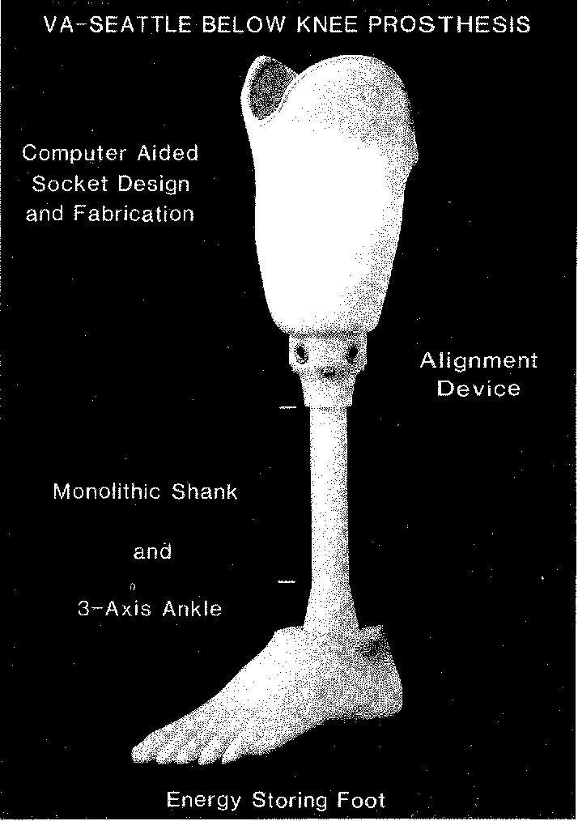
Figure ‎2-1 : The Seattle foot.[2]
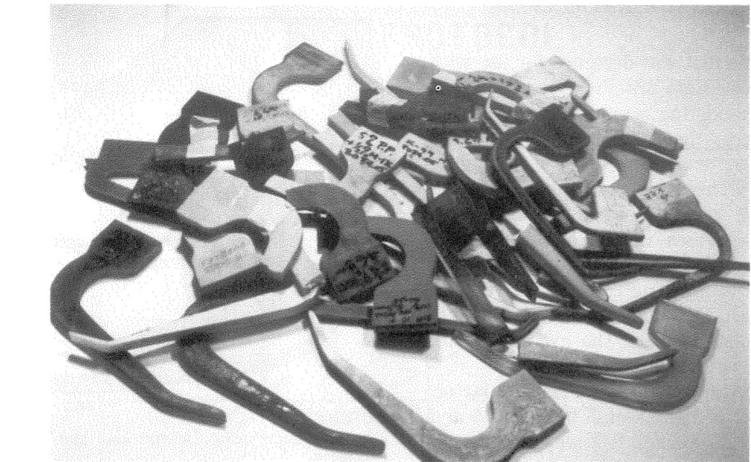
Figure ‎2-2 : Old Keels design.[3]
The full control of a prosthesis ankle was introduced in 1997 by Ottobock, called C-leg. The control function of the prosthesis adapts to the individual gait pattern of each user. The prosthesis is operated by a microcontroller controlled hydraulic system that is flexible to different walking speeds. Simultaneously, the controller makes sure that the phase of the gait cycle is correct based on sensors. These sensors record the force on the knee joint every fraction of a second to clearly determine the stage the gait cycle. Two hydraulic valves that are adjusted by maxon RE-max 13 motors modify the characteristics of the hydraulic system. Two motors are used in each C-Leg. The key features of these DC motors are their compact design and high-power output.
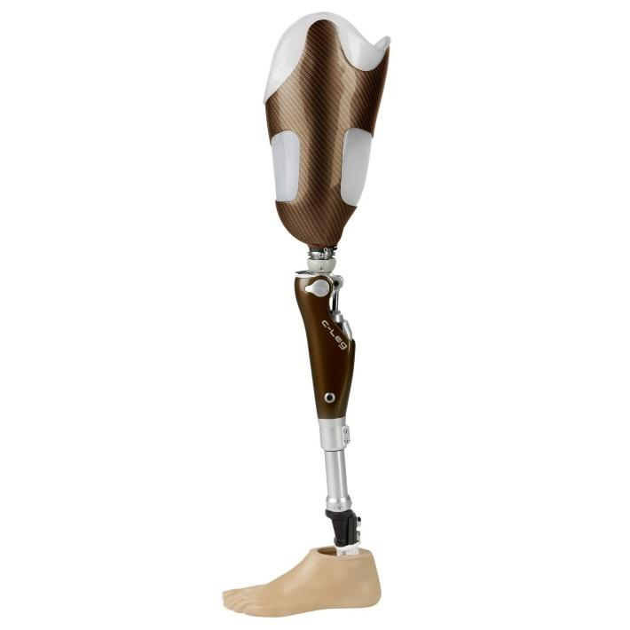
Figure ‎2-3 : The proprio foot.[4]
In 2006, the Proprio Foot (Ossur) became the first bionic or microprocessor-controlled prosthetic foot. PROPRIO FOOT is a low-to-moderately active amputee's adaptable microprocessor-controlled ankle. Motorized ankle motion raises the forefoot in the swing phase, increasing toe clearance and minimizing the danger of trips and falls. It also adjusts the ankle angle in response to changes in topography, resulting in improved gait quality on stairwells and sloped surfaces. When compared to a traditional, passive, and elastic foot, active plantar flexion-dorsiflexion can reduce an amputee's metabolic energy required to transfer unit body weight to unit distance.
The SPARKy3 is the most current electrically powered ankle foot prosthesis created by Arizona State University's Human Machine Integration Lab (Spring Ankle with Regenerative Kinetics).shown in figure 2-4. Amputees in the military are generally energetic and youthful. They must execute physically hard dynamic tasks under extreme conditions as part of their job. Current state-of-the-art equipment, both commercially available and in development, do not meet their specific needs. SPARKy is the first and only gadget of its type, created to meet the technologically demanding needs of highly active Military amputees.
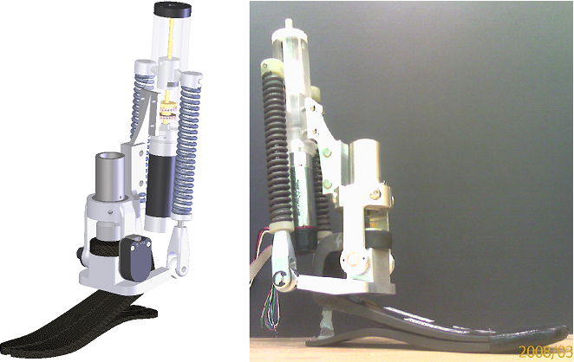
Figure ‎2-4 : Sparky3.[5]

DIFFERENT ACTIVE ANKLE PROSTHESIS

Ankle mimicking prosthetic foot (AMP) 2.0

Mechanical Design
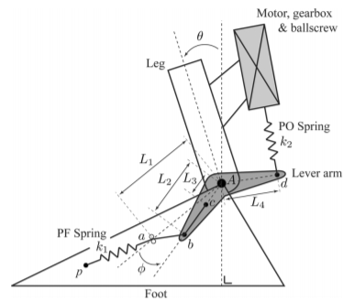
Figure ‎2-5 : Amp foot 2-D design.[6]

L1 Distance between ankle axis (A) and point a.
L2 Distance between ankle axis (A) and point b.
L3 Distance between ankle axis (A) and point c
L4 Distance between ankle axis (A) and point d.
𝛳 Angle between foot and leg.
𝜙 Angle between foot and lever arm.
K1 Plantar Flexion spring stiffness.
K2 Push-off spring stiffness.

As shown in Figure 2-5 there are two springs in the amp 2.0 and a BLDC motor. These three actuators contribute to the ankle torque needed while taking a step or a stride which was discussed in the gait cycle. The idea of the ankle is to store energy when the person takes a step and return the ankle to angle zero which is the starting position for a step, the motor and ball screw mechanism apply more torque to the ankle to mimic the real muscles of the ankle.

The locking of the four-bar linkage shown in Figure 2-6 allows for a delayed injection of power into the PO spring which decreases the power needed from the actuator is reduced, which means reduction in size while still providing the torque needed for the motion.

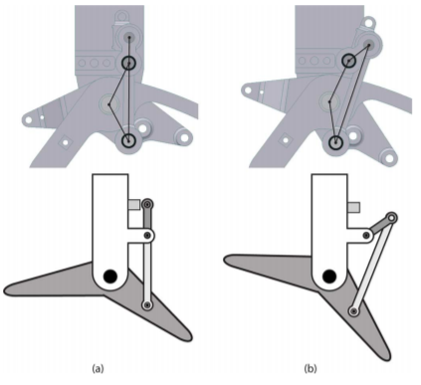
Figure ‎2-6 : Four bar linkage (a): locked state, (b): unlocked.[6]

Control of the AMP foot 2.0

Using two force sensing resistors at the heel and toes indicate contact with the ground therefore, indicating the state of the step. As shown in Table 2-1. Using a current sensor to control the motor power produced during the stance phase (which represents the first three phases of taking a step). While the motor returns to the original position during the swing phase by open loop velocity control.

Table 1: Full scale triggers.[7]
Heel contact | Toe contact | Phase
1 | 0 | HS to FF
1 | 1 | FF to HO
0 | 1 | HO to TO
0 | 0 | Swing

The torque required by the motor is set by the controller depending on the phase, torque required is represented by current which is sensed by the current controller and the error is fed to the PI controller to control the torque of the BLDC motor as shown in figure-5.
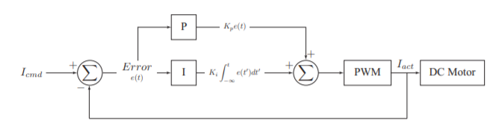
Figure ‎2-7 :PI control of the motor's torque.[7]

Conclusions

Advantages:
- Simple control.
- Low energy consumption due to usage of two springs in the design. And using a four-bar linkage contributes to less power consumption.
- Lighter weight due to smartness in design and usage of 4 bar linkage.

Disadvantages:
- Simple control provides low level of smartness, therefore low level of assistance and comfortability for the amputee.
- Simple control assists the amputee if moving at a constant speed only.
- Simple control proved only applicable in preliminary research.

Due to these disadvantages the researchers came to the conclusion of using the sensors shown in Table-2 and a microcontroller (ATmega2560) to improve the control of the AMP foot 2.0. The algorithm of control quoted from the authors is as follows “As soon as a first step has been detected, the walking mode is triggered. In this mode, the high level controller feeds a well-defined current command to the low level controller during the stance phase. While walking, the position of the motor is measured and compared with the desired end position. If the motor arrives too soon to its final destination, which means the subject walks slower than expected, the commanded current value is decreased for the next step. On the contrary, if the motor is not able to reach its end position before TO, which means that the amputee is walking faster than expected, the commanded current value is increased. If the subject suddenly stops walking, the controller detects that the phases of stance are not followed correctly and therefore the motor undergoes a reset. Before a new step is completely determined, the AMP-Foot 2.1 works passively. Using this system of flags, daily life scenarios like start or stop walking, opening doors, taking a step backward, increasing or decreasing the walking speed are made possible with a relatively simple control algorithm.” [7]

Table 2: Sensors used in the amp 2.0 [7]
Sensor | Measurement
Current sensor | Current drawn by the DC motor (torque)
Load cell | Force acting on the spring
Linear potentiometer | Ballscrew position
Force Sensing Resistors (FSR) | Heel and toe contact
Magnetic encoder | Angle of the ankle joint

SPARKy3

Intentions and Goals
SPARKy 3 has adopted a novel method to giving the prosthetic ankle two degrees of flexibility in order to revolutionize powered transtibial prosthesis design. While the ordinary amputee may not require agility, many would want to be able to live a more active lifestyle without being restricted by their prosthetic ankle : Some people have communicated this desire to us directly. Military amputees may gain the most from such a gadget, as they must do skills like running, leaping, and passing their PT test in order to return to active duty service. Our long-term objective is to use two extremely strong, lightweight motors to allow an individual to return to active service with enhanced athletic abilities.
Pre-design and Sketching:
The initial design goals were to achieve just running and leaping, which necessitated the use of two EC Powermax 30 motors to boost power capacity. The installation of a second motor encouraged research into adding a third degree of freedom. The notion of employing two motors in tandem for powered running and regulating each individual motor to power the additional rotating degree-of-freedom was then developed. Another goal of the design was to relocate the springs above the keel but still inside the foot's envelope, allowing an unaltered shoe to be worn over the device. This would result in a lower-profile gadget with less machinery hidden below the leg.
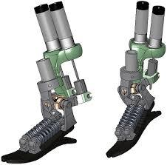
Figure ‎2-8 : 3-D view of SPARKy3.[5]

Variable impedance control for the active ankle:
A series-elastic linear motor drives a commercial polypropylene ankle orthosis. The angle between the shank and the foot is measured using a rotary potentiometer. Capacitive force transducers on the bottom of the foot are used to determine ground reaction forces (GRFs). To detect heel striking occurrences, an extra footswitch is put on the shoe heel. The control method is implemented on a Linux computer using an analog input–output circuit board.
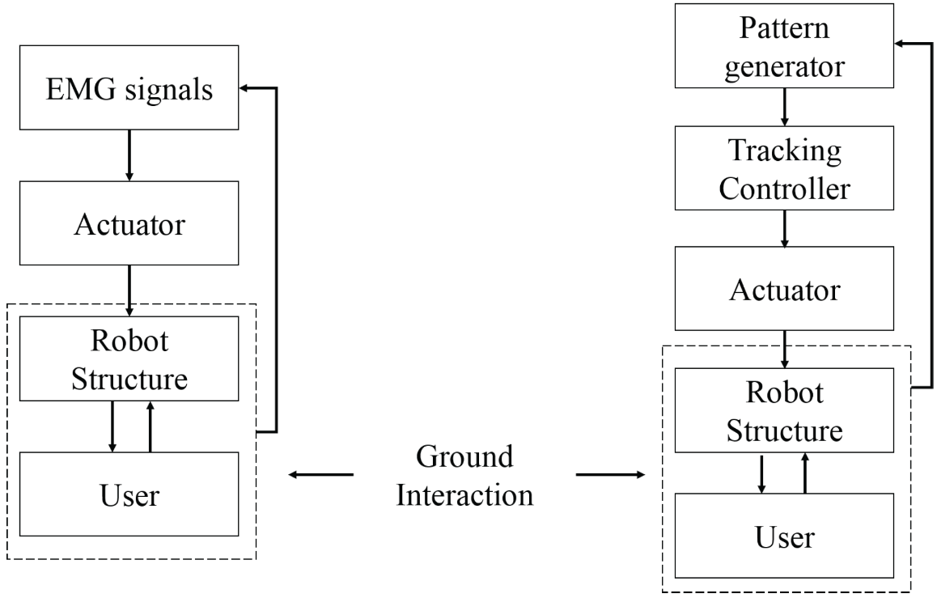
Figure ‎2-9 : Control Scheme for SPARKy3.[5]

Active Ankle Prosthesis by Electro-Hydrostatic Actuation

Goals of Electro-hydrostatic actuation
Ankle prosthesis attracts increasing attention, as an important human medical prosthesis serving as weight-bearing joints of the lower limb. Its stability and flexibility play an important role in various activities. It can withstand 5 times of the body weight. In pushing, the body goes forward and upward, 60% of the forces are produced by the ankle joints. According to different drive modes, ankle prosthesis can switch modes from passive, semi-active and active prosthesis with active actuation. Passive prostheses are widely used by amputees in the early stages to compensate in the body structure of amputees. However, these prostheses are inflexible so that amputees tend to be slow to walk. So we go to active prosthesis. To assist walking, particularly at high speed and climbing, several kinds of actuation have been used, including off-board electric motor with flexible tether, pneumatic actuation, a DC motor with a ball screw and electro hydrostatic actuation. Motor-driven ankle prostheses have disadvantages such as the power density ratio is so small that the holistic installed power is large, output torque is not sufficient enough for performing daily activities. Hydraulically actuated ankle prostheses can provide necessary cushioning and active facilitating force is large enough, but its main drawbacks are overall excessive weight, poor energy endurance and so forth. Ankle joint prostheses have high requirements for peak power and output torque, while relatively low demands for average power in most work cycles. There is a contradiction between the driver's requirements for peak power and weight as well as endurance. Pure motor drives or hydraulic drives cannot solve these problems. The innovative solution of this study was to design an active ankle prosthesis based on the principle of electro hydrostatic actuation (EHA). EHA is a new actuator that uses the power transmission technology and the volumetric speed regulation principle to integrate the actuation system energy source and the output actuator. It has dual advantages of power transmission and hydraulic actuation. The output velocity Ratio and output force ratio of EHA are large. This actuator can continuously regulate speeds, has the ability of self-resistance overload and self-lubrication. It also has desirable characteristics such as strong safety, high efficiency, more reliability and easy maintainability, implement integration and miniaturization.

Components used
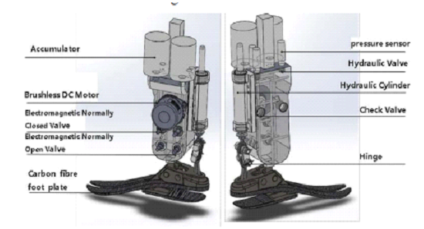
Figure ‎2-10 : Components used.[8]
It consists of more than ten parts, including BLDC motor and its drive, bidirectional pump, valves, double-outlet hydraulic cylinder, pressure sensors, accumulators, carbon fiber foot plate, gyroscope, displacement sensor, toe spring, microcontroller and Li-Po battery.

Hydraulic system Design
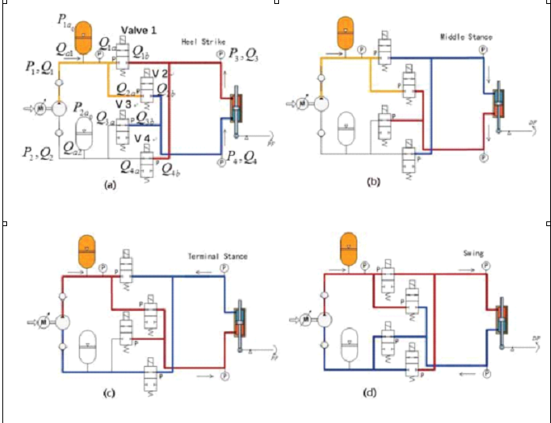
Figure ‎2-11 : Hydraulics system schematics diagram.[8]
Large number of components which cause difficulty in controlling the system, but it’s efficient and operates with high performance.

Controlling speed and angle of active ankle
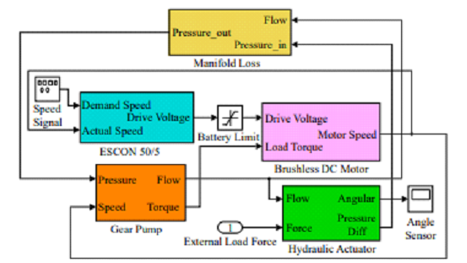
Figure ‎2-12 : Simulink model.[8]

Controlling torque/force of active ankle
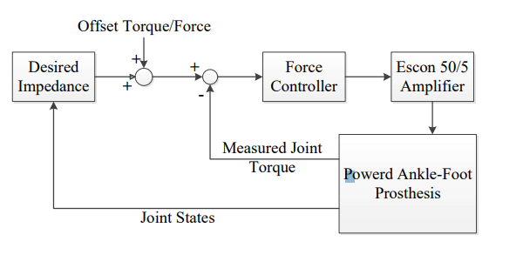
Figure ‎2-13 : Simulink model for torque control.[8]

Conclusions
Electro Hydraulic actuator EHA has the highest performance and efficiency in different modes of actuations. But it may be the most expensive as the large number of components in the system is one from its disadvantages. The other disadvantages are leakage of oil and complexity of controlling the system (not easy to be controlled as there are a large number of components to be controlled).

PKU-RoboTPro-II Prosthesis
To test the angle adjustment, a powered transtibial prosthesis (PKU-RoboTPro-II) was used. The PKU-RoboTPro-II utilised a DC motor (Maxon, RE-40, 150 W) to operate the ankle joint.
The average weight of the in the active ankle industry is 5 kg.

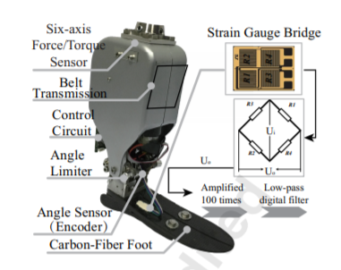
Figure ‎2-14 : PKU-RoboTPro-II prosthesis.[9]
Most sections of the PKU-RoboTPro-II were built of aluminum alloy to minimize overall weight; the total weight of the PKU-RoboTPro-II (without the rechargeable Li-ion battery) was 1.75kg. The ankle angle is defined as 0 when the shank is perpendicular to the plane of the carbon-fiber footplate. In this article, the positive angle indicates dorsiflexion and the negative angle represents plantar flexion. From 25 degrees dorsiflexion to 25 degrees plantar flexion, the joint angle was changed.

The following are the control system components utilized in the PKU-RoboTPro-II prosthesis: On the upper surface of the carbon fibe, a magnetic encoder was used to measure the ankle joint angle, a DC motor (Maxon, RE-40, 150 W) was used to actuate the ankle joint, a six-axis force/torque sensor (M3553E) was used to measure the interaction force between the amputee and the prosthesis, a control circuit (using the controller chip STM32F103), and an integrated strain gauge bridge with four strain gauges was used to measure The original Strain Gauge Bridge signals were amplified 100 times and then processed via a low-pass digital filter with a cut-off frequency of 10 Hz.

Control Strategy
The gait cycle begins with one foot's heel strike and concludes with the same foot's following heel strike. Controlled flexion (CF) and powered plantar flexion are included in the stance phase. Controlled plantar flexion (CP) and controlled dorsiflexion (CD) are two types of controlled flexion (CD). Controlled plantar flexion (CP) begins with heel impact (the ankle joint begins to plantarflex) and finishes with the foot flat (figure B) (the ankle joint starts to dorsiflex). CD begins with the foot flat (figure B) and finishes when the ankle reaches the maximal dorsiflexion angle (figure C) (Figure A). After controller Dorsiflexion (CD), powered plantar flexion (PP) begins and finishes at toe off. The swing phase begins at toe off (pre-swing toe off figure E) and concludes at heel strike (terminal swing figure G). We develop a velocity control approach that establishes a precise motor velocity based on each subject's preferences. 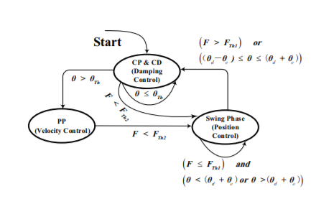
Figure ‎2-15 : Control logic.[9]

F represents the vertical pressure between an adaptor and a prosthesis.
${F }_{Th1}$ represents the gravitational pressure threshold at heel strike. (Refer to 200N)
${F }_{Th2}$ represents the gravitational pressure threshold at toe off. (Refer to 100N)
$θ_{e}$ represents the allowable angle error. (Refer to 0.5 degree)
$θ_{Th}$ represents a minimum angle to detect the beginning of push-off.
$θ_{d}$ represents the desired ankle angle at the end of swing phase. θe represents the allowable angle of error.
θ represents the ankle joint angle.

For ramp ascent, level ground and ramp descent, the desired angle θd is 5, 0 and -5 degrees, respectively.

Angle Adjustment Necessity
Angle encoders positioned at the ankle rotation axis were utilized in previous techniques, however they were unable to monitor the changing angle owing to deformation. If the ankle angle measurement did not take the deformation of the carbon-fiber footplate into account, the ankle angle measurement would be incorrect, depending on the research. If the accurate ankle angle threshold (reference ankle angle) is used to determine push-off, the angle inaccuracy may affect walking performance and control effect evaluation. We discovered that deformation of the carbon-fiber footplate influenced the ankle angle, and we hypothesized that the deformation of the carbon-fiber footplate mostly resulted in angle error, with an error or minor discrepancy between the encoder angle and the deformation of the footplate, We needed to establish a link between the human weighted force (deformation of carbon-fiber-footplate) and the angle encoder sensor, therefore we conducted an experiment to discover the relationship between the strain gauge bridge's measured value and the altered ankle joint angle.
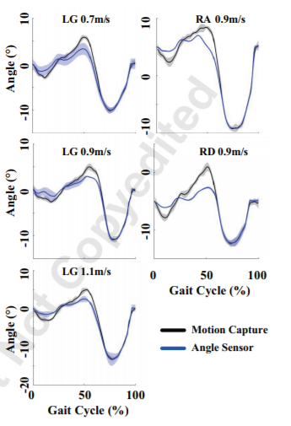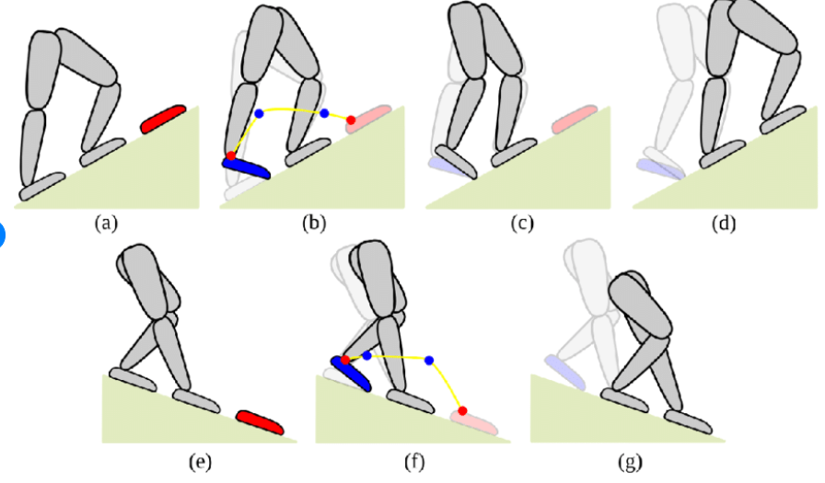
Figure ‎2-16 : The ankle angle using different measurements for different conditions.[9]

The black line represents motion capture data, while the blue line represents data from an ankle angle sensor built into the prosthesis' spinning shaft, s. A standard deviation is indicated by the darkened region. Level ground, ramp ascension, and ramp descent are all abbreviated as LG, RA, and RD, respectively. The ankle joint reference angle was calculated using the motion capture system's markers to record the motion trajectory. Amputees were put through walking tests to see if angle adjustment was possible. As shown in figure 2-16.

Angle Adjustment Theory
θ = 90◦ −∠2 = −90◦ +∠1+∠3 (1)
- ∠2 is the angle between the shank extension line and lower footplate surface
- ∠1 is an angle directly measured by an angle sensor (encoder)
- ∠3 is an angle between the extension line (upper rear footplate where an encoder was placed) and the lower footplate.
When 3 remains constant, such as throughout the swing phase, ankle angle may reflect the true angle. Where, as shown in Figure 2-17, 3 changes throughout the stance phase owing to footplate deformation. When you land on your back foot, 3 decreases, and the corresponding real decreases. On the other hand, when you land on your forefoot, 3 goes up, and the matching real goes up.
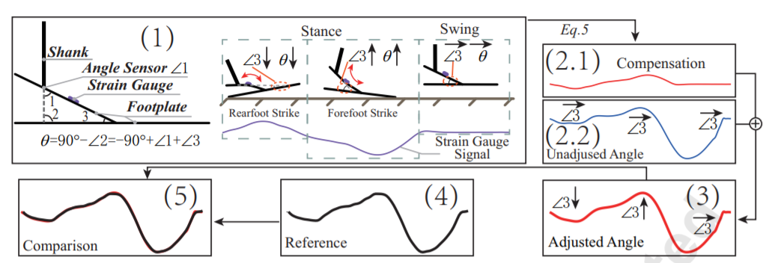
Figure ‎2-17: Angle adjustment flow diagram.[9]

The strain gauge bridge can detect two-direction deformation during the stance phase. The strain gauge bridge bends downward as the backfoot strikes it. The strain gauge bridge, on the other hand, bends upward as the forefoot strikes. A 100-fold amplification was used to acquire the original signal, which was then processed via a low-pass digital filter with a 10 Hz cut-off frequency. A correction angle was produced by plugging the original signal into Eq. 1. An unadjusted ankle angle is only derived from an angle sensor reading plus a constant drift (90 +3) when 3 is taken as a constant. In reality, throughout the stance phase, 3 was not a constant (see (1)). (3) The adjusted ankle angle is equal to the compensation angle (2.1) plus the unadjusted ankle angle (2.2). (4) The black line represents the motion capture system's measurement of the ankle angle. (5) When comparing an adjusted ankle angle to a measured angle from the motion capture system, there is a slight discrepancy. Figure 2-17 depicts the labels mentioned.

BIONIC RUNNING FOR UNILATERAL TRANSTIBIAL MILITARY AMPUTEES
Active prostheses serve to mimic the lower appendage Muscle-limb System in the sagittal plane with a combination of a linear spring and actuators. The linear springs store and regenerate the energy during the stand stage, while the actuator adequately reduces the equivalent length the spring after the dorsal flexion of the stand stage supply the measure and amount of potential energy it stores and releases.
There is almost a threefold increment in energy needed during the gait cycle to transition to running from walking. Also, the step frequency almost double, requiring near to six times the output power from the muscle-tendom complex while running when contrasted with strolling.
The gait cycle frequency increase in transition from walking to running, but the acceleration of actuator components inside each walk cycle increments as a result of the changes in kinematics between strolling and running.
The impact of an increasing gait cycle frequency and decreased time for storing and releasing “discharging” vitality per cycle is a sensational rise in power required to overcome the inertial effects of the actuators and supply the needed rapid power surge at push-off. Robust finite state control frameworks adapt to changes within the gait by controlling invariant parameters inside distinctive parameters of the gait.
One execution divides the stance position into five regions based on the angular position of ankle, and controls either ankle stiffness or angular speed inside each zone. This strategy looks for to control angular speed when the ankle is plantarflexing and stiffness when the lower leg is dorsiflexing within the position stage.
The optimal angular speed and stiffness parameters change based on the position inside the gait cycle, which the control strategy addresses by characterizing particular parameters for three separate plantarflexion zones and two isolated dorsiflexion zones, accounting for five special parameters for a given stride cycle.
As the idea angular ankle angular speed and firmness profiles, also change beneath reasonable conditions, this control framework employments state logic to decide the amputee action given the conditions, and maps the five ideal parameters to that certain activity.

Mechanical design:
The running prosthesis was basically an update of the SPARKy walking active ankle prosthesis. Refining the strolling prosthesis for running required component adjustment and modification resist the increased dynamic loads on the structural components and provide the expanded actuator power vital for running.
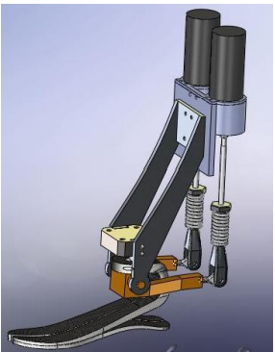
Figure ‎2-18 : 3-D View of the prosthesis.[10]
Finite component analysis of the components indicated three basic zones for update: the muscle interfaceThe robotic system interface at the beginning transmits inputs from the actuator to both springs, which resulting in critical internal moments and shear loads within the interface component. To relieve the large normal and shear stress at the contact each motor uses a single spring.
Increased moments applied on the joint at the ankle caused over the top shear loads on the bolted tibia-ankle interface adjoining to the ankle joint. To reduce the hazard of failure at the revolute joint, this interface is reinforcement to sustain these moments.
The 300-400W actuator control necessity ordered substitution of the Maxon RE40 based actuator system evaluated up to 150W. The group assessed three options with comparative control characteristics: a single Maxon RE75 brushed engine actuator, dual Maxon RE40 actuator system and a single EC40 brushless motor., the weight and inertial characteristics of the components, and the clearance given for the lower appendage socket. The RE75 permitted for the best motor control algorithm, but provided less than ideal socket clearance due to the large diameter of the motor casing. In addition, the RE75’s inertia was double to fourfold of the inertia of the other two options, which would have constrained its efficiency. Moreover, the single actuator system would have produced excessive moments in the muscle-tendon interface component. The double actuator framework needed additional control requirements to synchronize the two motors, but moderated chance of muscle-tendon component failure. Also, in spite of the fact that inertial power requirements were less than the RE75 system, they were double the EC40 brushless motor actuator control prerequisites. In any case, the EC40 brushless motor framework control had some instabilities during actuator direction inversion, and tested strategies demonstrated questionable at that specific transition in the gait cycle. Thus, the RE40 double framework demonstrated the leading compromise between motor control necessities, efficiency, and compatibility with the amputee.

Motors Selected:
- Maxon RE 40 motor:
RE 40 Ø40 mm, Graphite Brushes, 150 Watt

- EC 40 brushless motor:
EC 40 Ø40 mm, brushless, 120 Watt, with Hall sensors

Control system:
A PC104 microprocessor is used with a Sensory DAQ unit attached to PC104. Utilizing control code generated from MATLAB, it drives two custom brushed motor position controllers.
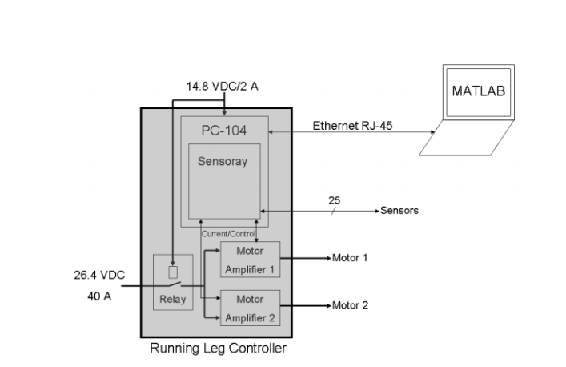
Figure ‎2-19 : Control schematics.[10]
Portable electronics are powered by a 26.4V battery pack. An Ethernet connected to the MATLAB PC is used to generate the control code as well as collect the data measured from the robotic ankle.
PC104 has several modules and it depends on the system parameters.

Conclusion
This prototype of active ankle prosthesis is efficient and more powerful for transition this ankle from walking process to running process. This ankle could operate at speed of 3.6 m/sec. comparing with sparky1 prototype that could operate at 2.1m/sec. its disadvantages are complexity in synchronizing the two motor to operate at the same time without any delay.

CHAPTER CONCLUSIONS
As different types of active ankles were mentioned the choice of mechanical design and components became clear. As for mechanical design most of the ankles have the same general design, so our active ankle must follow this general design, which will be mentioned later in details in the mechanical design section. As for the control components we gained an insight of the most used components and their need in the system and more details will be given in the control chapter.

Chapter three

CONCLUSIONS AND FUTURE WORK
In this report we came to the realization of the active ankle prosthesis needed to mimic the human ankle and why previous manufacturers of different ankles used certain components. Through our mechanical design that was completed by us based on the information gained and referenced from other ankle designs and the project were manufactured. Also the control strategy and control schematics are also completed and each component was tested separately. We could adjust our active ankle to add a custom bracket designed for a lower limb amputee and test our system more based on the feedback and comfort of the amputee. Moreover we could add an IoT application for our system that detects the steps of the amputee to measure his overall activity, to start the active ankle through wireless control and also to send the amputee information about the battery of the system and notify him when it needs to be recharged.

REFERENCES
[1] “Ankle range of motion and injuries - correct footwear fitting.” https://profeet.co.uk/ankle-range-motion-injuries/ (accessed Jan. 08, 2021).
[2] “Seattle Foot prosthetic device introduced in 1985. - HistoryLink.org.” https://www.historylink.org/File/2104 (accessed Jan. 08, 2021).
[3] D. C. Wing and D. A. Hittenberger, “Energy-storing prosthetic feet,” Arch. Phys. Med. Rehabil., vol. 70, no. 4, pp. 330–335, 1989, doi: 10.5555/uri:pii:000399938990155X.
[4] J. Z. Laferrier and R. Gailey, “Advances in Lower-limb Prosthetic Technology,” Phys. Med. Rehabil. Clin. N. Am., vol. 21, no. 1, pp. 87–110, 2010, doi: 10.1016/j.pmr.2009.08.003.
[5] R. D. Bellman, M. A. Holgate, and T. G. Sugar, “SPARKy 3: Design of an active robotic ankle prosthesis with two actuated degrees of freedom using regenerative kinetics,” Proc. 2nd Bienn. IEEE/RAS-EMBS Int. Conf. Biomed. Robot. Biomechatronics, BioRob 2008, no. January 2017, pp. 511–516, 2008, doi: 10.1109/BIOROB.2008.4762887.
[6] P. Cherelle, V. Grosu, A. Matthys, B. Vanderborght, and D. Lefeber, “Design and validation of the ankle mimicking prosthetic (AMP-) Foot 2.0,” IEEE Trans. Neural Syst. Rehabil. Eng., vol. 22, no. 1, pp. 138–148, 2014, doi: 10.1109/TNSRE.2013.2282416.
[7] P. Cherelle, K. Junius, V. Grosu, H. Cuypers, B. Vanderborght, and D. Lefeber, “The AMP-foot 2.1: Actuator design, control and experiments with an amputee,” Robotica, vol. 32, no. 8, pp. 1347–1361, 2014, doi: 10.1017/S026357471400229X.
[8] J. Fang, X. Wang, R. Li, S. Wang, and W. Wang, “Active ankle prosthesis powered by electrohydrostatic actuation technology: Design and implementation,” in IET Conference Publications, 2018, vol. 2018, no. CP743, pp. 1170–1175, doi: 10.1049/cp.2018.0177.
[9] Y. Feng, J. Zhu, and Q. Wang, “Metabolic cost of level-ground walking with a robotic transtibial prosthesis combining push-off power and nonlinear damping behaviors: Preliminary results,” Proc. Annu. Int. Conf. IEEE Eng. Med. Biol. Soc. EMBS, vol. 2016-Octob, no. September 2018, pp. 5063–5066, 2016, doi: 10.1109/EMBC.2016.7591865.
[10] J. K. Hitt et al., “Bionic Running for Unilateral Transtibial Military Amputees,” 27th Army Sci. Conf., p. 8, 2010, [Online]. Available: http://www.stormingmedia.us/58/5842/A584235.html.
[11] D. C. Kirtley, “Effect of Speed on Joint Angles Angle ( deg .).”

