Statistics Final Project

**Step 1**

***Pick two separate corporations and from*** [***www.nasdaq.com***](http://www.nasdaq.com)***, pick the "historical quote" option and randomly select 30 opening stock prices for the last two years.***

I pick two separate corporation from NASDAQ website; the stocks are for the semiconductor makers Advanced Micro Devices **(AMD)** and its main competitor and dominant player in the microprocessor space, Intel Corp **(INTC).** The csv files are attached. Using MS Excel 2016, I copied the data from the csv files into individual worksheets in the project workbook and named the INTC and AMD historical quote worksheets.

**Step 2**

***Place the data into an Excel spreadsheet and outline your sampling method in the main Word document for the project.***

I first created a sampling frame for the data by inserting a new column in Column A. This new column was named Sampling frame and is shaded in green. I then assigned numbers in ascending order from row 2 to row 506, as the 2 year data had 505 data points. The sampling frame was identically inserted in worksheets of the two historical quotes. The opening prices are shaded in. I then used the following formula to generate random numbers within the specified sampling frame:

**“RANDBETWEEN (MIN(AMDHistoricalQuotes!$A$2:$A$506),MAX(AMDHistoricalQuotes!$A$2:$A$506))”**

Max() and Min() formulas were used to define the top and bottom number. As a result the random generation of numbers, was restricted to within the sampling frame. The formula was copied in 30 cells in the worksheet called Step 1 and 2 sampling. I then used VLOOKUP to retrieve the data from the historical quote worksheets. The formula used is presented as:

**“VLOOKUP($C3, AMDHistoricalQuotes!$A1:$G$506,5)”.**

After retrieving the data, I noticed the RANDBETWEEN formula linked to the VLOOKUP kept updating the values so I created a new column in Column C, which become the selected sample of 30 randomly selected of the two opening prices paired by dates.

**Step 3**

***Determine a claim (prior to analyzing the descriptive statistics) based on two population means/samples.***

While, reading an article on *AMD versus Intel: Is AMD Catching Up?* By Adam Hayes, from the Investopedia website dated June 12, 2017. I got curious about know size of INTC stock price relative to the AMD stock price. The article reported that over the past 12 months, shares of Advanced Micro Devices (AMD) had blown away Intel Corp (INTC). Over the past 12 months, Intel shares have gained around 16.6%, while AMD was up by a staggering 130%, which implied that AMD had grown nearly 10 times in 12 months. However, when I checked the opening prices of the stock, I noticed that the AMD is valued at 14.15(as of 11 July 2017), while INTC is valued at 34.29 (as of 12 July 2017). Despite having grown 10 times in the las 12 months. Therefore, I premise that the INTC opening prices is valued at **b** times that of AMD, with *b* being an integer between 1 and 10. Therefore, the claim is that:

* ***The mean opening stock price for INTC is b times the mean opening stock price of AMD.***

**Step 4**

*Calculate the descriptive statistics for the two separate corporations. The distribution shape should be analyzed to determine the appropriate descriptive statistics to use (mean/standard deviation versus median/IQR).*

**Table 1: Descriptive Statistics of the Two Corporations**



Table 1 present the results of the descriptive statistics calculate in the Excel and located in the Step 1 to 2 worksheet. INTC has a mean that nearly six times that of AMD while their ranges for maximum and minimum are nearly the same. Therefore, median/IQR would be ideal for graphically comparing the two distribution. As a result, Box and Whisker chart in MS Excel was used.

**Step 5**

*The graph should be included in the main Word document for the project. Find the appropriate descriptive statistics and place this in the Word document noting any outliers or any irregularities discovered.*

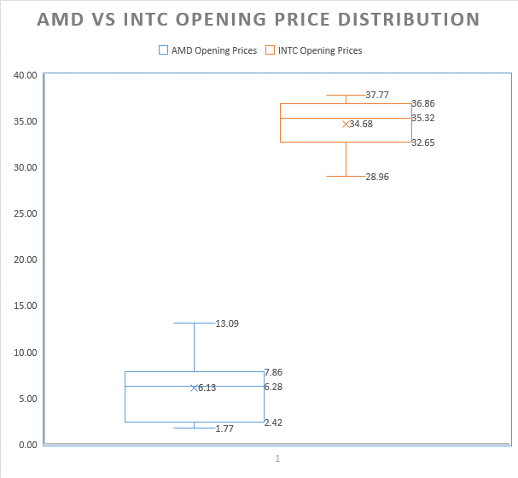

**Figure 1: Box and Whisker Chart for the Two Distributions**

Figure 1, show the descriptive statistics for both INTC and AMD opening prices. The plot show that there were not outliers. The INTC distribution is negatively skewed, which implies that the sample has frequent small gains and a few extreme losses. While, the AMD distribution is positively, which implies frequent small losses and a few extreme gains. This is consistent with Investopedia article by Hayes, (2017), where AMD value has increased by more than 10 times in the last 12 months. These distributions trends can help explain why the AMD share prices have grown by staggering 130% in the past 12 months, compared to 16.6% gains in the INTC prices over the same period.

**Step 6**

***Conduct the hypothesis test based on the claim from item 2. Outline all the specifics in the Word document describing your conclusion. Note any possible reasons for the results. This might include some research on the corporations chosen in item 1.***

I created a dynamic hypothesis testing worksheet in Excel that tests the Distribution of the Difference of Two Means. The formulas are dynamically link to the other worksheets and the cell for the value of ***b.*** Figure 2 the Worksheet screenshot of the hypothesis test done in Excel.



I used VLOOKUP to link the sample data to the original historical quotes data, by linking it to the Step 1 to 2 sampling worksheet. I then created ***b*** value cell that allowed me to test hypothesis for 1 to 10 times the value of AMD. The ***b*** value is used to multiply the opening prices of AMD and then I compared the mean of INTC with ***b* times** the mean of AMD. I also used the following Excel formulas for calculating the mean, standard deviation, pool variance, t-critical, t-statistic and used logical formulas to reject the hypothesis. My formulas followed the five step hypothesis testing method as follows:

**Step 1: State the null and alternative hypotheses**

The claim in item 2 was then aligned to the hypothesis that there was no significant difference between the mean of INTC and b times the mean of AMD.In this case, the null hypothesis supported the *claim that INTC opening price is 6 times the opening price of AMD.*

Two-Tailed test

H0: μ1-μ2 = 0

H1: μ1-μ2 ≠ 0

**Step 2: Decide on a level of significance, α.**

The alpha level was also designed to be dynamic, which allowed for hypothesis testing at different alpha levels. In this instance, it was set at *0.01.* Thedegrees of freedom was calculate as n-1 = 30-1 =29

Decision rule for the worksheet was based on both t-statistic and its p-value

|  |  |
| --- | --- |
| if T-stat < T-crit (1T=1.67), (2T=2.00) | **Fail to reject the Null hypothesis/Claim** |
| T-stat> T-crit | **Reject the Null hypothesis/Claim** |
| if p(T-stat) > alpha (1T=0.05), (2T=0.025) | **Fail to reject the Null hypothesis** |
| if p(T-stat) < alpha (1T=0.05), (2T=0.025) | **Reject the Null hypothesis/Claim** |

The p-value (b=6) was 0.722 > 0.01, Since the P-value > α, so we fail to reject the null hypothesis and the claim. The process was repeated for b values between 1 and 10 and found that the claim holds for the values when b is equal to values between 5 and 8. The worksheet calculated them as p-values of p( b=5) = 0.421 , p(b=6) =0.722, p(b=7) =0.238, and p(b=8) = 0.072.Therefore, we can conclude that at the alpha level 0.05 or 0.01, the mean opening prices of INTC is 5 to 8 times the mean opening prices of AMD,

In the past 18 months, since its launch of its new Ryzen chip AMD has emerged as a real competitor to Intel (INTC) after decades of second best. However, it will still take some time for AMD to catch up to it competitor. For instance, the INTC share are valued at 5 to 8 times more than AMD shares. Additionally, AMD is had been losing money in rolling out its latest product lines, losing 0.55 EPS last quarter, and a -7.22% net profit margin in Q2 of 2017. At the same time, Intel boasted a 2.30 EPS and a +20% net profit margin. Intel also pays a 3% dividend yield while AMD does not pay a dividend at all. In addition, the Google, which has developed an innovative chip called a Tensor Processing Unit (TPU) that could present a notable threat to these established chip producers (Bovaird, 2017). Therefore, the INTC opening prices shall continue to be negatively skewed unless they come up with a product that can help maintain their dominance in the chip sector.

Charles, Bovaird (July 6, 2017) Intel, Nvidia Face Chipmaking Threat From Google | Investopedia <http://www.investopedia.com/news/intel-nvidia-face-chipmaking-threat-google/#ixzz4n1Ymkwx5>

Adam Hayes (June 12, 2017)<http://www.investopedia.com/news/intel-nvidia-face-chipmaking-threat-google/?lgl=rira-baseline-vertical>

Sullivan III, M. (2013) Statistics, Informed Decisions Using Data. Pearson Education