[Place the following copy over the hero visual]
CCOUNTING & CONSULTING
Protect Client Data Wherever the Work Happens
Give employees, clients and external collaborators secure, controlled access to confidential information across existing storage—without moving the data.
FileFlex Enterprise extends Zero Trust to the data layer, giving accounting and consulting firms centralized control over who can access client information and what they can do with it.
[BUTTON — Request a Demo]

[HERO VISUAL]
Creative direction:
A sophisticated, photorealistic professional-services environment. Accountants or consultants collaborating with a client in a modern office, with laptops or large displays visible but not dominant.
The image should communicate professionalism, trust, client collaboration and confidentiality, rather than cybersecurity.
For a full-width hero, keep the left 45–50% dark blue and visually quiet to accommodate the headline and copy. Put the primary photographic activity on the right.

[Place the copy on the left and GRAPHIC 1 — CONTROLLED ACCESS TO DISTRIBUTED CLIENT DATA on the right]
Client Data Is Everywhere. Access Needs to Remain Controlled.
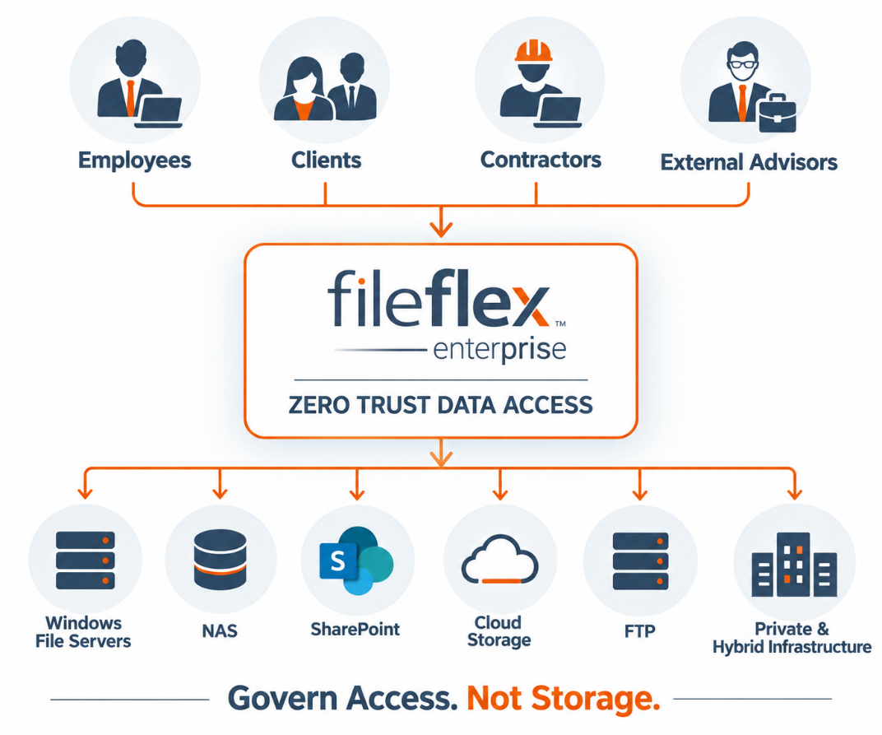
Accounting and consulting firms operate across clients, offices, practices, project teams and external partners. Confidential information may reside across Windows file servers, NAS, SharePoint, cloud storage, FTP and private or hybrid infrastructure.
At the same time, employees need remote access, clients need to exchange documents, and outside specialists may need temporary access to specific information.
The challenge isn't simply sharing files. It's controlling access to client data wherever that data resides.

[Please place the following copy and headline on the left column and VISUAL 2 — PROFESSIONAL SERVICES COLLABORATION in the right column.]

Secure Collaboration Across Every Client Engagement
From routine client services to highly sensitive transactions, professional-services firms need to give the right people access to the right information—without creating unnecessary copies or exposing underlying storage infrastructure.
[Please make the following into cards with photo headers]
Audit & Assurance
Provide engagement teams and authorized clients controlled access to financial statements, working documents and supporting information.
Tax & Advisory
Securely access and exchange sensitive financial, tax and personally identifiable information with clients.
Consulting Engagements
Give project teams controlled access to client information and working documents across the lifecycle of an engagement.
M&A & Due Diligence
Create secure virtual data rooms for transactions, due diligence and other confidential projects without moving information into another storage platform.
External Specialists
Provide lawyers, accountants, contractors and other outside advisors access only to the files and folders required for their work.
Client Portals
Give clients an intuitive way to securely access and exchange documents while the firm maintains centralized control.

[The following copy is for the right column and put GRAPHIC 3 — MOVE GOVERNANCE, NOT DATA in the left column.]
Protect Client Data Without Moving It
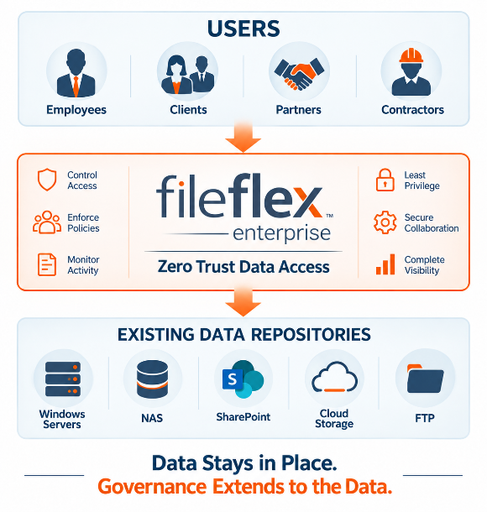
Traditional collaboration platforms can require organizations to upload, copy or synchronize information into another repository before it can be remotely accessed or shared externally.
FileFlex takes a different approach.
Data stays in place.
FileFlex Enterprise provides a secure access layer across existing storage infrastructure. There is no need to migrate client information into a FileFlex repository or create another storage silo.
Windows File Servers • NAS • SharePoint • Cloud Storage • FTP • Private & Hybrid Infrastructure
Your firm maintains its existing storage architecture while FileFlex governs access to the data.

Maintain Control of Sensitive Client Information
Accounting and consulting firms routinely handle financial records, tax information, personally identifiable information, intellectual property, transaction documents and other confidential client data.
FileFlex Enterprise allows firms to apply granular access controls to that information while keeping it within existing customer-controlled storage environments.
Control What Users Can Do
View Only • No Download • No Share • Edit • Upload • Expiration • User & Group Controls
Access can be restricted to individual files and folders, helping firms provide users with only the information required for a particular client, project or engagement.

[Please place the text in the left column and GRAPHIC 4 — SECURE CLIENT VIRTUAL DATA ROOM in the right column]
Turn Existing Client Data Into Secure Virtual Data Rooms
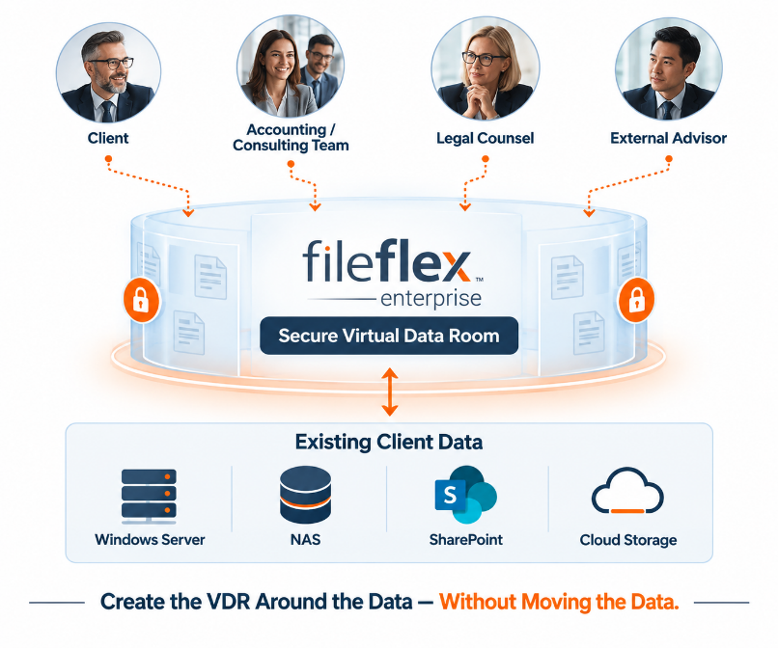
Client engagements, audits, transactions and due diligence frequently require firms to provide outside participants with controlled access to confidential information.
FileFlex Enterprise enables firms to create secure virtual data rooms without uploading that information into a separate VDR repository.
Authorized clients, advisors and project participants can access the information they need while the firm controls what they are permitted to do with it.
The data stays in its existing repository. FileFlex governs access to it.

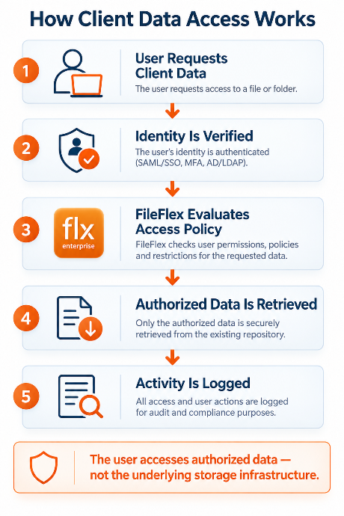
[Please place the text on the right and GRAPHIC 5 — HOW CLIENT DATA ACCESS WORKS on the left]
How Secure Client Data Access Works
FileFlex Enterprise separates users from the underlying storage infrastructure. Users request information through FileFlex, access policies are evaluated, and only authorized data is retrieved.

[Place GRAPHIC 6 — CENTRALIZED GOVERNANCE, DISTRIBUTED ENGAGEMENTS on the left and the copy on the right]
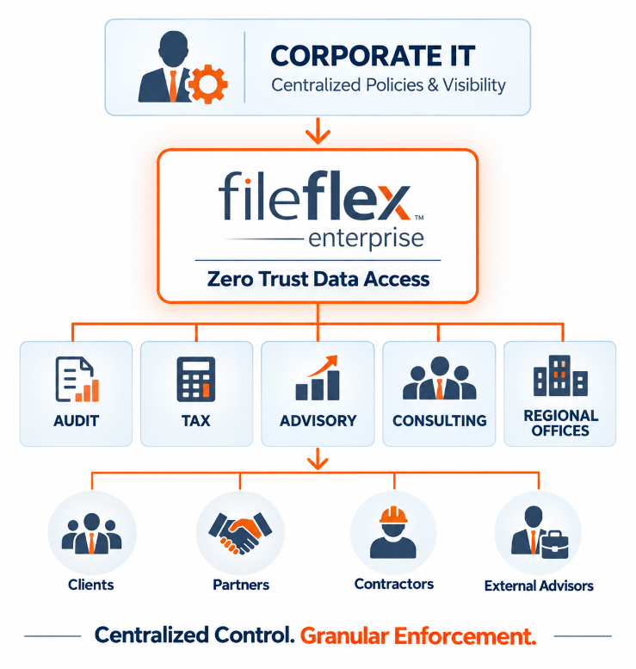
Centralized Governance. Distributed Client Engagements.
Large accounting and consulting organizations often operate across multiple practices, offices, business units and client teams.
Corporate IT needs centralized governance and visibility, while authorized administrators need the flexibility to manage access for their own users, clients and engagements.
FileFlex Enterprise supports both.
Corporate IT can establish centralized policies and maintain visibility across the organization, while access can be administered closer to the individual practice, office or engagement.

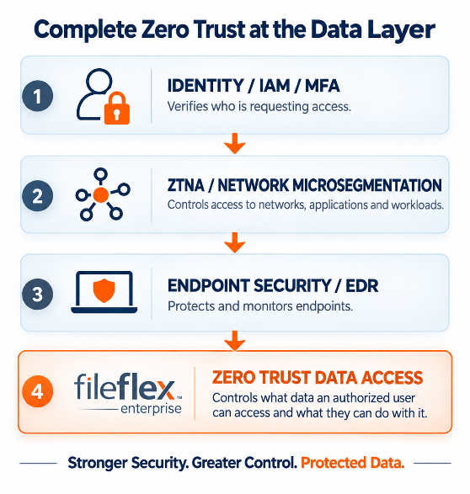
[Place the text on the left and GRAPHIC 7 — COMPLETE ZERO TRUST AT THE DATA LAYER on the right]
Extend Zero Trust to Client Data
Accounting and consulting firms have invested in identity, MFA, endpoint security and secure network access.
But verifying identity and securing a connection do not by themselves determine which individual files an authorized user should be permitted to access—or what that user should be permitted to do with them.
FileFlex Enterprise extends Zero Trust to the data layer.

Zero Trust Data Access for Professional Services
[Please make the following as cards with icon headers]
Protect Client Confidentiality
Apply granular controls to sensitive client information at the file and folder level.
Simplify External Collaboration
Give clients and outside participants secure access without exposing the underlying storage infrastructure.
Keep Data in Place
Extend controlled access across existing repositories without migrating information into another storage platform.
Maintain Visibility
Activity logging provides visibility into access and sharing actions across FileFlex-controlled data access.
Support Existing Workflows
Give authorized users secure access to existing information without forcing the organization to replace its underlying storage infrastructure.
Strengthen Zero Trust
Extend Zero Trust beyond identities, endpoints, applications and networks to the data itself.

[Please place the following copy over the final visual]
Protect Client Data Without Changing Where It Lives
Your clients trust you with some of their most sensitive information.
FileFlex Enterprise helps accounting and consulting firms protect that trust by extending Zero Trust directly to the data at the center of every client engagement.
Control access. Simplify collaboration. Keep data in place.
[BUTTON — Request an Accounting & Consulting Demo]

[FINAL VISUAL]
Creative direction:
A clean, premium image of a professional-services/client collaboration environment. Rather than another meeting-room image, this could show a broader modern office environment with multiple teams working across different client engagements.
A very subtle visual treatment could suggest distributed access or connectivity, but the photograph should remain realistic and sophisticated.
The final impression should be:
Client Collaboration Without Losing Control of Client Data.

