**Introduction:**

Sports play a great in everyone’s busy life especially for students. Everyone should involve themselves in the sports activity even for a small time all through the day. Sports are necessary because it brings physical and mental fitness to the person involved in this on regular basis. People who have busy schedule in their life get tired very easily. As we all know that, living a relaxed and comfort life we need a sound mind and a sound body. Education is very necessary to get name, fame and money. In the same way, getting a sound mind and body, everyone must involve in some type of physical activities for which sports is the best way.

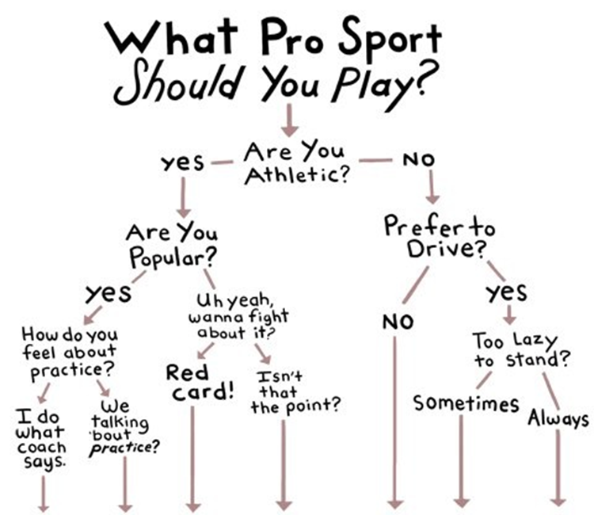

Being involved in sports activities benefits a person in many ways. It does not provide only physical strength however it increases mental power too. Outdoor sports such as football, cricket, volleyball, hockey, running, etc helps in improving physical health and mental fitness. However, some indoor games and sports like brain games, chess, Sudoku, etc improves mental power and concentration level.

When **playing a sport**, children have the opportunity to show their skills, gain greater self-awareness, and enjoy an activity that they love the most. 2. Provides consistent exercise. ... Team **sports** commits your child to regular exercise, which helps boost immunity and contributes to overall physical health

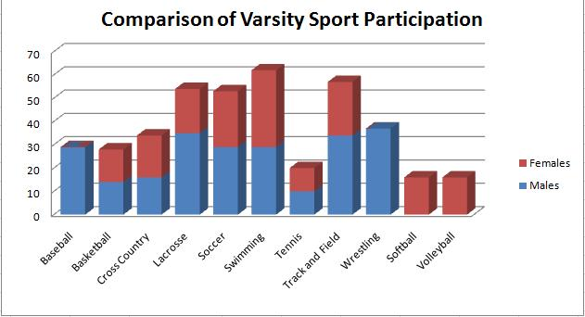

. The health Benefits of **sport** and physical activity. ... The positive, direct effects of engaging in regular physical activity are particularly apparent in the prevention of several chronic diseases, including: cardiovascular disease, diabetes, cancer, hypertension, obesity, depression and osteoporosis

In our website we are describing about mainly (what benefits is mainly provided by state and central government for a sports person?).And we are describing about modules like sports calendar, Training and workshop for those who are interested in participation of sports ,and we are adding help ,registration of your slots for your interested sport ,and involvement of state as well as central government in sports