Real-Time UI Architecture: Engine Performance Benchmarking
Project: Machine Learning Regime Dynamics in Multi-Asset Execution
Date: 2026-07-13
Status: Architecture Design
Goal: A high-performance real-time UI dashboard to benchmark and compare Supervised vs. Reinforcement Learning policies using live paper trading execution data.

1. Core Objectives
- Benchmarking Focus: Provide a side-by-side visual comparison of how different models (e.g., Random Forest (Breiman, 2001) vs. Decision Transformer (Chen et al., 2021)) perform under identical live market conditions.
- Real-Time Visualization: Plot live asset prices (1-second/1-minute OHLCV) and immediately overlay trade execution markers (Buys/Sells) as they happen in paper trading.
- Metric Tracking: Display live risk-adjusted return metrics (Sharpe Ratio (Sharpe, 1966), Max Drawdown, Cumulative PnL) for each active engine.

2. Technology Stack Selection
To achieve the goal of rendering multiple real-time charts simultaneously without lag while maintaining a clean, modern UI:
- Frontend Framework: Next.js (React)
  - Why: Provides robust state management for handling high-frequency WebSocket streams, and there is already an existing next directory stub in the repository (Vercel, no date).
- Charting Library: TradingView Lightweight Charts (TradingView, no date)
  - Why: An HTML5 canvas-based charting library specifically built for financial data. It can render 60fps real-time data and overlay multiple series (e.g., Grid levels, EMA bands) and markers (Buy/Sell arrows) efficiently.
- Backend / API Relay: FastAPI (Ramírez, no date) + WebSockets
  - Why: The Rust Trading Engine Core operates locally and logs trades/state. A lightweight Python FastAPI sidecar can read the Rust Trading Engine Core's SQLite trades table and internal state, broadcasting them to the Next.js frontend via WebSockets.

3. System Architecture & Data Flow
The diagram below illustrates the end-to-end data pipeline powering the benchmarking dashboard. The architecture follows a three-tier pattern: (1) data ingestion via exchange WebSocket feeds consumed by the Rust Trading Engine Core, (2) strategy execution through parallel ML policy engines (Supervised and RL), and (3) real-time presentation via a FastAPI WebSocket relay broadcasting to the Next.js frontend. Trade events, regime classifications, and performance metrics flow from the execution layer to the UI with sub-second latency.

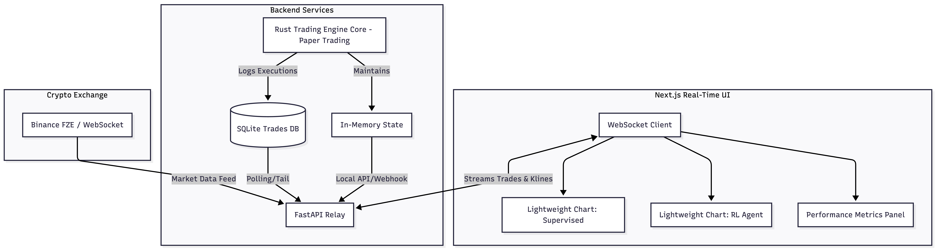

4. Key UI Components

A. The Engine Comparison Dashboard
The primary view splits the screen to show the active policies side-by-side:
- Left Panel: Supervised Regime-Switching Router
- Right Panel: Reinforcement Learning Policy (Decision Transformer / PPO) (Schulman et al., 2017)

B. Live Charting (Lightweight Charts)
Each panel contains a real-time chart configured as follows:
- Candlestick Series: Live OHLCV data streaming from the exchange.
- Markers: Green Arrow Below Candle: Buy Order Filled; Red Arrow Above Candle: Sell Order Filled
- Overlays: EMA 200, Bollinger Bands (Bollinger, 2002), and dynamic grid levels (if applicable).

C. Real-Time Metrics Strip
A persistent header/footer showing live comparison metrics calculated dynamically from the paper-trading execution feeds:
- Total PnL: (Supervised vs. RL)
- Active Drawdown: (Supervised vs. RL)
- Win Rate: Calculated based on closed trades in the session.
- Current Regime State: E.g., RANGING vs. TRENDING as inferred by the respective ML models.

5. Handling High-Frequency Data
To ensure the UI remains responsive and does not suffer from memory leaks over long paper trading sessions:
- Data Throttling: The FastAPI relay should batch WebSocket updates every 500ms instead of pushing on every single tick.
- Rolling Buffers: The Next.js state should maintain a fixed-size buffer for candlestick data (e.g., last 1000 candles). Older data is flushed from memory unless requested via historical pagination.
- Optimistic Rendering: Use Lightweight Charts’ native update() methods to append single data points directly to the canvas rather than triggering full React re-renders.

6. Deployment & Monitoring Strategy
The system is designed to run locally during the paper-trading phase, with each component containerized for portability. The Rust Trading Engine Core, the FastAPI relay, and the Next.js frontend each run in separate Docker containers orchestrated via Docker Compose (Docker, no date). Key monitoring considerations include:
- WebSocket Health: Heartbeat checks between the relay and frontend to detect disconnections and trigger automatic reconnection.
- Latency Tracking: Measure round-trip time from trade execution in the Rust Trading Engine Core to UI marker render, targeting < 500ms end-to-end.
- Resource Usage: Monitor browser memory consumption during long sessions to validate the rolling buffer strategy.

7. Error Handling & Resilience
Given that the dashboard operates over extended paper-trading sessions, resilience against transient failures is essential:
- Exchange Disconnection: If the upstream exchange WebSocket drops, the Rust Trading Engine Core's built-in reconnection logic handles recovery. The FastAPI relay broadcasts a stale-data warning flag to the frontend until the feed resumes.
- Relay Failure: The Next.js frontend displays a "Connection Lost" overlay and retries with exponential back-off (1s, 2s, 4s, capped at 30s).
- Data Integrity: On reconnection, the relay sends a snapshot of the last N candles and recent trades so the chart can backfill any gaps without requiring a full page reload.

8. Future Enhancements
Planned extensions for subsequent project phases:
- Historical Replay Mode: Allow replaying past sessions from the SQLite trade log, enabling offline analysis of regime transitions and execution quality.
- Multi-Asset View: Expand the dashboard to support simultaneous monitoring across multiple trading pairs, with a configurable grid layout.
- Performance Analytics Export: Add a one-click CSV/JSON export of session metrics for downstream analysis in Python notebooks.
- Alert System: Configurable threshold alerts (e.g., drawdown > 5%, regime change detected) pushed via WebSocket notifications to the UI.

References
Bollinger, J. (2002) Bollinger on Bollinger Bands. New York: McGraw-Hill.
Breiman, L. (2001) 'Random forests', Machine Learning, 45(1), pp. 5–32. doi:10.1023/A:1010933404324.
Chen, L., Lu, K., Rajeswaran, A., Lee, K., Grover, A., Laskin, M., Abbeel, P., Srinivas, A. and Mordatch, I. (2021) 'Decision Transformer: Reinforcement Learning via Sequence Modeling', Advances in Neural Information Processing Systems, 34, pp. 15084–15097.
Docker (no date) Docker Compose overview. Available at: https://docs.docker.com/compose/ (Accessed: 13 July 2026).
Ramírez, S. (no date) FastAPI. Available at: https://fastapi.tiangolo.com/ (Accessed: 13 July 2026).
Schulman, J., Wolski, F., Dhariwal, P., Radford, A. and Klimov, O. (2017) 'Proximal Policy Optimization Algorithms', arXiv preprint arXiv:1707.06347.
Sharpe, W.F. (1966) 'Mutual fund performance', The Journal of Business, 39(1), pp. 119–190.
TradingView (no date) Lightweight Charts. Available at: https://www.tradingview.com/lightweight-charts/ (Accessed: 13 July 2026).
Vercel (no date) Next.js documentation. Available at: https://nextjs.org/docs (Accessed: 13 July 2026).

