1. These are the outputs that show how I used Files to fill the customers’ and mechanics’ data [Bonus]

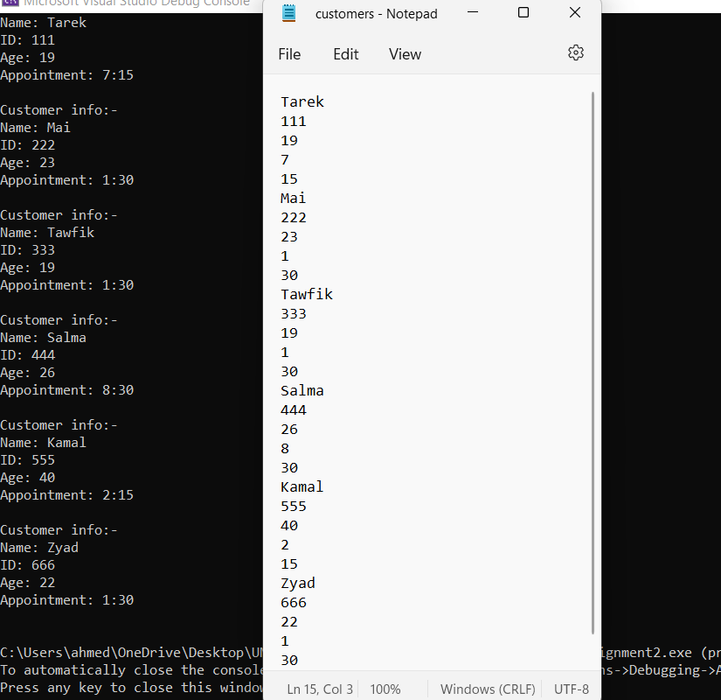

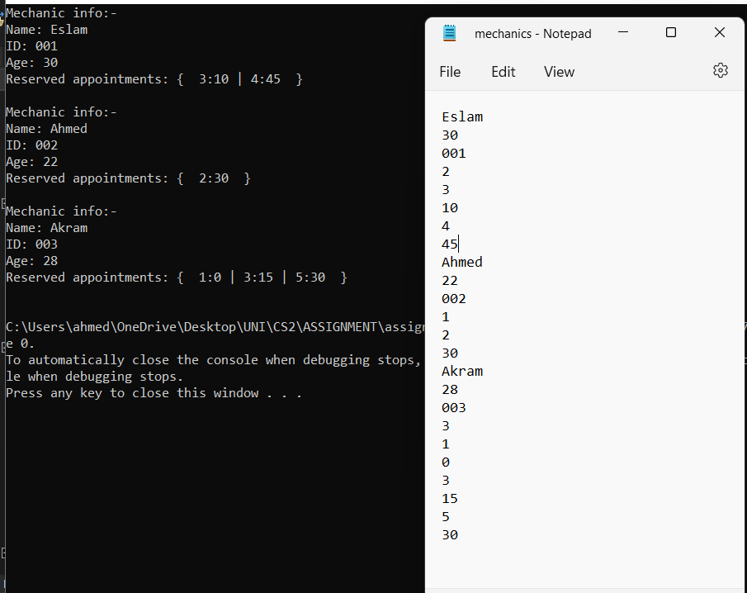

1. Here is the output of the queue.

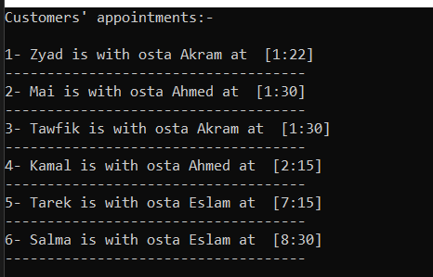

1. And that if all mechanics are already reserved;

