Part A: Theoretical Questions
Question 1: Explain what DevOps Engineering is. How does it differ from traditional development and operations roles?
DevOps Engineering is a software engineering approach that combines software development (Dev) and IT operations (Ops) to improve collaboration, automate workflows, and deliver software faster and more reliably. DevOps engineers use tools and practices such as version control, Continuous Integration and Continuous Delivery (CI/CD), automated testing, infrastructure as code, monitoring, and cloud computing.
In traditional organizations, developers write application code and hand it over to operations teams for deployment and maintenance. This separation can cause communication gaps, deployment delays, and difficulties identifying problems.
In contrast, DevOps promotes shared responsibility throughout the software lifecycle. Development and operations teams collaborate to automate builds, testing, deployment, monitoring, and incident recovery.
For example, instead of manually deploying an application after every release, a DevOps team can configure a CI/CD pipeline that automatically tests the code and deploys approved changes.
Question 2: Describe how DevOps fits into the Software Development Life Cycle (SDLC). Mention at least three SDLC phases where DevOps adds value.
DevOps supports the Software Development Life Cycle (SDLC) by introducing automation, collaboration, continuous feedback, and monitoring throughout the development process.
DevOps adds value in the following phases:
- Planning: Teams collaborate to define requirements, prioritize tasks, and plan releases using tools such as Jira or GitHub Projects.
- Development: Developers use Git and GitHub for version control, collaboration, and code management.
- Testing: Automated testing tools help identify defects early and improve software quality.
- Deployment: CI/CD tools such as Jenkins or GitHub Actions automate application builds and deployments.
- Operations and Monitoring: Tools such as Prometheus and Grafana help monitor application performance, resource utilization, and system availability.
- Feedback and Improvement: Logs, metrics, and user feedback help teams identify problems and improve future releases.
Therefore, DevOps makes the SDLC more continuous, automated, collaborative, and reliable.
Question 3: What values does a DevOps Engineer bring to an organization? Explain any four values with examples.
A DevOps Engineer provides several organizational benefits. Four important values are:
1. Faster Software Delivery: Automation reduces the time required to build, test, and deploy applications. For example, a CI/CD pipeline can automatically test and deploy approved code changes.
2. Improved Reliability: Automated tests, health checks, monitoring, and controlled deployments help reduce failures. For example, monitoring alerts can notify engineers when application response times increase.
3. Better Collaboration: DevOps encourages developers, testers, and operations engineers to share information and responsibility. For example, a shared incident channel helps all team members coordinate during an outage.
4. Reduced Operational Costs: Infrastructure automation and efficient resource management reduce repetitive manual work and unnecessary resource consumption. For example, cloud resources can be scaled according to application demand.
These values help organizations deliver better software while improving productivity, stability, and customer satisfaction.
Question 4: Why is prior Software Engineering (SWE) experience considered helpful before becoming a DevOps Engineer?
Prior Software Engineering experience is helpful because DevOps engineers work closely with application code, development workflows, testing, and deployment processes.
Understanding programming, debugging, data structures, APIs, and software architecture helps DevOps engineers identify application-related problems. Knowledge of Git, testing, and dependency management also makes it easier to design effective CI/CD pipelines.
For example, when a deployment fails because a required environment variable is missing, an engineer with software development experience can understand how the application uses that variable and help resolve the problem.
However, prior professional software engineering experience is not mandatory for every DevOps role. Beginners can enter DevOps by learning programming fundamentals, operating systems, networking, cloud platforms, and automation tools.
Question 5: Explain why networking knowledge (DNS, ports, protocols, IP addressing) is important for DevOps roles.
Networking knowledge is essential because applications, servers, containers, and cloud services communicate through networks.
The major concepts include:
- DNS: Domain Name System translates domain names into IP addresses. DNS troubleshooting helps resolve problems when a website cannot be reached through its domain name.
- Ports: Ports identify the network services receiving traffic. For example, port 80 is commonly used for HTTP, port 443 for HTTPS, and port 22 for SSH.
- Protocols: Protocols such as HTTP, HTTPS, TCP, and UDP define how data is transmitted between systems.
- IP Addressing: IP addresses identify network interfaces and help engineers configure servers, firewalls, routing, and access controls.
For example, if an application is running locally on port 8000 but cannot be accessed remotely, a DevOps engineer may check the server status, listening port, firewall rules, IP configuration, and network connectivity.
Therefore, networking knowledge helps DevOps engineers deploy, secure, connect, and troubleshoot distributed applications.
Question 6: What soft skills are essential for a DevOps Engineer? Explain how these skills help during incidents or failures.
Important soft skills for a DevOps Engineer include communication, teamwork, problem-solving, adaptability, time management, and leadership.
Communication: Clear communication helps engineers share incident updates, explain technical problems, and coordinate recovery actions.
Teamwork: Collaboration allows developers, system administrators, security engineers, and other team members to investigate incidents together.
Problem-solving: Analytical thinking helps engineers identify the root cause of failures instead of relying on guesswork.
Adaptability: DevOps engineers must learn new tools and adjust to changing technologies and operational requirements.
Time management: Prioritizing tasks helps engineers focus on critical production issues before lower-priority work.
For example, during a production outage, an engineer may investigate application logs while another checks network connectivity. Clear communication and coordinated responsibilities help the team restore service efficiently.
Question 7: Explain the importance of patience and troubleshooting mindset in DevOps with a real-life example.
Patience and a systematic troubleshooting mindset are important because production problems may have multiple possible causes. Making unverified changes can introduce additional failures or make the original problem more difficult to diagnose.
A troubleshooting mindset involves observing symptoms, collecting evidence, testing possible causes, making controlled changes, and verifying the results.
For example, suppose a website becomes unavailable after deployment. Instead of immediately restarting every server, the DevOps engineer checks deployment logs, application health, network connectivity, environment variables, and database connections. The investigation reveals that the new application version uses an incorrect database configuration.
The engineer corrects the configuration, verifies the application's health, and confirms that users can access the website again.
This example demonstrates how patience and evidence-based troubleshooting can reduce downtime and prevent unnecessary changes.

Part B: Scenario-Based Questions
Question 1: A new student joins a DevOps course but is unfamiliar with GitHub and cloud platforms. How would you onboard this student efficiently using tools, documentation, and communication channels?
I would onboard the student through a structured learning process.
Step 1: Assess the student's current knowledge. Identify their familiarity with command-line tools, programming, Git, and cloud computing.
Step 2: Provide setup instructions. Share a checklist for installing Git, a code editor, and the required command-line tools. Introduce GitHub account creation and basic repository operations.
Step 3: Use practical exercises. Ask the student to create a repository, commit a file, push changes, and create a pull request.
Step 4: Introduce cloud platforms gradually. Demonstrate the basic concepts of virtual machines, storage, networking, and access management using a cloud provider's documentation and beginner tutorials.
Step 5: Provide documentation and communication channels. Maintain a shared knowledge base in GitHub or a documentation platform. Use Slack, Microsoft Teams, or Discord for questions and announcements.
Step 6: Assign a small project. Ask the student to build a simple application and run it locally before introducing automated testing and deployment.
This approach reduces confusion, encourages independent learning, and helps the student become productive through practical experience.
Question 2: During a production deployment, an application goes down unexpectedly. As a DevOps Engineer, describe step-by-step how you would troubleshoot and handle the situation.
I would follow an incident response process focused on restoring service safely and identifying the root cause.
- Acknowledge the incident: Confirm the outage through monitoring alerts, health checks, or user reports. Assess the impact and severity.
- Communicate with the team: Notify the incident channel and assign responsibilities for investigation, communication, and recovery.
- Investigate the deployment: Check recent code changes, deployment logs, application logs, infrastructure metrics, and health-check results.
- Identify the likely cause: Examine application errors, configuration changes, database connectivity, resource utilization, and network issues.
- Restore service: If the new release is responsible and a safe previous version is available, roll back to the last known-good version. Apply a targeted fix only when appropriate.
- Verify recovery: Test application availability, important business functions, database connectivity, and error rates.
- Monitor the system: Continue monitoring to confirm that the problem does not recur.
- Conduct a post-incident review: Document the timeline, root cause, impact, corrective actions, and preventive measures.
The main priority is to restore service safely, communicate clearly, and prevent similar incidents in the future.
Question 3: Your team releases features frequently, but system stability is decreasing. How can DevOps practices help balance speed and reliability?
DevOps practices can improve both release speed and system stability by introducing automation, testing, monitoring, and controlled deployment strategies.
Automated testing: Run unit, integration, and regression tests before approving a release.
CI/CD pipelines: Standardize build, test, security-check, and deployment procedures to reduce human error.
Staged deployments: Deploy changes to development and staging environments before production.
Canary and blue-green deployments: Release changes to a limited portion of users or switch between environments to reduce deployment risk.
Monitoring and alerting: Track error rates, latency, availability, and resource utilization to detect failures quickly.
Rollback mechanisms: Maintain a tested recovery procedure that can restore a previous stable version.
Post-incident reviews: Analyze failures and use the findings to improve the development and deployment process.
These practices allow teams to release features frequently while maintaining quality, reliability, and user confidence.
Question 4: A team struggles with communication during incidents because members are distributed. How can proper onboarding to communication platforms improve DevOps workflows?
Proper onboarding to communication platforms helps distributed teams coordinate work and respond to incidents more effectively.
The organization should establish a shared platform such as Slack or Microsoft Teams and create dedicated channels for deployments, incidents, monitoring alerts, and general technical discussions.
Team members should learn how to report incidents, share logs and screenshots, mention responsible engineers, and post status updates. The team should also define escalation procedures and clarify who is responsible for incident coordination.
Runbooks and troubleshooting guides should be stored in an accessible shared repository. Important incident decisions and recovery steps should be documented rather than left only in private conversations.
For example, when a production application fails, an automated monitoring alert can notify the incident channel. The responsible engineers can share findings, coordinate rollback activities, and post recovery updates in one place.
This approach improves transparency, reduces duplicated effort, and helps distributed teams resolve incidents more efficiently.

Part C: Practical evidence checklist
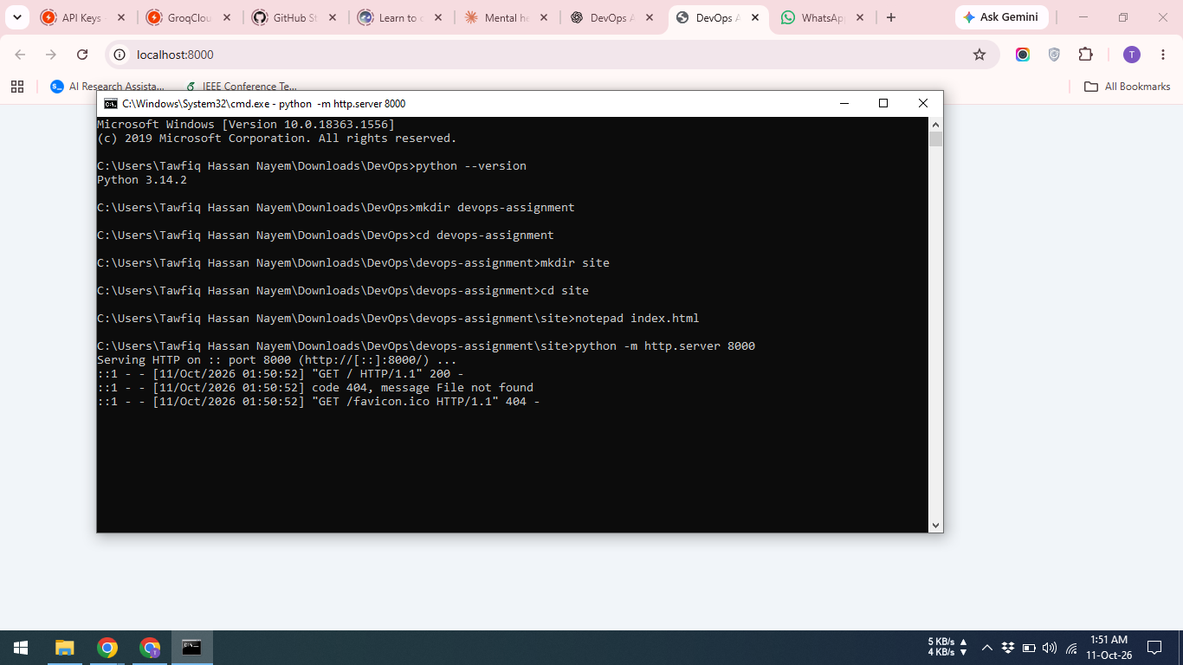
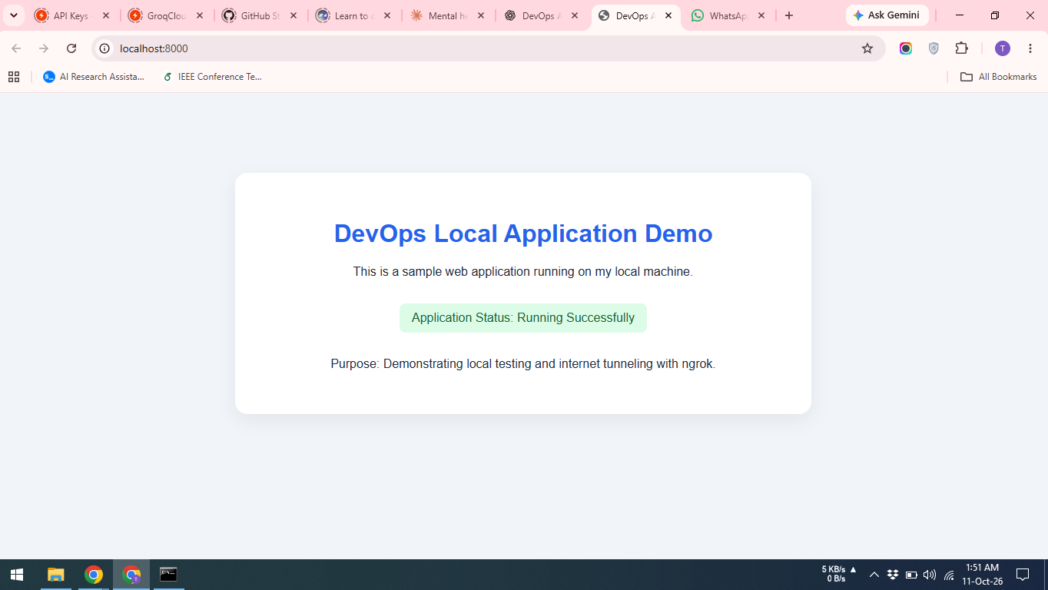
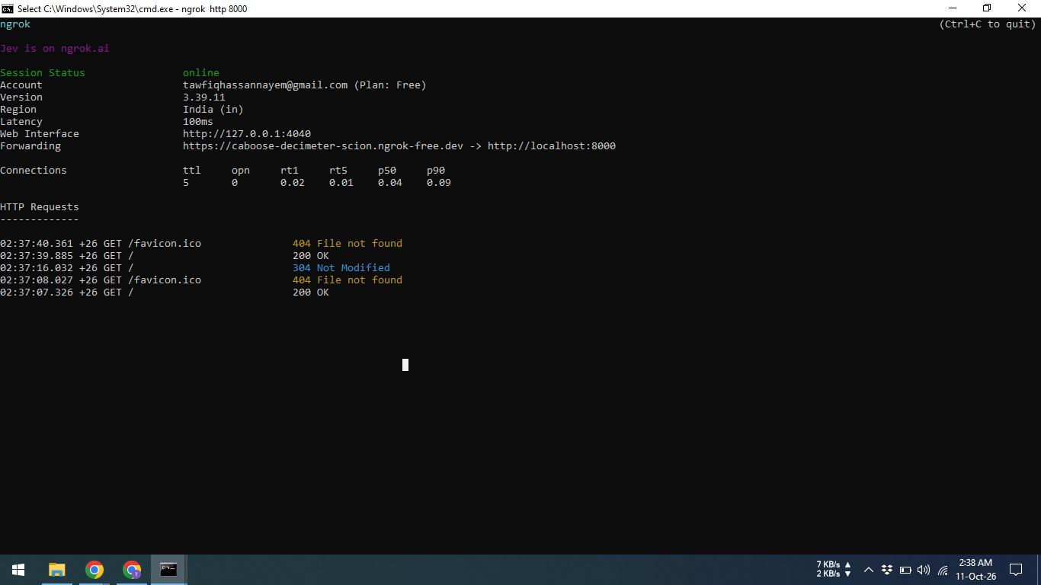
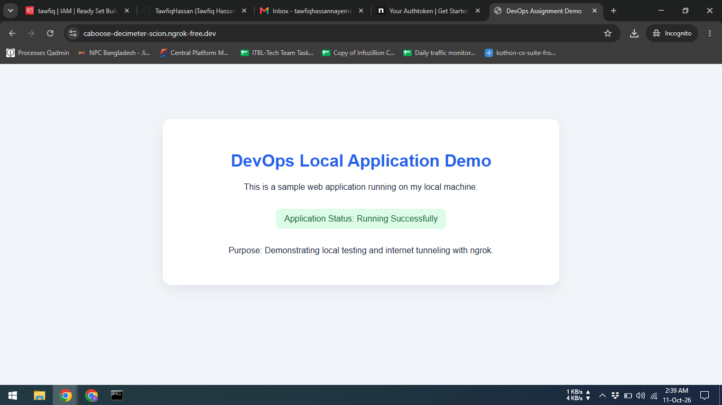

Conclusion
This assignment provided an understanding of DevOps engineering, its role in the Software Development Life Cycle, and its importance in improving collaboration, automation, and software reliability. The scenario-based questions demonstrated how DevOps practices support onboarding, incident response, stable releases, and communication among distributed teams. The practical demonstration showed how to run a web application locally and expose it through ngrok tunnel for remote testing. Overall, these activities illustrate how DevOps principles help teams deliver and maintain software more efficiently.

