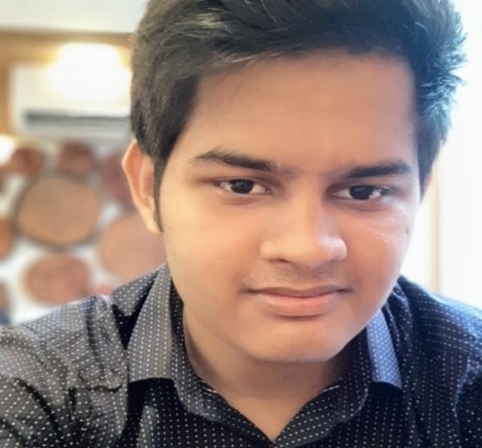

TAWFIQUE HASSAN STUDENT

**Block-D House-4 Banasree**

**+8801772690992**

**tawfiquehassan@gmail.com**

Skill’s

HTML 60%

CSS 50%

C++ 80%

JAVA 70%



Contact

/ **github.com/Tawfiques**

**Fb.com/safints**

ABOUT ME

I am currently a student of North South University. I can handle

multiple task on daily basis and flexible working with other people.

So, others can rely on me.

Education

2006-2016

Completed SSC from Ideal School and College

2016-2018

Completed HSC from Dhaka Imperial College

2019-Present

Currently Studying at North South University

Work-Experience

NONE

Hobbies

**F**

   