

AMERICAN INTERNATIONAL UNIVERSITY–BANGLADESH (AIUB)
FACULTY OF SCIENCE & TECHNOLOGY
Fall 2025-26

MICROPROCESSOR AND EMBEDDED SYSTEMS
Section: M (GROUP-6)
OEL LAB REPORT ON:
Air Quality Monitoring System
Supervised By
DEBRAJ DAS
Submitted By: MD. TAWFIQUL ISLAM TAMAL
Name | ID
1. MD. TAWFIQUL ISLAM TAMAL | 23-52978-3
2. RAFID HOSSAIN | 23-52980-3
3. MD ABU SIAM | 23-52991-3
4. ASMA AKTHER | 23-53029-3
5. ANIK DEB BISWAS | 23-53889-3
6. NADIM HOSSAIN | 23-53906-3

Date of Submission: 30-Dec-2025

Experiment Title:
Air Quality Monitoring System
Introduction:
The main objective of this experiment is to design and implement an air quality monitoring system using a microcontroller and gas sensor module. This experiment aims to understand the working principles of gas sensing technology, including detection of gas concentration levels, analog signal processing, and threshold-based alert mechanisms.
Through this experiment, air quality monitoring is practically demonstrated by measuring gas concentration from the surrounding environment and displaying real-time values on an LCD. When the gas level exceeds a predefined safe limit, an automated alert system activates a buzzer. The experiment helps in understanding how sensor-based embedded systems collect, process, and respond to environmental data in real-time safety and monitoring applications.

Theory and Methodology:
Air quality monitoring systems are designed to detect the presence of harmful gases and measure their concentration levels in the surrounding environment. In this experiment, a gas sensor module was used to sense gas concentration by producing an analog output voltage proportional to the amount of gas present in the air. The sensor operates based on changes in electrical resistance when exposed to different gas concentrations.
In this experiment, an Arduino Uno microcontroller board was used as the main processing unit. The gas sensor was connected to the analog input pin of the Arduino. The Arduino continuously reads the sensor output and converts the analog signal into a digital value using its built-in Analog-to-Digital Converter (ADC). The measured gas concentration value is then processed using a predefined threshold-based algorithm.
The system functionality was implemented using the Arduino programming environment. The Arduino compares the sensed gas value with a predefined safe limit. When the gas concentration exceeds the threshold level, the microcontroller activates a buzzer as an alert signal and displays the gas concentration value on an LCD. Based on the sensor readings, the system provides real-time monitoring and warning, demonstrating practical implementation of sensor interfacing, data processing, and automated alert mechanisms in embedded systems.
Experimental Circuits & Result:
In this experiment, an Arduino Uno microcontroller board was connected with a gas sensor, an LCD display, and a buzzer using proper resistors and breadboard connections. The gas sensor was connected to the analog input pin of the Arduino, and the LCD and buzzer were connected to the digital pins.
Two main operations were performed:
- Gas Level Monitoring: The gas sensor continuously detected the amount of gas present in the surrounding air. The Arduino read the sensor value and showed the gas level on the LCD display in real time.
- Alert Activation: When the gas level crossed the safe limit, the Arduino turned ON the buzzer to give a warning sound. At the same time, a warning message and the gas level were shown on the LCD to alert the user about unsafe air quality.
The system was tested by changing the gas level near the sensor and observing the LCD readings and buzzer response. The results confirmed that the system correctly detected gas concentration and activated the warning system when the gas level became unsafe.

Figure 1: When the push button on the Master Arduino was pressed

Figure 2: When the push button on the Slave Arduino was pressed
As shown in Figures 1, 2, and 3, an object was placed in front of the sonar sensor while the circuit was running. When the object was far within the sensor’s range (between 50 cm and 80 cm), only the green LED turned ON, indicating that the object was at a safe distance. When the object moved closer (between 30 cm and 50 cm), the yellow and red LEDs turned ON together, showing that the object was getting nearer to the sensor. Finally, when the object came very close to the sensor (less than 30 cm), all three LEDs—green, yellow, and red—glowed at the same time, signaling that the object was at a very short distance.
Figure 3: All LED turned ON when a distance as at a close distance

Figure 2: When the push button on the Master Arduino was pressed

As shown in Figures 3 and 4, when the code starts running, the Arduino microcontroller begins monitoring the air quality by continuously reading data from the gas sensor. The sensor detects the gas concentration in the surrounding environment and sends the analog value to the Arduino. Based on this value, the system updates the LCD display and controls the alert components.
When the air quality is within the safe range (Figure 3), the Arduino displays the gas concentration value on the LCD along with the message “AQI Good”. In this condition, the green LED remains ON, and the buzzer remains OFF, indicating that the air quality is safe.
When the gas concentration increases and crosses the predefined threshold level (Figure 4), the Arduino identifies the air quality as unsafe. In response, the LCD displays the message “AQI Hazardous” along with the gas value. At the same time, the red LED turns ON and the buzzer is activated, confirming that the air quality has reached a dangerous level.

Simulation Circuits & Result:
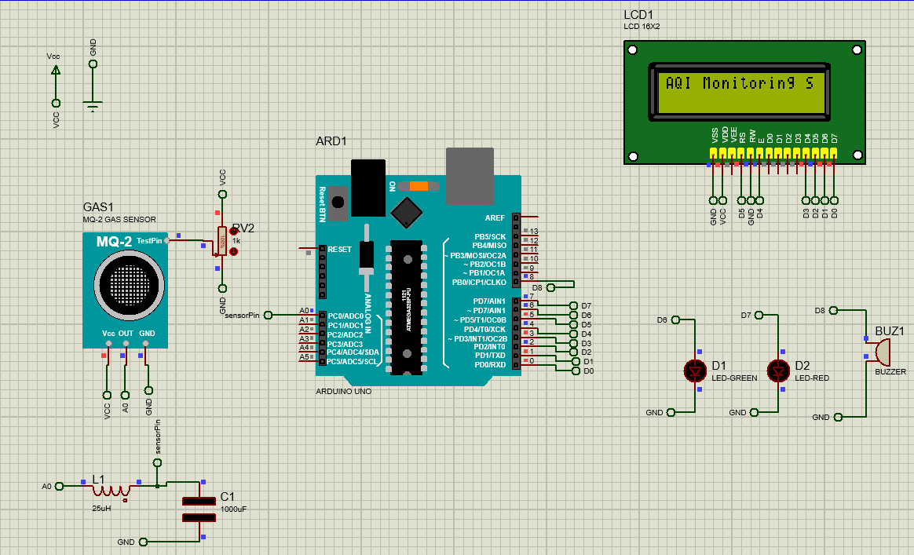

Figure 3: Proteus Simulation of AQI Monitoring System

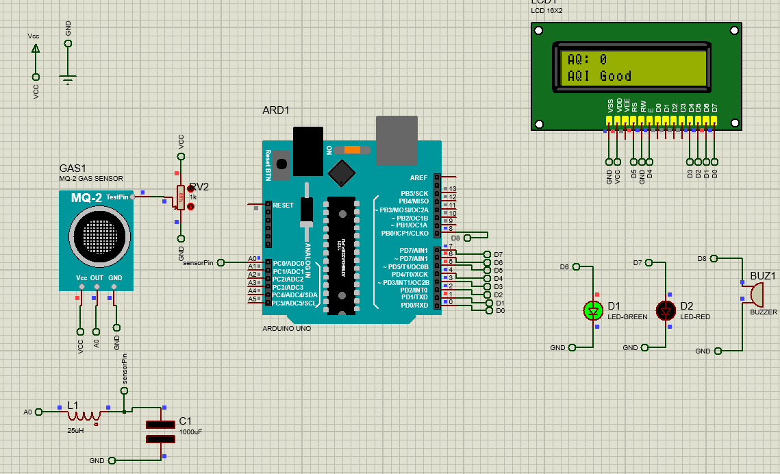

Figure 4: Proteus Simulation When AQI is Good

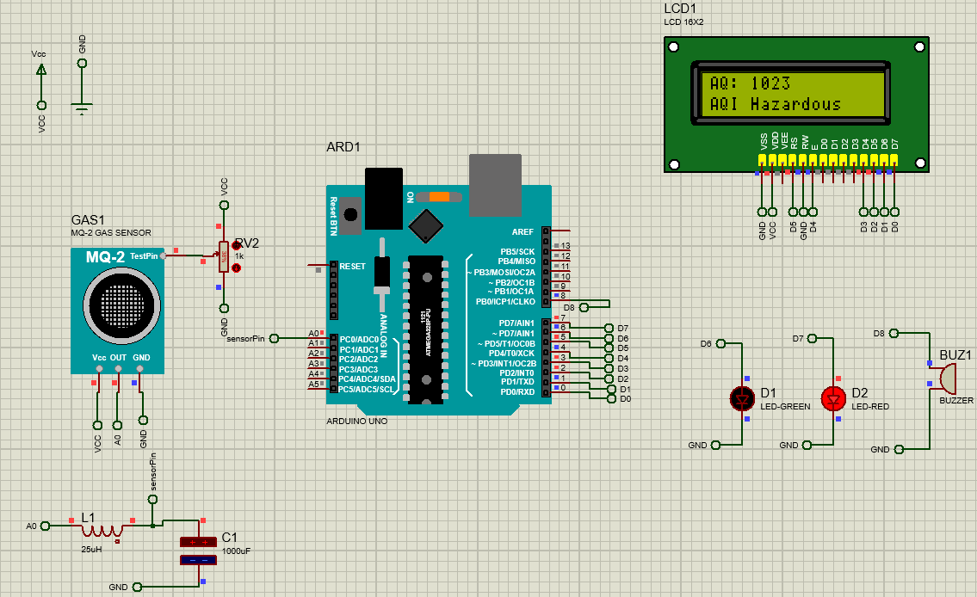

Figure 4: Proteus Simulation When AQI is Hazardous

As shown in Figures 3 and 4, when the code starts running, the Arduino microcontroller begins monitoring the air quality by continuously reading data from the gas sensor. The sensor detects the gas concentration in the surrounding environment and sends the analog value to the Arduino. Based on this value, the system updates the LCD display and controls the alert components.
When the air quality is within the safe range (Figure 3), the Arduino displays the gas concentration value on the LCD along with the message “AQI Good”. In this condition, the green LED remains ON, and the buzzer remains OFF, indicating that the air quality is safe.
When the gas concentration increases and crosses the predefined threshold level (Figure 4), the Arduino identifies the air quality as unsafe. In response, the LCD displays the message “AQI Hazardous” along with the gas value. At the same time, the red LED turns ON and the buzzer is activated, confirming that the air quality has reached a dangerous level.

Conclusion:
The primary purpose of this experiment was to design and implement a microcontroller-based air quality monitoring system that can detect harmful gas concentrations and provide timely alerts to ensure environmental and human safety. The experiment demonstrated how sensor-based monitoring systems can be used effectively for pollution detection and hazard prevention.
Through this experiment, practical knowledge was gained on gas sensor interfacing, analog signal processing, and real-time data monitoring using Arduino. The experiment enhanced understanding of threshold-based alert systems, LCD interfacing, and embedded system programming. It also improved skills in circuit design, algorithm implementation, and environmental monitoring applications, strengthening overall concepts of sensor-based embedded systems.

Reference:
[1] Proteus Design Suite, “How to Simulate Arduino Projects in Proteus,” Labcenter Electronics. [Online]. Available: https://www.labcenter.com
[Accessed: May 5, 2025].
[2] AIUB Microprocessor and Embedded Systems Lab Manual’s

