Mining Optimisation Solutions Ltd
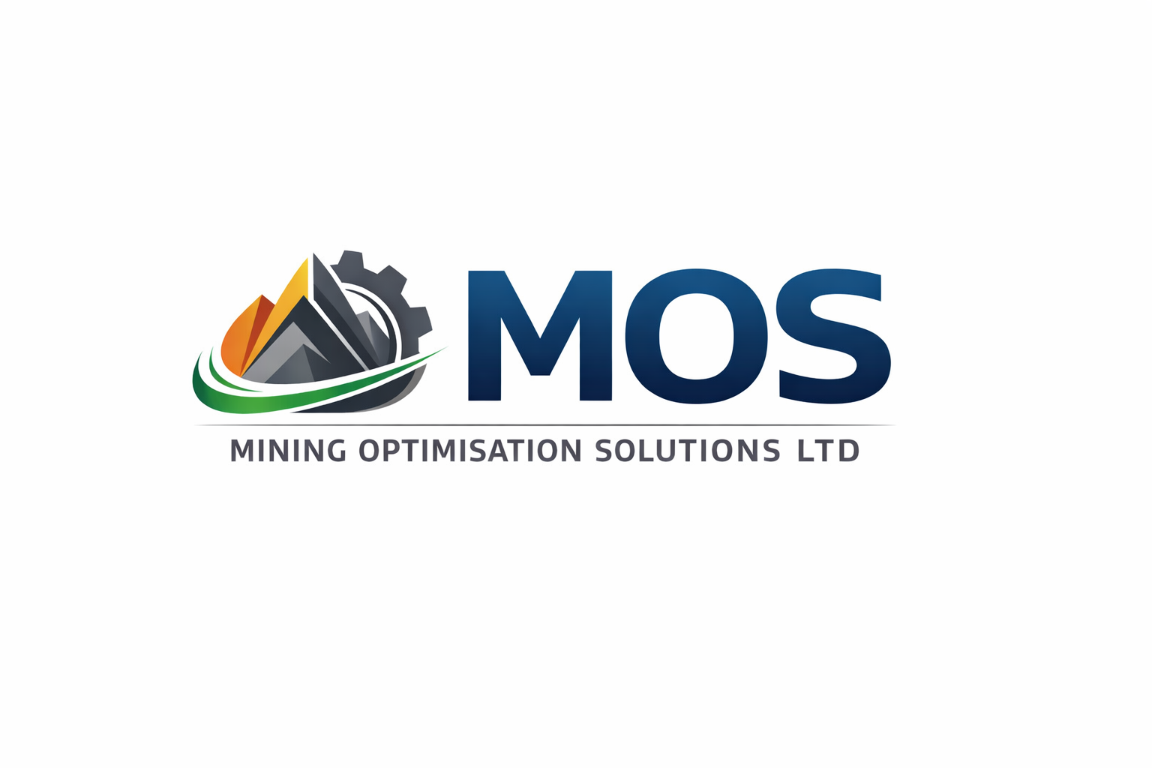
Official Website Content, Brand Kit & SEO Pack

1. BRAND KIT
Brand Essence: Performance. Precision. Sustainability.
Primary Colors:
- Deep Blue (Corporate Trust)
- Industrial Grey
- Sustainability Green
- Accent Orange (Mining & Energy)
Typography:
- Headings: Montserrat / Poppins (Web)
- Body: Open Sans / Lato
Logo Usage:
- Use full-color logo on white or light backgrounds
- Use monochrome version on dark backgrounds
- Do not distort, recolor, or crop the logo

2. SEO TITLES & META DESCRIPTIONS
Home:
Title: Mining Optimisation Solutions Ltd | Contract Mining & EPC Ghana
Meta: Engineering-led mining, EPC, technology and environmental solutions across Ghana and West Africa.
About:
Title: About MOS | Engineering & Mining Solutions West Africa
Meta: Learn about Mining Optimisation Solutions Ltd, an engineering-led mining and EPC company.
Services:
Title: Mining & EPC Services | Mining Optimisation Solutions Ltd
Meta: Contract mining, EPC, mining technologies, IT and environmental services.
Contact:
Title: Contact MOS | Mining & EPC Experts in Ghana
Meta: Contact Mining Optimisation Solutions Ltd in Accra for mining and EPC solutions.

3. WEBSITE CONTENT

HOME
Performance. Precision. Sustainability.
Mining Optimisation Solutions Ltd delivers contract mining, EPC delivery,
technology-enabled systems, and environmental solutions across Ghana and West Africa.

ABOUT MOS
Founded in 2019, Mining Optimisation Solutions Ltd is a Ghanaian-owned, engineering-led company
supporting mining and industrial clients with safe, reliable, and sustainable solutions.

SERVICES
Contract Mining:
Operational support, mine development, and optimisation engagements.
EPC Services:
Engineering, procurement, construction, and commissioning support.
Mining Technologies & Systems:
Production monitoring, optimisation tools, and reporting dashboards.
IT Supplies & Services:
Enterprise hardware, software, networking, and managed IT services.
Environmental & HSE:
Environmental compliance, HSE systems, audits, and ESG-aligned support.

HSE & ESG
MOS operates a safety-first culture aligned with Ghanaian regulations
and international best practice, ensuring zero harm and responsible delivery.

CAREERS
We welcome experienced professionals across mining, engineering, HSE, and IT disciplines.
Send CVs to info@miningopts.com

CONTACT
A88 Legon Bypass, Westlands, Accra
Phone/WhatsApp: +233 24 473 4616
Email: info@miningopts.com

