**Investigating the Relationship Between Solar Irradiance and Output Voltage in**

**Photovoltaic Systems: Correlation and Regression Analysis**

## Submission info:

Submitted to:

**Dr. Mohiuddin Ahmad**  
Professor  
Electrical and Electronic Engineering  
Khulna University of Engineering & Technology (KUET)

**Dr. Md. Shahjahan**  
Professor  
Dept. of Electrical and Electronic Engineering  
Khulna University of Engineering & Technology (KUET)

## Submitted by:

* Tawseef Salim Rafi

Roll: 2003022

* Mahdi Muntakim

Roll: 2003025

**Course no:** EE 3122

**Course title:** Sessional on Numerical Methods and Statistics

**Department:** Department of Electrical and Electronic Engineering

**Institute:** Khulna University of Engineering & Technology

**Date of submission:**

**ABSTRACT**

This project investigates the relationship between solar irradiance and output voltage in photovoltaic (PV) systems through correlation and regression analysis. The primary objective is to understand how variations in solar irradiance levels affect the output voltage of PV systems, which is crucial for optimizing their performance and efficiency. The methodology involves collecting data on solar irradiance and output voltage from a range of PV systems installed in different locations and under various environmental conditions. Correlation analysis is used to explore the degree of linear relationship between solar irradiance and output voltage, while regression analysis is employed to develop predictive models. Key findings reveal a strong positive correlation between solar irradiance and output voltage, indicating that higher levels of solar irradiance lead to increased output voltage in PV systems. The regression models derived from the analysis provide valuable insights into the expected output voltage based on solar irradiance levels. The conclusions drawn from this study underscore the importance of considering solar irradiance as a significant factor in optimizing the performance of PV systems, thereby contributing to the advancement of renewable energy technologies**.**

**Keywords:** Photovoltaic Systems, Solar Irradiance, Output Voltage, Correlation Analysis, Simple Linear Regression, Modeling, Simulation

**1.INTRODUCTION**

Fossil fuel consumption for meeting energy needs has led to environmental consequences such as global warming and air pollution. To mitigate climate change and air pollution, the adoption of clean and renewable energy sources has become imperative. Solar energy, in particular, has gained significant attention as a viable renewable energy option due to its environmental benefits. Consequently, extensive research is being conducted to explore various aspects of harnessing solar power. [1]

Bangladesh generates 99% of its energy from fossil fuels. However, it has several renewable energy targets for 2030 and 2040 that require significant financial and time investments. Solar power will play an essential role in reaching these targets, and Bangladesh can't afford to postpone the transition in favour of LNG.

There is significant potential for **solar energy in Bangladesh**. Not only is the low-lying country committed to growing [its renewable energy capacity](https://energytracker.asia/renewable-energy-in-bangladesh-current-trends-and-future-opportunities/" \t "https://energytracker.asia/solar-energy-in-bangladesh-current-status-and-future/_blank), but the population of [over 171 million](https://worldpopulationreview.com/countries/bangladesh-population" \t "https://energytracker.asia/solar-energy-in-bangladesh-current-status-and-future/_blank) is growing at 1% annually. This growing population and its developing economy generate an average energy [demand increase of 4.68%](https://ourworldindata.org/energy/country/bangladesh" \t "https://energytracker.asia/solar-energy-in-bangladesh-current-status-and-future/_blank) annually. [2]

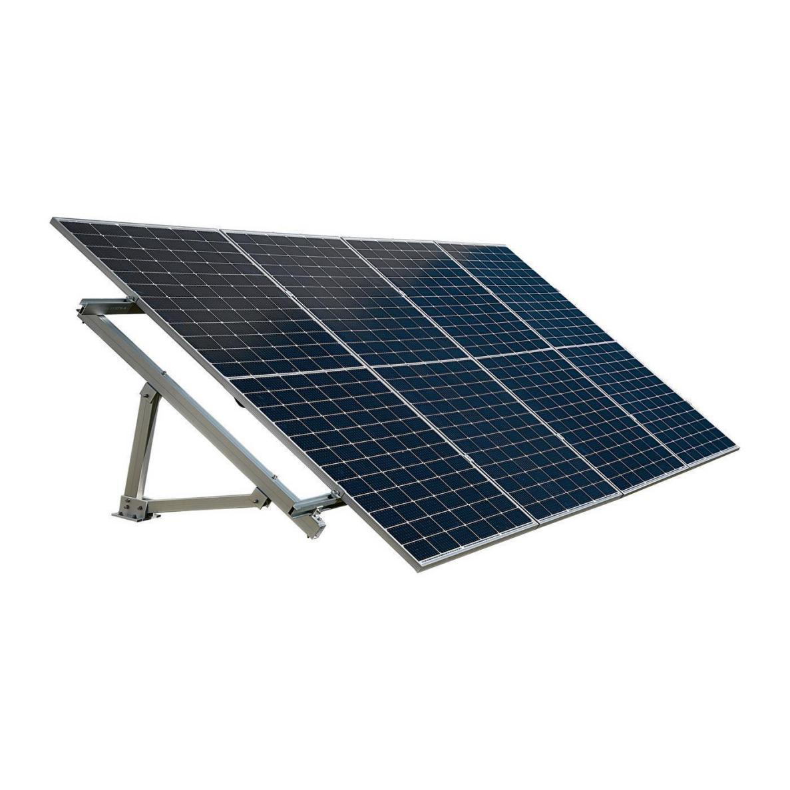

Figure 01: Poly-crystalline Photovoltaic Solar Panel Module

The efficiency of solar panels plays a crucial role in determining the economic viability of a solar photovoltaic (PV) power plant, as it directly converts solar energy into electrical energy. This efficiency is influenced by multiple factors, including solar intensity, temperature, wind speed, rainfall, humidity, dew point, and cloud cover. Consequently, investigating the impact of these factors on solar panel efficiency has become a key area of interest for researchers.

It can be concluded intuitively that the effect of irradiance, cell temperature and wind speed on PV systems depends on geographical location and environmental and meteorological conditions. Researchers around the world strive to better comprehension of the impact of these parameters on PV systems. Understanding the effect of these parameter is realized by designing robust and reliable theoretical models and/or conducting experiments. By building simple and accurate mathematical models based on actual performance conditions to predict behavior of PV systems, this work aims to add a significant contribution to the PV literature. In this work, we have experimentally collected PV system parameters during 12 hourly data sets under real conditions. Based on the performance parameters, a model is developed to predict the system’s output behavior employing simple linear regression (SLR). The model considered the solar irradiance as the independent variable, and PV output voltage as the dependent variable. [3]



Fig 02: Solar irradiance index value of Bangladesh

In the context of Electrical and Electronic Engineering (EEE), this research holds significant implications for the design, operation, and management of PV systems, offering valuable contributions to the ongoing efforts towards sustainable energy transition and environmental conservation. By addressing key challenges and uncertainties associated with solar energy utilization, this study aims to facilitate informed decision-making and policy formulation in the renewable energy sector.

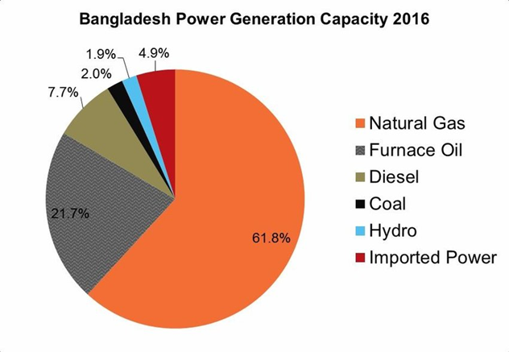

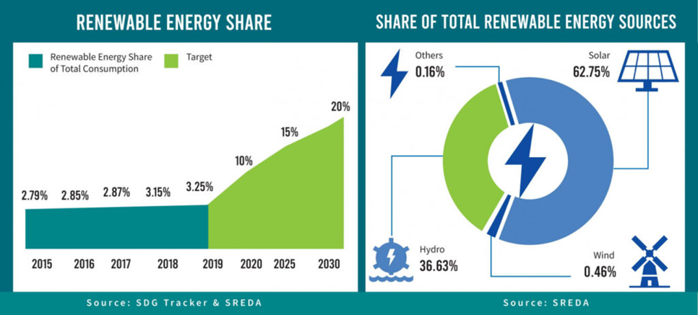

Fig 03:Power Generation of Bangladesh

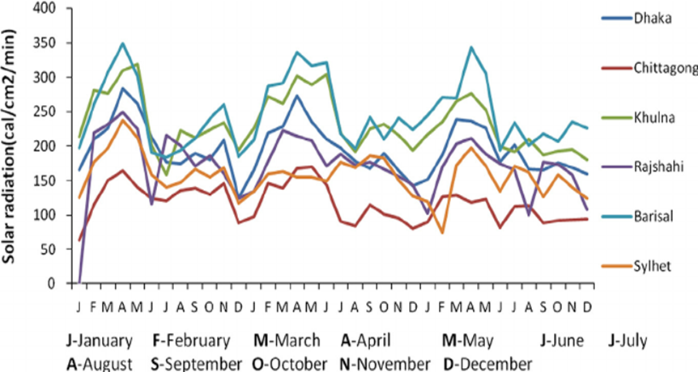

Fig 04: Average solar radiation in the six divisions in Bangladesh

**1.1.Objectives:**

* Investigate the relationship between solar irradiance and output voltage in photovoltaic systems.
* Analyze real-world data from multiple PV installations to understand the impact of sunlight intensity on electrical output.
* Quantify the correlation between solar irradiance and output voltage using statistical methods.
* Use regression analysis to model the relationship between solar irradiance and output voltage.
* Provide insights into optimizing the efficiency and reliability of PV systems based on the findings.

**1.2.Scope:**

* Collection of data from diverse PV installations in various geographical locations and environmental conditions.
* Preprocessing of collected data to ensure consistency and accuracy.
* Statistical analysis using correlation and regression techniques to determine the relationship between solar irradiance and output voltage.
* Interpretation of results to identify trends, patterns, and dependencies.
* Comparison of findings with existing literature and industry standards to validate the research outcomes.

**1.3.Motivations:**

* Address the increasing demand for renewable energy sources amid global concerns over climate change and energy security.
* Enhance the efficiency and reliability of photovoltaic systems to accelerate the transition towards sustainable energy solutions.
* Contribute to the advancement of knowledge in the field of Electrical and Electronic Engineering (EEE) by providing insights into the performance of PV systems.
* Support decision-making processes for policymakers, energy industry professionals, and researchers involved in renewable energy initiatives.

Understanding the relationship between solar irradiance and output voltage in photovoltaic (PV) systems is vital for optimizing energy generation and system performance. This knowledge enables engineers to design more efficient and reliable PV installations, ensuring consistent energy supply and advancing the development of sustainable renewable energy technologies.

1. **LITERATURE REVIEW**

Several studies have examined the relationship between solar irradiance and the output voltage of photovoltaic (PV) arrays, employing correlation and regression analysis techniques. Kazem et al. [4,5] explored the impact of solar radiation on PV systems in Oman, highlighting its potential for investment despite challenges posed by high temperatures. Similarly, Yousif et al. [6] conducted a feasibility study on solar power production in Oman, emphasizing its promising prospects due to abundant solar radiation.

On the other hand, Song et al. [7] investigated the adverse effects of PM2.5 pollution on solar energy availability in Hong Kong. Their findings revealed a negative impact on solar energy generation, with significant reductions observed in global horizontal irradiance and PV system performance due to pollution.

Studies by Singh and Ravindra [8], Makrides et al. [9], and Ebhota and Tabakov [10] focused on understanding the influence of temperature on solar cell performance. Singh and Ravindra observed decreases in efficiency parameters as temperature increased, while Makrides et al. found varying thermal losses among different solar cell types in Cyprus. Ebhota and Tabakov compared the performance of different PV modules under temperature variations.

Chakraborty et al. [11] employed machine learning techniques to investigate the impact of meteorological parameters on solar PV systems in eastern India, achieving high prediction accuracy for PV power plants. Aoun (13) evaluated mathematical models estimating the temperature of PV modules based on solar radiation and ambient temperature inputs.

Additionally, Ghazy et al. [12] proposed a hybrid PV module and desalination system to enhance performance in hot regions, while Mehmood et al. [13] assessed the integration of solar PV into residential sectors, emphasizing the importance of grid connectivity and battery storage systems.

Furthermore, studies by Gwandu and Creasey [14], Panjwani and Narejo [15], and Mekhilef et al. [16] investigated the effects of humidity on PV module performance. They observed nonlinear relationships between humidity and solar radiation, with humidity causing reductions in PV power output.

Other studies such as those by Sohani et al. [20], Akonjom and Njok [21], and Hussein et al. [22] explored the impacts of various meteorological parameters on PV performance, including temperature, humidity, wind speed, and solar radiation. These studies identified optimal conditions for PV operation and optimal tilt angles for maximum power output.

Based on the reviewed literature, it is evident that existing studies on PV cell performance primarily focus on assessing the feasibility of specific locations for solar energy harnessing, [4-6] determining the optimal tilt angle for maximum output, [19] comparing the performance of different PV cell technologies, [9] and investigating the effects of various meteorological parameters on PV cell performance. The meteorological parameters considered include solar intensity, [4,5] ambient temperature, [4-11] humidity, [14-18] wind speed, [10,18] and dew point. However, neither of these studies has considered any linear regression model of the photovoltaic system in context of Bangladesh’s geographical and atmospheric viewpoint.

In light of these considerations, this study aims to develop a correlation between PV module’s output voltage and solar irradiance through correlation and regression analysis of experimental data while considering temperature as a constant parameter and including the context of Bangladesh’s geographical and atmospheric condition. The experimental setup details and outcomes are discussed in subsequent sections.

**3.METHODOLOGY**

The methodology of this project entails a systematic approach to investigate the correlation and regression analysis between irradiance and output voltage of a photovoltaic (PV) system. A flowchart has been proposed to obtain the objectives of this project by means of correlation and regression analysis, followed by error analysis:

Start

Initialize Dataset

Estimate Regression and Correlation Coefficent

Mathematical Modelling Of PV System

Predict Values From Prediction Function

Estimate Mean Absolute Percentage Error

Plot Regression Line

End

Figure 03: Flowchart diagram for proposed methodology to obtain the objectives of project

**3.1.Initialization of Dataset:**

Firstly, data collection will involve gathering irradiance values and corresponding output voltages from the PV array under varying environmental conditions. This includes controlling factors such as temperature and shading to minimize confounding variables. In this case, we have considered an average constant temperature of . The data for solar irradiance have been recorded from 6:00 AM to 6:00 PM, for overall 12 hours of a certain day.

In order to estimate the value of output voltage, a simulation of PV array has been implemented by means of Simulink blocks. We have used a user-defined PV array in this regard.

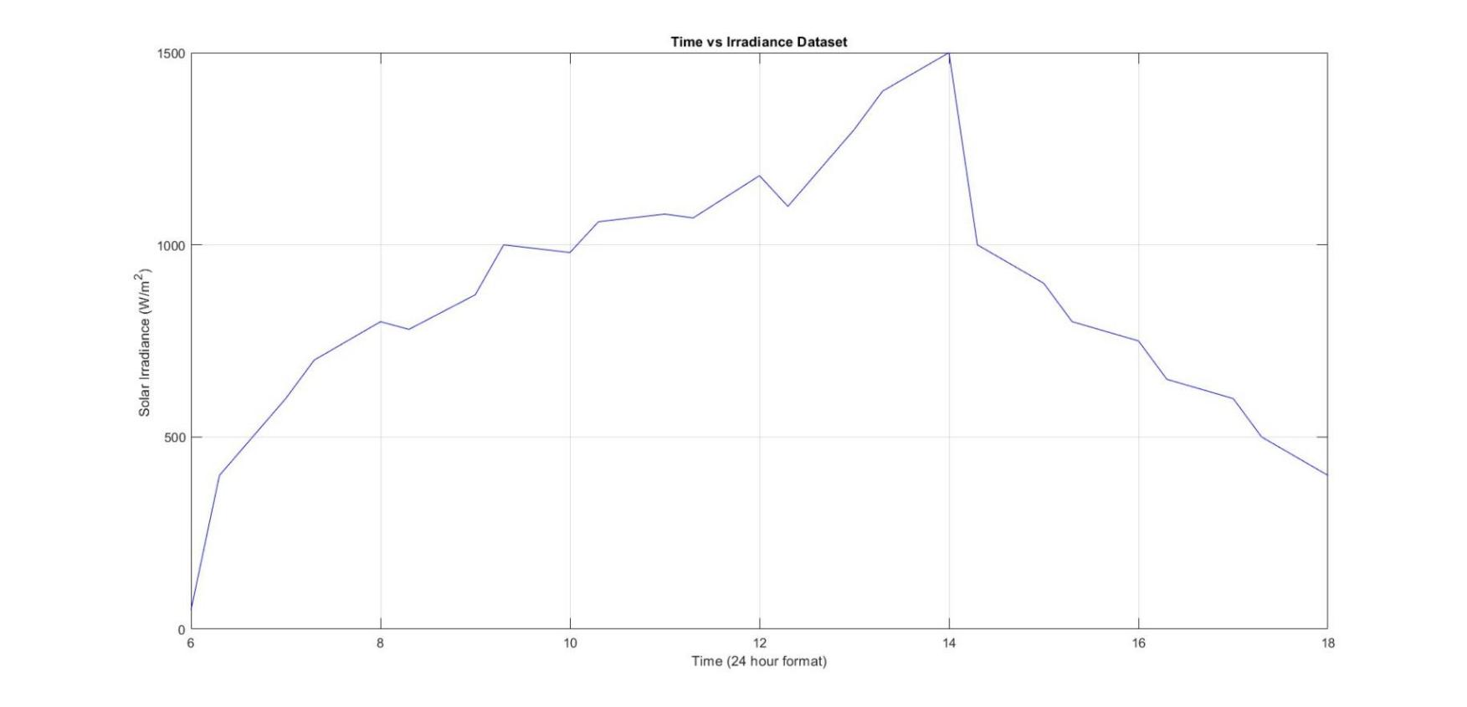

Figure 04: Graphical Representation of Solar Irradiance vs Time dataset of a PV array

To load the raw data text file (Appendix A) obtained from the simulation, the following MATLAB code has been developed:

**MATLAB CODE**

%read data from txt file

file=readtable("C:\Users\ASUS\Desktop\Project.txt");

x=file.Var1;

y=file.Var2;

z=file.Var3;

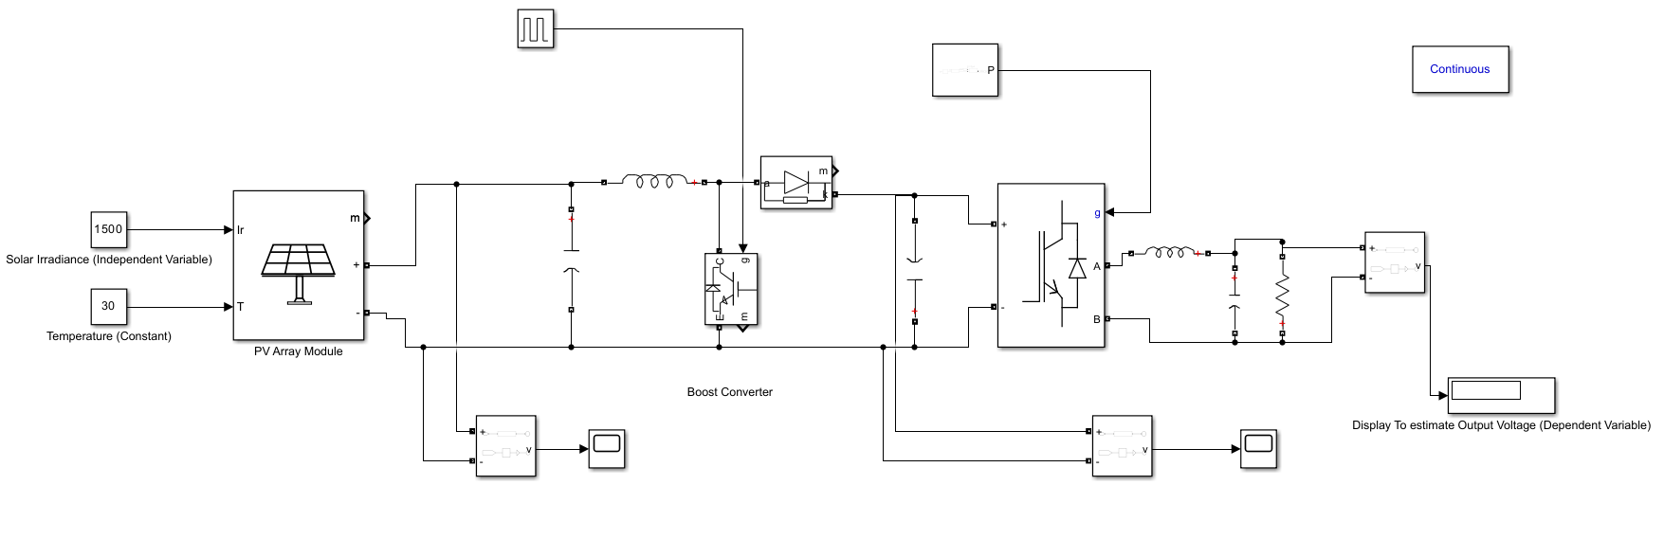

Figure 05: Simulink block diagram of a user-defined PV array system to estimate the value of output voltage

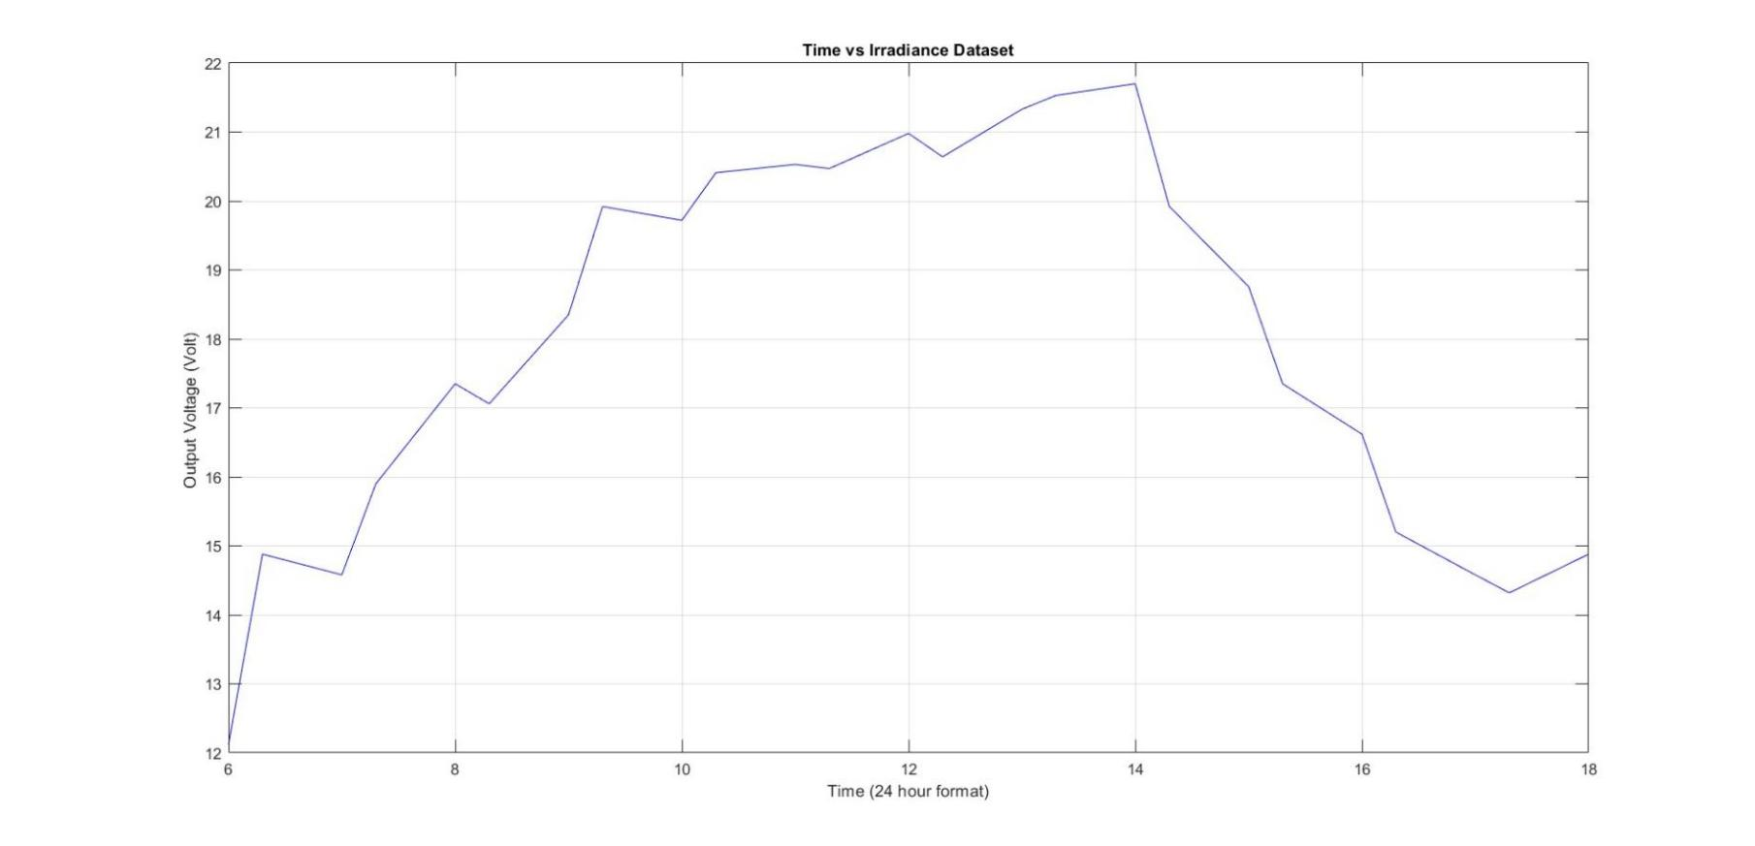

Figure 06: Graphical Representation of Output Voltage vs Time dataset of a PV array

**3.2.Estimation of Correlation and Regression Coefficient:**

To estimate the correlation and regression coefficient, we have to conduct the statistical analysis of our raw dataset by means of correlation and regression analysis. To determine correlation, we have used Karl Pearson’s coefficient of correlation. Pearson's correlation coefficient will quantify the strength and direction of the relationship.

**3.2.1.Determination of Karl Pearson’s Coefficient of Correlation**

Karl Pearson suggested a mathematical method for measuring the magnitude of relationship between two variables. It gives the most widely used formula, called Pearson’s coefficient of correlation and denoted by r. This formula is also called product moment correlation coefficient.

Karl Pearson’s Correlation Coefficient,

That is,

Where,

=

=

where,

*dx* = *X* − = deviation of series *X* from its mean

*dy* = *Y* − = deviation of series *Y* from its mean

Thus,

**3.2.2.Degree of Correlation:**

The relationship between two variables degrees as explained below :

1. Perfect Correlation : The correlation is said to be be perfect when a change in one variable is always followed by a corresponding proportional change in the other. If this change is in the same direction it is said to be perfect positive correlation and if this change is in the opposite direction it is said to be perfect negative correlation .

2. Absence of Correlation : When a change in one variable does not effect another variable, then we call it no correlation.

3. Limited Degrees of correlation : When the change in one variable is always followed by a corresponding change in other variable but not in the same proportion, then correlation is said to be limited. Limited degrees of correlation are :

(a) High Degree of Correlation

(b) Moderate Degree of Correlation

When correlation is measured with help of Karl Pearson’s coefficient of correlation,r, then we have the results :

|  |  |  |
| --- | --- | --- |
| **Correlation** | **Positive Value of *r*** | **Negative Value of *r*** |
| Perfect Correlation | +1 | −1 |
| Very High Degree Correlation | between .9 to .99 | between −0.99 to −0.9 |
| High Degree Correlation | between .75 and .9 | between−0.9 to −0.75 |
| Moderate Degree Correlation | between .25 and .75 | between −0.75 and −0.25 |
| Low Degree Correlation | between 0 and .25 | between −0.25 and 0 |
| No Correlation | 0 | 0 |

Following this, regression analysis will be employed to develop a predictive model, assessing how changes in irradiance affect output voltage. Regression analysis is necessary for modeling and analyzing several variables, when the focus is on the relationship between a dependent variable and one or more independent variables. Regression analysis helps us understand how the typical value of the dependent variable changes when any one of the independent variables is varied, while the other independent variables are held fixed.

**3.2.3.Determination of Regression Coefficients**

Let *r* be the correlation Coefficient between *X* and *Y,* be standard deviation of *X* and be standard deviation of *Y*. Then,

1. is called the regression coefficient of *X* on *Y* and is denoted by
2. is called the regression coefficient of *Y* on *X* and is denoted by

Thus,

= and =

Therefore, = =

The sign of and are same. When both are positive, then *r* is positive, when both are negative then *r* is negative.

**Regression of Y on X**

The line of regression of *Y* on *X* is,

where ,represents the mean of *X* and *Y* respectively. is regression coefficient of *Y* on *X* and is given as =

**Regression of X on Y**

The line of regression of *X* on *Y* is, =

where ,represents the mean of *X* and *Y* respectively. is regression coefficient of *X* on *Y* and is given as =

**Regression Lines and Correlation**

1. If there is either perfect positive of perfect negative correlation between the two variables (i.e., r = ±1), the two regression lines coincide and there will be only one line of regression.

2. If the two regression lines cut each other at right angle, then *r* = 0.

3. The nearer the two regression lines (i.e., the smaller the acute angle between the two regression lines) the greater is the degree of correlation.

The necessary MATLAB code to determine correlation and regression coefficient is provided below:

**MATLAB CODE**

%read data from txt file

file=readtable("C:\Users\ASUS\Desktop\Project.txt");

x=file.Var1;

y=file.Var2;

xsquare=x.^2;

ysquare=y.^2;

xy=x.*y;

n=length(x);

xavg=sum(x)/n;

yavg=sum(y)/n;

%regression coefficient

Bxy=(n*sum(xy)-sum(x)*sum(y))/(n*sum(ysquare)-(sum(y))^2);

Byx=(n*sum(xy)-sum(x)*sum(y))/(n*sum(xsquare)-(sum(x))^2);

%correlation coefficient

r=sqrt(Bxy*Byx);

**3.3.Mathematical Modelling of PV System:**

This section aims at proposing a mathematical model utilizing simple linear regression

**3.3.Mathematical Modelling of PV System:**

This section aims at proposing a mathematical model utilizing simple linear regression (SLR) to predict and estimate PV output voltage. The output voltage is defined as the response variable, whereas the solar irradiance (*I*) is treated as predictor or causal variable while considering other factors like cell temperature (*T*), and wind speed *(V*) as constant parameters . Therefore, the SLR model suggested in this work becomes as follows:

Where, is the output voltage across photovoltaic system , *I* is the average solar irradiance of a certain area, is the regression model intercept and is the regression coefficient.

To estimate the regression model intercept and coefficient (*μ*) shown in Equation. (i), the necessary MATLAB code is given below:

**MATLAB CODE**

%regression eq of irradiance on output voltage

Bxy=(n*sum(xy)-sum(x)*sum(y))/(n*sum(ysquare)-(sum(y))^2);

fprintf("\nRegression eq of solar irradiance: \nI = %.2f*(V-%.2f)+%.2f\n",Bxy,yavg,xavg);

%regression eq of output voltage on irradiance

Byx=(n*sum(xy)-sum(x)*sum(y))/(n*sum(xsquare)-(sum(x))^2);

fprintf("\nRegression eq of output voltage: \nV = %.2f*(I-%.2f)+%.2f \n",Byx,xavg,yavg);

**3.4.Prediction of Output Voltage from Prediction Function:**

In this section, we will predict a set of approximate values of output voltage corresponding to solar irradiance from the obtained prediction function. Therefore, a MATLAB code has been developed to obtain desired values from prediction function:

**MATLAB CODE**

%Predicting Value from Prediction Function

predicted=zeros(n,1);

for i=1:n

predicted(i)=Byx*(x(i)-xavg)+yavg; %prediction function

end

**3.5.Estimation of Mean Absolute Percentage Error (MAPE):**

To determine the accuracy of prediction function, we have used mean absolute percentage error (MAPE) in this regard. It represents the average of the absolute percentage errors of each entry in a dataset to calculate how accurate the forecasted quantities were in comparison with the actual quantities.

Mean Absolute Percentage Error,

Where,

*n* is the number of times the summation iteration happens

is the actual value

is the predicted value

The necessary MATLAB code to determine MAPE is given below:

**MATLAB CODE**

%Mean Absolute Percentage Error

error=zeros(n,1);

for j=1:n

error(j)=abs((exact(j)-predicted(j))/exact(j));

end

MAPE=sum(error)/n*100

**3.6.Plotting of Regression Line:**

In this section, we have developed a MATLAB code to show the plot of regression lines in order to visualise the relationship between solar irradiance and output voltage.

**MATLAB CODE**

%Overall plot

Y=min(y):max(y);

P=Bxy*(Y-yavg)+xavg;

X=min(x):max(x);

Q=Byx*(X-xavg)+yavg;

figure;

scatter(x,y,'b','linewidth',2,'DisplayName','Recorded Point');

hold on;

plot(P,Y,'-r','linewidth',1,'DisplayName','Regression Of Irradiance');

hold on;

plot(X,Q,'-g','linewidth',1,'DisplayName','Regression of Output Voltage');

hold off;

xlabel("value of Irradiance");

ylabel("value of Output Voltage");

title("Regression Analysis of PV System");

legend('Location','best');

**4.RESULT AND DISCUSSION**

The investigation into the relationship between solar irradiance and output voltage of photovoltaic system yielded several noteworthy findings. Firstly, a statistical relationship between solar irradiance and output voltage has been figured out by means of correlation analysis.

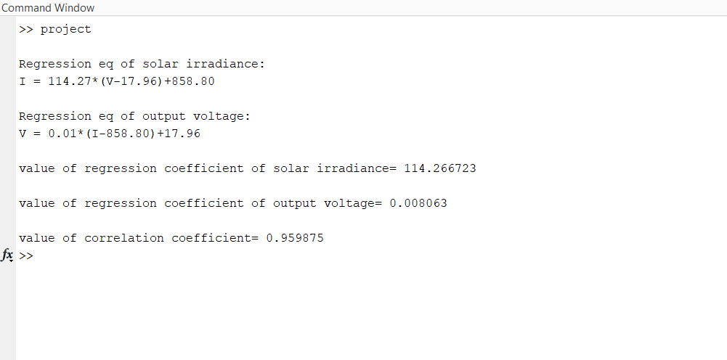

Figure 07: Resultant values of coefficient parameters related to the investigation by using

MATLAB

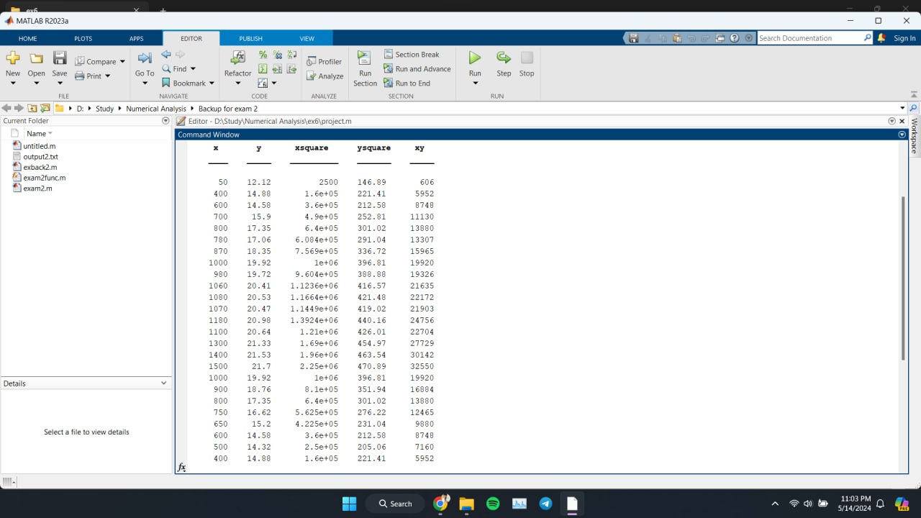

Figure 08: Calculated values of several parameters related to the investigation by using

MATLAB

In this investigation, the value of Pearson’s correlation coefficient is estimated to be approximately 0.96 which shows a very high degree positive correlation. This indicates that as solar irradiance increases, the output voltage of the photovoltaic system also tends to increase. The strength of this correlation implies that changes in irradiance can reliably predict changes in output voltage, highlighting the dependency of PV array performance on incident solar radiation. Furthermore, the scatter plots depicting the relationship between solar irradiance and output voltage visually confirmed the positive correlation observed in the correlation analysis.

Secondly, the regression analysis further confirms this relationship by establishing a predictive model that quantifies the impact of irradiance on output voltage. The regression equation obtained from the analysis allows us to estimate the output voltage based on the given irradiance levels. Such predictive capability is instrumental in designing and optimizing PV systems, as it provides insights into the system's behavior under varying environmental conditions. The regression equation was derived, allowing for the estimation of output voltage based on solar irradiance levels.

Regression eq of output voltage: V = 0.01* (I-858.80) + 17.96

This indicates that the solar irradiance has a causative relation with the output voltage in PV system.

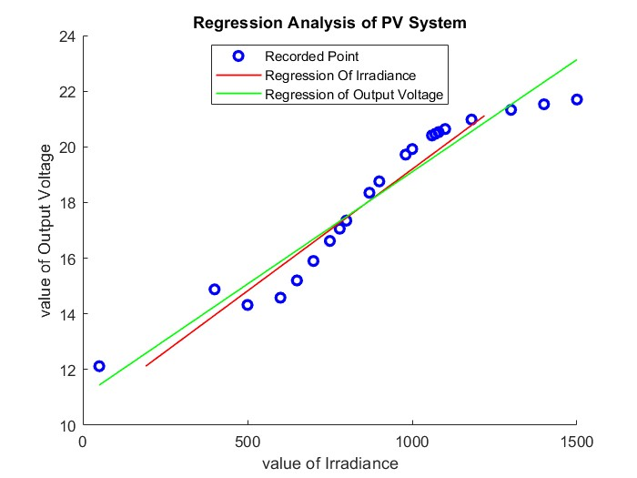

Figure 09: Graphical Representation of regression lines along with scatter plot by using MATLAB

Moreover, the error analysis conducted alongside the regression model reveals the precision of the predictions made. The residuals, or errors, represent the discrepancies between the actual output voltage values and the values predicted by the regression equation.

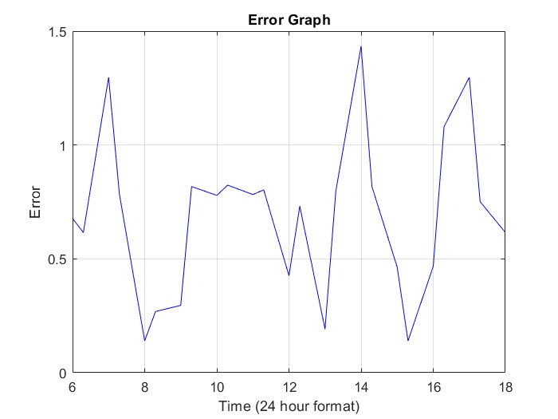

Figure 10: Error analysis of estimated regression model of PV system

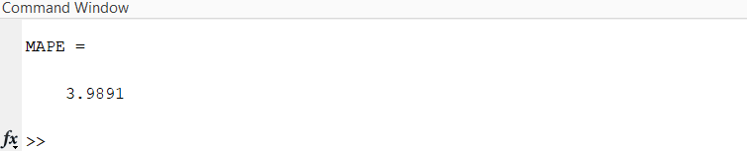

Figure 11: Estimated value of MAPE by using MATLAB

The value of mean absolute percentage error is approximately , which means that, on average, the model's predictions deviate from the actual values by only 4 percent. A MAPE of 4 percent indicates a high level of accuracy in this regression model. It suggests that the model's predictions are very close to the actual values, with minimal error. Therefore, we can precisely generate the output voltage of the PV system for any value of incident solar irradiance.

These findings underscore the importance of optimizing solar irradiance levels to maximize the efficiency and output of photovoltaic systems. Moreover, the results have implications for the design, operation, and maintenance of photovoltaic installations, emphasizing the need for accurate monitoring and management of solar irradiance levels.

**5.CONCLUSION**

In conclusion, this study has provided valuable insights into the relationship between solar irradiance and output voltage in photovoltaic systems. The strong positive correlation and the predictive capabilities of the regression model highlight the importance of considering solar irradiance as a critical factor in photovoltaic system performance.

Moving forward, these findings can inform the development of strategies for optimizing photovoltaic system efficiency and output under varying solar irradiance conditions. By leveraging this understanding, stakeholders in the renewable energy sector can enhance the reliability, sustainability, and economic viability of photovoltaic installations. Continued research in this area will contribute to the ongoing advancement and adoption of solar energy technology in the transition towards a greener and more sustainable energy future.

**6.REFERENCES**

|  |  |
| --- | --- |
| [1] | Pranjal Sarmah, Dipankar Das, Madhurjya Saikia, Virendra Kumar, Surendra Kumar Yadav, Prabhu Paramasivam  and  Seshathiri Dhanasekaran. “Comprehensive Analysis of Solar Panel Performance and Correlations with Meteorological Parameters”. <https://pubs.acs.org/doi/10.1021/acsomega.3c06442> [accessed April 4, 2024] |
| [2] | Eric Koons. “Solar Energy In Bangladesh: Current Status and Future”.  <https://energytracker.asia/solar-energy-in-bangladesh-current-status-and-future/> [accessed March 30, 2024] |
| [3] | Adnan Al-Bashirabu , Mohamed Al-Dweri, Ahmad Al-Ghandoor, Bashar Hammad, Wael Al-Kouz. “Analysis of Effects of Solar Irradiance, Cell Temperature and Wind Speed on Photovoltaic Systems Performance”.  <https://www.econjournals.com/index.php/ijeep/article/view/8591>  [accessed March 30, 2024] |
| [4] | Hussein A. Kazem, Tamer Khatib. “Techno-economical assessment of grid connected photovoltaic power systems productivity in Sohar, Oman”.  <https://www.sciencedirect.com/science/article/abs/pii/S2213138813000465?via%3Dihub> [acessed April 4, 2024] |
| [5] | Hussein A. Kazem, Tamer Khatib, K. Sopian ,Wilfried Elmenreich. “Performance and Feasibility Assessment of a 1.4 kW Roof Top Grid-Connected Photovoltaic Power System under Desertic Weather Conditions” . Energy and Building 2014,82,123– 129.  <https://www.sciencedirect.com/science/article/abs/pii/S0378778814005301?via%3Dihub%20[accessed%20April%204,%202024]> |
| [6] | Yousif J. H., Al-Balushi H.A., Kazem H.A. ,Chaichan M. T. “Analysis and forecasting of weather conditions in Oman for renewable energy applications”. *Case Stud. Therm. Eng.* **2019**, *13*, 100355.  <https://www.sciencedirect.com/science/article/pii/S2214157X18303253?pes=vor> [accessed April 4, 2024] |
| [7] | Song Z. ,Wang M., Yang H. ,“Quantification of the Impact of Fine Particulate Matter on Solar Energy Resources and Energy Performance of Different Photovoltaic Technologies”.  *ACS Environmental Au* **2022**, *2* (3), 275– 286.  <https://pubs.acs.org/doi/10.1021/acsomega.3c06442> [accessed April 4, 2024] |
| [8] | Priyanka Singh, N.M. Ravindra. “Temperature dependence of solar cell performance—an analysis”.  <https://www.sciencedirect.com/science/article/abs/pii/S0927024812000931?via%3Dihub> [accessed April 4, 2024] |
| [9] | George Makrides, Bastian Zinsser, Alexander Phinikarides, Markus Schubert, George E. Georghiou. “Temperature and thermal annealing effects on different photovoltaic technologies”  <https://www.sciencedirect.com/science/article/abs/pii/S0960148111006483?via%3Dihub> [accessed April 4, 2024] |
| [10] | W.S. Ebhota, P.Y. Tabakov. “Influence of photovoltaic cell technologies and elevated temperature on photovoltaic system performance”. <https://www.sciencedirect.com/science/article/pii/S2090447922002957?pes=vor> [accessed April 4, 2024] |
| [11] | Aamir Mehmood, Jingzheng Ren, Long Zhang. “Achieving energy sustainability by using solar PV: System modelling and comprehensive techno-economic-environmental analysis”.  <https://www.sciencedirect.com/science/article/pii/S2211467X23000767> |
| [12] | Ghazy, M.; Ibrahim, E. M. M.; Mohamed, A. S. A.; Askalany, A. A.  “Experimental investigation of hybrid photovoltaic solar thermal collector (PV/T)-adsorption desalination system in hot weather conditions”.  *Energy* **2022**, *254*, 124370.  <https://www.sciencedirect.com/science/article/abs/pii/S0360544222012737?via%3Dihub> |
| [13] | Aoun, N.   “Methodology for predicting the PV module temperature based on actual and estimated weather data”. *Energy Conversion and Management: X* **2022**, *14*, 100182  <https://www.sciencedirect.com/science/article/pii/S2590174522000058?pes=vor> |
| [14] | Gwandu, B. A. L.; Creasey, D. J., “Humidity: a factor in the appropriate positioning of a photovoltaic power station”. *Renewable Energy* **1995**, *6* (3), 313– 316.  <https://www.sciencedirect.com/science/article/abs/pii/096014819500073S?via%3Dihub> |
| [15] | Panjwani, M. K.; Narejo, G. B. “Effect of humidity on the efficiency of a solar cell (photovoltaic)” International Journal of Engineering Research and General. *Int. J. Eng. Res. Gen. Sci.* **2014**, *2* (4), 499– 503.  <https://citeseerx.ist.psu.edu/document?repid=rep1&type=pdf&doi=d077183993f465743ed004ef3cc622eb5eea33d2> |
| [16] | Mekhilef, S.; Saidur, R.; Kamalisarvestani, M. “Effect of dust, humidity and air velocity on efficiency of photovoltaic cells.” *Renewable and Sustainable Energy Reviews* **2012**, *16*, 2920– 2925.  <https://www.sciencedirect.com/science/article/abs/pii/S1364032112001050?via%3Dihub> |
| [17] | Sohani, A.; Sayyaadi, H.; Miremadi, S. R.; Samiezadeh, S.; Doranehgard, M. H. “Thermo-electro-environmental analysis of a photovoltaic solar panel using machine learning and real-time data for smart and sustainable energy generation”. *J. Cleaner Prod.* **2022**, *353*, 131611.  <https://www.sciencedirect.com/science/article/abs/pii/S0959652622012288?via%3Dihub> |
| [18] | Akonjom, N. A.; Njok, A. O. “Effect of Meteorological Parameters on the Performance of Photovoltaics Installed under the Guinea Savannah Atmosphere in Ogoja, Cross Rivers State, Nigeria”. *Journal of Applied Sciences and Environmental Management* **2022**, *26* (7), 1299– 1306.  <https://www.ajol.info/index.php/jasem/article/view/228501> |
| [19] | Hussein, H. M. S.; Ahmad, G. E.; El-Ghetany, H. H. “Performance evaluation of photovoltaic modules at different tilt angles and orientations”. *Energy Conversion and Management* **2004**, *45* (15–16), 2441– 2452.  <https://www.sciencedirect.com/science/article/abs/pii/S0196890403003571?via%3Dihub> |

**7.APPENDICES**

Appendix A

Different meteorological data obtained from experimental measurements are given in Table A1.

**Table A1:**

|  |  |  |
| --- | --- | --- |
| **Time (24 Hour Format)** | **Solar irradiance (W/** | **Output Voltage (Volt)** |
| 6:00 | 50 | 12.12 |
| 6:30 | 400 | 14.88 |
| 7:00 | 600 | 14.58 |
| 7:30 | 700 | 15.9 |
| 8:00 | 800 | 17.35 |
| 8:30 | 780 | 17.06 |
| 9:00 | 870 | 18.35 |
| 9:30 | 1000 | 19.92 |
| 10:00 | 980 | 19.72 |
| 10:30 | 1060 | 20.41 |
| 11:00 | 1080 | 20.53 |
| 11:30 | 1070 | 20.47 |
| 12:00 | 1180 | 20.98 |
| 12:30 | 1100 | 20.64 |
| 13:00 | 1300 | 21.33 |
| 13:30 | 1400 | 21.53 |
| 14:00 | 1500 | 21.7 |
| 14:30 | 1000 | 19.92 |
| 15:00 | 900 | 18.76 |
| 15:30 | 800 | 17.35 |
| 16:00 | 750 | 16.62 |
| 16:30 | 650 | 15.2 |
| 17:00 | 600 | 14.58 |
| 17:30 | 500 | 14.32 |
| 18:00 | 400 | 14.88 |

Appendix B

MATLAB Code:

%read data from txt file

file=readtable("C:\Users\ASUS\Desktop\Project.txt");

x=file.Var1;

y=file.Var2;

z=file.Var3;

xsquare=x.^2;

ysquare=y.^2;

xy=x.*y;

n=length(x);

xavg=sum(x)/n;

yavg=sum(y)/n;

%regression eq of irradiance on output voltage

Bxy=(n*sum(xy)-sum(x)*sum(y))/(n*sum(ysquare)-(sum(y))^2);

fprintf("\nRegression eq of solar irradiance: \nI = %.2f*(V-%.2f)+%.2f \n",Bxy,yavg,xavg);

%regression eq of output voltage on irradiance

Byx=(n*sum(xy)-sum(x)*sum(y))/(n*sum(xsquare)-(sum(x))^2);

fprintf("\nRegression eq of output voltage: \nV = %.2f*(I-%.2f)+%.2f \n",Byx,xavg,yavg);

%regression and correlation coefficient

fprintf("\nvalue of regression coefficient of solar irradiance= %f \n",Bxy);

fprintf("\nvalue of regression coefficient of output voltage= %f \n",Byx);

r=sqrt(Bxy*Byx);

fprintf("\nvalue of correlation coefficient= %f \n",r);

%Predicting Value from Prediction Function

predicted=zeros(n,1);

for i=1:n

predicted(i)=Byx*(x(i)-xavg)+yavg; %prediction function

end

%Mean Absolute Percentage Error

error=zeros(n,1);

for j=1:n

error(j)=abs((exact(j)-predicted(j))/exact(j));

end

MAPE=sum(error)/n*100

%Error Plot

plot(z, error(1:end),'b-');

xlabel('Time (24 hour format)');

ylabel('Error');

title('Error Graph');

grid on;

%Overall plot

Y=min(y):max(y);

P=Bxy*(Y-yavg)+xavg;

X=min(x):max(x);

Q=Byx*(X-xavg)+yavg;

figure;

scatter(x,y,'b','linewidth',2,'DisplayName','Recorded Point');

hold on;

plot(P,Y,'-r','linewidth',1,'DisplayName','Regression Of Irradiance');

hold on;

plot(X,Q,'-g','linewidth',1,'DisplayName','Regression of Output Voltage');

hold off;

xlabel("value of Irradiance");

ylabel("value of Output Voltage");

title("Regression Analysis of PV System");

legend('Location','best');