Calculus II Lesson 26 Conics Sections - Ellipse
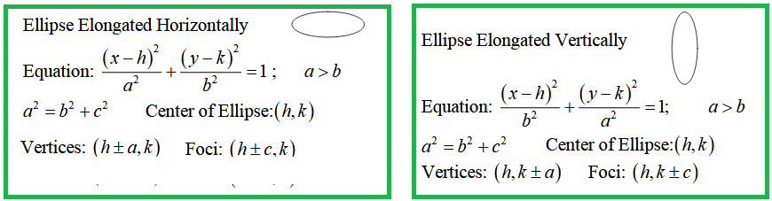

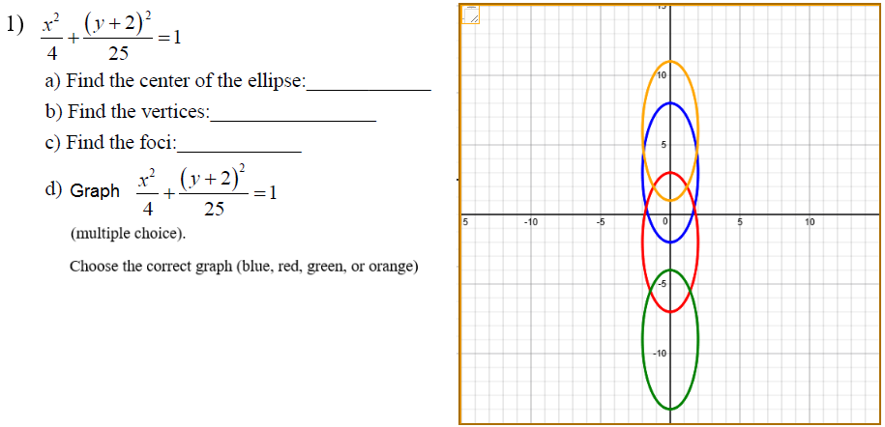

Answers (#1)
a ) b) c) d)

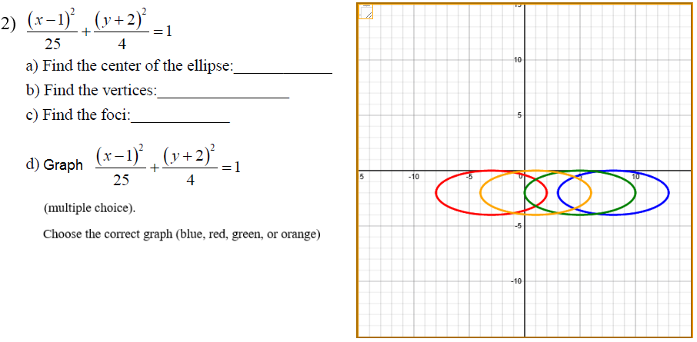

Answers (#2)
a ) b) c) d)

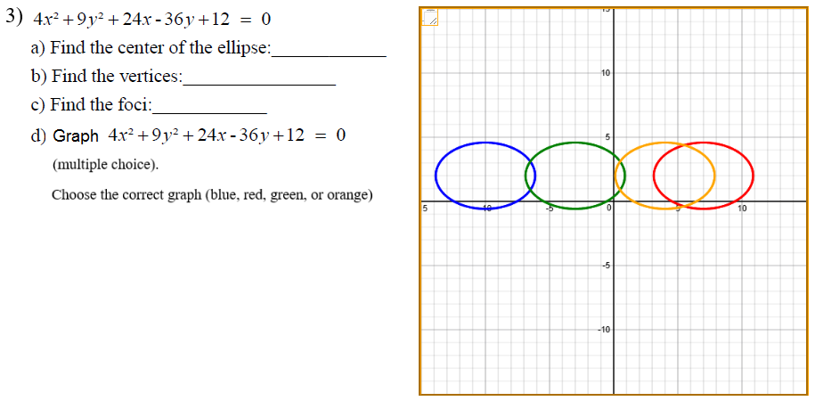

Answers (#3)
a ) b) c) d)

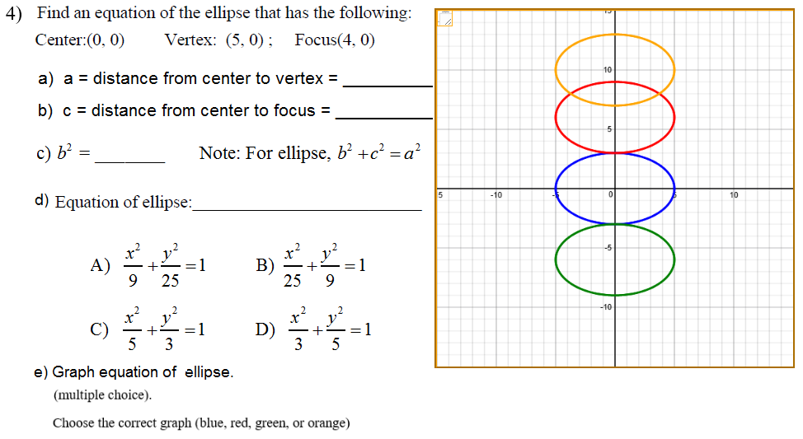

Answers (#4)

a ) b) c) d) e)

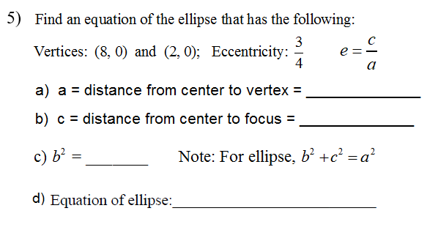

Answers (#5)
a ) b) c) d)

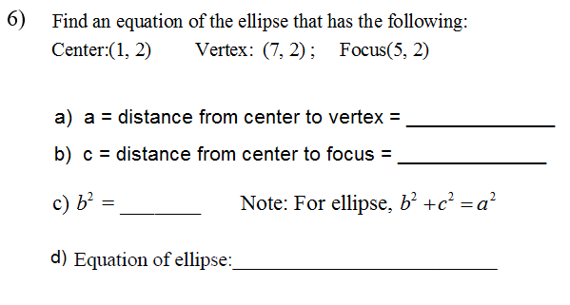

Answers (#6)
a ) b) c) d)

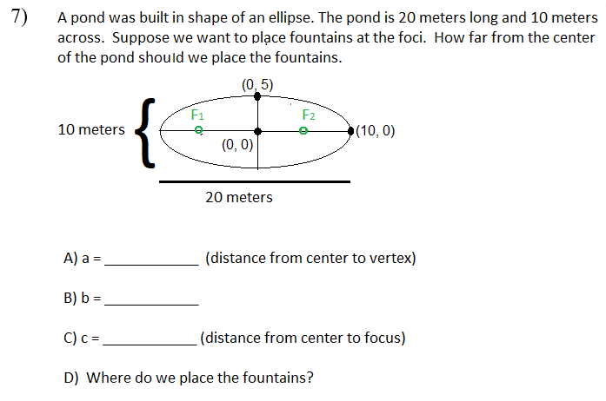

Answers (#7)
A ) B) C) D)

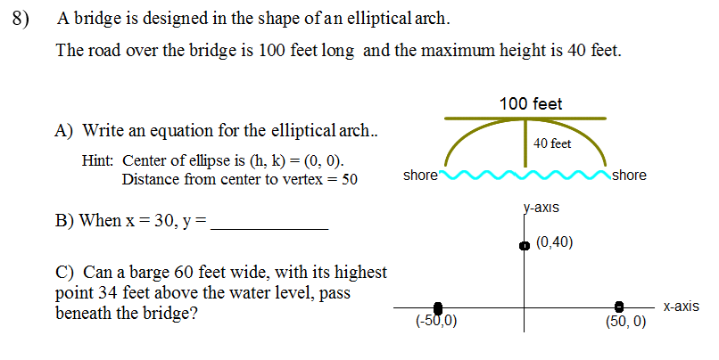

Answers (#8)
A ) B) C)

