Calculus II Lesson 31B: Rectangular Equation and Polar Equation
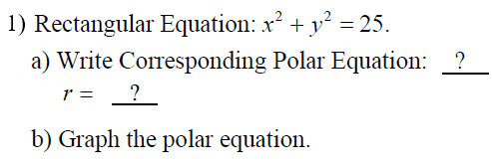
(multiple choice). Choose the correct graph (blue, red, green, or orange)
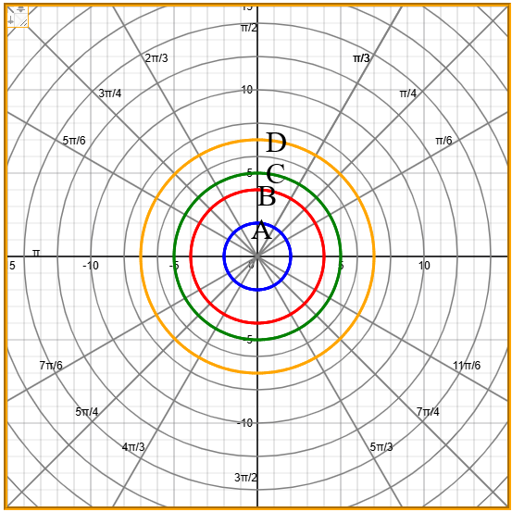

Answers
a)

b)

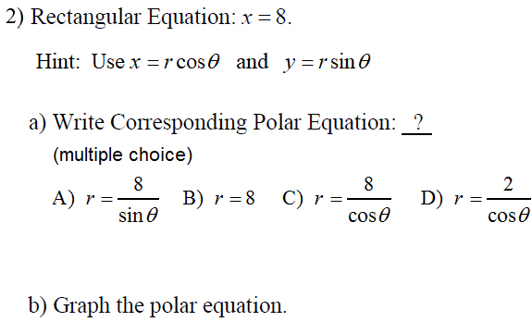
(multiple choice). Choose the correct graph (blue, red, green, or orange)
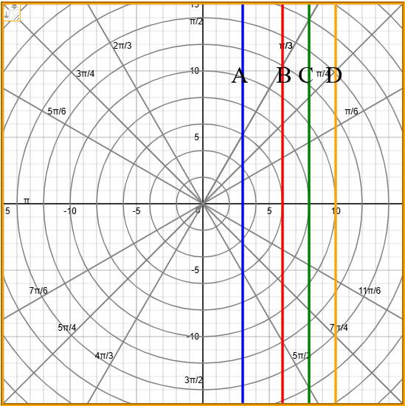
Answers
a) b)

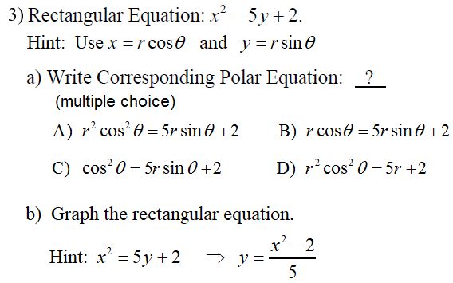
(multiple choice). Choose the correct graph (blue, red, green, or orange)
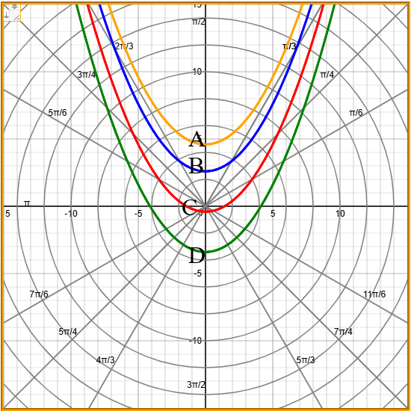
Answers
a) b)

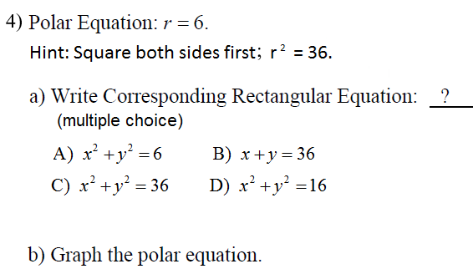
(multiple choice). Choose the correct graph (blue, red, green, or orange)
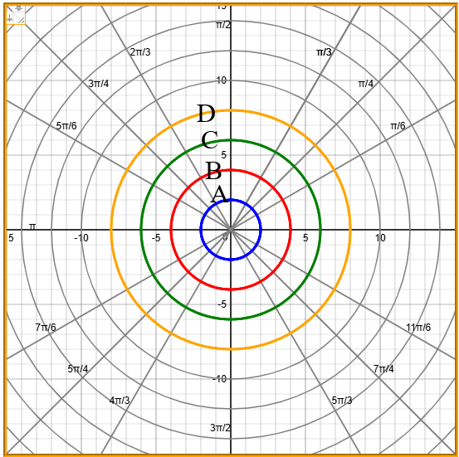
Answers
a)

b)

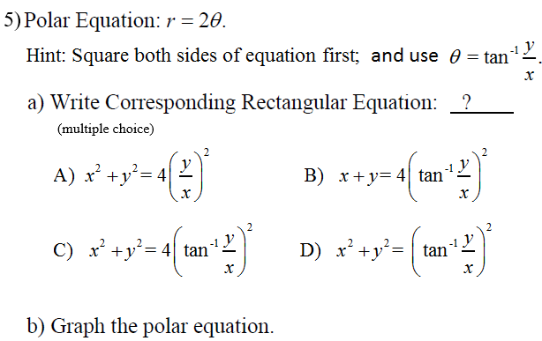
(multiple choice). Choose the correct graph (blue, red, green, or orange)
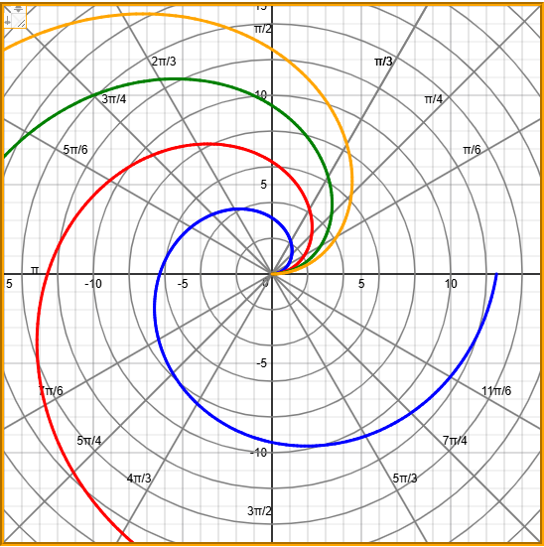
Answers
a)

b)
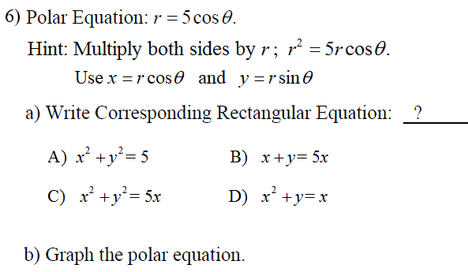
(multiple choice). Choose the correct graph (blue, red, green, or orange)
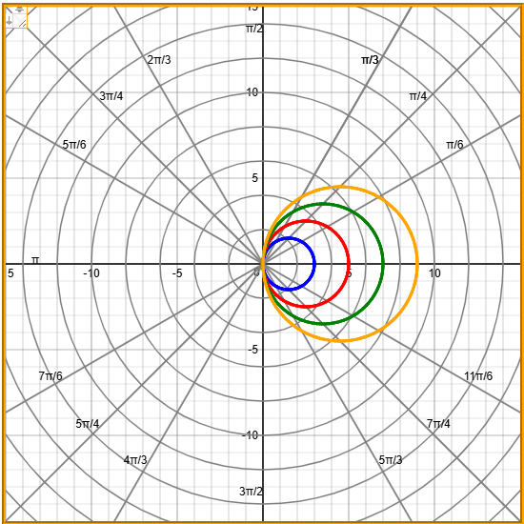
Answers
a) b)

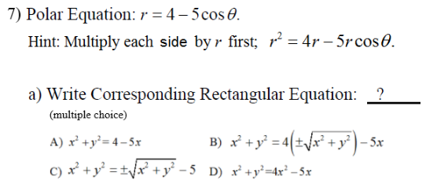

(multiple choice). Choose the correct graph (blue, red, green, or orange)

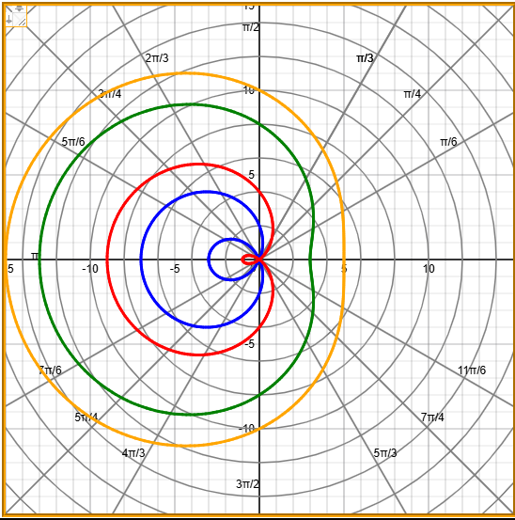
Answers
a) b)

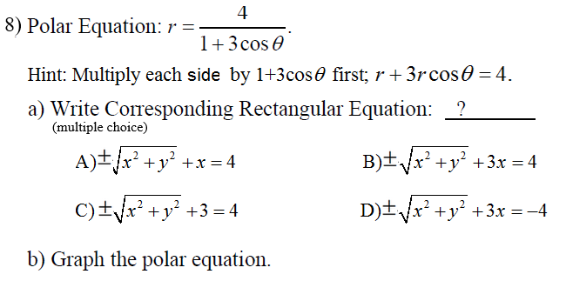
(multiple choice). Choose the correct graph (blue, red, green, or orange)

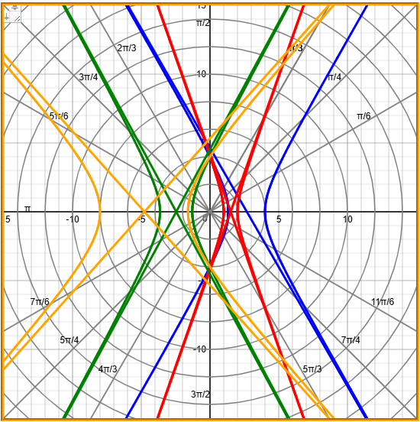
Answers
a) b)

