Lesson 28: Plane Curves and Parametric Equations

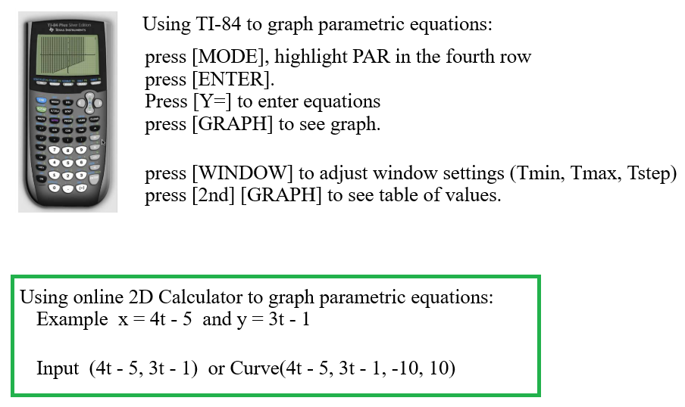

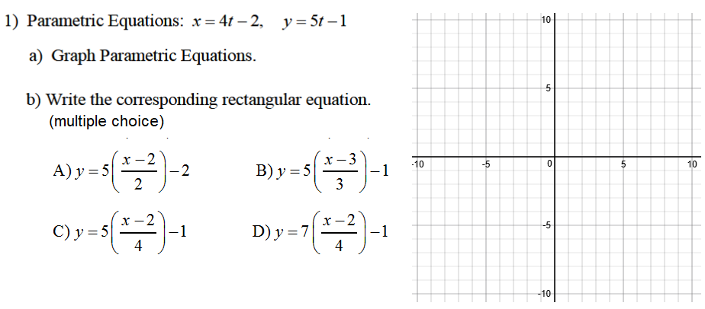

Answers
- Use an online 2D Calculator. Insert image here.

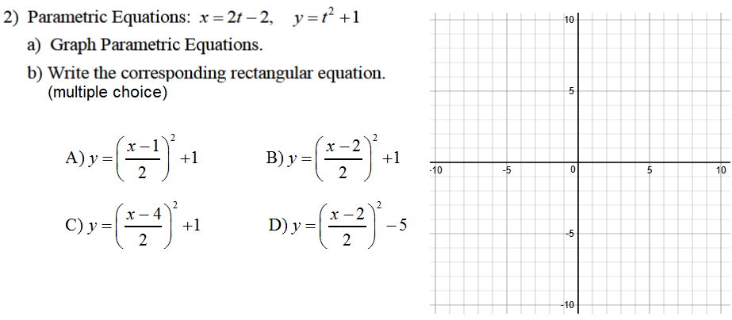

Answers
a) Use an online 2D Calculator. Insert image here.

b)

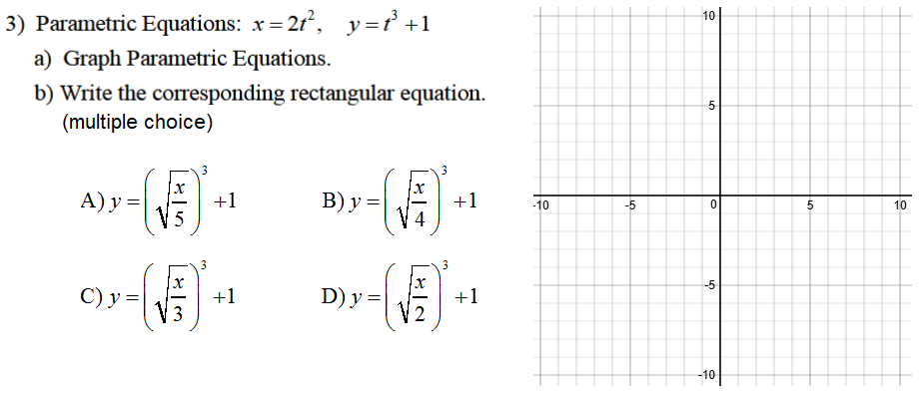

Answers
a) Use an online 2D Calculator. Insert image here.

b)

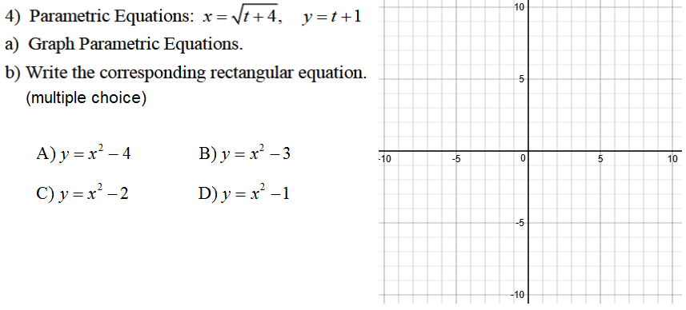
Answers
a) Use an online 2D Calculator. Insert image here.

b)

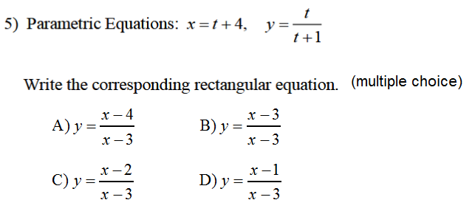

Answer:

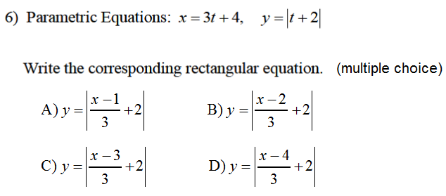

Answer:
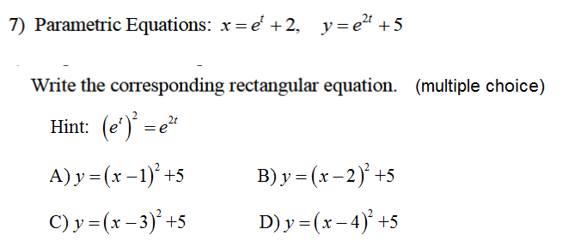

Answer:

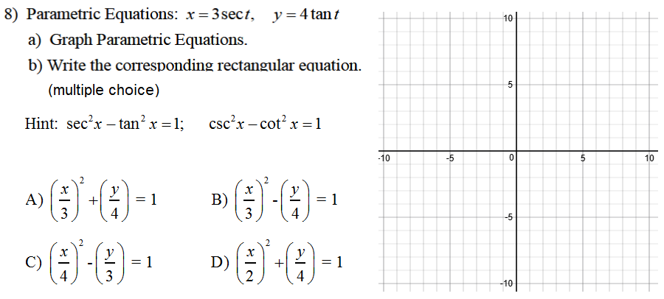
Answer:

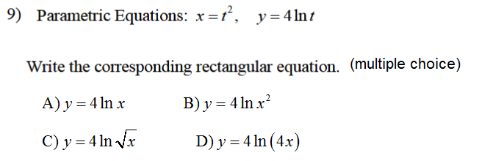
Answer:
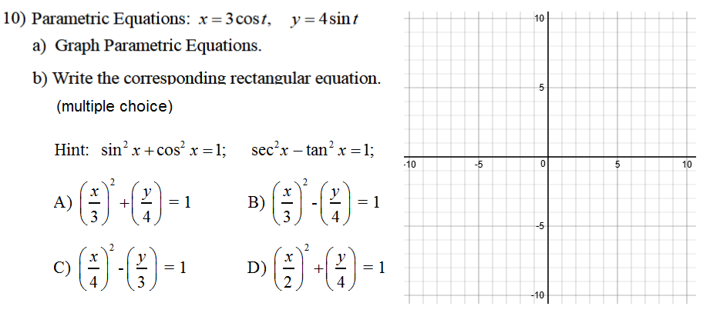

Answers
a) Use an online 2D Calculator. Insert image here.

b)

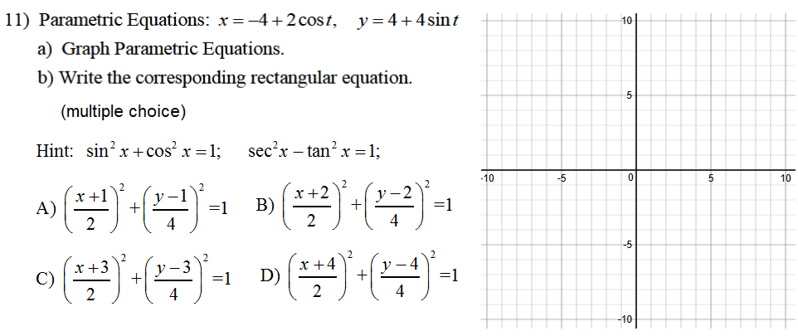
Answers
a) Use an online 2D Calculator. Insert image here.

b)

