Lesson 29: Differentiation and Parametric Equations

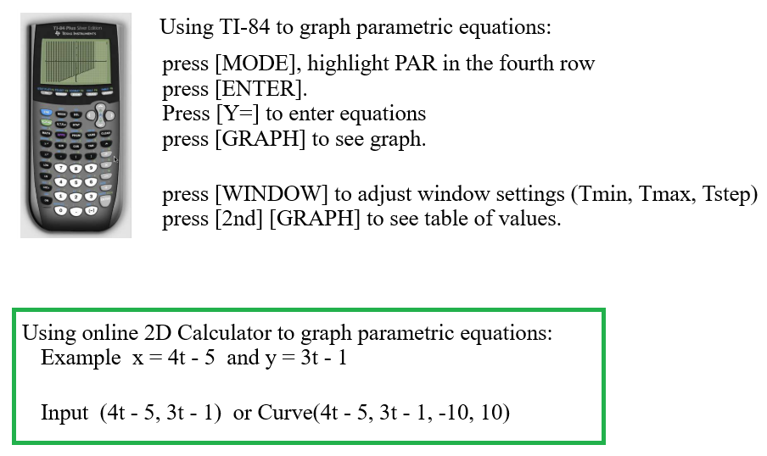

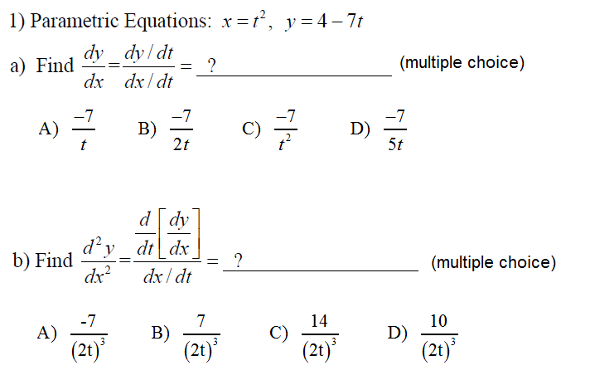

Answers
a)

b)

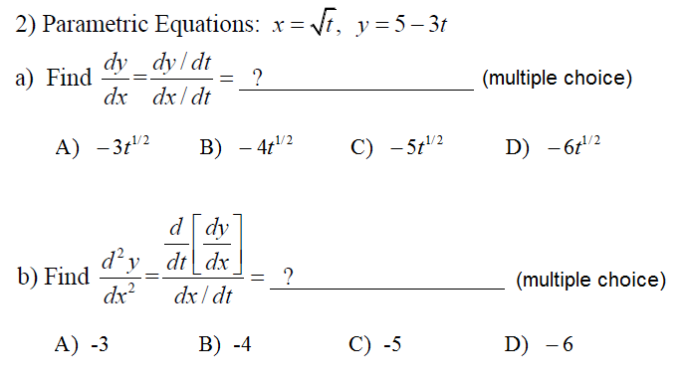
Answers
a)

b)

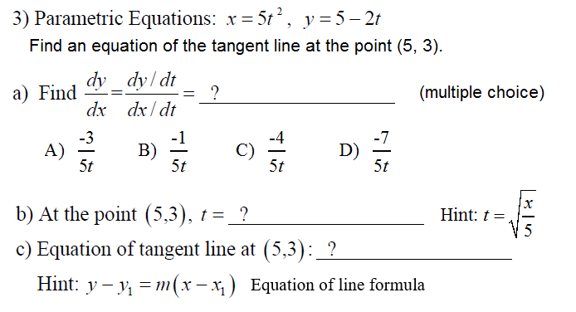

Answers
a)

b)

c)

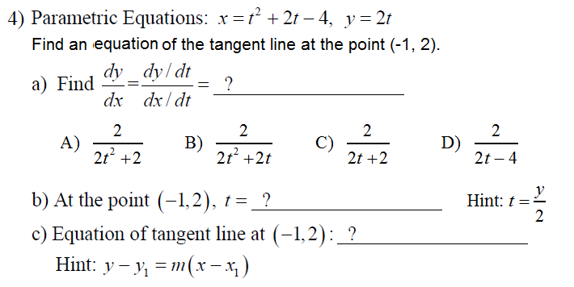

Answers
a)

b)

c)

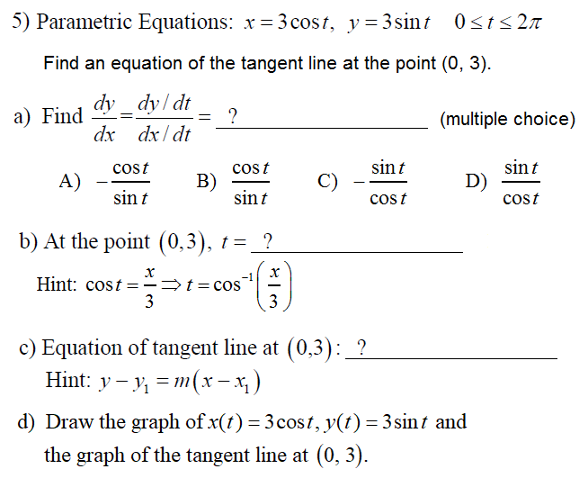
Hint: Use an online 2D Calculator.
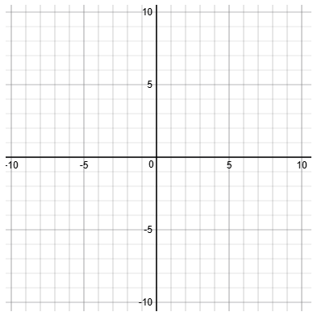

Answers (#5)
a)

b)

c)

d) Use an online 2D Calculator. Insert image here.

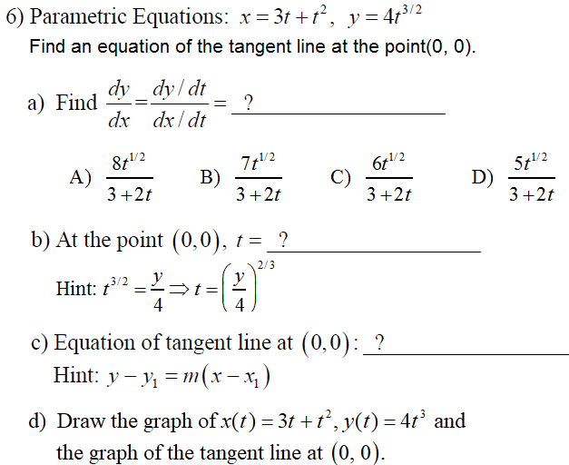
Hint: Use an online 2D Calculator.


Answers (#6)
a)

b)

c)

d) Use an online 2D Calculator. Insert image here.

