Lesson 30: Arc Length of Plane Curve and Parametric Curve

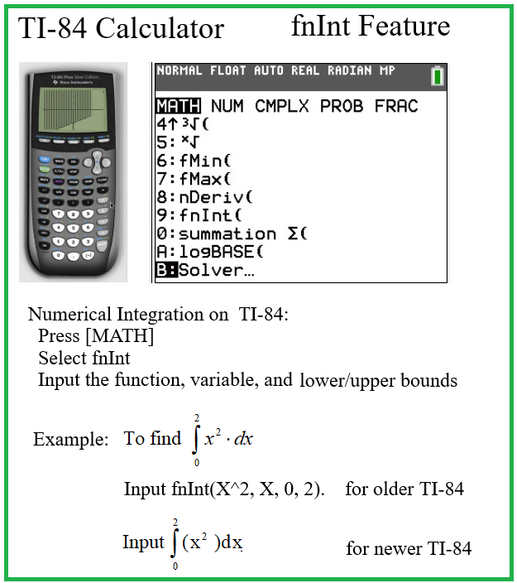
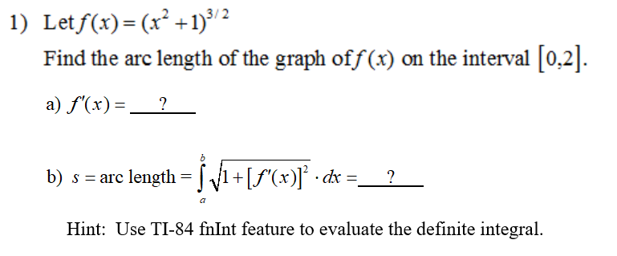

Answers
a)

b)

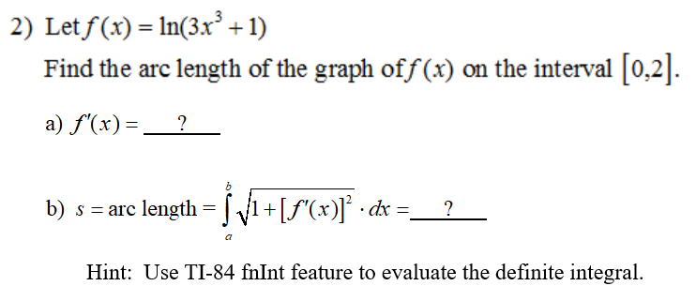

Answers
a)

b)

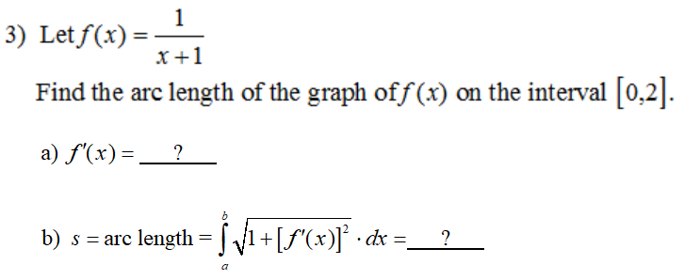

Answers
a)

b)

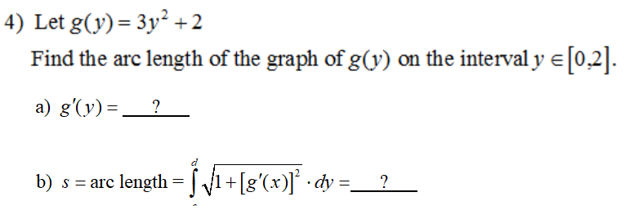

Answers
a)

b)

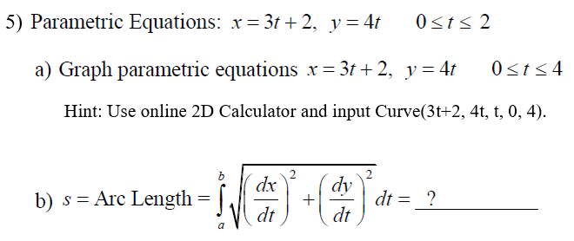

Answers
a) Use an online 2D Calculator. Insert image here.

b)

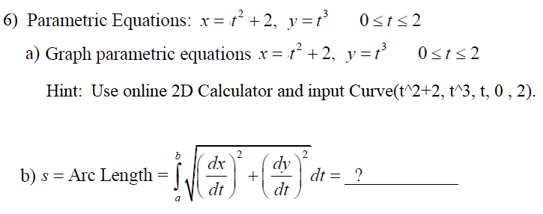

Answers
a) Use an online 2D Calculator. Insert image here.

b)

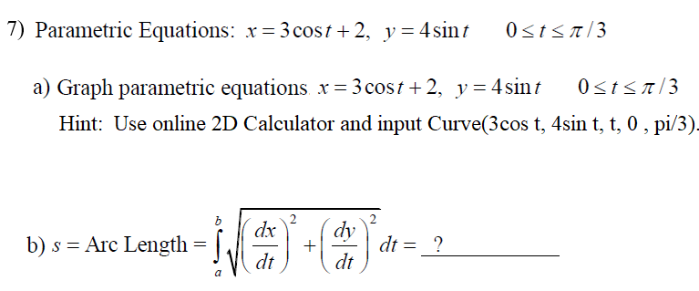

Answers
a) Use an online 2D Calculator. Insert image here.

b)

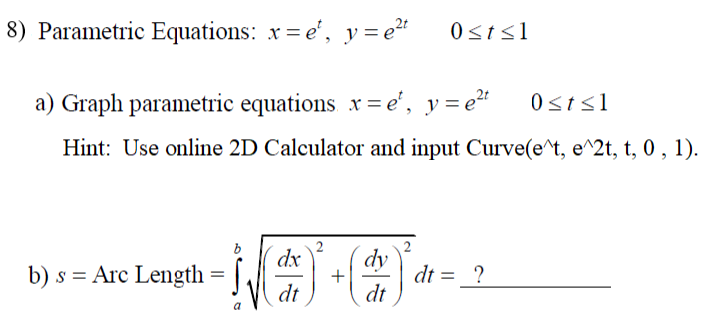

Answers
a) Use an online 2D Calculator. Insert image here.

b)

