Calculus II Lesson 31: Polar Coordinates

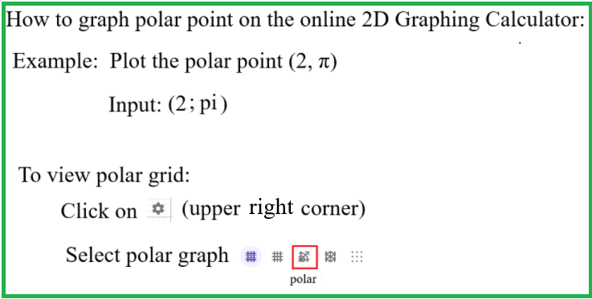

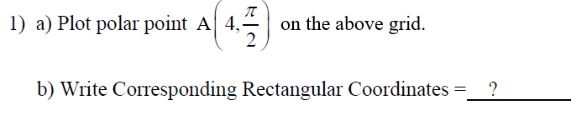

Answers
a) Use an online 2D Calculator. Insert image here.

b)

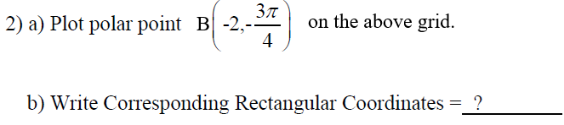

Answers
a) Use an online 2D Calculator. Insert image here.

b)

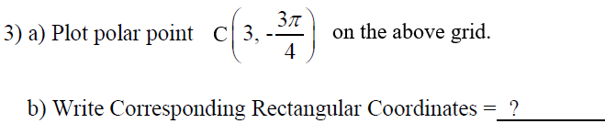

Answers
a) Use an online 2D Calculator. Insert image here.

b)

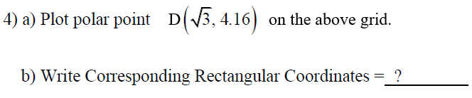

Answers
a) Use an online 2D Calculator. Insert image here.

b)

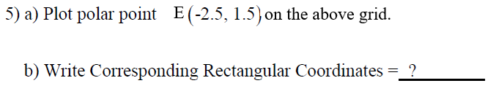

Answers
a) Use an online 2D Calculator. Insert image here.

b)

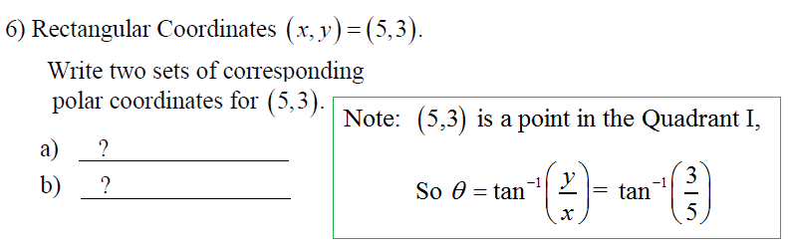

Answers
a)

b)

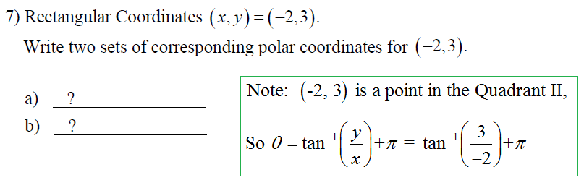
Answers
a)

b)

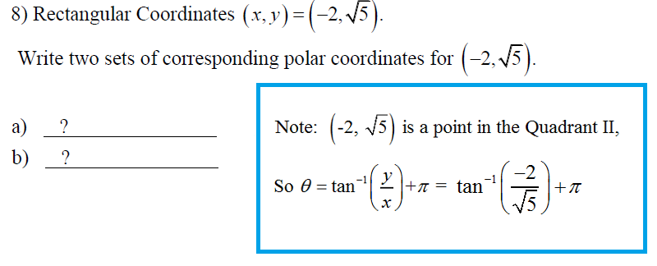

Answers
a)

b)

