Calculus II Lesson 25 Conics Sections - Parabola
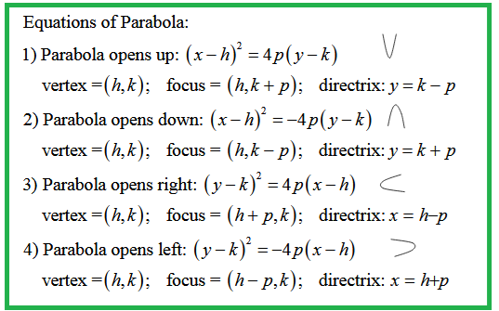

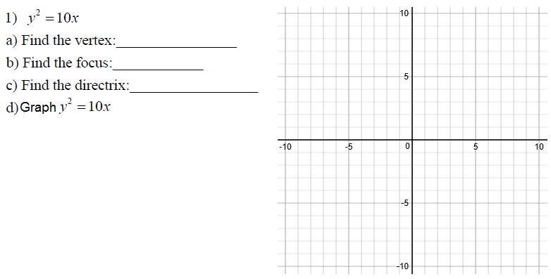
Answers

a )

b)

c)

d)Use an online 2D Calculator. Insert image here.

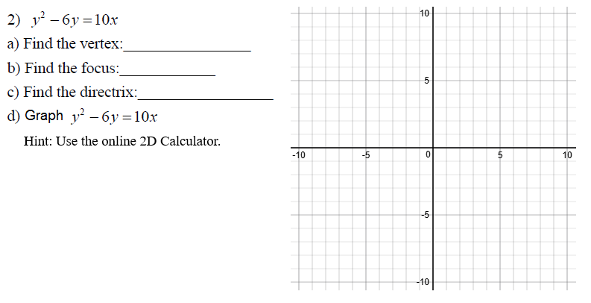

Answers

a )

b)

c)

d) Use an online 2D Calculator. Insert image here.

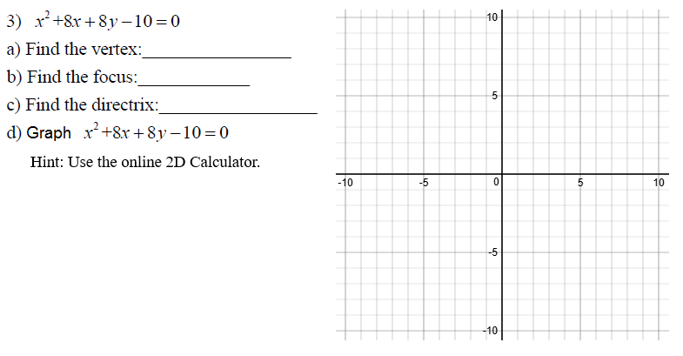
Answers

a )

b)

c)

d) Use an online 2D Calculator. Insert image here.

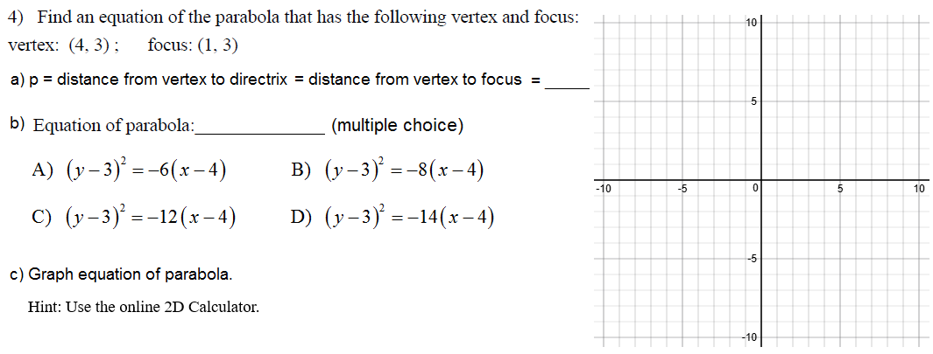

Answers

a )

b)

c) Use an online 2D Calculator. Insert image here.

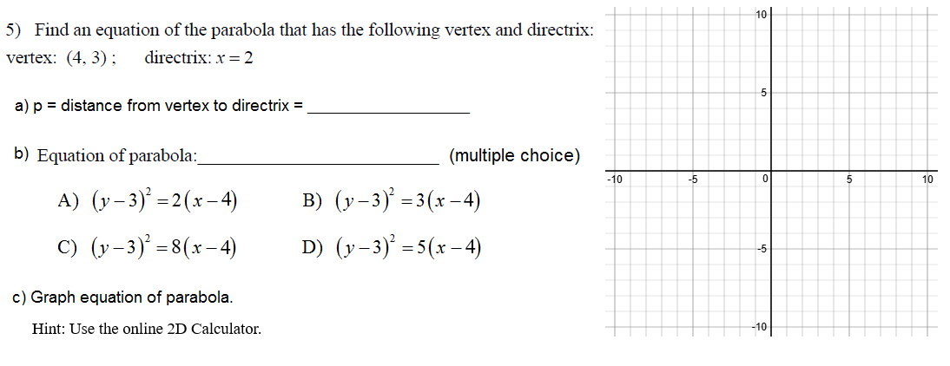

Answers

a )

b)

c) Use an online 2D Calculator. Insert image here.

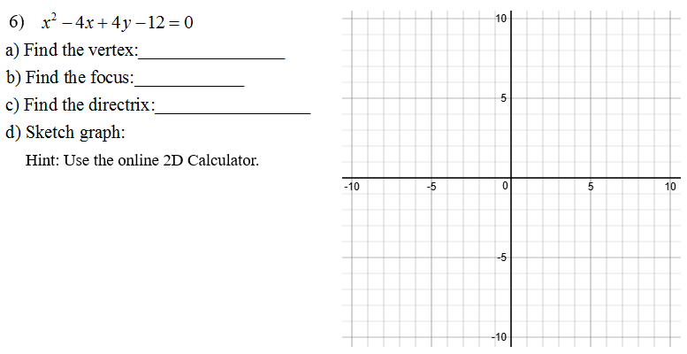
Answers

a )

b)

c)

d) Use an online 2D Calculator. Insert image here.

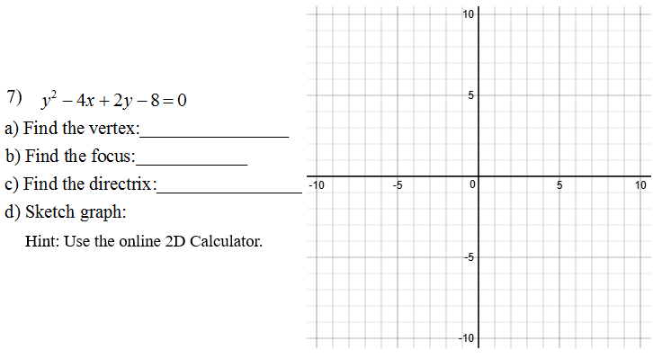

Answers

a )

b)

c)

d) Use an online 2D Calculator. Insert image here.

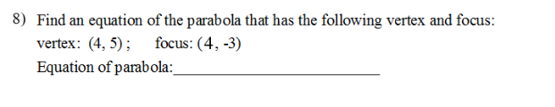
Answer:

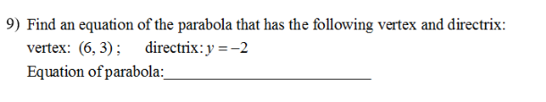

Answer:

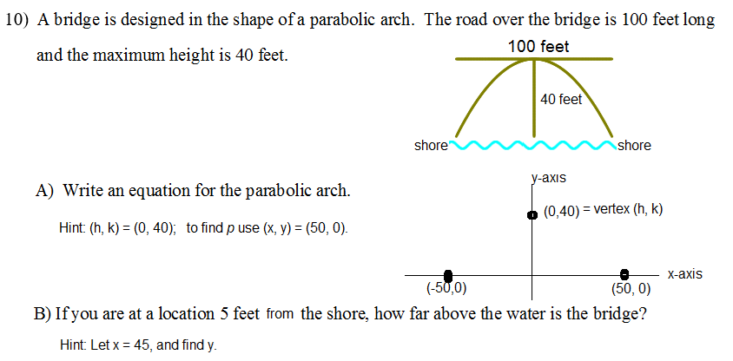

Answers

A )

B)

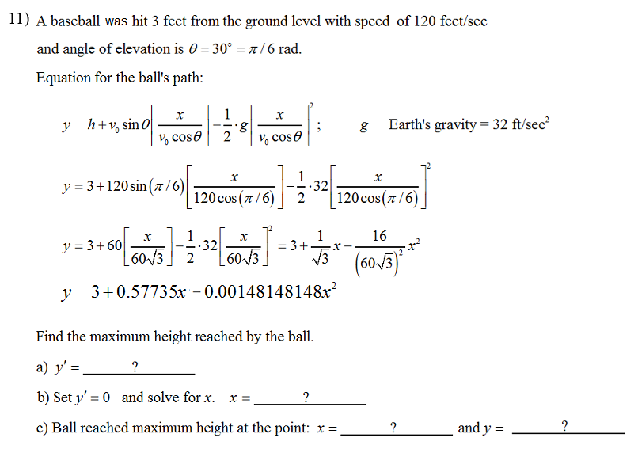
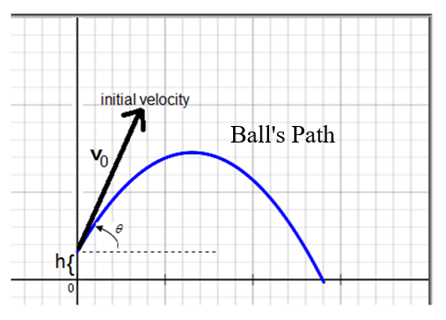

Answers (#11)

a )

b)

c)

