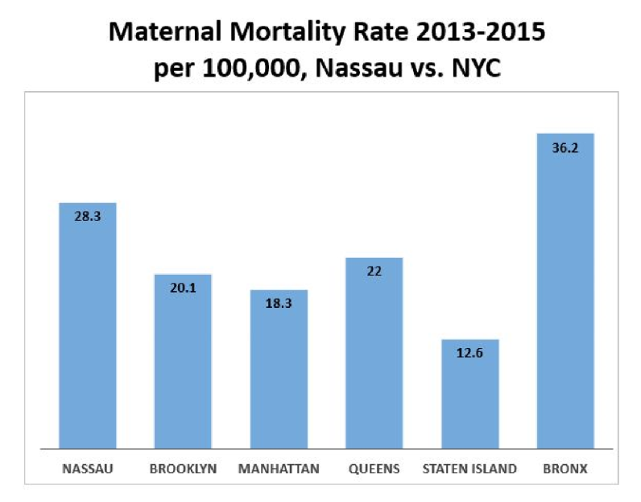
Background:
In 2016, New York State (NYS) was ranked 30th in the nation for its maternal mortality rate, with clear racial disparities. Black women are 3-4 times more likely to die of pregnancy complications than white women. Studies find that stress caused by racial discrimination plays a significant role in maternal and infant mortality.
Nassau County has a higher rate of maternal mortality than most of NYC and neighboring zip codes within Nassau have drastically different rates of infant mortality which suggests racial and economic factors impact this issue (2014-2016 NYS Vital Statistics Data).

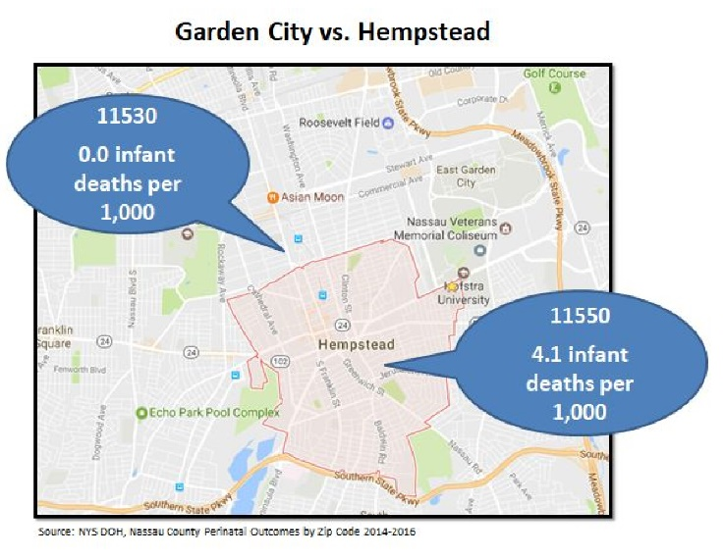
Goal: Create a Maternal and Infant Mortality Task Force for Nassau County
- The Nassau County Maternal and Infant Mortality Task Force will convene experts, advocates, and stakeholders to plan and implement recommendations from the NYS Taskforce on Maternal Mortality and Disparate Racial Outcomes (March 2019) to reduce maternal deaths and improve outcomes of women and families of color in Nassau County
- The Task Force will take the lead to provide a county-wide coordinated effort to address maternal mortality. No other County in NYS has responded to this issue in a coordinated way
- NYC and NJ have created plans and allocated millions of dollars in funding to address maternal mortality

Recommendations for County-level Action:
- Expand and enhance community health worker programs and further develop their role^{1,2}
- Optimize postpartum care by ensuring that women can receive ongoing support during their postpartum period with the use of providers and agencies¹
- Promote birth preparedness and postpartum continuity of care for all women¹
- Increase health care professionals’ awareness of racial disparities in health outcomes^{1,2}
- Promote a better understanding of the reasons why African American women have poorer pregnancy health outcomes, and acknowledgement of the impact of race and racism of those outcomes

- New York State Taskforce on Maternal Mortality and Disparate Racial Outcomes. (2019). Recommendations to the governor to reduce maternal mortality and racial disparities. New York State. - City of New York. (2018). De Blasio administration launches comprehensive plan to reduce maternal deaths and life-threatening complications from childbirth among women of color. Retrieved from: https://www1.nyc.gov/office-of-the-mayor/news/365-18/de-blasio-administration-launches-comprehensive-plan-reduce-maternal-deaths-life-threatening

