HW3 學號:B05605030 系級:森林二 姓名:郭玟妍

第一題

|  |  |  |  |  |
| --- | --- | --- | --- | --- |
|  |  | signed magnitude | signed-1’s complement | signed-2’s complement |
| (a) | 0011 | 1011 | 1100 | 1101 |
| (b) | 01010011 | 11010011 | 10101100 | 10101101 |
| (c) | 11010011 | 01010011 | 00101100 | 00101101 |
| (d) | 00000000 | 10000000 | 11111111 | 00000000 |

第二題

(a)

|  |  |  |
| --- | --- | --- |
|  | signed-1’s complement | signed-2’s complement |
| X = 00110110 | 11001001 | 11001010 |
| Y = 00010011 | 11101100 | 11101101 |

|  |  |  |  |  |
| --- | --- | --- | --- | --- |
|  | X+Y | X-Y | Y-X | -X-Y |
| signed-1’s complement | 01001001 | 00100011 | 11011100 | 10110110 |
| signed-2’s complement | 01001001 | 00100011 | 11011101 | 10110111 |

計算過程:

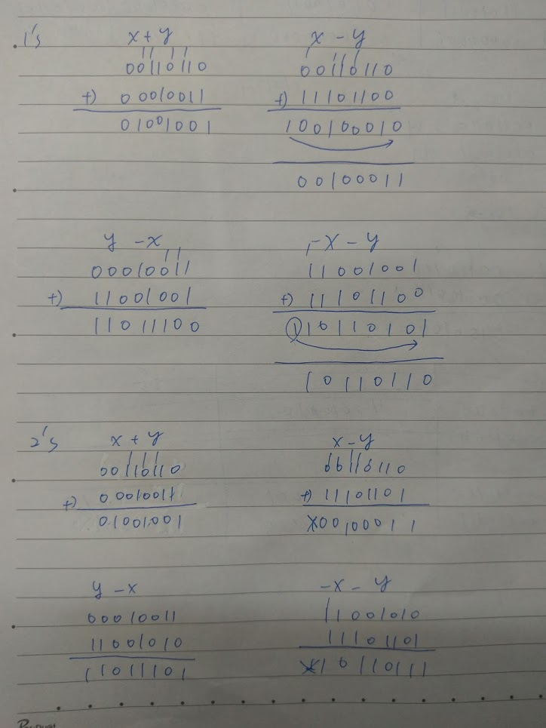

(b)

所記錄的數字超過電腦規劃的容量所能夠紀錄的極限。

8bits的範圍是-127~128，所以計算120+60的時候就會產生溢位的狀況。