Taylor Downey

5/5/2016, BI 410

1. 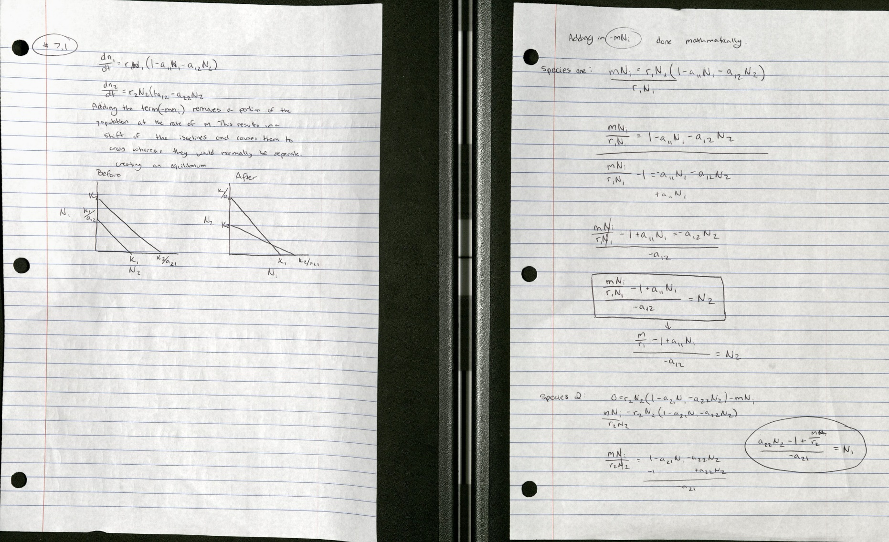Book Problems:





1. See other document for code.

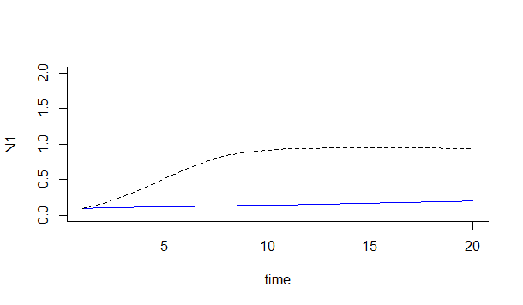

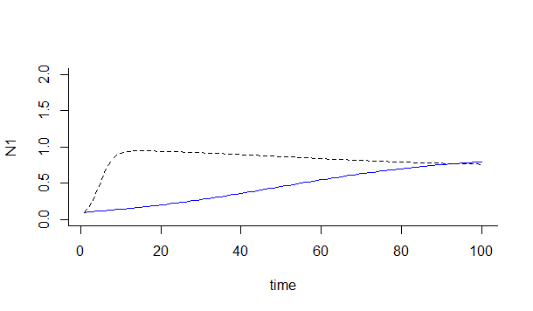

Based on the two graphs that were gathered from the coded data. The longer the ecological experiment is extended, the more likely it is for the declining species in the competitive system to increase in number and catch up. In this case species one is observed to be the better competitor with a higher K-value with the exception of a low growth rate in comparison to species 2. As such the two ecological studies need to be considered differently as the outcome changes drastically as the low birth rate of species 1 is no longer a limiter in a longer time-frame, and would even begin to decrease some of species 2 as demonstrated in the graph. Short term ecological studies are good for understanding how complex systems are formed, which can only be done on the short term.

So all in all, you get different results based on the length of time you study the organisms.

1. Zika. If not the Zika that we had planned, then the invasive species seems interesting.