Taylor King

1/12/24

GitHub Repository Setup

1. <https://github.com/TayKing/csd-310.git>
2. 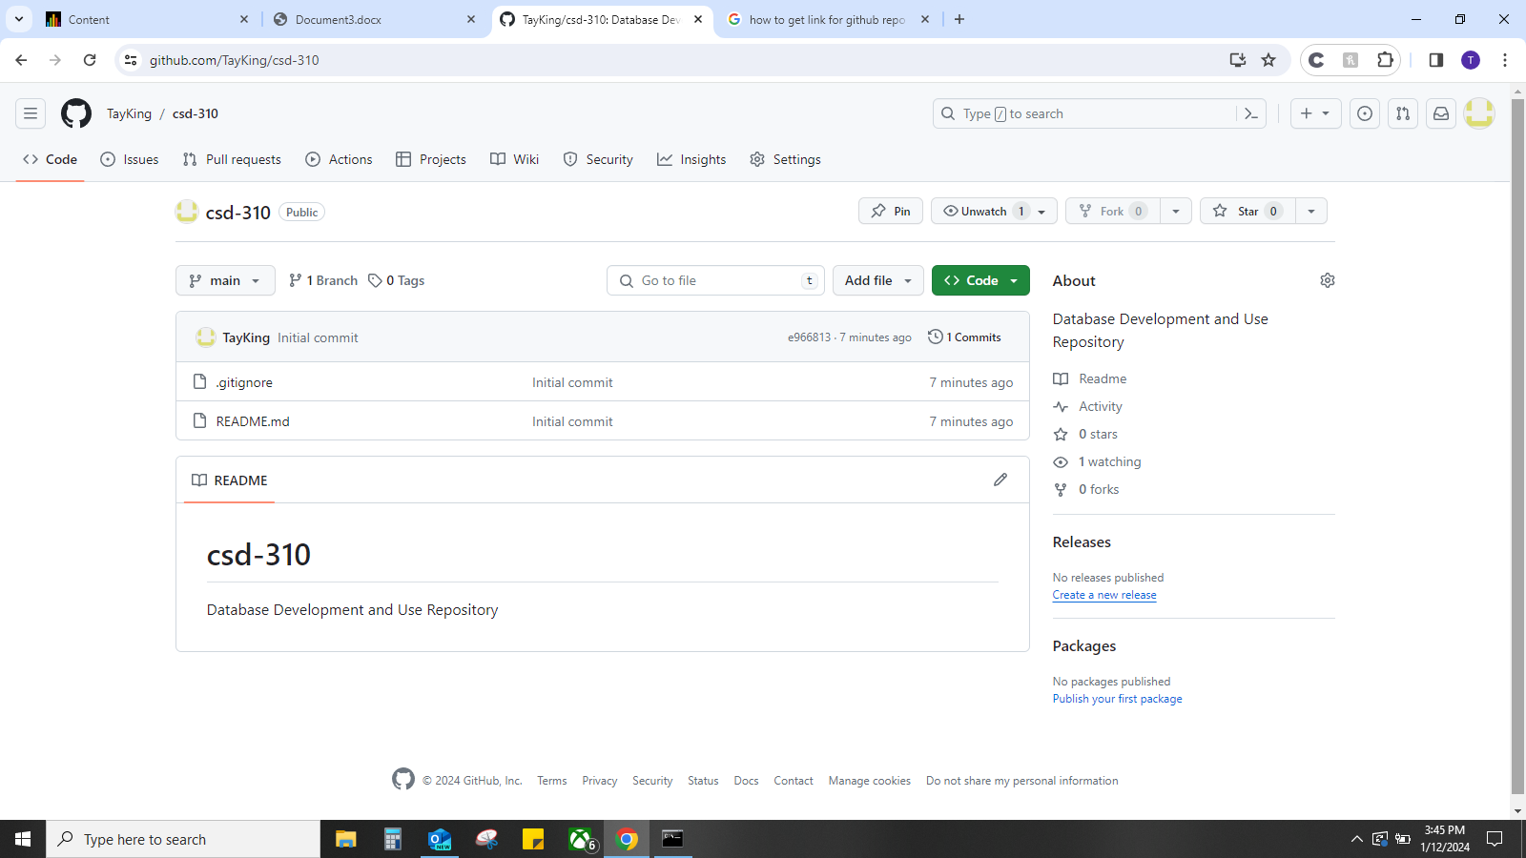
3. 