Taylor King

1/21/24

Module 2.3 Data Models

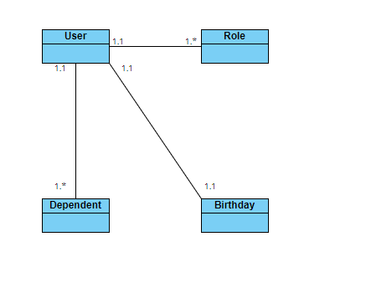

NoSQL Data Structure:

{

"user”,

"roles": [

{

"role1"

},

{

"role2"

}

],

"birthdate": "YYYY-MM-DD",

"dependents": [

{

"name": "dependent1_name",

"relationship": "dependent1_relationship"

},

{

"name": "dependent2_name",

"relationship": "dependent2_relationship"

}

]

}