Taylor King

2/18/24

Module 7.2 Table Queries

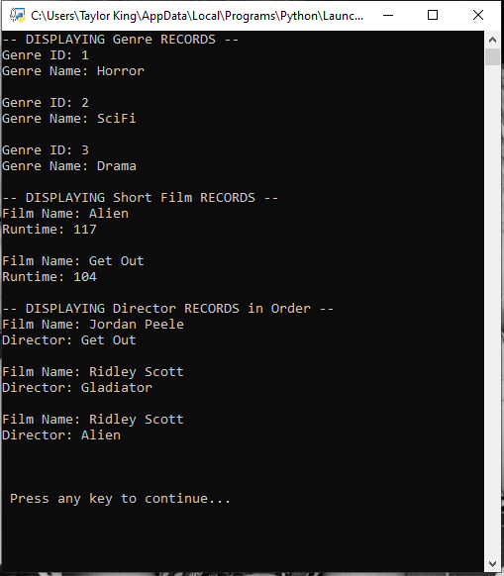

<https://github.com/TayKing/csd-310.git>